**Homework II** (Due March 25 12pm, 2021)

1. Display the value of ***pi*** to 16 significant digits.

> options(digits = 16)

>pi

1. “A Beginner’s Guide to R”中文版第二章习题1、习题2和习题4（p52-53）
2. The *n*th triangular number is given by *n*(n+1)*/*2*.
3. Create a sequence of the first 20 triangular numbers.
4. R has a built-in constant, ***letters***, that contains the lowercase letters of the Roman alphabet. Name the elements of the vector that you just created with the first 20 letters of the alphabet.
5. Select the triangular numbers where the name is a vowel (元音字母).
6. Create a list variable that contains all the square numbers in the range of 0 to 9 in the first element, in the range 10 to 19 in the second element, and so on, up to a final element with square numbers in the range of 90 to 99. Elements with no square numbers should be included!
7. R ships with several built-in datasets, including the famous iris (flower) data collected by Anderson and analyzed by Fisher in the 1930s. Type ***iris*** to see the dataset. Create a named matrix that consists of the numeric columns of the iris dataset, and calculate the means of its columns.(data frame change to matriex)

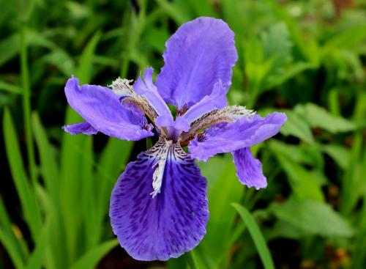

1. 使用系统内建数据集islands:
2. 列出排序第30到第35名的岛名称和面积（降序）(sort)
3. 列出前15大（降序）到后15大（升序）的岛名称和面积
4. 分别列出在奇数位和偶数位的岛名称（只列出名称）
5. 分别列出在奇数位和偶数位的岛面积（只列出面积）