**基础查询**

**首先创建一张students学生表，增加字段与插入数据如下**

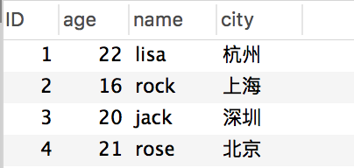

**创建不带参数的存储过程**

查看学生个数

DROP PROCEDURE IF EXISTS select_students_count; -- 没有括号()

DELIMITER ;; --将分割符改为 ;;

CREATE PROCEDURE `select_students_count`() --给存储过程命名

BEGIN

SELECT count(id) from students;

END;;

DELIMITER ; --将分隔符改回为 ;

执行存储过程

call select_students_count();

**https://images2015.cnblogs.com/blog/996472/201706/996472-20170601163633821-220886623.png**

**带参数的存储过程**

根据城市查询总数

DROP PROCEDURE IF EXISTS select_students_by_city_count;

DELIMITER ;;

CREATE PROCEDURE `select_students_by_city_count`(

in _city varchar(**225**)

)

BEGIN

SELECT count(id) from students where city = _city;

END;;

DELIMITER ;

执行存储过程

call select_students_by_city_count('杭州');

**https://images2015.cnblogs.com/blog/996472/201706/996472-20170601163524633-445270020.png**

**带有输出参数的存储过程**

根据姓名查询的学生信息，返回学生的城市

DROP PROCEDURE IF EXISTS select_students_by_name;

DELIMITER ;;

CREATE PROCEDURE `select_students_by_name`(

in _name varchar(**225**), -- 输入参数

out _city varchar(**225**), -- 输出参数

inout _age int(**11**) -- 输入输出参数

)

BEGIN

SELECT city from students where name = _name and age = _age into _city;

END;;

DELIMITER ;

执行存储过程

set @_age = **20**;

set @_name = 'jack';

call select_students_by_name(@_name, @_city, @_age);

select @_city as city, @_age as age;

**https://images2015.cnblogs.com/blog/996472/201706/996472-20170601164009680-1447129188.png**

**MySQL**支持**IN**(传递给存储过程)，**OUT**(从存储过程传出)和**INOUT**(对存储过程传入和传出)类型的参数。存储过程的代码位于**BEGIN**和**END**语句内，如前所见，它们是一系列**SELECT**语句，用来检索值，然后保存到相应的变量(通过指定**INTO**关键字)

**带有通配符的存储过程**

通配符，在参数值赋值时，加上相应的通配符

DROP PROCEDURE IF EXISTS select_students_by_likename;

DELIMITER ;;

CREATE PROCEDURE `select_students_by_likename`(

in _likename varchar(**225**)

)

BEGIN

set _likename = '%s%'; -- 默认值

SELECT * from students where name like _likename;

END;;

DELIMITER ;

执行存储过程

call select_students_by_likename('%s%');

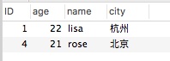

**使用存储过程进行增删改**

新增

新增学生信息

DROP PROCEDURE IF EXISTS insert_student;

DELIMITER ;;

CREATE PROCEDURE `insert_student`(

_id int,

_name varchar(**225**),

_age int,

_city varchar(**225**)

)

BEGIN

INSERT INTO students(ID,name,age,city) VALUES(_id,_name,_age,_city);

END;;

DELIMITER ;

执行存储过程

call insert_student(**5**,'张三',**19**,'上海');

执行完后表中就多了一条数据

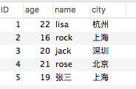

修改

根据学生ID，更新学生信息

DROP PROCEDURE IF EXISTS update_student;

DELIMITER ;;

CREATE PROCEDURE `update_student`(

_id int,

_name varchar(**225**),

_age int,

_city varchar(**225**)

)

BEGIN

UPDATE students SET name=_name, age=_age, city=_city where ID = _id;

END;;

DELIMITER ;

执行存储过程

call update_student(**5**,'amy',**22**,'杭州');

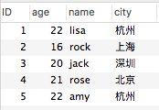

删除

根据ID，删除某学生记录

DROP PROCEDURE IF EXISTS delete_student_by_id;

DELIMITER ;;

CREATE PROCEDURE `delete_student_by_id`(

_id int

)

BEGIN

DELETE FROM students where ID = _id;

END;;

DELIMITER ;

执行存储过程

call delete_student_by_id(**5**);

students表中id为5的那条记录就删除啦！