**Specifications & Requirements**

1. **Upon start of the application, the users should see a splash screen.**
2. **Main menu gives the user the option to register for an account or login with an existing one.**
3. **Login requires a valid username and passwords that is verified with the database**
4. **Registration requests the user to input ssn, first name, last name, email, username, password, address, city, state, country, zip, security question, security answer, and id.**
5. **User should be able to recover access to their account through their security question and answer.**
6. **Two different types of users should exist in the database; admin and customer. Admin should have the same functionality as customer but with more privileges.**
7. **After a customer successfully logs into the application they should be able to:** 
   1. **Access their main menu with the options to book a ride or view their booked rides.**
   2. **Be able to successfully book a ride and view all available trips. Booked rides must populate into their booked rides page.**
   3. **Be able to view their booked rides and delete any unwanted trips.**
   4. **Customer must not be able to double book a trip.**
   5. **Customer must be warned of any time conflicts with their current booked trips and prospective trips.**
   6. **Customer can view how many passengers will be on the trip and not be able to book a full one.**
8. **Admin should have all the functionality of a customer but with an additional option to add, edit, or delete a bus trip.**
9. **Users should be able to go back to the main menu or logout from any screen they are viewing.**
10. **Upon logout, previously booked rides must stay populated and not be removed.**

**Class UML Diagram**

**Data Model**

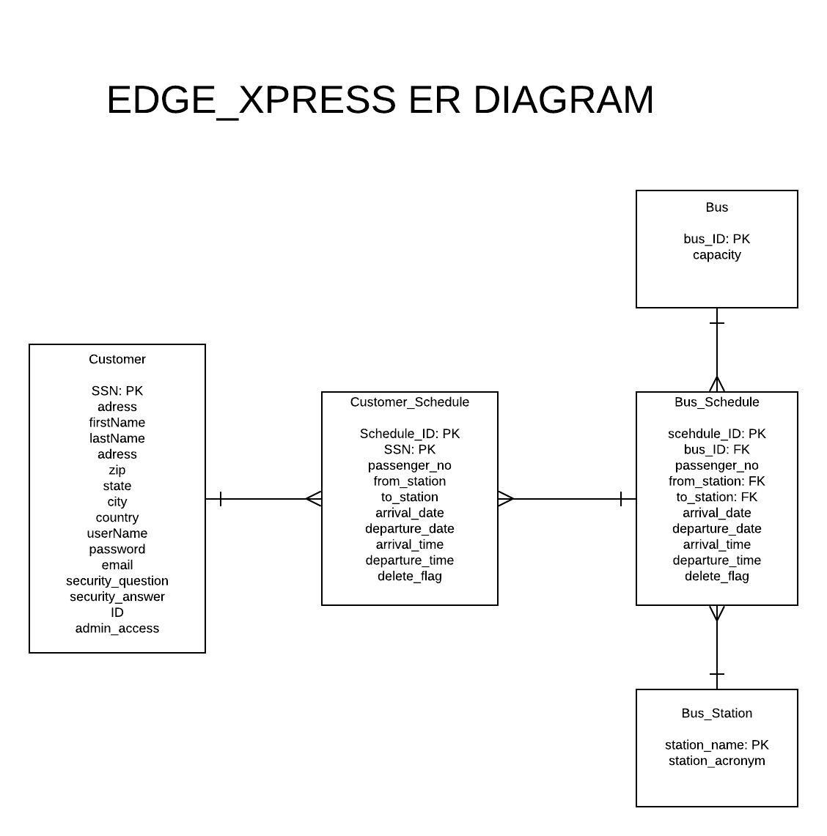

**Flow of Application**

**Login**

**The application first starts by bringing the user to the login window. At this point, the user can login, and register click forgot password if needed. A user is either a customer or an admin. If an admin logs in they are taken to a specialized Home Menu GUI made for them. If the user is not an admin, they are taken to the customer Home Menu GUI.**

**Registration**

**When the user clicks register, they can enter information and click complete to Sign Up. If the username already exists, they will not be able to sign up. They will also not be able to sign up if the SSN they entered is incorrect. If the registration is successful, the user will be taken right back to the login screen.**

**Forgot Password**

**The user is first prompted to enter their username before they can answer their security question. If the username provide is not in the system, the user will be notified that the username does not exist. If the username does exist, the security question for that specific username is displayed. The user must enter a correct answer to change their password. The answers are case sensitive. If answer is invalid, the user is notified to try again. If answer is correct, the user can change password. After changing passwords, they are taken back to the login screen.**

**Customer & Admin Home Menu**

**The customer GUI has three options for the customer to do. The Log Out button allows the user to log out. The “book rides” button takes the customer to a screen where they can book rides. The “view my rides” button takes the customer to a screen where they can view their rides. The customer home menu also greets the user with “welcome [ user’s first name]”. The admin home menu is identical to the customer home menu with one exception. The admin has an extra button named “Edit Bus Rides”. This takes the admin to a GUI where they can add rides, delete rides, and update rides.**

**View My Rides**

**The “View My Rides” GUI functions exactly the same for admins and customers. Here, the user can view every ride they have booked. They can also delete rides that they have. Deleted rides can be registered again if the ride is not full. Once user deletes a ride, the actual ride is not deleted in the database. This is so we can keep additional information about what rides customers delete and also analyze why it was deleted. When a customer ride is deleted, the number of passengers is updated as well. The user can go back to home menu or log out from this screen.**

**Book Rides**

**The “Book Rides” GUI functions exactly the same for admins and customers. In this window the user is provided with every available bus ride. If a user tries to book a ride that they have already scheduled they will be notified with an error. If a user tries to book a ride that they have already booked, they will be notified with an error. Upon a successful booking, the user will be notified that their ride has been booked. This also updates the number of passengers in for that current ride. This window allows user to go back to home menu or log out.**

**Edit Bus Rides**

**ADD**

**The “Edit Bus Rides” GUI allows the admin to add rides, delete rides, and update existing rides. The admin can add rides by utilizing the forum on located on the left side of the screen. If the admin puts a location that edge Xpress bus stations are not located, the admin will be notified with a list of all our current station locations. If the admin puts an incorrect date format, they will be notified that the date is in a wrong format. If a time is inputted incorrectly, the admin will be notified with the right time format to put. The date and time are checked using regex. If an admin tries to put a bus number that doesn’t currently exist, they will be notified that the bus # is not in our systems. Once the forum is complete and correctly formatted the admin can click add ride to add it to the table view. At this point the forum field text is also removed. Admins cannot create schedule ID's since they are handled on the database by virtue of auto incrementing.**

**DELETE**

**The admin can easily delete rides by selecting a ride from the table view and clicking the delete button. If a customer is currently scheduled for that ride, it will still delete the ride. The customer will not be able to see this ride anymore on their end as well. The ride is deleted in the application but still kept in the database for analytic purposes.**

**UPDATE**

**An admin can select a ride from the table view and click the update button to update a current ride. This takes the user to a separate window where they can fill out a forum to update the ride. They are also provided with the information of the ride they are updating. Each text field is verified to ensure the admin is putting valid information. If all information is valid, the user can click update ride to update the current ride. The admin can also go back to the edit info screen and also to the home screen with the two buttons located at the top.**