CHAPTER ONE
1.0 BACKGROUND OF THE STUDY
Recognizing the need for more critical thinking on seed storage options for smallholder farmers, the United States Office of Foreign Disaster Assistance (OFDA), supported a series of grants from 2009–2013 examining diverse seed storage methods across countries and diverse crops. A learning workshop was also held in April 2013 in Bujumbura, Burundi to document and socialize lessons learned across the varied initiatives ((CRS), 2013).In terms of general findings, field programs indicated some advances in reduction of seed storage loss, improved seed quality (viability and vigor) and ultimately yield. As examples, in Mozambique, farmers’ combined use of 1.5 liter bottles, ash, and cooler box technology allowed for stabilized temperature and resulted in reported germination rate increases of 50–90% for maize (as fluctuations negatively impact germination). In Afghanistan, ventilation of traditional pit storage, rigorously combined with improved plant selection in the field and better seed handling practices (separating seed from tubers destined for consumption), cut potato storage losses down from 30% to 5% and resulted in marked yield increases, from 12 to 16 metric tons per hectare.

Unfortunately, farmers often struggle to prevent losses in stored seed that may impede their ability to maintain quality seeds for upcoming plantings. Among other constraints, stored seed may be attacked by insects and pests; or it may lose its ability to germinate, perhaps due to high temperature or too much moisture. Investing in good seed storage, that is, investing in efforts to help farmers save their seed “at the front end” (preventatively), should be seen as a strategic investment. Particularly with vulnerable farmers and in high stress regions, better seed storage options may mean less need for emergency assistance when times get tough “at the back end,” when drought or flood or other stresses mean that multiple sowings, or more seed overall, might be needed to ensure that farmers can adequately sow their fields.
1.1 SEED DETERIORATION
Deterioration following harvest and its effects on seed germination and vigour has been extensively documented. Seed deterioration is progressive with the consequences manifested in a reduction in performance capacity of stored seeds (Adebisi and Ajala, 2000). Thus, the level of seed germinability and vigour declines as the level of seed deterioration increases (Miles, 1985). Deterioration is acclaimed to be influenced by the physical, genetic and physiological composition of the seed lot; Thus, (Miles, 1985) proposed that the acquisition of events defining viability, germination and vigour during seed storage is the inverse of the loss of this same process during seed deterioration. Many studies on seed deterioration have shown that loss of seed vigour during storage precedes decline in seed germination, which occurs well before a seed loses viability ( Heydecker and Robert, 1972). The rate of seed deterioration (fast or slow) is of course dependent on the seed storage environment and the initial physical and physiological quality of the seed (Tekrony, 1993). Regardless of the storage condition (poor or ideal) there is ample evidence to show that seed vigour declines very rapidly to low levels before there is a significant reduction in germination (Eglis, 1979). A hypothetical representation of the relationship among seed germinability, vigour and deterioration was presented by (Delouche and Caldwell, 1960). These authors illustrated the, with curves, increasing difference between germinability and vigour of seeds in storage relative to increase seed deterioration. Seeds are known to be quiescent in storage, undergoing certain irreversible changes. These charges are basically called ‘deterioration’ (Anderson, 1973). It is often stated that ‘seed ageing’, which is synonymous to ‘seed deterioration’ does not actually start in storage, but begins far away at seed physiological maturity in field (Anderson, 1973). (Roberts, 1972) however postulated the classification of primary causes of loss of viability into extrinsic and intrinsic factors. Extrinsic factors are those referred to as external causal factors of seed deterioration e.g. insects, fungi and interaction of other storage environmental factors. Intrinsic factors on the other hand deal with seed deterioration as a result of seed physiology and molecular changes, which occur in deteriorating stored seed (Kehinde, 2013)

1.2 STATEMENT OF THE PROBLEM
The decline of agricultural output which has made Nigeria to turn from a major agricultural exporter to a country that imports agricultural goods has prompted this research with a view to boosting our agricultural products by monitoring the effect of different storage methods on the quality of crops. Nigerian farmers especially the rural ones have always encountered problems on the best storage method to retain the quality of crop so has for sales for income or for further planting.

1.3 SCOPE AND LIMITATIONS
1.3.1 SCOPE OF THE STUDY
The scope of this study is on the effect of storage methods on the quality of some selected seed. The laboratory experiment was conducted at Institute of Agricultural Research and Training, IAR&T, Ibadan, between November 2017 and April 2018 at the seed testing laboratory of IAR&T, Ibadan.

1.3.2 DELIMITATION OF THE STUDY
In this study, the type of seeds are maize and cowpea considered under four different storage method, plastic, calabash, cold room and clay pot.

1.3.3 LIMITATION OF THE STUDY
A major limitation of this study is on the retrieval of a well-structured data, the data collected was unorganized and needed a lot of data cleaning in other to suit the analysis to be made. Also from the data collected the only seeds in which we were able to obtain a well comprehensive information about was the maize and cowpea seed, it would have been of more benefit if in this study we were able to carry out the research on numerous kinds of seed and also, the storage methods which were considered were only of four types. Also, part of the limitations is the fact that only three attributes of the seed were considered in this study which were the FGP, SVI and SWDT.

1.4 RESEARCH QUESTIONS AND HYPOTHESIS OF RESEARCH
1.4.1 RESEARCH QUESTION
- How does a storage container affect the quality of seeds?
- What container would be best for a healthy germination and vigor of seeds?

    - HYPOTHESIS OF RESEARCH HYPOTHESIS
- Do differences that exist in the SDWT, FGP, and SVI base on crop type.
- Do differences that exist in the SDWT, FGP, and SVI base on storage material.
- Do differences that exist in the SDWT, FGP, and SVI base on the interaction between crop type and storage material.
1.5 AIM AND OBJECTIVES
The aim of this study is to determine the effect of storage method on the quality of maize and cowpea seeds and the objectives are:
- To compare the effect of storage methods on germination rate of the selected seed.
- To study the effect of storage methods on vigour of the selected seed.
- To study the effect of storage methods on seed weight of the selected seed.
- Attain a suitable storage method that would preserve the quality of the harvest.

1.6 SIGNIFICANCE OF THE STUDY
There are many advantages for farmers in being able to store their own seed. Using seed from their own stores means that: a) farmers can sow varieties whose quality and management requirements they know well; b) they can access seed without having to lay out cash (in contrast to spending for seed purchased from agro-dealers and local markets); and c) their stored seed is always available on time and just nearby. Unfortunately, farmers often struggle to prevent losses in stored seed that may impede their ability to maintain quality seeds for upcoming plantings.
The finding will also help practitioners design better on-farm seed storage proposals in consultation with famers, implement activities which better meet farmers’ needs, and monitor and evaluate their activities more effectively.
Among the causes of seed insecurity in Africa is inadequate facilities and inappropriate methods for seed storage among rural farmers. This impairs the maintenance of sufficient and safe seed resources compounded with poverty, and insufficient technical and financial support. Successful seed storage is key to farmers’ seed security and may also enable communities to generate income through collecting, storing and selling seeds. Seed storage problems are partly responsible for farmers’ failure to save seeds of non-traditional crops. Poor seed storage conditions have been reported to cause up to 10% loss in seed quality in the tropics mainly through loss of viability.

1.7 DEFINITION OF ACRONYMS
- ANOVA: Analysis Of Variance
- CI: Confidence Interval
- DF: Degree Of Freedom
- FGP: Final Germination Percentage
- $H_{0}$: Null Hypothesis
- $H_{1}$: Alternative Hypothesis
- Mean (M): The Average Of The Numbers
- MSB: Mean Square Between
- MSE: Mean Square Error
- MSW: Mean Square Within
- N: Total sample size
- SDWT: Seed Weight
- Sig (p): Significant Value
- SSB: sum of square between
- SSE: Sum Of Square Error
- SSW: Sum Of Square Within
- SST: Sum Of Square Treatment
- Std. Error (SD): Standard Error
- SVI: Seed Vigour Index
- t: Treatment size

CHAPTER TWO
2.0 LITERATURE REVIEW
Grace (2013) studied the effect of containers on viability and vigour of spider plant seeds stored for six months. The purpose of this research was to increase insight into how the seed quality of spider plant is affected by different packaging containers, seed moisture content and storage temperatures, with a view to finding out the optimal method of packaging and storing of these seeds. Dried seeds were sealed in aluminum foil packets and polyethylene packets and stored at three storage temperatures: ambient (22oC to 30oC), 5oC and minus 20oC for three and six months. After each storage period, seed samples were drawn and viability and vigour tests carried out. Data sets were factorially combined and subjected to Analysis of Variance (ANOVA) and descriptive analysis. Means separation was by Least Significance Difference (LSD). Levels of significance, means and standard deviations were obtained for various data sets. Seed stored for six months at 5% moisture content and minus 20oC recorded the highest seed quality. There were no significant differences between seeds packaged in aluminum foil packets and polyethylene packets. In this study, a germination of 85% was recorded for seed dried to 5% moisture content and stored at room temperature. Therefore, on the basis of these findings, farmers can dry their seeds at about 5% moisture content, package them in polyethylene (since readily available) and store at room temperatures for six months.

Maina (2017) performed a research on the effects of storage methods and seasons on seed quality of jute mallow morphotypes (corchorus olitorius) in kakamega country, Kenya. Jute mallow is an important source of nutrients, income and traditional medicine in Kenya. It is extensively grown and consumed in Western Kenya. However, its production is constrained by lack of quality seeds due to varied farmers agronomic and postharvest practices. The aim of the study was to investigate the effect of storage methods on seed quality of jute mallow in Western Kenya. Seeds of two morphotypes of C. olitorius (with 70% and above germination) were stored in clay pots, transparent plastic jars, brown paper bags and polythene bags at room temperature in Kakamega and Siaya Counties. Seeds were also stored in a freezer at Chepkoilel campus in Eldoret at-20C. In Kakamega County, average room temperature was 230C and relative humidity was 85% during the storage period of May to July 2006. In Siaya County, the average room temperature was 250C and relative humidity was 80% during the same period. Between December and February 2006, the average room temperature was 260C while relative humidity was 80% in Kakamega County. In Siaya County, the average temperature was 280C and relative humidity 65% for the same period. Storage duration was 90 days, which is the length of time farmers in the study areas store jute mallow seeds to avoid seed dormancy. Seed viability and vigour of the seeds was determined. Data obtained were subjected to Analysis of Variance (ANOVA) and T-tests using Statistical Analysis Software (SAS) programme.
Season of growth and storage methods influenced the seed quality. Seeds stored in clay pots, brown paper bags, plastic transparent jars and freezer had higher seed quality than those stored in polythene bags. Even though there was varied response to different storage methods, generally it was recommended that in order to obtain high quality seeds, farmers should store jute mallow seeds in clay pots or brown paper bags or plastic transparent jars or freezer.

Edward and Dackious (2015) studied the Storage Conditions and Period Effects on Quality of Pinus kesiya Seeds from Malawi. In Dedza, Malawi Pinus kesiya seeds are collected in good production years, stored in sealed black polythene tubes at (4´–1) C and used thereafter for seedling production. However, information about the effect of conditions and period of storage on seed quality is scarce. Therefore, the objective of this study was to evaluate the germination percentage (GP) and germination energy (GE) of Pinus kesiya seeds recently collected and after four and ten months after storage in sealed black polythene bags at the temperature of (4´–1) C, dried at 20%, 14%, 7% and 3% moisture content levels. The results shows there were significant (P< 0.001) differences on both GP and GE among different moisture content levels. GP and GE increased with a decrease of moisture content up to 7%, then decline at 3% moisture content. Consequently, there were significant (P< 0.001) differences on both GP and GE among storage period at 3% moisture content. GP and GE decreased with an increase of storage period. In contrast, there were no significant (P> 0.05) differences on GP among the storage period at 20%, 14% and 7% moisture content levels. Similarly, no significant (P> 0.05) differences were observed on GE during the first four months of storage at 20%, 14% and 7% moisture content levels. However, GE significantly declined by the tenth month. Highest GP of (96.6´–2.1)%,(95.8´–2.6)%,(95.2´–2.8)% and GE of (78.3´–2.2)%,(75.9´–2.7)%,(60.2´ 2.7)% at 7% moisture content were obtained for 0, 4 and 10 months of storage respectively. Therefore, the present study recommends storage of Pinus kesiya seeds in sealed black polythene bags with a moisture content of 7% at (4´–1) C temperature in order to maintain the seed viability for a long period.

Shilpa et al (2016) examined the effect of packaging materials on germination of cashew seed nut and survival of cashew seedlings (Anacardium occidentaleL.) was conducted under the polyhouse condition. Six treatments consisting of different packaging materials i.e, 150 gauge poly bag, 300 gauge poly bag, gunny bag, 150 gauge poly bag along with gunny bag, 300 gauge poly bag along with gunny bag and open storage were used for seed storage. The packaging treatment of 300 gauge poly bag along with gunny bag recorded maximum germination percentage (93.05%), highest fresh weight of seedling (51.32 g), highest dry weight of seedling (20.89 g) and maximum survivability (98.98 per cent) with higher seedling vigour as compared to open seed storage. Similarly, 150 gauge poly bag along with gunny bag also maintained germinability and survival of stored cashew seed nut.

Rashmi (2013) carried out a research on seed production and seed storage studies in cosmos (Cosmos sulphureus). The seed storage experiment in the laboratory involving four containers viz., aluminium foil, polythene bag (700 gauge), plastic bottle and cloth bag with or without silica gel revealed that, seeds stored in aluminium foil with silica gel (10 g/kg seeds) was found better upto six months of storage with high germination (86.63%), seedling vigour (1488) and other seed quality parameters as compared to seeds stored in cloth bag.
Among the containers, the seeds stored in aluminium foil and polythene bag moisture impervious containers retained significantly more viability followed by plastic bottle compared to those stored in cloth bag moisture pervious containers besides showing higher speed of germination and higher seedling vigour parameters. Greater fluctuation of moisture content was noticed in seeds stored in moisture pervious containers when compared to those in moisture impervious containers. Aluminium foil was recorded significantly higher seed germination (83.06%), shoot length (9.80 cm), root length (6.79 cm), seedling dry weight (0.89 mg) and seedling vigour index (1294) followed by polythene bag with seed germination (76.91%), shoot length (9.25 cm), root length (5.38 cm), seedling dry weight (8.6 mg) and seedling virour index (1275) and lower was recorded in cloth bag with seed germination (36.42%), shoot length (6.34 cm), root length (4.70 cm), seedling dry weight (6.2 mg) and seedling virour index (365).

Kiran (2011) carried out a study on the Effect of Seed Treatments and Containers on Storability of Jute Varieties (Corchorous olitorius). Seeds packed in polythene bag recorded higher germination (76.28%), vigour parameters with lower electrical conductivity and moisture content as compared to seeds stored in cloth bag at the end of storage period. In the interaction effect of varieties and treatments (VxT), JRO 204 and JRO 524 seeds treated with tannic acid recorded significantly satisfactory higher germination (83.38% and 86.23% respectively) as per minimum seed certification standards and other vigour parameters throughout the storage period. In the interactions between varieties and packaging materials (VxC), JRO 524 variety seeds packed in polythene bag was superior in all the seed quality parameters compared to cloth bag. In the interactions of seed treatments and containers (TxC), seed treated with tannic acid and stored in polythene bag recorded higher satisfactory germination (85.61%) with higher vigour parameters at the end of storage period. Among the interactions of varieties, seed treatments and containers (VxTxC), JRO 524 seeds treated with tannic acid and packed in polythene bag recorded higher satisfactory germination (87.36%) and other seed quality parameters at the end of storage period.

Marcia et al (2009) carried out a research on the physiological quality and storability of carambola seeds. This study was conducted to determine the physiological quality of carambola seeds convectively dried at 38 ´”C, at the end of germination tests in paper rolls and lasting 84 days. Seed storability using two types of packaging, water vapour permeable and impermeable, under two storage conditions, ambient at 25 ´”C and 61% relative humidity, and inside a 10 refrigerated chamber with relative humidity of 82%, was also assessed for periods of 90 and 180 days. Mean germination percentage of fresh seeds was 87%. The results obtained through germination testing showed that carambola seeds can be stored for 90 or 180 days at 10 ´”C, or for 90 days at ambient conditions, in vacuum-sealed packaging, without impairing their physiological quality. Seeds may also be stored for 90 days in water vapour-permeable packaging under refrigeration. Vigour estimated through the germination speed index and the mean time of germination was consistently higher for seeds stored in vacuum-sealed packaging,
irrespective of storage time and temperature.

Ghimire (2003) studied the effects of different storage periods and packaging materials on storability of onion and okra seeds stored in different type of packaging materials significantly influenced the normal seedling production (standard germination), seedling emergence (viability) and speed of germination (vigor). It was found that after 9 months of storage, the mean germination percent was the highest in laminated pouches (70.81%) followed by plastic containers (68.50%), polyethylene bags (67.38%), plastic sacks (57.88%) and cloth bags (57.13%) in case of okra and also stated that the seed qualities were maintained for longer period in laminated pouches, plastic containers and polyethylene bags.

Tripathi and Lawande (2012). The investigation was carried out to study the effect of seed moisture and packing material on viability of onion seed. Agrifound Dark Red of different moisture levels ie 5, 6, 7 and 8 percent were packed in various packing materials ie cloth bags, polyethylene bags, laminated aluminum bags and laminated aluminum bags with vacuum packing and stored at ambient condition for 27 months. The germination and viability of seed was recorded after 12, 15, 18, 21, 24 and 27 months. The results indicated that germination percent and seed vigour Index were higher in seed having 5% moisture than seed having 8% moisture. Seeds with higher moisture lost viable faster than seed with lower moisture after 18 months of storage. Among the packing materials, lower seed germination and viability was recorded in cotton cloth bags. The seed packed in cloth bags lost their complete viability and vigour within 18 months of storage. The highest seed germination was observed in laminated aluminum bags with vacuum packing. The seed packed in aluminum laminated bags were remained viable for 27 months. Among the various treatments combinations seed having 5% moisture and vacuum packed in aluminums laminated bags remain viable for longer period with percent germination was 61.7% germination 27 months of storage. The seed vigour index was
also higher in this treatment than other treatments.

Olosunde et al (2018). A storage experiment was conducted at the seed testing laboratory of the National Centre for Genetic Resources and Biotechnology (NACGRAB), Ibadan, Nigeria to examine the effect of packaging materials and storage periods on seed germination of cowpea. Seeds of two improved varieties of cowpea: Ife Brown and SAMPEA 12 were packed using three packaging materials viz. aluminium bags, plastic containers and envelopes. The seeds were dried to 12% moisture content with initial germination percentages of 90% and 88% respectively. The packaged seeds were stored under short-term storage conditions (temperature of 15.1 to 22.6°C and relative humidity of 26.9 to 50.7%) in February 2015. The experiment was arranged in 2 x 3 x 5 factorial using completely randomized design (CRD) in three replications. The three factors were two varieties of cowpea, three packaging materials and five storage periods. The results of analysis of variance revealed that effect packaging materials were significant (P=.05) while an effect of storage period was highly significant (P<0.01) on seed germination of cowpea. The seeds packed in plastic containers recorded highest germination percentage of 75.9%. Germination values for seeds packed in envelopes (73.53%) and aluminum bags (70.20%) were not significantly different. Hence, plastic containers appeared to be the best for storage of cowpea seeds. Furthermore, increasing storage periods from 3, 6, 9 12 and 15 months resulted to declining in germination percentage with respective values of 91.4, 84.6, 74.4, 68.1 and 47.6%. Moreover, means for the interactive effect of variety by storage period revealed that cowpea varieties could retain viability values of 70% and above up to 12 months in storage at the present conditions used in the study. Based on this work, we are interested in the effect of storage containers on the final germination percentage, seed vigour and seed weight of some selected seed.

CHAPTER 3
3.0 RESEARCH METHODOLOGY
The details of the materials and methods of this research work were described in this chapter as well as on experimental site, experiment period, experimental materials and experimental design, data collection on seed quality as well as seedling attributes. In this chapter the theoretical framework and methodology adopted to accomplish those objectives are discussed.

3.1 RESEARCH PURPOSE
The overall purpose of this research is to study the impact of storage containers on maize and cowpea seed quality (i.e. how it affects the seed germination percentage, seed vigour and the seed weight).

3.2 DATA COLLECTION
Data collection is the process of gathering and measuring information on targeted variables in the established systematic fashion, which then enables one to answer relevant questions and evaluate outcomes. It is known as the systematic gathering of data for a particular purpose from various sources that has been systematically observed, recorded and organized.
The data used in this study was collected from the Institute of Agricultural Research and Training, IAR&T, Ibadan. The laboratory experiment was conducted at Institute of Agricultural Research and Training, IAR&T, Ibadan, between November 2017 and April 2018 at the seed testing laboratory of IAR&T, Ibadan. The seeds were said to have been dried to about 12% moisture content with initial germination percentages of 97%, initial seed weight of 20.4 and initial seed vigour index of 26.6. The seeds were of different types but for this study we would be looking into just the maize and cowpea crop, along with the numerous storage methods of which we would just be considering the cold room, plastic container, calabash and clay pot. The effects of containers in this study would be classified based on its influence on the seed weight (SDWT), Seed Vigour Index (SVI), and Final Germination Percentage (FGP) in which all these are all the qualities of the seed we would be looking into.

3.3 RESEARCH MODEL AND DATA ANALYSIS
The data were subjected to analysis of variance (ANOVA) using Statistical package for social sciences (SPSS version 16). Data on final germination percentages (FGP) and seed vigour (SVI) do not conform to normal distribution, the data were therefore transformed to a normalized distribution before subjecting them to the ANOVA. However, since ANOVA did not detect any significant difference between transformed and untransformed values, untransformed values are hereby presented. The Levene’s test was also used to test the homogeneity of variance which gave a positive result. Pertinent means were thereafter separated by the use of the Turkeys HSD at 0.05 level of probability.

3.4 LEVENE’S TEST
Levene's test (Levene 1960) is used to test if k samples have equal variances. Equal variances across samples is called homogeneity of variance. Some statistical tests, for example the analysis of variance, assume that variances are equal across groups or samples. The Levene test can be used to verify that assumption.
Levene's test is an alternative to the Bartlett test. The Levene test is less sensitive than the Bartlett test to departures from normality. If you have strong evidence that your data do in fact come from a normal, or nearly normal, distribution, then Bartlett's test has better performance.
The Levene test is defined as:

$H_{0}$ : $σ_{1}^{2}=σ_{2}^{2}=…=σ_{k}^{2}$
$H_{0}$ : $σ_{1}^{2}≠σ_{2}^{2}≠…≠σ_{k}^{2}$
3.5 ANOVA
Analysis of variance (ANOVA) is a statistical technique that is used to check if the means of two or more groups are significantly different from each other. ANOVA checks the impact of one or more factors by comparing the means of different samples. The ANOVA technique extends what an independent sample t test can do to multiple means.

3.5.1 One-Way ANOVA
In an analysis of variance the variation in the response measurements is partitoned into components that correspond to different sources of variation.The goal in this procedure is to split the total variation in the data into a portion due to random error and portions due to changes in the values of the independent variable(s).
The variance of n measurements is given by
$s^{2}=\frac{{\sum_{i=1}^{n}{(y_{i}-\overline{y})}}^{2}}{n-1}$,
Where $\overline{y}$ is the mean of the $n$ measurements
The numerator part is called the $sum of squares$ of deviations from the mean, and the denominator is called the $degrees of freedom.$
The variance, after some algebra, can be rewritten as:
$s^{2}=\frac{{\sum_{i=1}^{n}{y_{i}}}^{2}-\frac{1}{n}{(\sum_{i=1}^{n}{y_{i}})}^{2}}{n-1}$.
The first term in the numerator is called the "$raw sum of square$" and the second term is called the "$correlated term of the mean$". Another name for the numerator is the "$correlated sum of squares$", and this is usually abbreviated by $Total SS or SS(Total)$
The $SS$ in a one-way ANOVA can be split into two components, called the "$sum of square treatments$" and "$sum of square error$", abbreviated as $SST$ and $SSE$, respectively.
Algebraically this can be expressed by:
$SS\left(total\right) = SST + SSE$
$\sum_{i=1}^{k}{\sum_{j=1}^{n_{i}}{{(y_{ij}-{\overline{y}}_{..})}^{2}}} = \sum_{i=1}^{k}{{{ n}_{i}\left(y_{i.}-{\overline{y}}_{..}\right)}^{2} + \sum_{i=1}^{k}{\sum_{j=1}^{n_{i}}{{(y_{ij}-{\overline{y}}_{i.})}^{2}}}}$,
where $k$ is the number of treatments and the bar over the $y..$ denotes the "$grand mean$" or "$overall$" mean. Each $n_{i}$ is the number of observations for treatment $i$. The total number of observations is $N$ (the sum of the $n_{i}$).
Table 3.5.1: The resulting One-Way ANOVA table
Source | SS | DF | Mean square | F-Ratio
$$Between treatment$$ | $$SSB$$ | $$t-1$$ | $$MSB=\frac{SSB}{t-1}$$ | $$\frac{MSB}{MSE}$$
$$Error$$ | $$SSA$$ | $$N-1$$ | $$MSE=\frac{SSA}{N-1}$$
$$Total$$ | $$SST$$ | $$N-1$$

3.5.2 Two-Way ANOVA
For a case in which when the outcome or dependent variable is affected by two independent variables/factors we use a slightly modified technique called two-way ANOVA. The purpose of the two-way ANOVA is to examine for the interaction between two independent variables on one dependent variable.
In order to run two-way ANOVA, you must have:
- Two independent variables – categorical (in this case it is the storage material and crop).
- One dependent variable – continuous (could be SDWT/ FGP/ SVI).
MODEL
$Y_{IJ}=µ+T_{I}+ β_{J}+γ_{IJ}+e_{IJK}$
For $i=1,2,…,a,$ $j=1,2,…,b,$ $k=1,2,…,r.$
Where $µ$ is the overall mean response, $T_{I}$ is the effect due to the $i^{th}$ level of factor A, $β_{J}$is the effect due to the $j^{th}$ level of factor B and $γ_{IJ}$ is the effect due to any interaction between the $i^{th}$ level of factor A and the $j^{th}$ level of factor B.
When an $a×b$ factorial experiment is conducted with an equal number of observations per treatment combination, the total (corrected) sum of square is partitioned as :
$SST=SSA+SSB+SSAB+SSE$
Where $AB$ represents the interaction between A and B.
For reference, the formulas for the sum of squares are:
$SSA=rb\sum_{i=1}^{a}{{({\overline{y}}_{i..}-{\overline{y}}_{...})}^{2}}$
$SSB=ra\sum_{j=1}^{b}{{({\overline{y}}_{.j.}-{\overline{y}}_{...})}^{2}}$
$SSAB=r\sum_{i=1}^{a}{\sum_{j=1}^{b}{{({\overline{y}}_{ij.}-{\overline{y}}_{i..}-{\overline{y}}_{.j.}+{\overline{y}}_{...})}^{2}}}$
$SSE=\sum_{k=1}^{r}{\sum_{j=1}^{b}{\sum_{i=1}^{a}{{(y_{ijk}-{\overline{y}}_{ij.})}^{2}}}}$
$SST=\sum_{k=1}^{r}{\sum_{j=1}^{b}{\sum_{i=1}^{a}{{(y_{ijk}-{\overline{y}}_{... })}^{2}}}}$
Table 3.5.2: The resulting ANOVA table for an $a×b$ factorial experiment
Source | SS | DF | Mean square | F-Ratio
$$Factor A$$ | $$SSA$$ | $$a-1$$ | $$MSA=\frac{SSA}{a-1}$$ | $$\frac{MSA}{MSE}$$
$$Factor B$$ | $$SSB$$ | $$b-1$$ | $$MSB=\frac{SSB}{b-1}$$ | $$\frac{MSB}{MSE}$$
$$Interaction$$ | $$SSAB$$ | $$(a-1)(b-1)$$ | $$MSAB\frac{SSAB}{\left(a-1\right)(b-1)}$$ | $$\frac{MSAB}{MSE}$$
$$Error$$ | $$SSE$$ | $$(N-ab)$$ | $$MSE=\frac{SSE}{(N-ab)}$$
$$Total$$ | $$SST$$ | $$\left(N-1\right)$$

3.6 HYPOTHESIS TESTING
It examines the significant difference among the various types of storage materials on the quality of the different types of crops
- $H_{0}$ : storage material will have no significant effect on SDWT/FGP/SVI
- $H_{0}$ : crop seed would have no significant effect on SDWT/FGP/SVI
- $H_{0}$: storage material and crop interaction will have no significant effect on SDWT/FGP/SVI

3.7 TUKEY’S HSD
Tukey’s HSD test is a post-hoc test, meaning that it is performed after an analysis of variance (ANOVA) test. This means that to maintain integrity, a statistician should not perform Tukey’s HSD test unless she has first performed an ANOVA analysis. In statistics, post-hoc tests are used only for further data analysis; these types of tests are not pre-planned. In other words, you should have no plans to use Tukey’s HSD test before you collect and analyze the data once. The purpose of Tukey’s HSD test is to determine which groups in the sample differ. While ANOVA can tell the researcher whether groups in the sample differ, it cannot tell the researcher which groups differ. That is, if the results of ANOVA are positive in the sense that they state there is a significant difference among the groups, the obvious question becomes: Which groups in this sample differ significantly? It is not likely that all groups differ when compared to each other, only that a handful has significant differences. Tukey’s HSD can clarify to the researcher which groups among the sample in specific have significant differences.

CHAPTER 4
4.0 DISCUSSION, ANALYSIS AND RESULT
Investigations were carried out to evaluate how storage materials could affect seed quality of some selected seed in relation to quality attributes like final germination percentage, seed vigor index and seed weight. Tests were also conducted to see the difference between this seeds in relation to some characteristic attributes. It is to be noted that a 95% level of significance will be used, and the decision rule will be based on the fact that if there occurs a significant value less that 0.05 we would reject the null hypothesis and fail to reject the alternative hypothesis.
4.1 EXPERIMENTAL MATERIALS
Storage container
The experiment comprised with the four containers treatments as storage packing materials. They are as follows:
- Plastic container
- Calabash
- Clay pot
- Cold room
Type of seeds
The experiment comprised with two types of seed. They are:
- Maize seeds
- Cowpea seeds

4.2 EXPERIMENTAL DESIGN AND LAYOUT
The experiment consisted of two factors, the first factor is the storage container with four different levels and the second factor is the type of seed used which consist of two different levels.

Table 4.2.1: Sample size of storage material
STORAGE MATERIAL |  |  | N
 |  | Calabash | 42
 |  | clay pot | 42
 |  | Cold room | 42
 |  | Plastic | 42

Table 4.2.2: Sample size of seed
CROP |  | N
 | Cowpea | 84
 | MAIZE | 84

From Table 4.2.1, we can see we have calabash, clay pot, cold room and plastic as the different levels of the storage material factor with all the sample sizes equal with 42. With crop sample sizes being equal with 84 each in Table 4.2.2.

4.3 PARAMETER STUDY AS QUALITY TESTS
The following parameter were studied as quality of maize and cowpea seeds
  - Percentage of seed germination
  - Seedling vigor index (SVI)
  - Dry weight of seedling

Germination test
The germination capacity was expressed in percentage based on total seed used in the test (ISTA, 2006).
The data were expressed in percentage based on total number of seeds plated. The germination was expressed in percentage which was calculated using following formula.
% Germination = 100×$\frac{X 1}{X}$ Where, X = Total number of seeds per paper towel X1 = Number of seedlings per paper towel.

Seedling vigor
For seedling vigor test, after a period seedlings were randomly selected used for germination test. Root length (cm) and shoot length (cm) of the seedlings were recorded and mean values of the two parameters were computed. Vigor index was computed following a standard formula as suggested by Abdul– Baki and Anderson (1973), where Vigor index = [Mean root length (cm) + mean shoot length (cm)] × germination (%).

Dry weight of seedling
The seedlings used for measuring the seedling length are assumed to be put in the butter paper bag and dried in a hot air oven, maintained at 70±10C temperature for 24 hours. Then the seedlings removed and allowed to cool in a desiccator for 30 minutes, the weighing was done in an electronic balance. The weight of dried samples recorded and average of the seedling dry weight in grams recorded (Anon, 1976).

4.4 FINAL GERMINATION PERCENTAGE (%) (FGP)
4.4.1 EFFECT OF STORAGE MATERIAL
Establishing the hypothesis:
$H_{0}$ : Storage material would have no significant effect on FGP
$H_{1}$ : Storage material would have significant effect on FGP
Table 4.4.1 A one-way between groups (Dependent Variable: FGP)
Source | Sum of Squares | df | Mean Square | F | Sig.
STORAGE_MATERIAL | 1492.184 | 3 | 497.395 | 13.068 | .000
Error | 6242.089 | 164 | 38.062
Total | 1435414.430 | 168

In Table 4.4.1 A one-way between groups ANOVA was performed to compare the impact of storage material on FGP. There was found a statistical significant difference in FGP for the storage material with (F (3,164) = 13.068, p = .000).

Table 4.4.2: Multiple Comparisons (FGP Turkeys HSD)
STORAGE_MATERIAL | N | Subset
STORAGE_MATERIAL | N | 1 | 2
Clay pot | 42 | 88.7595
Plastic | 42 | 89.7262
Calabash | 42 |  | 94.6619
Cold room | 42 |  | 95.5929
Sig. |  | .892 | .903

In the Table 4.4.2 we went further to detect where the difference lies within the storage material by conducting a turkey’s HSD (honestly significant difference) test. It is to be noted that materials grouped in subset 1 are significantly different from materials in subset 2. The turkeys HSD test gives a result where we see the significant values in which we could conclude that we do not have no significant difference between calabash and cold room with means 88.7595 and 89.7262 respectively and p = .892, there also exist no significant difference between calabash and cold room with mean values 94.6619 and 95.5929 respectively and p = .903.
Figure 4.4.1: Estimated marginal mean of FGP (storage material)

We can see that from Figure 4.4.1 the FGP values of the clay pot and plastic is relatively low and for calabash and cold room, the value of the FGP is relatively high.
4.4.2 EFFECT OF SEED TREATMENT
Establishing the hypothesis:
$H_{0}$ : Seed would have no significant effect on FGP
$H_{1}$ : Seed would have significant effect on FGP
Table 4.4.3: Tests of Between-Subjects Effects(Dependent Variable: FGP)
Source | Sum of Squares | df | Mean Square | F | Sig.
CROP | 19.271 | 1 | 19.271 | .415 | .521
Error | 7715.001 | 166 | 46.476
Total | 1435414.430 | 168

In Table 4.4.3 A one-way between subject effects ANOVA was performed to compare the crop FGP. There was no statistical significant difference in FGP for the crop (F(1,166) = .415, p = .521).

Figure 4.4.2: estimated marginal means of FGP (crop)

4.4.3 COMBINED EFFECT OF STORAGE MATERIAL AND SEED TREATMENT
$H_{0}$ : Interaction between seed and storage material would have no significant effect on FGP
$H_{1}$ : Interaction between Seed and storage material would have significant effect on FGP
Table 4.4.4: Tests of Between-Subjects Effects (Dependent Variable: FGP)
Source | Sum of Squares | df | Mean Square | F | Sig.
CROP | 19.271 | 1 | 19.271 | .497 | .482
STORAGE_MATERIAL | 1492.184 | 3 | 497.395 | 12.827 | .000
CROP * STORAGE_MATERIAL | 18.536 | 3 | 6.179 | .159 | .924
Error | 6204.282 | 160 | 38.777
Total | 1435414.430 | 168
From Table 4.4.4 we have the interaction effect, F(3,160) = .159, p= .924. There was insufficient evidence to reject the interaction effect null hypothesis, F(3,160) = .159 p= .924.
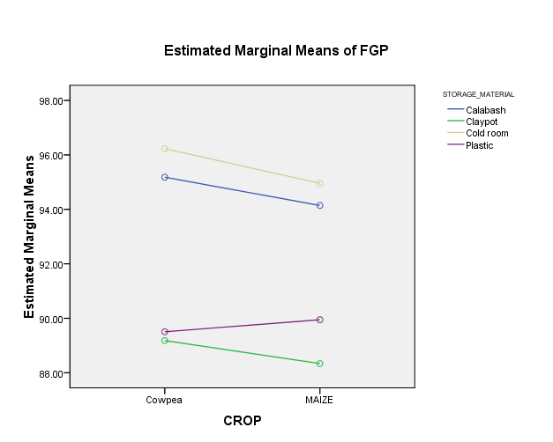Figure 4.4.3: Estimated marginal mean of FGP (interaction between seed and storage material)

From Figure 4.4.3 we see that the grey line and the blue line are parallel, so we won’t be expecting an interaction effect between calabash and cold room. Also from the figure looking at the purple line we can deduce that plastic is a better storage material for maize compared to that of cowpea seeing that there is an increase in the value of FGP. On the other hand we see that clay pot is a worst storage container for both maize and cowpea, we see that there is a decline in its slope.

Figure 4.4.4: Graphical display of the descriptive summary of the interaction between crop and storage material (Dependent Variable: FGP).

From Figure 4.4.4 we see that cold room could be considered as best storage material when looking at their FGP. From the graph we see that pairing of cowpea and cold room, maize and cold room with the highest values.

4.5 SEED VIGOUR INDEX (SVI)
4.5.1 EFFECT OF STORAGE MATERIAL
$H_{0}$ : storage material would have no significant effect on SVI
$H_{1}$ : storage material would have significant effect on SVI
Table 4.5.1: Tests of Between-Subjects Effects (Dependent Variable: SVI)

Source | Sum of Squares | df | Mean Square | F | Sig.
STORAGE_MATERIAL | 219.305 | 3 | 73.102 | 4.354 | .006
Error | 2753.201 | 164 | 16.788
Total | 77894.440 | 168

In Table 4.5.1 A one-way between groups ANOVA was performed to compare the impact of storage material on FGP. There was a statistical significant difference in SVI for the storage material (F(3,164) = 4.354, p = .006).

Table 4.5.2: Multiple Comparisons (SVI Turkeys HSD)
STORAGE_MATERIAL | N | Subset
STORAGE_MATERIAL | N | 1 | 2
Claypot | 42 | 19.8762
Plastic | 42 | 20.1429
Cold room | 42 | 21.8571 | 21.8571
Calabash | 42 |  | 22.5952
Sig. |  | .122 | .841

Since we have a significant effect of storage material on the SVI of a seed , we would like to detect within which pairs of levels of storage material the significant difference exists. From the Table 4.5.2 it could be observed that the Turkeys HSD test indicates a significant difference between all materials in subset 1 and materials in subset 2. It could further be stated that there exist no significant difference between clay pot, plastic and cold room with p =.122 and also there exist no significant difference between cold room and calabash with p = .841.

Figure 4.5.1: estimated marginal means of SVI (storage material)

From Figure 5.5.1 we see that clay pot has the lowest mean value for SVI and calabash is having the highest mean value of SVI. We could conclude tha
t in relation to the SVI calabash would be the most favorable storage material for a seed

4.5.2 EFFECT OF SEED TREATMENT
$H_{0}$ : Seed would have no significant effect on SVI
$H_{1}$:Seed would have significant effect on SVI

Table 4.5.3: Tests of Between-Subjects Effects(Dependent Variable: SVI)
Source | Sum of Squares | df | Mean Square | F | Sig.
CROP | 44.229 | 1 | 44.229 | 2.507 | .115
Error | 2928.278 | 166 | 17.640
Total | 77894.440 | 168

Form Table 4.5.3 computation we have the sig value of crop to be crop (F(1,166) = 2.507, p = .115).This implies that we fail to reject the null hypothesis and make a conclusion that there is no significant difference in crops.

Figure 4.5.2: estimated marginal means of SVI (crop)

We see from the means of the SVI crops, they are actually close but just a little difference with
the maximum level of SVI to be cowpea (21.6310) and minimum maize (20.6048).
4.5.3 COMBINED EFFECT OF STORAGE MATERIAL AND SEED TREATMENT
$H_{0}$ : Interaction between seed type and storage material would have no significant effect on SVI
$H_{1}$ : Interaction between seed type and storage material would have significant effect on SVI
Table 4.5.4: Tests of Between-Subjects Effects (Dependent Variable: SVI)
Source | Sum of Squares | df | Mean Square | F | Sig.
CROP | 44.229 | 1 | 44.229 | 2.648 | .106
STORAGE_MATERIAL | 219.305 | 3 | 73.102 | 4.377 | .005
CROP*STORAGE_MATERIAL | 37.010 | 3 | 12.337 | .739 | .530
Error | 2671.962 | 160 | 16.700
Total | 77894.440 | 168

From Table 4.5.4 Interaction effect, F(3,160) = .739 p= .530. There is insufficient evidence to reject the interaction effect null hypothesis, F(3,160) = .739 p= .530. therefore we conclude that there is no interaction effect between crop and storage material.
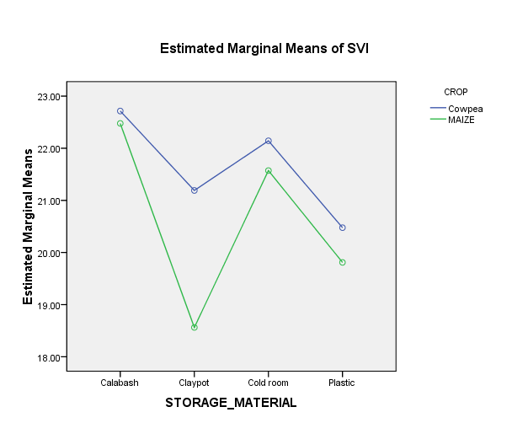
Figure 4.5.3: Estimated marginal means of SVI (storage material)

From Figure 4.5.3 the graph it could be said that there is no level of interaction between the two crops and the different storage materials when considering their SVI and again we see the maize having the lowest value of SVI when stored in the clay pot.

Figure 4.5.4: descriptive statistics on the interaction between storage material and crop
From Figure 4.5.4 when considering the SVI value, maize seed when stored in a clay pot would give lowest value or result of SVI when compared to other result produced by the effect of container on seed. The highest SVI value of a seed can be obtained when storing cowpea in a calabash.
4.6 SEED WEIGHT (SDWT)
4.6.1 EFFECT OF STORAGE MATERIAL
$H_{0}$ : Storage material would have no significant effect on SDWT.
$H_{1}$ : Storage material would have significant effect on SDWT
Table 4.6.1: Tests of Between-Subjects Effects (Dependent Variable: SDWT)

Source | Sum of Squares | df | Mean Square | F | Sig.
STORAGE_MATERIAL | 50.976 | 3 | 16.992 | 7.305 | .000
Error | 381.452 | 164 | 2.326
Total | 58029.630 | 168

In Table 4.6.1 A one-way between groups ANOVA was performed to compare the impact of storage material on FGP. There was a statistical significant difference in FGP for the storage material (F(3,164) = 7.305, p = .000).

Table 4.6.2: Multiple Comparisons (SDWT Turkeys HSD)
STORAGE_MATERIAL | N | Subset
STORAGE_MATERIAL | N | 1 | 2
Cold room | 42 | 17.8979
Plastic | 42 | 18.0755
Calabash | 42 |  | 18.8486
Claypot | 42 |  | 19.2419
Sig. |  | .925 | .515

We have conducted a Turkeys HSD test (Table 4.6.2) so has to know where the difference lies. Looking at the sig value we have that there is no significant difference between cold room and plastic with p = .925 and also there is no significant difference between calabash and clay pot with p = .515. it could also be further stated that materials in subset 1 are significantly different from materials in subset 2.

Figure 4.6.1: Estimated marginal means of SDWT (storage material)

From the Table 4.6.1 we see that SWDT has its lowest value when the seeds are been stored in cold room and has its highest value of SDWT when they are been stored in clay pot.
4.6.2 EFFECT OF SEED TREATMENT
$H_{0}$ : Seed would have no significant effect on SDWT.
$H_{1}$ : Seed would have significant effect on SDWT

Table 4.6.3: Tests of Between-Subjects Effects(Dependent Variable: SDWT)
Source | Sum of Squares | df | Mean Square | F | Sig.
CROP | 102.617 | 1 | 102.617 | 51.649 | .000
Error | 329.810 | 166 | 1.987
Total | 58029.630 | 168

Since in Table 4.6.3 the tests of between-subjects effects we have a sig value of crop (F(1,166) = 51.649, p = .000) we reject the null hypothesis that says there is no significant difference between SDWT of the seeds. Concluding that the SDWT of maize is different from that of cowpea.

Figure 4.6.2: Estimated marginal means of SDWT (crop)

From the descriptive statistics we see maize with the highest mean value (19.2975) of SDWT and cowpea being the lowest (7.7344) with a difference of approximately 2.5.

4.6.3 COMBINED EFFECT OF STORAGE MATERIAL AND SEED TREATMENT
$H_{0}$ : Interaction between seed type and storage material would have no significant effect on SDWT
$H_{1}$ : Interaction between seed type and storage material would have significant effect on SDWT
Table 4.6.4: Tests of Between-Subjects Effects (Dependent Variable:SDWT)
Source | Sum of Squares | df | Mean Square | F | Sig.
CROP | 102.617 | 1 | 102.617 | 60.012 | .000
STORAGE_MATERIAL | 50.976 | 3 | 16.992 | 9.937 | .000
CROP*STORAGE_MATERIAL | 5.241 | 3 | 1.747 | 1.022 | .385
Error | 273.593 | 160 | 1.710
Total | 58029.630 | 168
From Table 4.6.4 Interaction effect, F(3,160) = 1.022, p = .385. There was insufficient evidence to reject the interaction effect null hypothesis, F(3,160) = 1.022, p = .385.

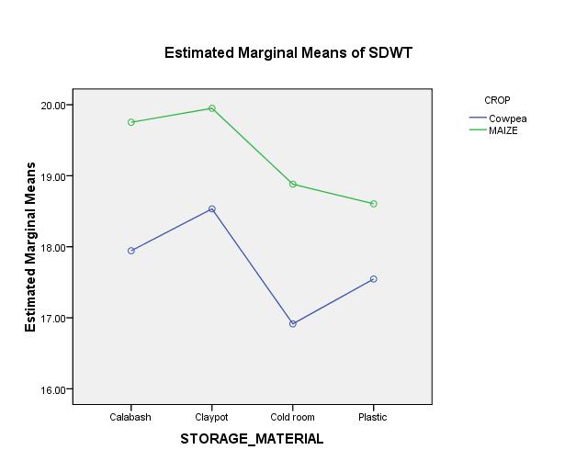
Figure 4.6.3: Estimated marginal means of SDWT (storage material)

In the estimated marginal (Figure 4.6.5) means of SDWT where storage material is on the horizontal we see that there is no visible interaction between the crops. But we could also deduce that calabash and clay pot are the two best storage materials for both maize and cowpea while cold room and plastic could be said to be the worse storage material when looking at SWDT.

Figure 4.6.4: descriptive statistics on the interaction between storage material and seed

From the descriptive statistics (Figure 4.6.4) we would see that for maize seed would retain its SDWT better when stored in a clay pot, and would loose its SDWT when stored in a plastic and the same goes for cowpea seed.

CHAPTER 5
5.0 SUMMARY, CONCLUSION AND RECOMMENDATION
5.1 SUMMARY
The present investigation was conducted on a data collected from the institute of agricultural research and training (IAR&T), Ibadan to determine the effect of different storage facilities on the quality of some selected seed. The study compared four storage facilities namely plastic, cold room, clay pot and calabash in which two types of seed were considered namely, cowpea and maize. In this study an ANOVA test was used to investigate if there was any significant difference with the storage methods, significant difference between the seed in relation to their attribute and also the interaction effect. The stored seed influenced by different storage methods was found to be statistically significant at all the character studied during the study.
5.2 CONCLUSION
This study has been carried out to see the effect of different storage methods on the quality of some selected seed based on three different seed attributes, the FGP, SVI and the SWDT.
In the case of FGP attribute due to storage materials, we saw that the FGP was significantly affected by the storage material and when further analysis were made to check for the differences between materials, it was figured out that there is no difference between calabash and cold room, which implies that whether a calabash or cold room is used to store the seed, the result of the FGP at the end of the day are approximately the same. Also, the same goes for using either clay pot or plastic. But a user of clay pot and another user of calabash would have extremely different result in their FGP attribute of the seed. It was also figured out that between maize seed and cowpea seed, there is no significant difference in there FGP. When considering interaction effect, it was found to be negative i.e. there exist no interaction effect between crop and storage material on the seed FGP. Finally from all the investigation conducted on the FGP, it’s to be concluded that to have the highest FGP, the seed should be stored in cold room for both maize and cowpea with mean value of 96.2% and 94.9% respectively. A calabash could be a second choice which has mean value of 95% and 94% for both cowpea and maize respectively, but a clay pot should never be a choice when compared to this other storage materials, likewise a plastic.
In the case of SVI quality attribute due to storage containers, it was figured out that there is a significant difference in the SVI when stored in the various storage materials. When further analyses were made it was figured out that the significant difference existed between calabash and clay pot then also calabash and plastic. In the study of the seed difference it was found that there is no significant difference between maize SVI and a cowpea SVI. When interaction tests were conducted, it was detected that there is no interaction effect between seed and storage material in relation to the SVI. It is to be concluded that for preserving either the maize and cowpea seed vigour, the best storage material to be used is calabash for both cowpea and maize with SVI mean of 22.7 and 22.4 repectively.it is also to be noted that from Figure 4.5.4 when considering a plastic and a clay pot, a clay pot is a better storage container for cowpea but bad for maize with mean of 21.19 for cowpea and mean of 18.56 for maize, which is the lowest value.
From the observation of the results regarding SDWT, significant difference was found to exist between the storage materials. When further study was carried out it was discovered that there exist no significant difference between calabash and clay pot, calabash and plastic, and cold room and plastic only. Looking at the seed weight between seeds, it was found that there exist a significant difference between seed and storage material on the attribute SDWT. It is to be concluded that in the aspect of preserving seed weight of both maize and cowpea seed, it’s to store the seed in a clay pot, which as the highest mean value of the SDWT of 18.5 and 19.95 respectively. A cold room is considered the worst storage material when preserving the SDWT.
5.3 RECOMMENDATION
In general a farmer may seek to know the only storage material that could preserve all the quality attributes at the same time, and from the findings of this study it could be said that using a calabash is the best storage container. It is also to be noted that in this study we can’t really figure out which is the worst storage material but due to this findings there is a little visibility that says plastic is the worst storage material. Also, more storage containers and seed attributes may be included for further study to ensure a better storage container in the case of maize and cowpea

REFERENCES
Abdul-Baki, A. and Anderson, J.D. (1973). Vigor determination in Soybean seed by multiple criteria. Crop Sci. 13: 630–633.
Adebisi, M.A and Ajala, M.O. (2000). Effect of seed dressing chemicals and period of storage on soyabean seed vigour. journal of tropical forest resources 16 (1), 126-135.
Anderson, J. (1973). Metabolic changes associated with senescence. Seed science and technology 1, 401-416.
Anonymous, (1976). International Rules for Seed Testing. International Seed Testing Accusation (ISTA). Seed Sci. Tech., 24 (Supplement) : 29–72.
CRS (Catholic Relief Services), ( 2013). Quality seed through storage in Burkina Faso.
Delouche, J.C and Caldwell, W.P. (1960). Seed vigour and vigour tests. Proceeding of the association of official seed Analysis, 50, 124-129.
Edward, M. and Dackious, K . (2015). Storage Conditions and Period Effects on Quality of Pinus kesiya Seeds from Malawi. Scholars Academic Journal of Biosciences 3(3), 315-319.
Eglis, D.B; White, G.M and Tekrony, D.M. (1979). Relationship between seed vigour and the storagabilty of soyabean seed. Journal of seed technology 3, 1-11.
Ghimire, S. (2003). influence of locations, storage period and packaging materials on storability of onion (Allium cepa L.) and okra seed (Abelmoschos esculentus L. Moench) seeds. M.Sc Thesis, Department of Horticulture, IAAS, Ramur, Chitwan, Nepal, Pp 87.
Grace, K. (2013). Effects of packaging and storage conditions on quality of spider plant (Cleome gynandra L.) Seed. African Journal of Food Agriculture Nutrition and Development.
Heydecker, W and Robert, E.H . (1972). Vigour Vialibilty of seeds. Syracuse University Press,Syracuse, NY,USA., Pp 209-252.
ISTA (International Seed Testing Association). (2006). International rules for seed testing. International Seed Testing Association, Bassersdorf, Switzerlan.
Kehinde, O. (2013). Longevity of maize seeds under controlled and open storage systems. Retrieved: www.researchgate.net/publication/... , 16-18.
Kiran, K. (2011). Effect of Seed Treatments and Containers on Storability of Jute Varieties (Corchorous olitorius). M.Sc Thesis Department Of Seed Science And Technology College Of Agriculture, Dharwad University Of Agricultural Sciences, Dharwad .
Maina, F.N; Gohole, L.S and Muasya, R.M. (2017). Effects of storage methods and seasons on seed quality of jute mallow morphotypes (Corchorus olitorius) in Siaya and Kakamega counties, Kenya. African Journal of Food, Agriculture, Nutrition and Development 17(3).
Marcia, T.R; Pedro, A.B; Henrique, D.V; Lima, T and Vinicius, O.C. (2009). Physiological quality and storability of carambola seeds. Revista Brasileira de Sementes 31 (2), 236-244.
Miles, D. (1985). Effect of storage development and the desiccation environment on soyabean seed quality and respiration during germination. Ph. D. Disssertation, University of Kentucky, Lexington, KY, USA.
Olosunde, A; Awoyomi, O; Ajiboye, T; Babatunde, A and Oluwadare, B. (2018) . Influence of Packaging Materials on Seed Germination of Cowpea Varieties during Short Term Storage. International Journal of Plant & Soil Science 21(5): 1-6
Rashmi, A. (2013). Seed production and seed storage studies in cosmos (Cosmos sulphureus). M.Sc Thesis, Department Of Seed Science And Technology College Of Agriculture, Dharwad University Of Agricultural Sciences, Dharwad.
Roberts, E. (1972). Cytological, genetic and metabolic changes associated with loss of viability. In: E.H Roberts (ed.) viability of seeds. Chapman Hall limited, London., Pp. 253-306.
Shilpa, R; Padhiar, B.V and Patel, V.D. ( 2016). Effect of Packaging Materials on Germination of Cashew Seed Nut and Survival of Cashew Seedling (Anacardium occidentale L.). Advances in Life Sciences 5 (5), 1851-1853.
Tekrony, D. (1993). Predicting soyabean seed germination during warehouse seed storage. Seed Sci. and Tech 21, 127-137.
Tripathi, P.C and Lawande, K.E . (2012). Effect of Seed Moisture and Packing Material on Viability and Vigour of Onion Seed. . Journal of Engineering Computers & Applied Sciences(JECAS).

APPENDIX
Appendix I. The initial data of FGP which was not normally distributed
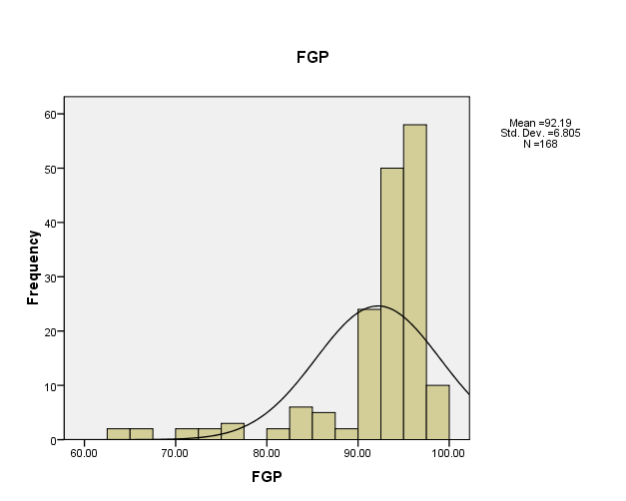
Appendix II. The normalized data for FGP after undergoing transformation
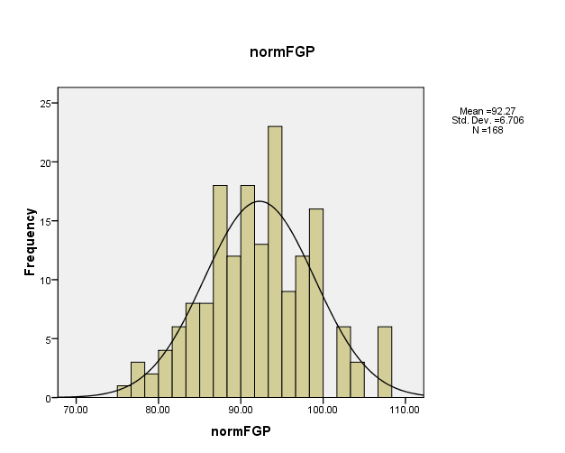
Appendix III. Levene's Test of Equality of Variances (Dependent Variable: FGP)
F | df1 | df2 | Sig.
.936 | 1 | 166 | .335

Appendix IV. Appendix III. Tests of Between-Subjects Effects (Dependent Variable: normFGP) which appears to have no significant difference with the ANOVA test conducted for the untransformed FGP data (compare with Table 4.4.4 )
Source | Sum of Squares | df | Mean Square | F | Sig.
CROP | 20.013 | 1 | 20.013 | .630 | .429
STORAGE_MATERIAL | 2280.968 | 3 | 760.323 | 23.935 | .000
CROP* STORAGE_MATERIAL | 127.075 | 3 | 42.358 | 1.333 | .265
Error | 5082.601 | 160 | 31.766
Total | 1437880.376 | 168
Appendix V. Multiple Comparisons (FGP Turkeys HSD)
STORAGE_MATERIAL | STORAGE_MATERIAL |  |  | Mean Difference |  |  | Std. Error |  | Sig. |  |  | 95% Confidence Interval
 |  |  |  |  |  |  |  |  |  |  |  | Lower Bound |  | Upper Bound
Calabash | Clay pot |  |  | 5.9024* |  |  | 1.34627 |  | .000 |  |  | 2.4080 |  | 9.3967
Calabash | Cold room |  |  | -.9310 |  |  | 1.34627 |  | .900 |  |  | -4.4253 |  | 2.5634
Calabash | Plastic |  |  | 4.9357* |  |  | 1.34627 |  | .002 |  |  | 1.4414 |  | 8.4301
Clay pot | Calabash |  |  | -5.9024* |  |  | 1.34627 |  | .000 |  |  | -9.3967 |  | -2.4080
Clay pot | Cold room |  |  | -6.8333* |  |  | 1.34627 |  | .000 |  |  | -10.3277 |  | -3.3390
Clay pot | Plastic |  |  | -.9667 |  |  | 1.34627 |  | .890 |  |  | -4.4610 |  | 2.5277
Cold room | Calabash |  |  | .9310 |  |  | 1.34627 |  | .900 |  |  | -2.5634 |  | 4.4253
Cold room | Clay pot |  |  | 6.8333* |  |  | 1.34627 |  | .000 |  |  | 3.3390 |  | 10.3277
Cold room | Plastic |  |  | 5.8667* |  |  | 1.34627 |  | .000 |  |  | 2.3723 |  | 9.3610
Plastic | Calabash |  |  | -4.9357* |  |  | 1.34627 |  | .002 |  |  | -8.4301 |  | -1.4414
Plastic | Clay pot |  |  | .9667 |  |  | 1.34627 |  | .890 |  |  | -2.5277 |  | 4.4610
Plastic | Cold room |  |  | -5.8667* |  |  | 1.34627 |  | .000 |  |  | -9.3610 |  | -2.3723
Appendix VI. Descriptive summary of the interaction between crop and storage material (Dependent Variable: FGP)
CROP |  | STORAGE_MATERIAL |  |  | Mean |  |  | Std. Error |  | 95% Confidence Interval
 |  |  |  |  |  |  |  |  |  | Lower Bound |  |  | Upper Bound
Cowpea |  | Calabash |  |  | 95.181 |  |  | 1.359 |  | 92.497 |  |  | 97.865
 |  | Claypot |  |  | 89.181 |  |  | 1.359 |  | 86.497 |  |  | 91.865
 |  | Cold room |  |  | 96.229 |  |  | 1.359 |  | 93.545 |  |  | 98.912
 |  | Plastic |  |  | 89.505 |  |  | 1.359 |  | 86.821 |  |  | 92.188
MAIZE |  | Calabash |  |  | 94.143 |  |  | 1.359 |  | 91.459 |  |  | 96.826
 |  | Claypot |  |  | 88.338 |  |  | 1.359 |  | 85.654 |  |  | 91.022
 |  | Cold room |  |  | 94.957 |  |  | 1.359 |  | 92.274 |  |  | 97.641
 |  | Plastic |  |  | 89.948 |  |  | 1.359 |  | 87.264 |  |  | 92.631
Appendix VII: Levene's Test of Equality of Variances (Dependent Variable:SVI
F |  |  | df1 |  |  | df2 |  |  |  |  | Sig.
.058 |  |  | 1 |  |  | 166 |  |  |  |  | .810
Appendix VIII. The intial data of SVI which was not normally distributed
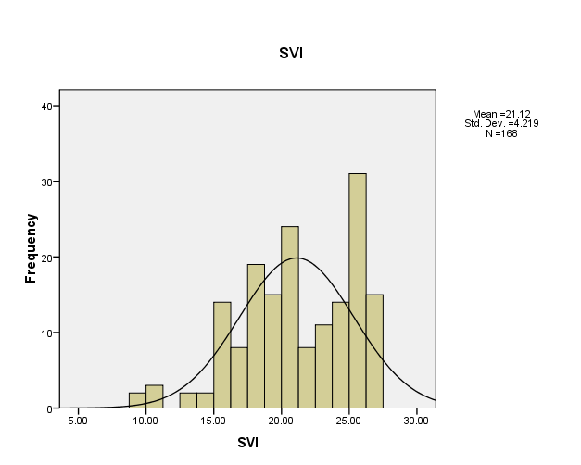
Appendix IX. The normalized data for SVI after undergoing transformation
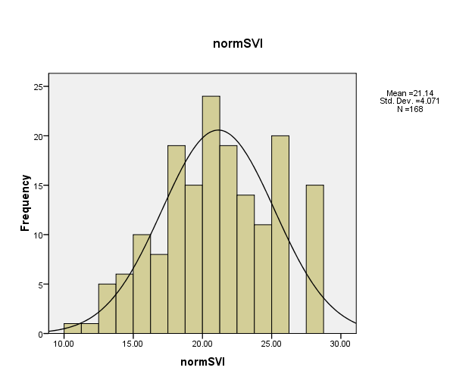
Appendix X. Tests of Between-Subjects Effects (Dependent Variable:normSVI) which appears to have no significant difference with the ANOVA test conducted for the untransformaed SVI data (compare with Table 4.5.4)
Source | Sum of Squares | df | Mean Square | F | Sig.
CROP | 62.070 | 1 | 62.070 | 3.969 | .048
STORAGE_MATERIAL | 180.585 | 3 | 60.195 | 3.849 | .011
CROP * STORAGE_MATERIAL | 23.192 | 3 | 7.731 | .494 | .687
Error | 2501.998 | 160 | 15.637
Total | 77865.433 | 168
Appendix XI. Multiple Comparisons (SVI Turkeys HSD)
STORAGE_MATERIAL | STORAGE_MATERIAL | Mean Difference | Std. Error | Sig. | 95% Confidence Interval
 |  |  |  |  | Lower Bound | Upper Bound
Calabash | Clay pot | 2.7190* | .89410 | .014 | .3983 | 5.0398
Calabash | Cold room | .7381 | .89410 | .842 | -1.5826 | 3.0588
Calabash | Plastic | 2.4524* | .89410 | .034 | .1317 | 4.7731
Clay pot | Calabash | -2.7190* | .89410 | .014 | -5.0398 | -.3983
Clay pot | Cold room | -1.9810 | .89410 | .123 | -4.3017 | .3398
Clay pot | Plastic | -.2667 | .89410 | .991 | -2.5874 | 2.0540
Cold room | Calabash | -.7381 | .89410 | .842 | -3.0588 | 1.5826
Cold room | Clay pot | 1.9810 | .89410 | .123 | -.3398 | 4.3017
Cold room | Plastic | 1.7143 | .89410 | .225 | -.6064 | 4.0350
Plastic | Calabash | -2.4524* | .89410 | .034 | -4.7731 | -.1317
Plastic | Clay pot | .2667 | .89410 | .991 | -2.0540 | 2.5874
Plastic | Cold room | -1.7143 | .89410 | .225 | -4.0350 | .6064
Appendix XII: Descriptive Statistics (Dependent Variable: SVI)
CROP | STORAGE_MATERIAL | Mean | Std. Deviation | N
Cowpea | Calabash | 22.7143 | 3.63515 | 21
Cowpea | Clay pot | 21.1905 | 4.09413 | 21
Cowpea | Cold room | 22.1429 | 3.88955 | 21
Cowpea | Plastic | 20.4762 | 4.15474 | 21
Cowpea | Total | 21.6310 | 3.97213 | 84
MAIZE | Calabash | 22.4762 | 2.71328 | 21
MAIZE | Claypot | 18.5619 | 5.58126 | 21
MAIZE | Cold room | 21.5714 | 3.74929 | 21
MAIZE | Plastic | 19.8095 | 4.31994 | 21
MAIZE | Total | 20.6048 | 4.41618 | 84
Total | Calabash | 22.5952 | 3.17044 | 42
Total | Claypot | 19.8762 | 5.01412 | 42
Total | Cold room | 21.8571 | 3.78425 | 42
Total | Plastic | 20.1429 | 4.19972 | 42
Total | Total | 21.1179 | 4.21894 | 168
Appendix XIII. The intial data of SDWT which was not normally distribute
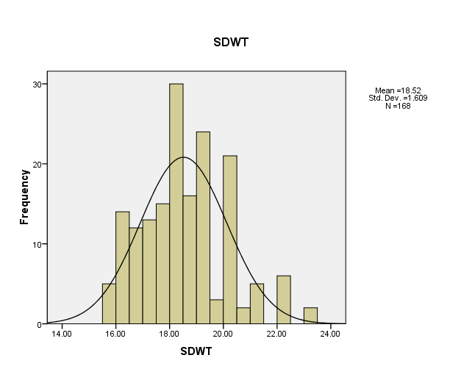
Appendix XIV. The normalized data for SDWT after undergoing transformation
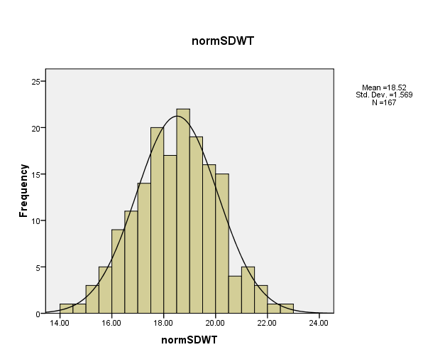
Appendix XV. Levene's Test of Equality of Error Variances (Dependent Variable: SDWT)
F | df1 | df2 | Sig.
.065 | 1 | 166 | .799

Appendix XVI. Tests of Between-Subjects Effects (Dependent Variable: normSDWT) which appears to have no significant difference with the ANOVA test conducted for the untransformed FGP data (compare with Table 4.6.4)
Source | Sum of Squares | df | Mean Square | F | Sig.
CROP | 98.363 | 1 | 98.363 | 58.663 | .000
STORAGE_MATERIAL | 37.448 | 3 | 12.483 | 7.445 | .000
CROP * STORAGE_MATERIAL | 6.654 | 3 | 2.218 | 1.323 | .269
Error | 266.603 | 159 | 1.677
Total | 57660.571 | 167
Appendix.XVII. Multiple Comparisons (SDWT Turkeys HSD)
STORAGE_MATERIAL | STORAGE_MATERIAL | Mean Difference | Std. Error | Sig. | 95% Confidence Interval
 |  |  |  |  | Lower Bound | Upper Bound
Calabash | Clay pot | -.3933 | .33280 | .639 | -1.2571 | .4705
Calabash | Cold room | .9507* | .33280 | .025 | .0869 | 1.8145
Calabash | Plastic | .7731 | .33280 | .097 | -.0907 | 1.6369
Clay pot | Calabash | .3933 | .33280 | .639 | -.4705 | 1.2571
Clay pot | Cold room | 1.3440* | .33280 | .000 | .4802 | 2.2079
Clay pot | Plastic | 1.1664* | .33280 | .003 | .3026 | 2.0302
Cold room | Calabash | -.9507* | .33280 | .025 | -1.8145 | -.0869
Cold room | Claypot | -1.3440* | .33280 | .000 | -2.2079 | -.4802
Cold room | Plastic | -.1776 | .33280 | .951 | -1.0414 | .6862
Plastic | Calabash | -.7731 | .33280 | .097 | -1.6369 | .0907
Plastic | Claypot | -1.1664* | .33280 | .003 | -2.0302 | -.3026
Plastic | Cold room | .1776 | .33280 | .951 | -.6862 | 1.0414
Appendix XVIII : Descriptive Statistics (Dependent Variable: SDWT)
CROP | STORAGE_MATERIAL | Mean | Std. Deviation | N
Cowpea | Calabash | 17.9438 | 1.24757 | 21
Cowpea | Clay pot | 18.5338 | 1.95184 | 21
Cowpea | Cold room | 16.9143 | .87794 | 21
Cowpea | Plastic | 17.5457 | .85703 | 21
Cowpea | Total | 17.7344 | 1.41694 | 84
MAIZE | Calabash | 19.7533 | 1.36934 | 21
MAIZE | clay pot | 19.9500 | 1.57970 | 21
MAIZE | Cold room | 18.8814 | .90483 | 21
MAIZE | Plastic | 18.6052 | 1.27241 | 21
MAIZE | Total | 19.2975 | 1.40210 | 84
Appendix XIX. Preview of Data collected
CROP | Storage materials | Replicates | 100_sdwt | FGP (%) | SVI
MAIZE | Plastic | 1 | 20.4 | 97 | 26.6
MAIZE | Plastic | 1 | 19.57 | 94.7 | 21.7
MAIZE | Plastic | 1 | 18.2 | 93.3 | 20.0
MAIZE | Plastic | 1 | 18.12 | 93.3 | 19.4
MAIZE | Plastic | 1 | 18 | 93.3 | 16.4
MAIZE | Plastic | 1 | 17.5 | 86 | 14.3
MAIZE | Plastic | 1 | 17.2 | 70.7 | 11.2
MAIZE | Plastic | 2 | 20.4 | 97 | 26.6
MAIZE | Plastic | 2 | 20.72 | 94.7 | 25.9
MAIZE | Plastic | 2 | 18.27 | 93.3 | 23.8
MAIZE | Plastic | 2 | 19.2 | 92.7 | 20.9
MAIZE | Plastic | 2 | 19.1 | 90 | 18.5
MAIZE | Plastic | 2 | 18 | 91.3 | 18.6
MAIZE | Plastic | 2 | 17.52 | 75.3 | 15.3
MAIZE | Plastic | 3 | 20.4 | 97 | 26.6
MAIZE | Plastic | 3 | 20.11 | 93.3 | 23.7
MAIZE | Plastic | 3 | 18.31 | 94.7 | 22.1
MAIZE | Plastic | 3 | 18.43 | 93.3 | 21.5
MAIZE | Plastic | 3 | 18.18 | 92 | 20.0
MAIZE | Plastic | 3 | 16.5 | 92 | 19.2
MAIZE | Plastic | 3 | 16.58 | 64 | 13.2
MAIZE | Calabash | 1 | 20.4 | 97 | 26.6
MAIZE | Calabash | 1 | 19.43 | 97 | 25.3
MAIZE | Calabash | 1 | 20 | 96.7 | 24.9
MAIZE | Calabash | 1 | 20.11 | 96 | 22.6
MAIZE | Calabash | 1 | 21 | 94.7 | 22.2
MAIZE | Calabash | 1 | 21.1 | 92.7 | 21.4
MAIZE | Calabash | 1 | 19.58 | 83.3 | 18.5
MAIZE | Calabash | 2 | 20.4 | 97 | 26.6
MAIZE | Calabash | 2 | 20.34 | 95.3 | 24.8
MAIZE | Calabash | 2 | 17.52 | 96.7 | 24.3
MAIZE | Calabash | 2 | 18.15 | 96 | 24.5
MAIZE | Calabash | 2 | 19.11 | 94.7 | 22.2
MAIZE | Calabash | 2 | 19.21 | 92.7 | 20.7
MAIZE | Calabash | 2 | 21.13 | 83.3 | 18.5
MAIZE | Calabash | 3 | 20.4 | 97 | 26.6
MAIZE | Calabash | 3 | 17.39 | 97.3 | 26.4
Cowpea | Plastic | 1 | 18.5 | 95 | 27.1
Cowpea | Plastic | 1 | 16.23 | 93.3 | 26.0
Cowpea | Plastic | 1 | 18.2 | 92 | 23.3
Cowpea | Plastic | 1 | 17.32 | 91.3 | 20.6
Cowpea | Plastic | 1 | 17.11 | 82 | 17.9
Cowpea | Plastic | 1 | 16.22 | 87.3 | 18.9
Cowpea | Plastic | 1 | 16.12 | 74 | 15.2
Cowpea | Plastic | 2 | 18.5 | 95 | 27.1
Cowpea | Plastic | 2 | 16.18 | 92 | 24.5
Cowpea | Plastic | 2 | 17.75 | 94 | 23.8
Cowpea | Plastic | 2 | 18.12 | 93.3 | 21.8
Cowpea | Plastic | 2 | 18 | 90.7 | 19.0
Cowpea | Plastic | 2 | 17.18 | 86.7 | 17.7
Cowpea | Plastic | 2 | 17 | 84.7 | 17.4
Cowpea | Plastic | 3 | 18.5 | 95 | 27.1
Cowpea | Plastic | 3 | 18.3 | 94 | 22.5
Cowpea | Plastic | 3 | 18.36 | 94 | 21.2
Cowpea | Plastic | 3 | 18.5 | 94 | 19.2
Cowpea | Plastic | 3 | 18.14 | 92 | 18.4
Cowpea | Plastic | 3 | 17 | 85.3 | 16.9
Cowpea | Plastic | 3 | 17.23 | 74 | 13.8
Cowpea | Calabash | 1 | 18.5 | 95 | 27.1
Cowpea | Calabash | 1 | 16.78 | 95.3 | 26.1
Cowpea | Calabash | 1 | 18 | 96 | 25.6
Cowpea | Calabash | 1 | 17.88 | 95.3 | 25.7
Cowpea | Calabash | 1 | 18.23 | 95.3 | 24.4
Cowpea | Calabash | 1 | 15.55 | 96 | 22.5
Cowpea | Calabash | 1 | 19 | 94 | 16.8
Cowpea | Calabash | 2 | 18.5 | 95 | 27.1
Cowpea | Calabash | 2 | 16.94 | 97.3 | 24.8
Cowpea | Calabash | 2 | 16.52 | 96.7 | 25.7
Cowpea | Calabash | 2 | 16 | 96 | 25.1
Cowpea | Calabash | 2 | 17.34 | 95.3 | 19.3
Cowpea | Calabash | 2 | 18.13 | 95.3 | 16.8
Cowpea | Calabash | 2 | 20.11 | 91.3 | 21.1
Cowpea | Calabash | 3 | 18.5 | 95 | 27.1
Cowpea | Calabash | 3 | 16.89 | 95.3 | 26.5
Cowpea | Calabash | 3 | 17.23 | 98 | 22.1
Cowpea | Calabash | 3 | 18 | 94.7 | 24.8
Cowpea | Calabash | 3 | 20.1 | 94.7 | 17.9
Cowpea | Calabash | 3 | 19.33 | 95.3 | 20.6

