Template for Testing Secretary

After rendering, the following image should be a screenshot of LibreOffice Writer.

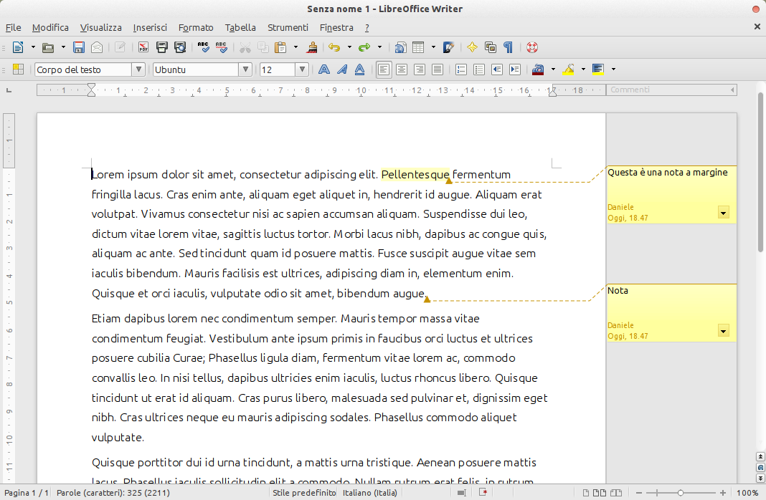
Secretary allows to replace placeholder images in templates. To set a image as a placeholder, set image's name as a jinja2 print variable (the ones with double curly braces). The variable should call the “image” filter. For instance, right click into above PLACEHOLDER image, select “Picture...” option in popup menu and navegate to “Options” tab.

inputs/writer.png

