**Preparing Your System for the Data Science in Business Bootcamp**

We will complete analysis and work for the bootcamp using Python 3. If you do not already have Python installed on your computer, follow these instructions to have python

1. Downloading Anaconda on Windows
2. Running Python from Anaconda w/ Python Notebooks
3. Checking your python version if it is previously installed

Anaconda is a platform that will install python on your system along with many of the supporting packages we will use throughout the bootcamp.

**1. Downloading Anaconda on Windows and Mac**

1. Click on the following link: <https://www.anaconda.com/distribution/>
2. Select Windows, Mac, or Linux computer

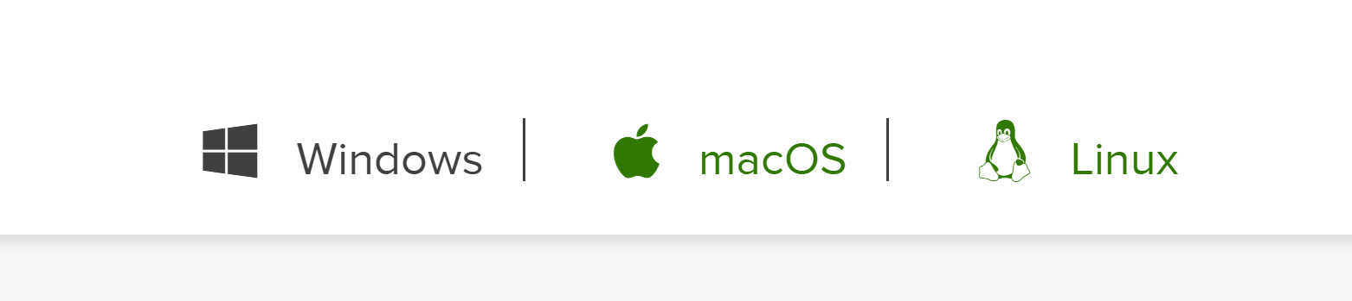

1. Download 34-bit or 64-bit installer, depending on what your laptop has.

If you do not know if you have 34-bit or 64-bit, select one of the following links to find out:

Windows: <https://youtu.be/E_rIxF9aDLw>

Mac: <https://www.youtube.com/watch?v=FaOIIekz9IY>

**2. Opening Python from Anaconda w/ Python Notebooks**

Once downloaded, open Anaconda Navigator and you should see something similar to the following:

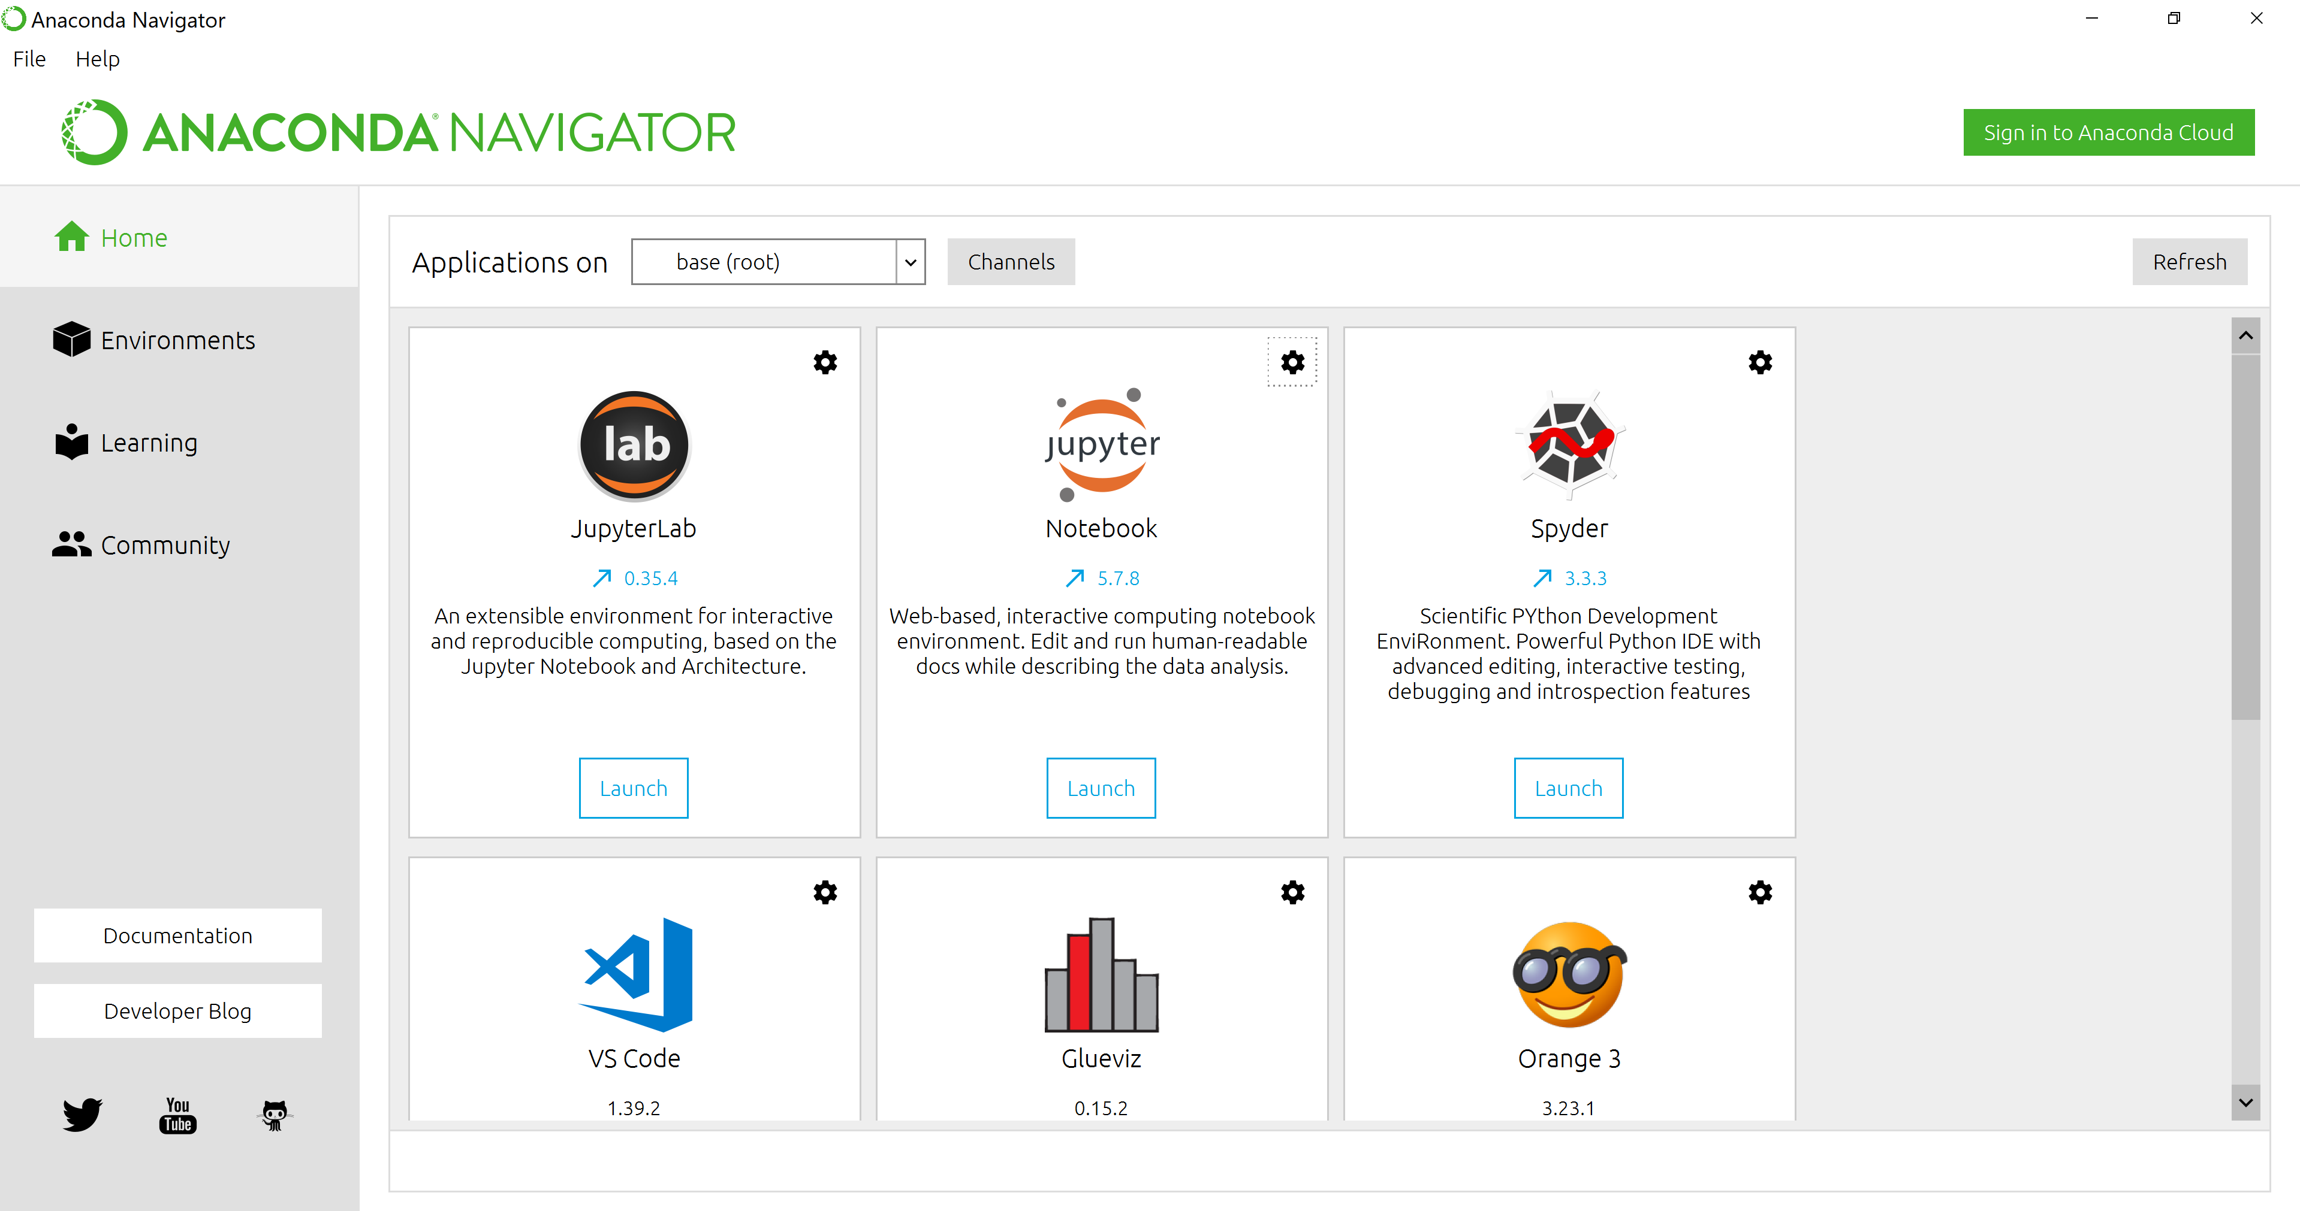

**Open Jupyter Notebook**

Jupyter Notebook will show the directory structure of your system, opening in your default browser. For this bootcamp, we will be using the Jupyter Notebook to navigate to an existing folder, create new folders, create new python notebooks, or execute analysis in existing python notebooks.

**Loading existing python notebooks in your working directory:**

1. Navigate to your desired working directory
2. Select the ‘Upload’ button
3. Find the notebook in your files

Please note that sometimes the notebook is a .txt file. You can change the file type by changing the name of the file in your files. Please note that all notebooks’ file names must end with “.ipynb”. For example: “introduction.ipynb”.

**Creating a folder or new python notebook in your working directory:**

1. Select the ‘New’ button on the left
2. To create a new folder, select ‘Folder’
3. To create a new notebook, select ‘Python 3’

A new notebook will look like this:

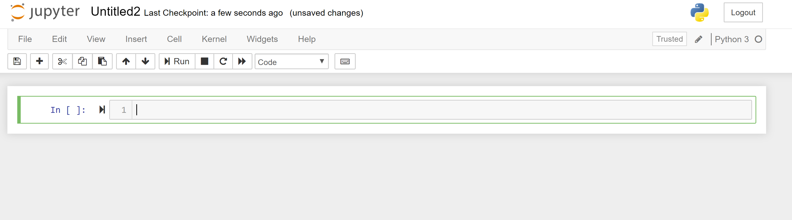

Change the name of the file by clicking on the name. In the above photo, you would click on Untitled2 and then enter the name of the new file name.

**Saving python notebooks:**

* Remember to save your file after you are finished and frequently as you are working
* Notebooks will not autosave, and closing the notebook tab without saving will result in lost changes

**Running code in python notebooks**

To run code, you can press Ctrl + Enter or you can press Shift + Enter.

For a better understanding of the Jupyter Notebook interface, refer to the Dataquest Jupyter Notebook Tutorial.

<https://www.dataquest.io/blog/jupyter-notebook-tutorial/>

Example of code executed in a new notebook:

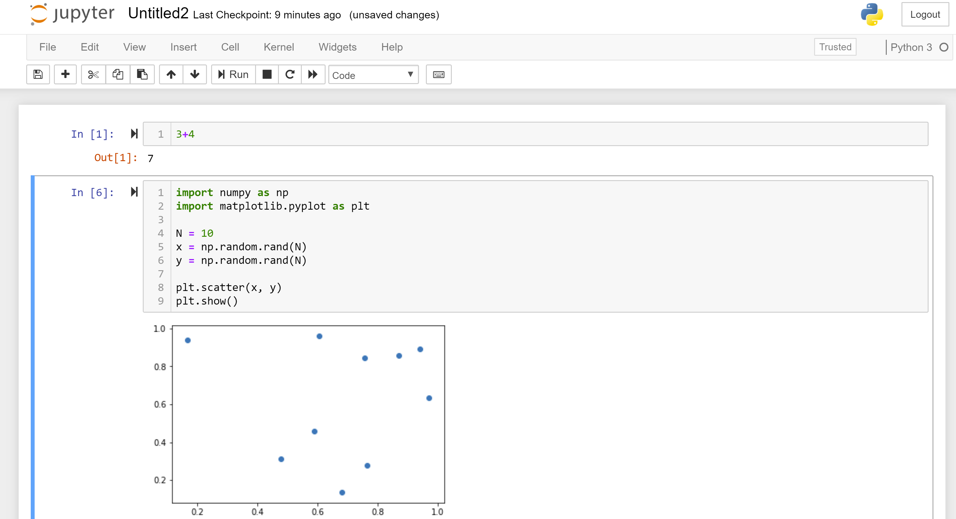

**3. Checking Python Version if it is Previously Installed**

If you already have python installed on your laptop, you should verify the python version. To check the python version on your system:

1. Follow the instructions in Step 2 to open a python notebook
2. In the first cell, insert the follow code:

from platform import python_version

print(python_version())

1. Execute the code. The python version on your system will print below.

1. If the version printed is greater than 3, no further action is needed.
2. If the version printed is less than 3, you will need to update python in order to run the notebooks for this bootcamp. As of January 1, 2020, Python 2 reached end of life and is no longer supported.

**Note:** if you have previously installed python without Anaconda, you may not have all of the packages required for this bootcamp pre-installed. If you are not familiar with the process to install packages in a python notebook, we suggest that you download Anaconda to run python.