Manual

I will provide a step by step instruction on how to use this application

1. Open the excel spreadsheet and click “OK” on the message box greeting.

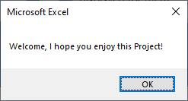

1. The main page is also a small manual going over the basics of the application. Please read it.

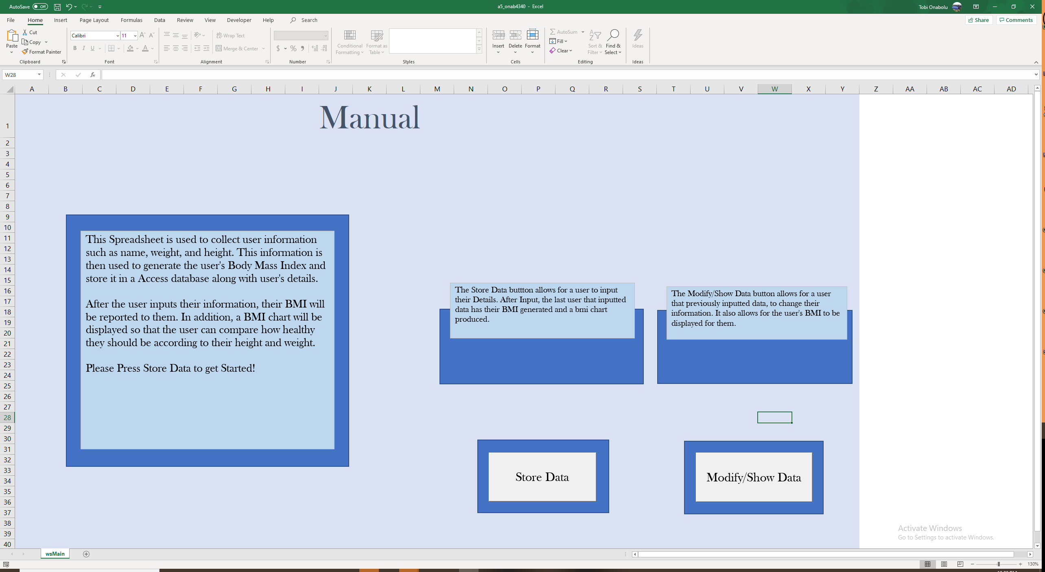

1. Once completed reading, click the “Store Date” button to get started. Notice there is also a small description of the button right above it.

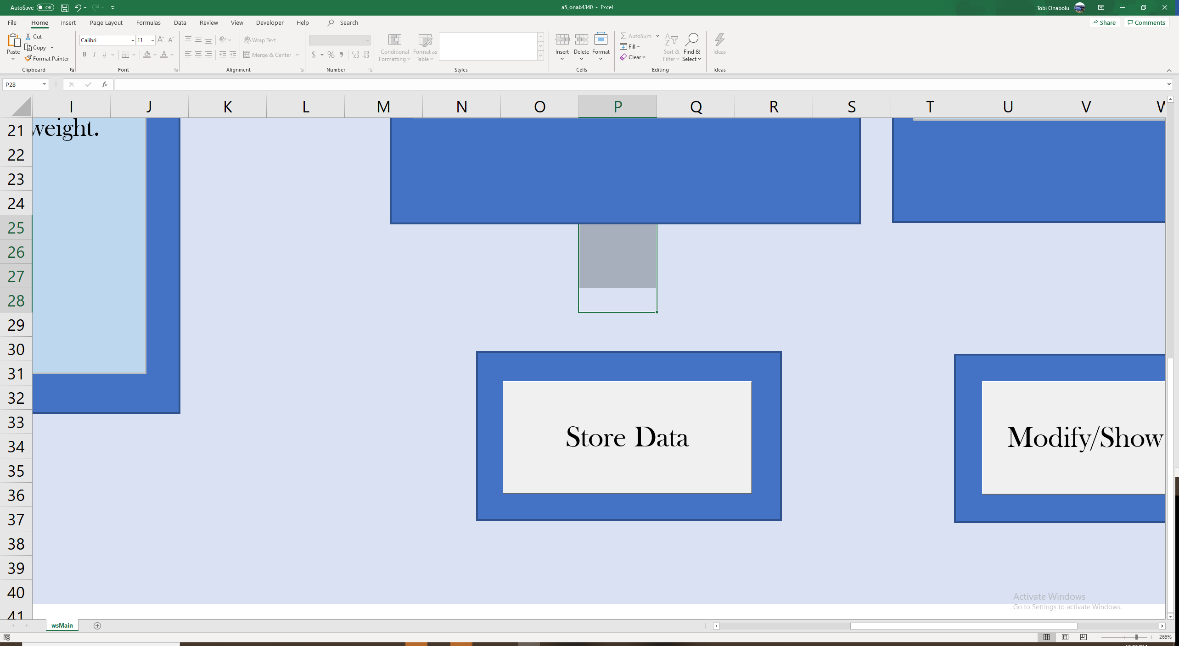 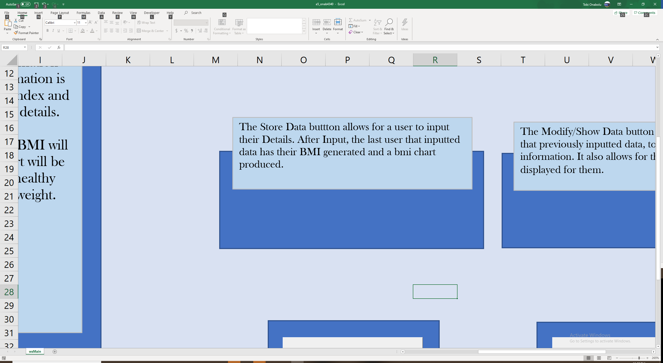

1. When the store data button is clicked the form shown below will appear. Fill in the fields as listed. Further instructions, can be seen in the instructions frame on the for.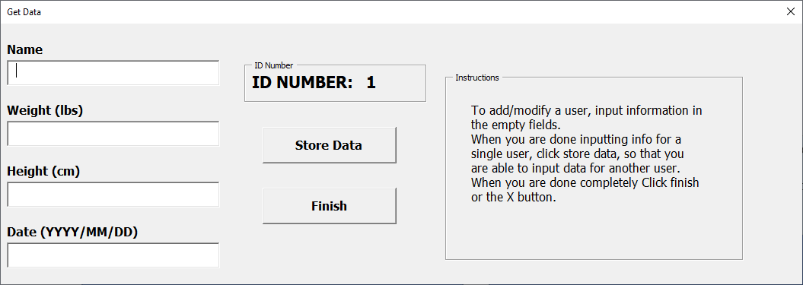
2. Note: if you leave any fields blank or fill them in incorrectly, a message like this will occur

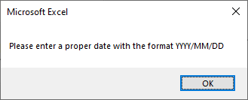

1. Once you have all field filled in and you hit store data, this message box will be shown. You can hit OK and enter another user, or you can close the Get Data window to generate BMI Chart. Please note that once you click X, Give the program some time to generate the chart.

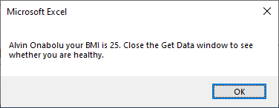

1. You can also click finish to generate the BMI Chart, but note, at least one person should have their data inside the data base for the chart to be displayed. Also allow some time for the program to generate the chart once you click finish.

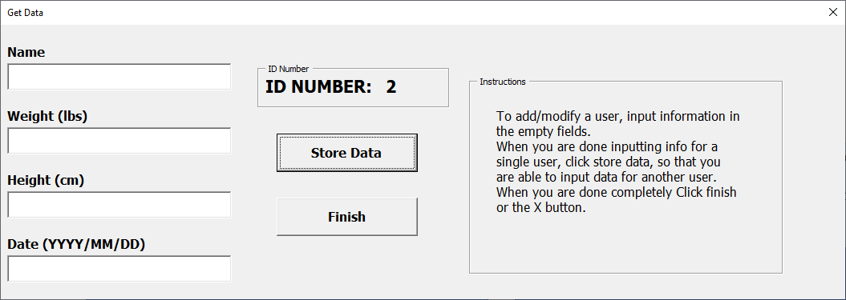

1. Once the chart is generated it will bring you to this sheet. Compare your BMI to the chart to see your results.

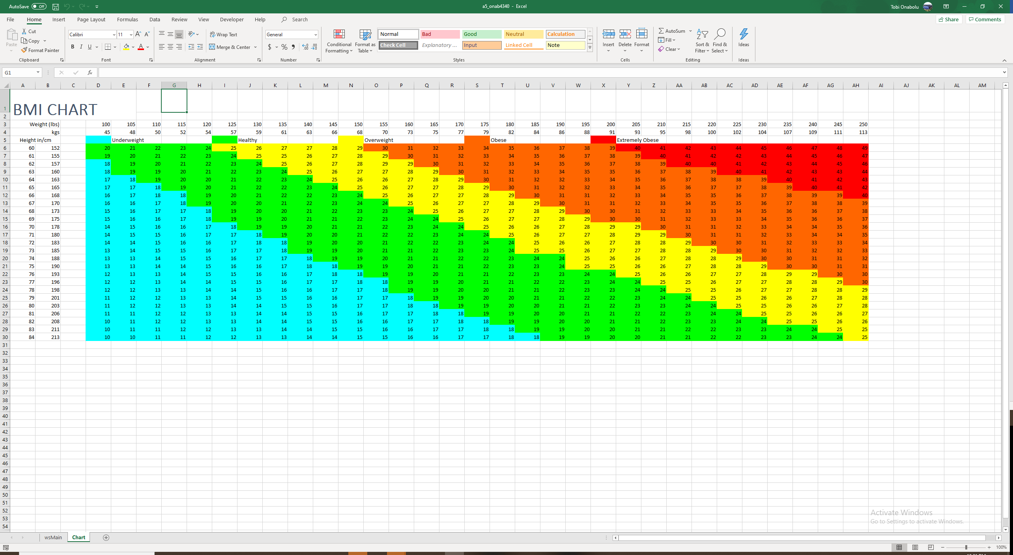

1. Once the chart is generated, the program automatically opens the blank report word document and exports it there, click your word application to see the document.

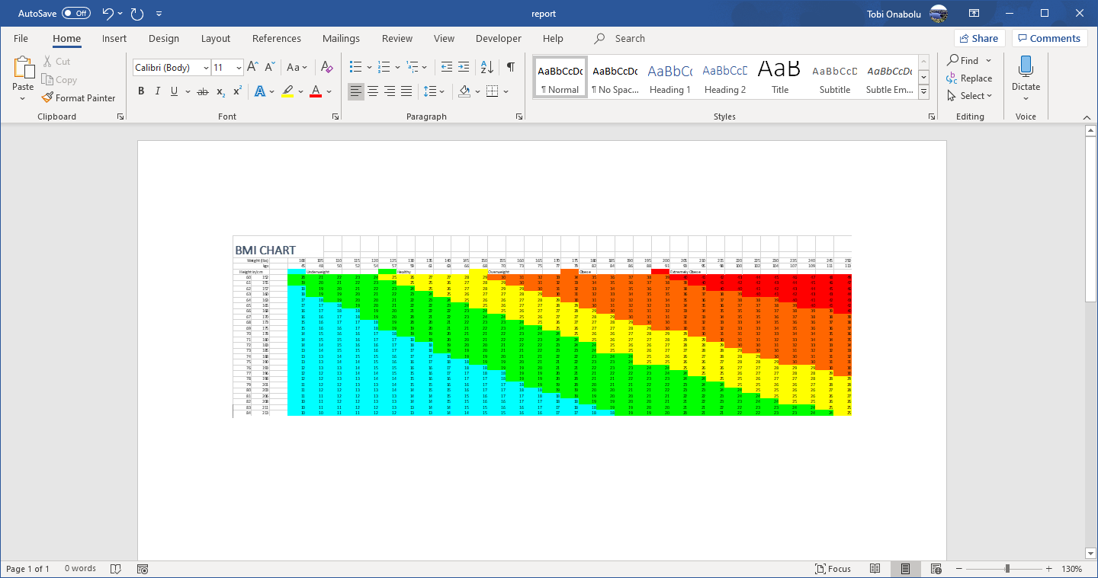

1. To modify data in the database or show the BMI of another user, click the modify/show button. Please ensure the report document is closed before this.

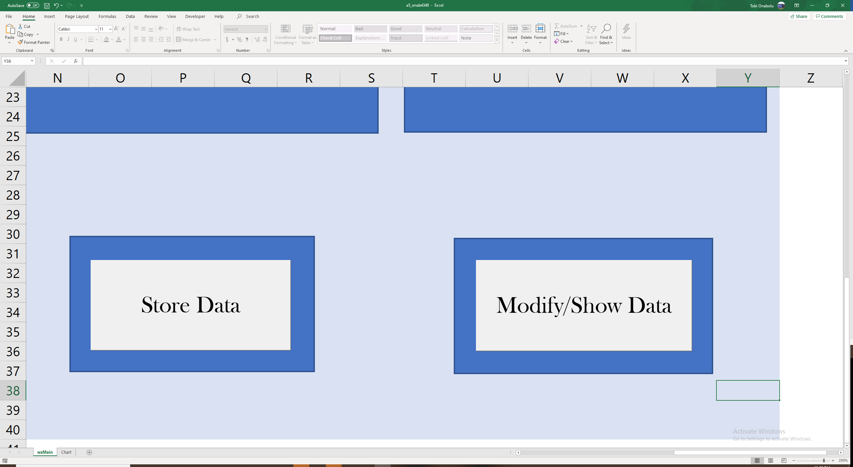 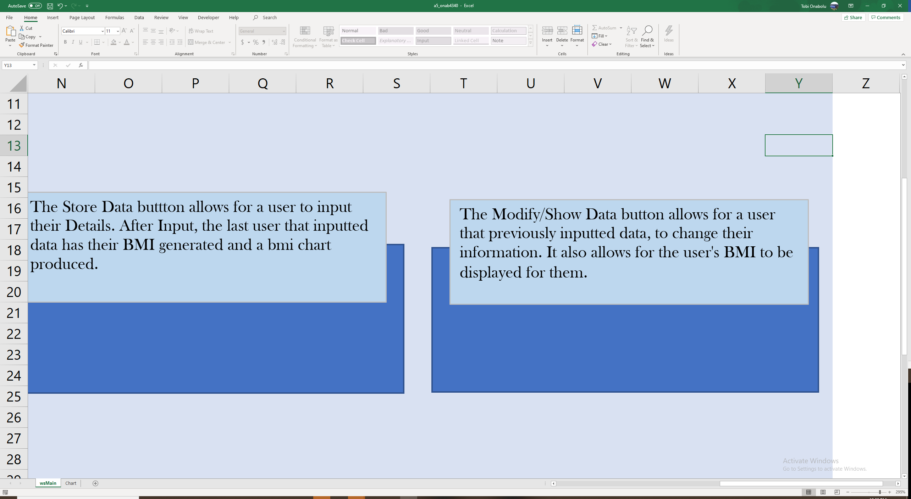

1. The following useform will be produced. Please click browse to select the database you would like to modify.(will only be the Nutrition database). Also further instructions are shown in the instructions frame.

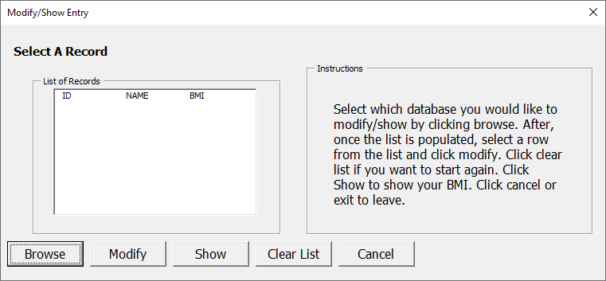

1. Once the correct database is chosen, the list box will be populated with the records of the ‘Profile Table’ of that database. If you select a record and click show, the program will display that records BMI and will generate a new BMI chart.
2. If you select a record and click modify, the program will take you to this user form to update that records information. Click modify when you are done to update that records information.

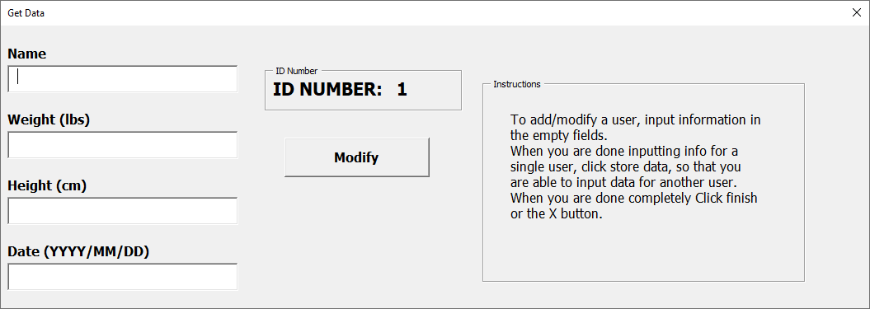

1. When you are done the form will close and a new BMI chart will be generated.
2. Hope you enjoy this program!