**SHORT USER MANUAL**

BlueM.QGISInterface

***for version 1.1***

**INSTALLATION & SYSTEM REQUIREMENTS**

The plugin requires QGIS 3.16.11 (LTR) or higher; Windows 10 is recommended.

It is not yet part of the QGIS Plugin repository, therefore it must be installed manually:

* 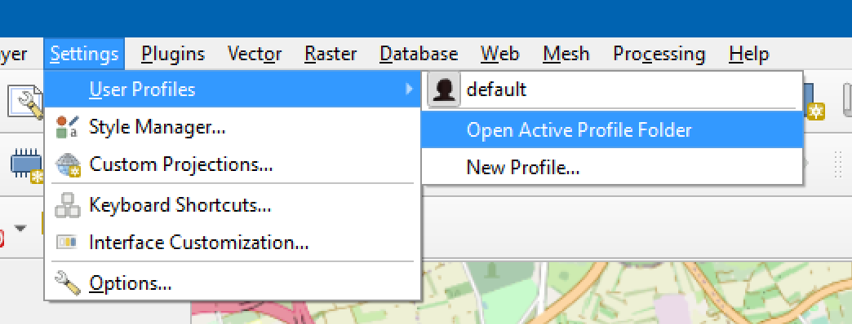Open active profile folder (see above).
* From there, navigate to the subfolder python\plugins (create the folder if it does not exist).
* Download or clone the files from <https://github.com/bluemodel/BlueM.QGISInterface>
* Extract or copy the folder BlueM.QGISInterface to the QGIS plugins folder.
* Rename the folder BlueM.QGISInterface to BlueMQGISInterface (no dots allowed).
* Restart QGIS and go to “Plugins” – “Manage and Install Plugins…”.
* Go to tab “Installed” and tick the box in front of “BlueM.QGISInterface”; then “Close”.
* The plugin is now part of your QGIS toolbar (as BlueM icon).

**HOW TO EXPORT BLUEM-FILES**

* Open the plugin by clicking on the BlueM icon.
* Decide which BlueM.Sim files you want to create and select a source layer for those filetypes in the corresponding combo box (only *Vector* and *NoGeometry* possible).
* Decide how you want to match the fields of the layer attribute table to the attributes needed for the BlueM.Sim file:
  + Check “by name” if the attributes should match automatically by their names
  + Check “manually” if you want to match the attributes yourself:

This will open a second window, where you can select the layer field names for every file attribute manually (the buttons down left may help you with this).

You can save your matches for this filetype with a click on “OK”.

* Enter a valid export path in the field at the bottom and press “Export”.
* The plugin will now export all files where a match-button is checked.

**OTHER TOOLS**

* Adapt existing layers to better suit the requirements of BlueM-files
* Or create new GeoPackage layers for that purpose
* Export attribute definitions for all BlueM-files as a CSV
* Generate a new layer with SYS-data from element-layers

**GOOD TO KNOW**

* The settings in the “**…**”-tab are worth a look and self-explanatory.
* Sometimes QGIS has trouble identifying the first row of an attribute table of an Excel file as the field names (it calls them “Field1”, etc.); the plugin can correct hat:

If the plugin detects this, it shows a button in the “manually”-window to correct the issue.   
*(At the moment this creates a doubling of the first row in the Excel source file.)*

* If a string or float is to long for its target cell, the plugin will shorten/round them.

If an integer is to long or the value does not match the required data type, it will be replaced with the replacement character you selected (default = “ “).

You can find information about these and other value changes in each file or the export log.

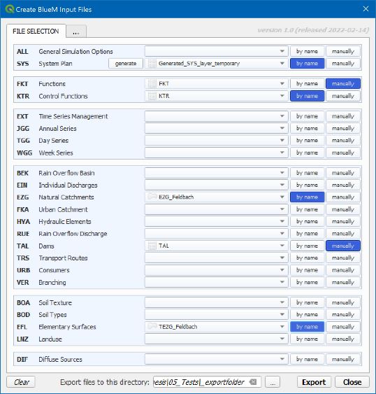

**USER INTERFACE OVERVIEW**

*The user interface of the plugin consists of 3 parts:*

❶ **Selection for BlueM Export**

all 23 BlueM-files and generate-SYS-button

layer selection for all filetypes

the buttons to match their attributes

define export path and start export

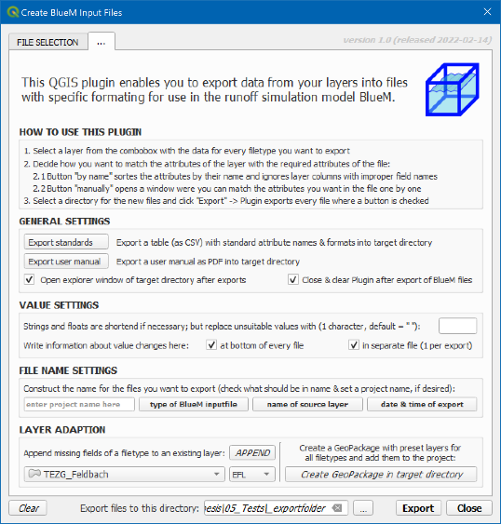

❷ **Settings and other tools**

export standards & user manual

and general options

decide where the export information should be

saved and define names for exported files

adapt an existing layer to a filetype

create a GeoPackage with layers for all filetypes

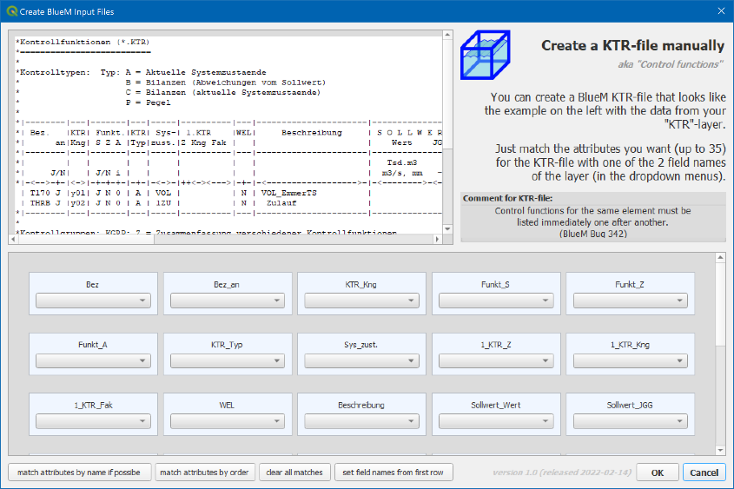

❸ **Manual attribute matching**

example of filetype

information about file & layer

select matches one by one

helpful tools