EasyCsv Document

It's just a lightweight helper class for writing and reading files in a "CSV" format.

Note:
1.Comments are not supported.
2.CSV files are best encoded in utf-8, or exceptions are parsed.

Quick start:

CsvHelper.Init();

var table = CsvHelper.Create(text.name, text.text);
Debug.Log(table.Read(0,0));
table.Write(0,0,"newValue");

Export class from csv data
- Open “Csv Tools Window”(Tools->EasyCsv->Csv Tools Window).
- Click “Csv->Class” button to export class text.(Note:Csv format must follow the example format)
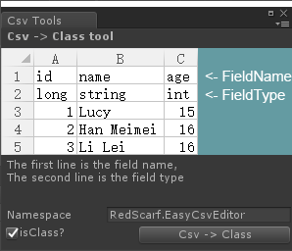

Padding data
You can use “CsvHelper.PaddingData”method to padding data.For example:

var testRowData = CsvHelper.PaddingData<TestRowData>(csvName, rowID);

Enjoy!

