UnityFbs: QuickStart guide
- First of all, you need to get a flatc-compiler. Due to Unity AssetStore restrictions I have to remove prepared binaries from package. But you can get flatc-compiler in two ways:
  - Download a prepared flatc-compiler for your platform form github of this plugin: https://github.com/Wunder9l/UnityFbs/tree/master/Assets/UnityFbs/Plugins/FlatBuffers/FlatcCompillersForPlatforms
  - Build by yourself according to documentation on https://google.github.io/flatbuffers/flatbuffers_guide_building.html
- Set flatc-compiler path: right click on flatc-compiler file in the Editor -> Set as flatc-compiler file:
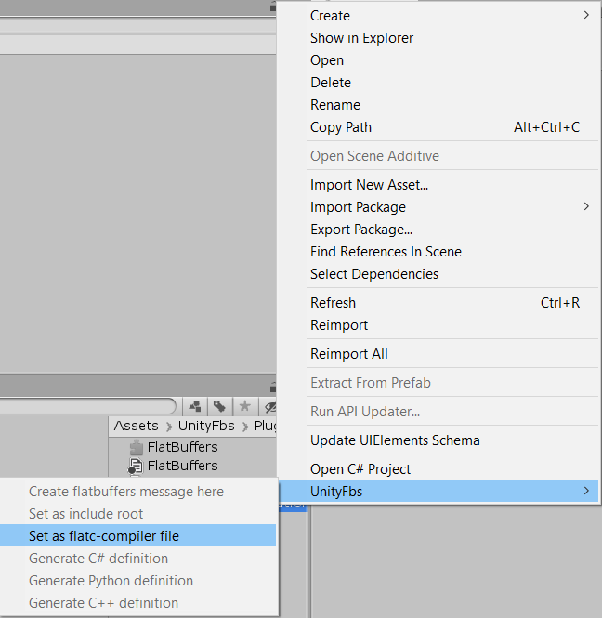
- Now you can use UnityFbs:

  - Create new .fbs-message:
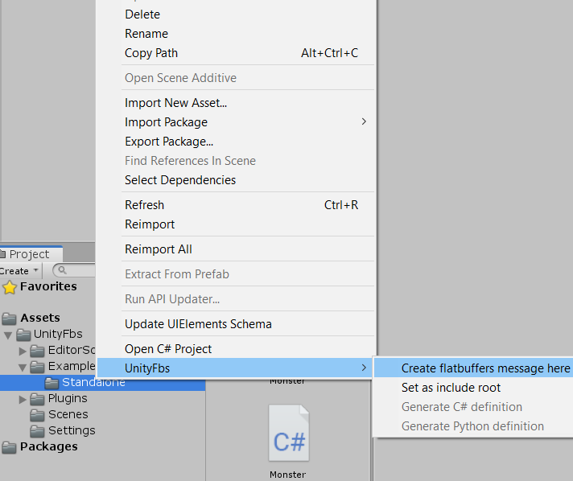
  - Compile it
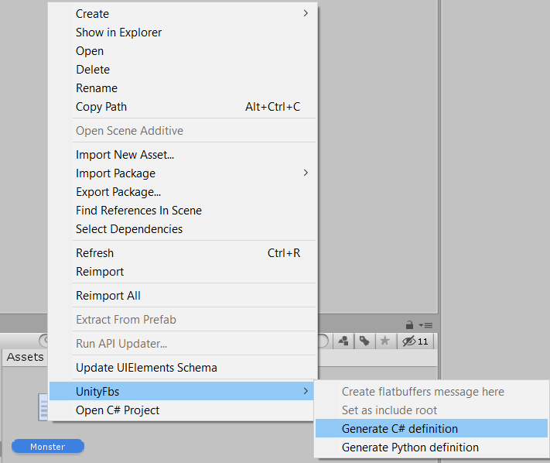

Extra
- You can check and set setting of UnityFbs at Edit->Project Settings->UnityFbs
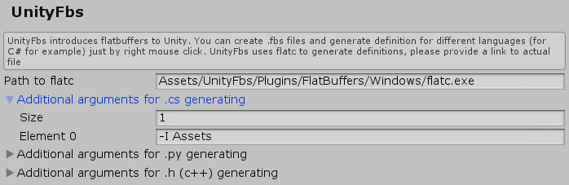
- If you use hierarchical structure of .fbs-messages and include one into another you probably need to set an include root directory:
