Title :

“A Critique of the Estimation Size-at-Maturity Estimation and its Interpretation”

Big questions:

- What is the relationship between the maturation probability and the probability of an individual in a sample being mature? Are these two descriptors equivalent? If not, what makes them different? (They seem to be at the very least tightly related).
- What methods are used to infer the evolution (genetic) of the maturation schedule?
- Does a positive coefficient in a regression context imply a positive correlation between the predictor variable and the response variable (as implied by Marita et al. 2006)? This obviously depends on the link function being used.
- Does the rejection of some predictor variables in favour of others necessarily imply that the latter ‘determine’ the response variable (Molita et al., 2006)? A given variable or subset of variables may simply explain a bit more of the variation of the response variable.
- What does a logistic regression of the maturity stage data set actually tell us? What inferences should we avoid making? Can you find examples of these?
- Can you formulate a spatial (or even temporal) framework for assessing the size-at-maturity?
- Should the term size-at-maturity be so intimately tied to these types of analyses?

We need strong, useful, practical recommendations with respect to this subject. Make sure that it has not been previously discussed in other fields.

Lexicography:

- ‘Size-at-maturity’ (variant ‘size@maturity’)

- ‘Size at the onset of maturity’

- ‘Size-at-50%-maturity’

- ‘Average size threshold for maturity’

- ‘Species response’

- ‘Norm of a reaction’ or ‘reaction norms’ : describes the pattern of phenotypic expression of a single genotype across a range of environments.

- ‘Probabilistic reaction norm’ :

- ‘compensatory growth’

- ‘maturation schedule’ : The timing (and thus sequence) of the various phases of the maturation process (relative to what? Absolute time? Events?)

- ‘Phenotypic plasticity’ :

- ‘Delayed maturation’(process) :

- ‘scale analysis’ : Chronology and morphometric measurement of fish scales.

- ‘backcalculation (context of otoliths or scales)’ : refers to the estimation of previous lengths based on morphometric measurements of ageing material.

- ‘Life history theory’ : an analytical framework widely used in animal and human biology, psychology, and evolutionary anthropology which postulates that many of the physiological traits and behaviors of individuals may be best understood in terms of the key maturational and reproductive characteristics that define the life course.

- ‘endogenous processes’ : Endogenous substances are those that originate from within an organism, tissue, or cell.

- ‘Size dependent maturation’ : There is only the implication that there is a relationship between size and maturation. The biological basis for the relationship, of if it is only secondary or tiertary depedent on other processes is not discussed.

- ‘growth increments’ : Refers to back-calculated growth sizes, from fish scales or increments, which are then used to derive past growth increments. We are dealing with data from individual fish. Does this imply a longitudinal data structure?

- ‘maturation probability’ or ‘probability of maturing’ : It seems to me that the term maturation probability conjures up ideas of an individual growing through time and there being some process dictating the probability of whether or not the individual will mature. Are there alternative ways of interpreting this term? Does gathering samples at different times enable us to make direct inferences on this process, given that we have many individuals? Must these types of inferences be necessarily based on longitudinal studies?

- ‘probability of a sample or individual being mature’ : From a given sample, we elaborate a model to predict the probability that a given sample is from a given maturity phase or not.

- ‘maturation’ : The process of becoming mature or at least transitioning from one maturity phase to another. Maturity phases may be continuous rather than discrete processes.

- ‘Size-dependent maturation’ :

- ‘Age-dependent maturation’ :

- Molita et al. 2006 equate ‘growth history’ and past growth increments as inferred by widths of snnuli on fish scales. Comment.

- Body size is an accumulated measure of past performance while the growth rate is a measure of the current performance to which certain developmental processes (e.g. maturation) depend.

- ‘resting mature’ : mature individuals during the quiescent phase (not reproducing).

- ‘median length of sexual maturity’ :

Sampling issues related to the proper estimation of size-at-maturity:

- Difficulties in differentiating between maturity stages.
- Heterogeneous morphometric measurements or measurement methods.
- Inferences of differences between estimates based on unaccounted for sampling biases.
- Spatial and temporal segregation of the maturity stages.
- Are the target inferences on the proportions for a region, a time period, fish within a region.

Plan:

We may present a critique of the particulars from which size-at-maturity is calculated, the fallacies surrounding the interpretation and inferences from it, but a target goal should be to provide practical recommendations regarding any of these points.

Bibliography:

Morita, K., Fukuwaka, M.-A., 2006. Does size matter most? The effect of growth history on probabilistic reaction norm for salmon maturation. Evolution 60(7). Pp. 1516-1521.

Philosophical musings:

These words are heavily imbued with meaning, some unconscious, as the original authors intented. The mathematical theory surrounding these concepts seems every bit as rigorous as a physical theory: with a small set of assumptions, differential equations, from which more concepts and parameters are derived. Each of the different parts is evocatively labelled according to the interpretation of the theory’s originators.

But biology is not physics.

To give the impression of knowledge you must at least master some subset of the lexicon of terms that are used. Saying a word implies to some extent that you know what it means, unless its misuse its context gives it away. Sometimes words and terms are given more meaning than their context actually allows. Is this the problem with such evocative terms as ‘maximum sustainable yield’ and ‘stock-recruitment relationship’? These terms are (rather rigidly) mapped onto analytical model components, comprising the theoretical framework for fisheries modeling. Can they be interpreted as far as their component words push them to be?

I’ll understand it enough to destroy it!

- Snow crab pattern of morphometric maturity shows evidence of three logit-linear phases rather than the usual single in most species.

FIGURES

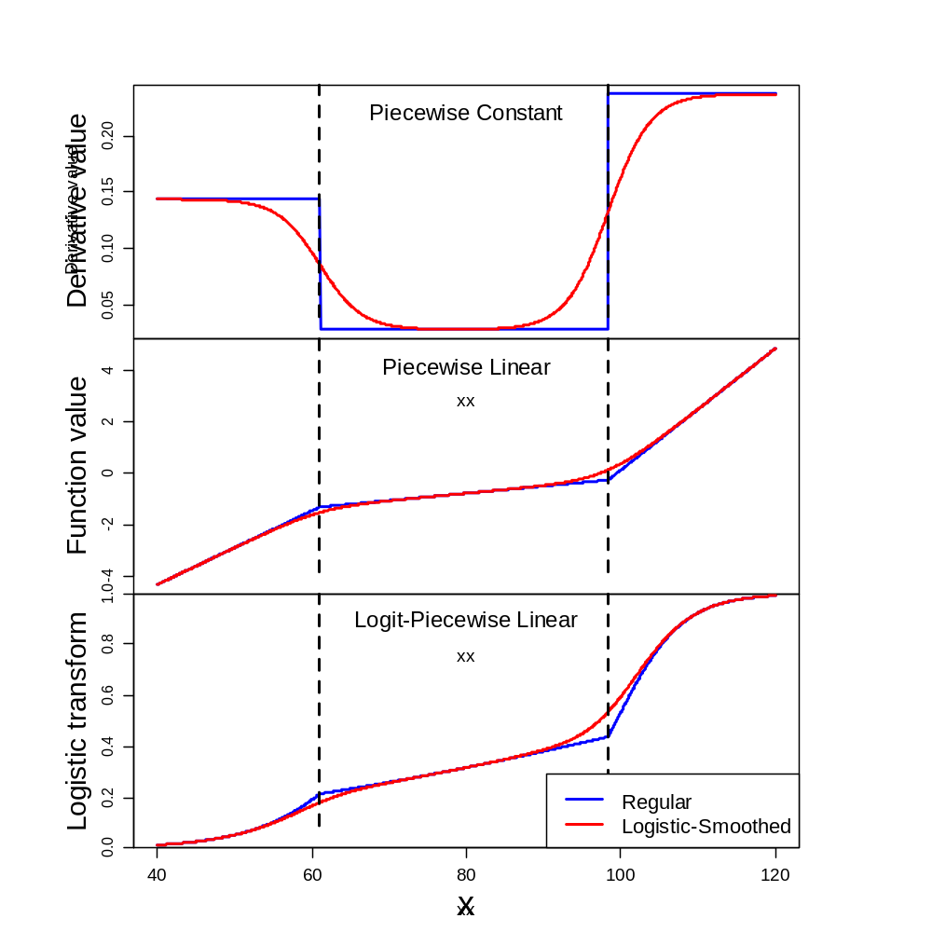
Figure X: Construction of regular (blue lines) and logistically smoothed (red lines) piecewise linear models (PLMs). Top panel shows the derivative of the two types of PLMs. The middle panel shows the PLMs. The bottom panel shows logistically transformed PLMs, which can be used to model proportions.
- Note that the smoothed piecewise constant model is the sum of two scaled logistic functions.
- In the context of the proportion of mature crab, these two logistic processes can be thought of as two separate maturation processes which active at different sizes.

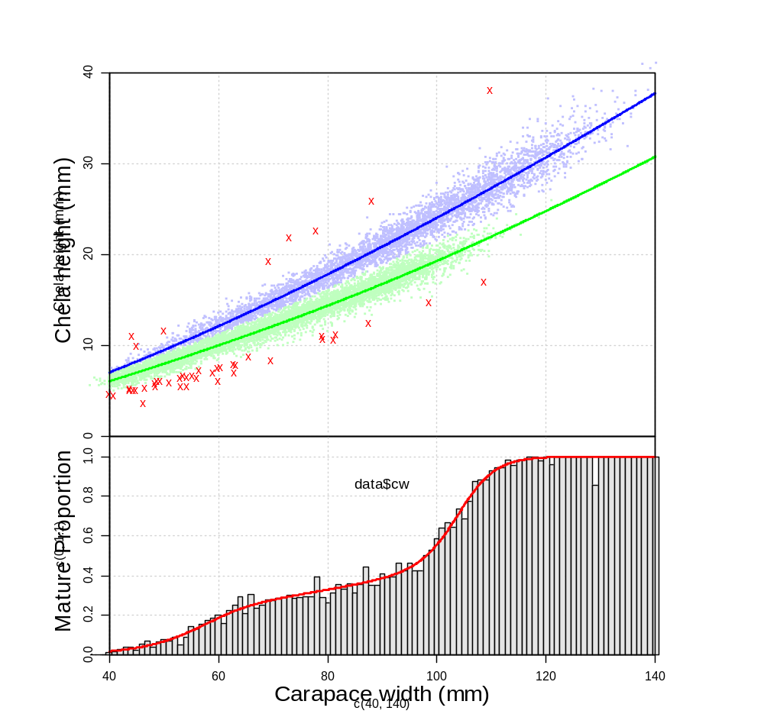
Figure X: Regression mixture model fit for male snow crab from the 2017 survey. The top panel shows a scatter plot of the chela height versus carapace width. Blue points and lines indicate mature crab observations and observations while green indicates those for immature crab. Red x’s show outliers in the data. Classifications are based on the maximum a posteriori from the model fit. The bottom panel shows the proportions of mature crab versus carapace width based on the model-based classifications along with the underlying size-based proportion model (red line).

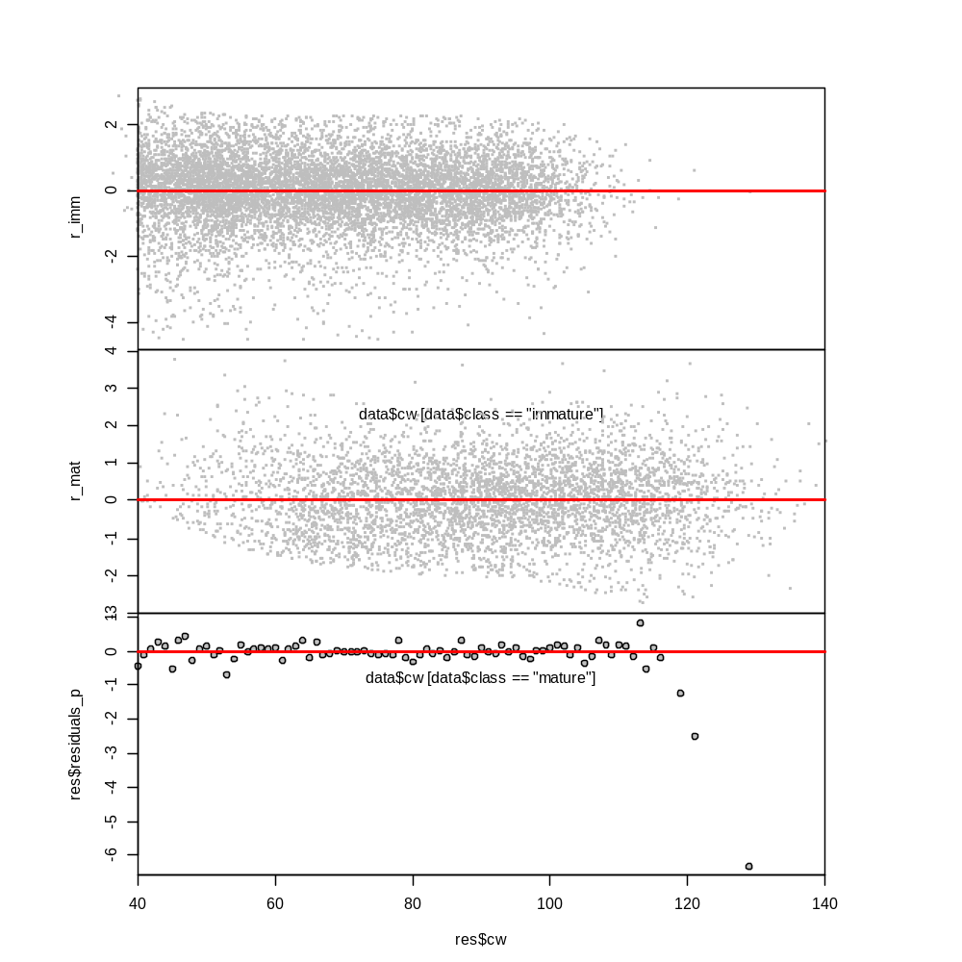
Figure X: Residual plots for the immature (top panel), mature (middle panel) and maturity proportion model (bottom panel).

