**Junhui He**

**junhuih**

**12-659 Section A1**

**Upgrading Image Quality With MATLAB**

**October 02, 2017**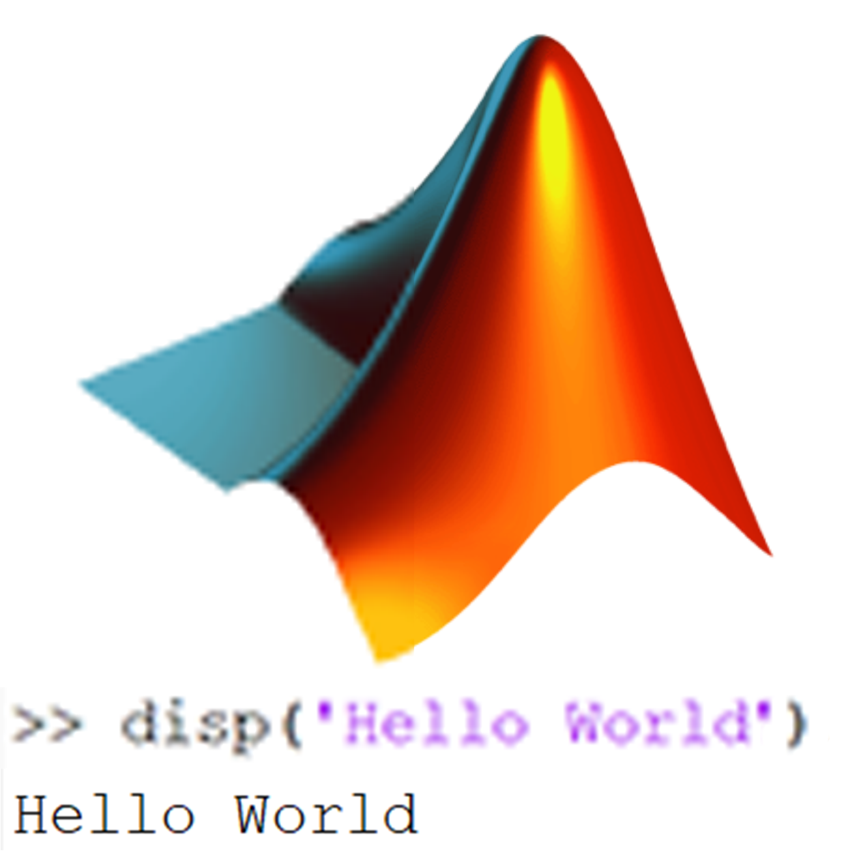

# Introduction

People often get an image with low quality for a lot of reason. The primary purpose of paper is to find out the ways to upgrade image quality of a photo. MATLAB could transforms an image into matrix of numbers. Then if the numbers can be edited in a correct way, the image quality could ideally increase. Grading the image quality automatically is hard[1] and merely impossible to be comprehensive and accurate. But the user can choose the way to increase the image quality by one’s own. Since there are too many ways to upgrade the image quality, the primary purpose of this paper will only focus on the methods to increase pixels in the image.

# Background

## Interpolation Methods

The Bilinear Interpolation method and Bicubic Interpolation method[2] are very popular methods to upgrade the image quality. They are primarily used to increases the pixels of the original image by “blurring” the colors of the image and creating new pixels.

The Bilinear Interpolation method takes the nearest 2 x 2 pixels, and calculate the average of it. Then it is smoothly added to the original image, making the original image looks larger.[3]

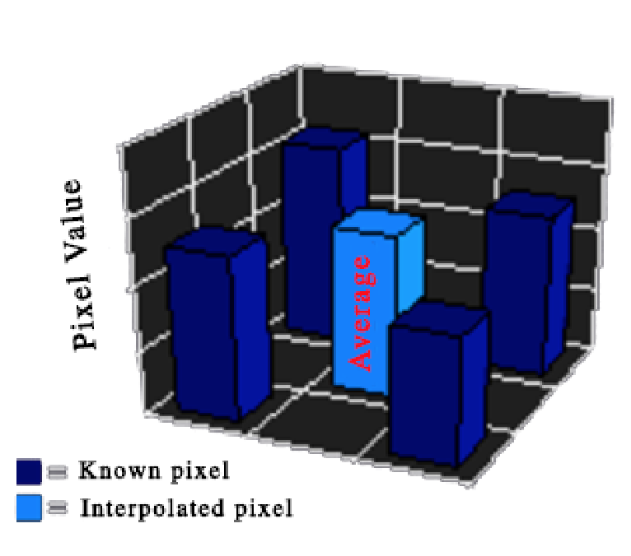  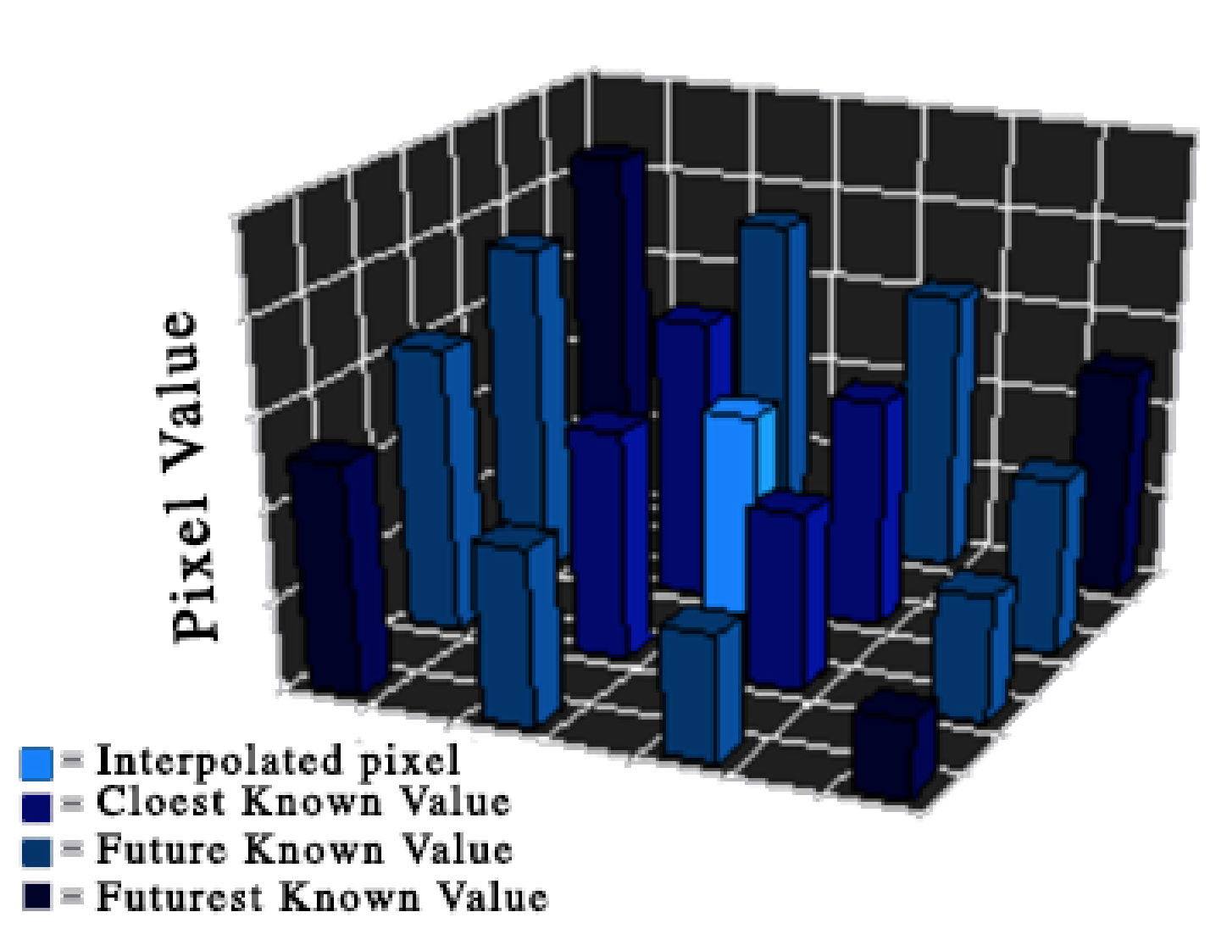

Figure 1. Bilinear Interpolation[3] Figure 2. Bicubic Interpolation method[3]

The Bicubic Interpolation method is more complicated than the Bilinear Interpolation method. It considers 4x4 number of pixels, and calculate the weight average of it. The closer pixels are weighted more heavily, and the pixel far away is weight lightly. This will help produce a sharper image compared to the Bilinear Interpolation method.

These two method are very helpful to make the image sharper and make the color more vivid and smooth. MATLAB has its built-in function to of interpolation.

output = imresize (image, scale, (method))

This is the default way. And the default method is indeed bicubic interpolation. When the ‘method’ is ‘bilinear’, it is then the default bilinear interpolation.

**Gaussian Blur**

Gaussian Blur is a king of fast blur commonly used to reduced noise and reduce detail. It smoothly blurs the image. This kind of blur is not usually used to upgrade image quality. But when the original image contains too few pixels, using Gaussian Blur as a method might increase the view quality.

The algorithm is here”

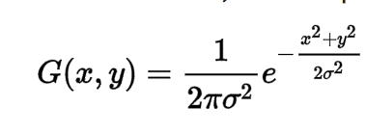

(x, y) stands for the pixel location, 2πσ2 stands for the normal distribution [4]

The primary goal is not about the Gaussian Blur. So it will use the MATLAB built-in function.

function out = gaussfilt(image, int)

out = imgaussfilt(image,sigma);

end

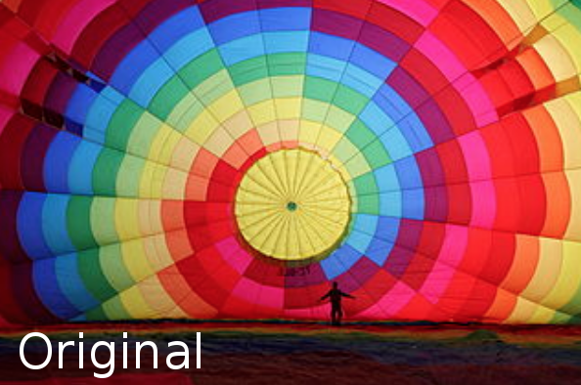 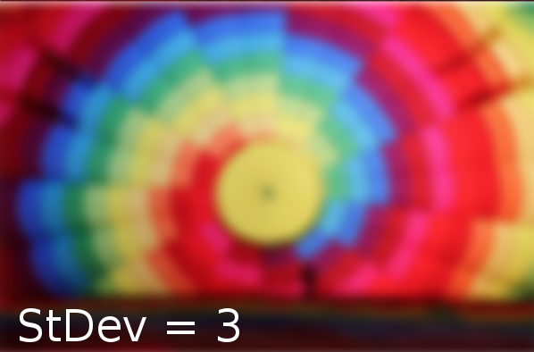 

Figure 3. Sample Gaussian Blur Image[4]

**Unsharp Masking**

Unsharp Masking is always used to sharp an image. It is like the opposite of the blur methods. Images might be too blurry after upscaling, thus using the Unsharp Masking might help emphasizing the edge of the image.

Unsharp Masking is not the primary goal of this paper. So it will use the MATLAB built-in function.

function out = sharp(image)

out = imsharpen (image)

end

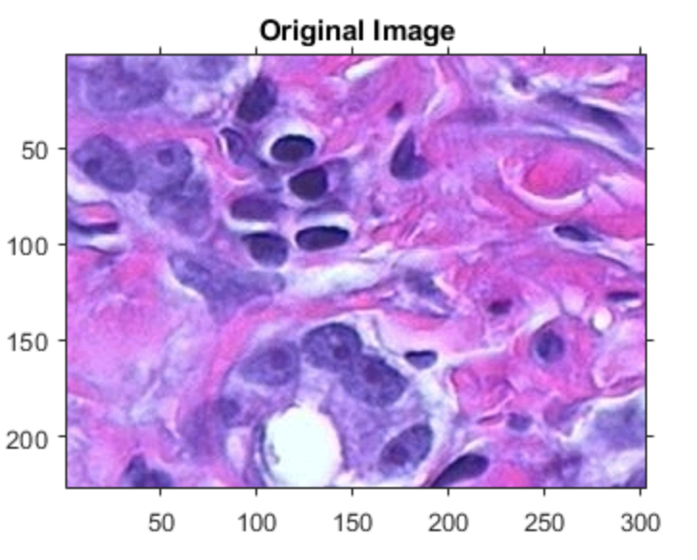 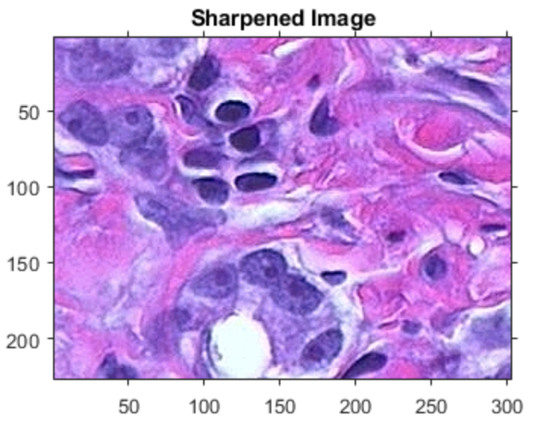

Figure 4. Sample Unsharp Masking[5]

# Implementation

The project currently only focuses on the image upscaling. It deals with multiple situation, especially when dealing with image with very low resolution.

# 

Figure 3: How the program will work

# Conclusions

# References

1. Zhou Wang and Alan C. Bovik, *WHY IS IMAGE QUALITY ASSESSMENT SO DIFFICULT?* , 2002

2. Prasantha H S, Shashidhara H L, Balasubramanya Murthy K N, *IMAGE SCALING COMPARISON USING UNIVERSAL IMAGE QUALITY INDEX* , 2009

3. *DIGITAL IMAGE INTERPOLATION*, http://www.cambridgeincolour.com/tutorials/image-interpolation.htm