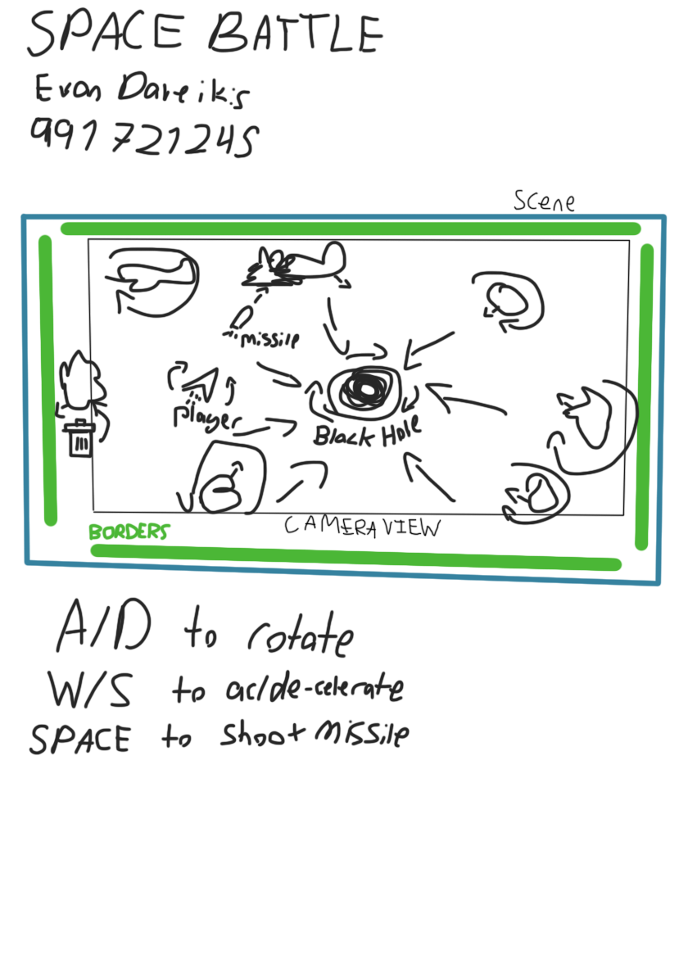

Spaceship.cs (player):

- Accelerates with W/S, rotates with A/D

- Shoots missiles with space

- Physics based (has a Rigidbody2D), and will coast around (like space)

- Has a collider for detecting collisions

- Destroyed on impact with an asteroid

- Will have a BlackHoleObject script once it is created (to get pulled towards black hole)

- Destroyed on being sucked into black hole

- Pseudocode:

- Variables for the rb, speed, maxSpeed, rotation speed, fire rate, fire timer, input

- Set callback for being sucked into black hole (destroy ourselves)

- Store input and check for missile launches in Update

- Instantiate a missile if the timer is low enough and space is pressed

- Apply forces and torque in FixedUpdate

- Detect asteroid collision in OnCollisionEnter2D (check tag) and destroy if colliding with an asteroid

Asteroid.cs:

- Physics objects (rigidbody) with a collider

- Instantiated outside of screen, flying towards the center (with a velocity)

- Have randomized size

- Spins slightly over time

- Will be affected by black hole (won't explode)

- Destroyed by player missiles (perhaps with a little effect)

- Destroyed after leaving screen (handled by border)

- Pseudocode

- Variables for the rb, angular velocity

- Set velocity towards the screen in Start

- Rotates in Update

- Exploding due to missiles is handled by missiles

- Function Explode() (shoots rock particles out maybe)

SpaceMissile.cs (missile):

- Physics object with collider

- Accelerates over a short time and then cuts the "thruster" and coasts

- Affected by black hole & explodes upon entering

- Faces towards its velocity vector

- Destroys asteroids

- Pseudocode

- Variables for rb, accelerationForce, accelerationTime, timer

- Set black hole callback in Start to explode

- Decrement & check timer and apply forces in FixedUpdate

- Rotate towards velocity in Update using Atan2

- Check for collision with asteroid in OnTriggerEnter2D and blow it up

- Function Explode() (explosion particles/sprites/animation)

BlackHole.cs:

- Pulls BlackHoleObjects towards it using Newton's ULOG

- Spins slowly

- Destroys objects that are unfortunate enough to fall in

- Pseudocode

- Variable for gravitational force multiplier, mass, spinRate

- apply physics in FixedUpdate to all BlackHoleObjects

- Detect objects entering in OnTriggerEnter2D, check for BlackHoleObject script and call callback, destroy object

BlackHoleObject.cs:

- Pulled towards the black hole

- Calls a function when entering the black hole

- Pseudocode

- Variable for rb, callback

- Static list of BlackHoleObjects

- Add self to list on start

- Remove self from list on destroy

- Action<> OnEnterBlackHole called by BlackHole.cs

Border.cs:

- Checks for players entering the trigger and wraps them around the screen

- Checks for asteroids/missiles entering and deletes them

- One on each side of the screen

- Pseudocode

- Variables for tags (for player, asteroid, missile), player teleport position

- Check for these tags in OnTriggerEnter2D and take an effect

- Delete missiles & asteroids

- Teleport players to the other position specified