LCA at Tallgrass: One-Page Brief

LCA at Tallgrass: One-Page Brief
Oct 2, 2026 · Andrew Gibson

How an LCA works
An LCA counts every greenhouse gas emitted and removed over a product's life. For Trailblazer, it sets the carbon intensity (CI) that scales 45Z and clean fuel credits, and the removal-credit yield. Four phases (ISO 14040/44):
- Goal and scope: what unit, which boundaries (corn field to Wyoming storage).
- Inventory: every input and output, from fertilizer to pipeline power.
- Impact: convert every flow to CO2-equivalent and total it.
- Interpretation: test what drives the answer (land use, grid power, leakage).

The programs Trailblazer can use
Program | Pays per | Land-use charge (iLUC) | Value | Market and outlook
45Z | Gallon, scaled by fuel CI | Excluded for fuel made after 2025 | ~$195–260 per tonne captured (est.) | $12.5B (FY2026, all fuels); ends Dec 31, 2029
45Q | Tonne stored | Not counted | $85 per tonne | $1.0B in FY2026, rising to $5.9B by FY2035
Clean fuel (CA, OR, WA) | Tonne CO2e below the CI standard | Included in CA | $80–87 per credit (Sep 30, 2026) | CA ~$190 (2019), ~$60 (2025); needs a CCS pathway
Removal credits (Puro) | Net tonne removed | Charged; about half of each captured tonne (est.) | $100–200 per credit (est.) | 30.4 Mt contracted in 2025, ~90% by Microsoft
A plant claims 45Z or 45Q in a year, never both. Puro bars reusing a removal in other environmental products, so a tonne earns clean fuel or removal credits, not both. iLUC: carbon released when corn for fuel pushes farming onto new land.

Cap-and-trade: a market to shape
Cap-and-trade is spreading. California's program (linked with Quebec) runs to 2045; Washington signed to join in June 2026, with a joint market expected in 2027. None of these, nor RGGI, credits CO2 stored in Wyoming.
- Most realistic: California's SB 840 requires CARB to consider carbon removal offset protocols by 2029. Push for one that accepts out-of-state Class VI storage.
- Long shot: a Wyoming or Nebraska program. Wyoming lawmakers tried to repeal even a CCS study mandate in 2026.

Where Tallgrass sits
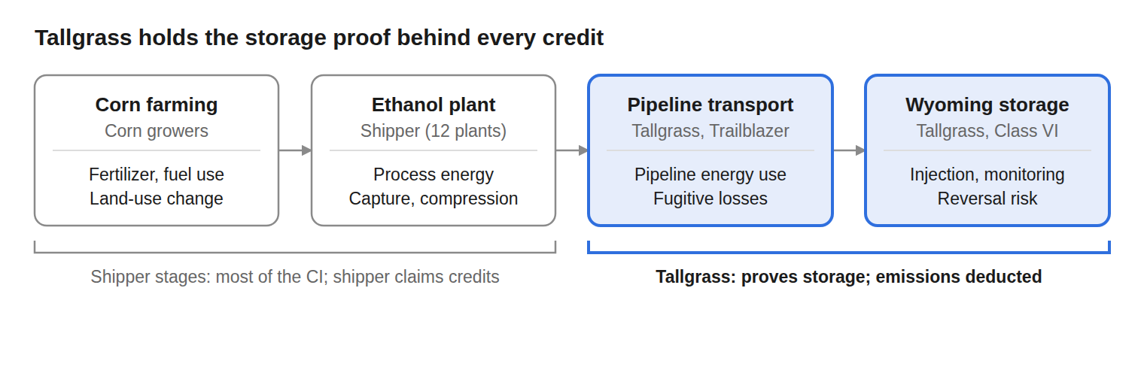

How Tallgrass applies it
- Own the storage-stage LCA: one audited data package that all 12 shippers can cite, for a fee or revenue share.
- Grade shippers' tonnes by full LCA: premium tonnes to strict buyers like Microsoft, the rest to spot.
- Screen new CO2 sources: coal earns only 45Q ($85/t) against capture costs of ~$60–100/t (industry estimates); it fits only as take-or-pay volume.
Sources: Treasury Tax Expenditures FY2027; FuSE prices (Sep 30, 2026); CDR.fyi; Puro GSC 2024 v.5; ICAP; WA Ecology. ~ or est. = estimate.

