Bank Marketing Campaign Insights
Who Converts, and Why — A Business Analytics Case Study
Prepared by Tobiloba Osikoya | AnalystLab Africa Data Analytics Internship — Week 5

Introduction
This report presents a business analytics case study built on the UCI Bank Marketing dataset, which records the outcomes of direct telephone campaigns run by a Portuguese retail bank to promote term deposit subscriptions. The objective is not simply to analyze the data, but to translate that analysis into business insights and concrete recommendations that can support marketing decision-making.
The analysis was carried out in Python (pandas, seaborn) for data cleaning, exploratory analysis, and driver identification, with findings translated into an interactive Power BI dashboard for stakeholder exploration.

Business Problem Statement
The bank's marketing team runs telephone campaigns to sell term deposits, but conversion rates are inconsistent across customer segments. This analysis identifies which customer characteristics and campaign approaches are most associated with subscription, so marketing can prioritize outreach, reduce wasted contact effort, and improve overall campaign efficiency.
Specifically, the analysis addresses two questions:
- Why do some customers subscribe to a term deposit while others do not?
- Which customer groups are more likely to respond positively to marketing campaigns?

Dataset Description
The dataset contains 11,162 customer records across 17 features, covering demographic attributes (age, job, marital status, education), financial attributes (account balance, housing loan, personal loan), and campaign attributes (contact method, number of contacts, days since last contact, previous campaign outcome). The target variable, deposit, records whether the customer subscribed to a term deposit.
No missing values or duplicate rows were found in the dataset. However, several categorical fields — job, education, contact, and poutcome — contain an “unknown” category that functions as a placeholder for missing data. These were retained as their own category rather than imputed, since they likely reflect gaps in data collection rather than a genuine customer attribute.
The target variable is close to evenly split: 47.4% of customers subscribed to a term deposit, and 52.6% did not — a balanced distribution that supports reliable comparison across segments.

Data Analysis Process
The analysis proceeded in three stages. First, univariate exploration examined the distribution of each variable: age and account balance were both right-skewed, with a small number of high-balance outliers pulling the mean well above the median. Call duration followed a similar right-skewed pattern.
Second, categorical variables were cross-tabulated against the deposit outcome to identify conversion rate differences by segment (job, marital status, education, housing loan, personal loan, previous campaign outcome, and contact method). Third, a correlation analysis of the numeric variables against the deposit outcome was used to quantify the strength of numeric drivers.
Two data quality caveats emerged during this process and are worth noting explicitly. Call duration is the strongest numeric predictor of subscription (correlation of 0.45), but it is only known after a call takes place, so it cannot be used to decide who to target beforehand. Similarly, the “unknown” category in the contact and previous-outcome fields shows unusually low conversion, which most likely reflects a data collection gap rather than a genuine behavioral pattern, and should not be presented as a real driver of conversion.

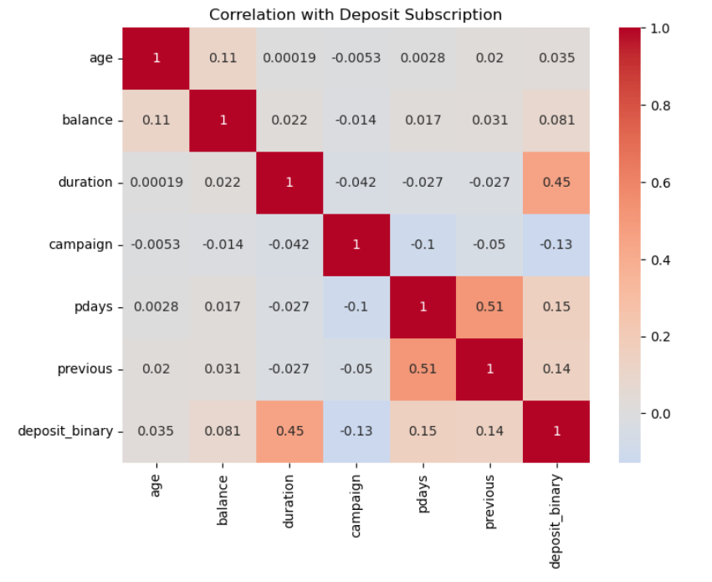Figure 1. Correlation of numeric features with deposit subscription.

Key Findings
- Prior campaign success is the strongest driver of conversion. Customers with a successful previous campaign outcome convert at over 90%, far above the approximately 47% baseline — prior relationship is the single strongest lever available to marketing.
- Debt load shapes conversion. Customers without a housing or personal loan convert noticeably more than those carrying either loan type (57% and 50% respectively, versus 37% and 33% for loan-holders) — likely reflecting differences in financial flexibility.
- Life stage and marital status matter. Students (74.7%) and retirees (66.3%) convert well above average, while blue-collar workers (36.4%) and entrepreneurs (37.5%) convert well below it; singles convert higher than married customers (54.3% vs. 43.4%).
- Repeated contact attempts show diminishing returns. The number of contact attempts within a campaign is negatively correlated with conversion (r = -0.13) — more calls to the same customer are associated with lower, not higher, conversion.
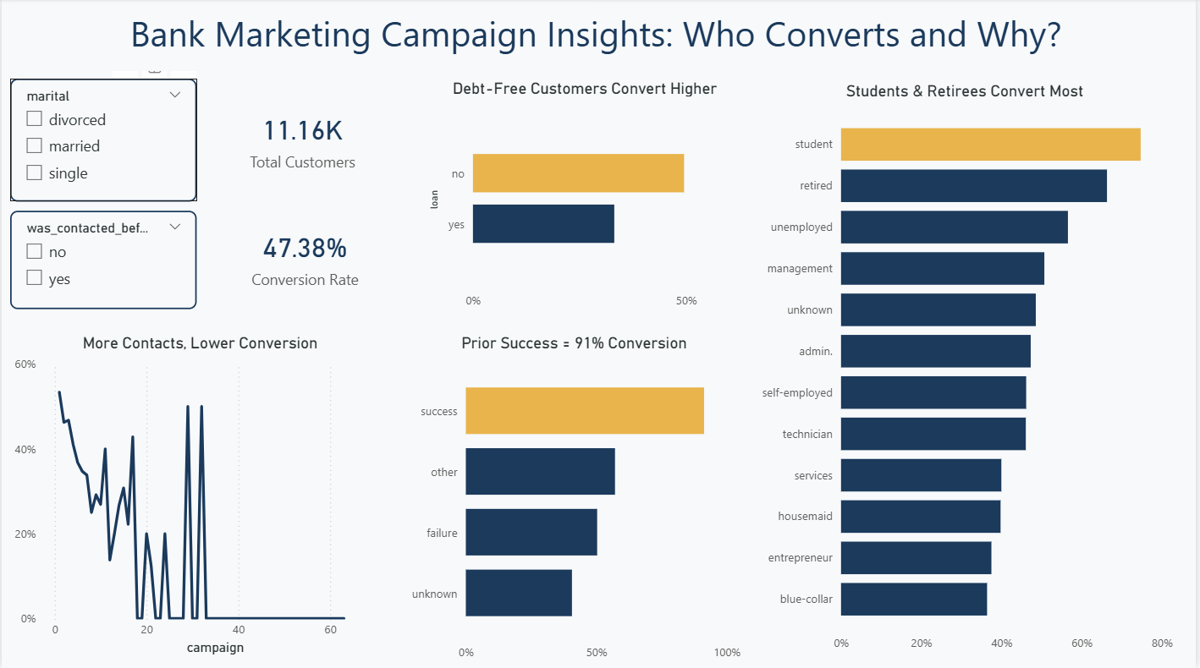Figure 2. Power BI dashboard summarizing conversion rate by key segment.

Business Insights
What patterns did we discover?
Conversion is driven far more by a customer's financial situation and prior relationship with the bank than by simple demographics like age alone. Prior successful contact, low existing debt, and certain life stages (student, retired) are the clearest positive signals.
What customer behaviors stand out?
Customers with more financial flexibility — fewer existing loan obligations, and life stages associated with more discretionary income or time (students, retirees) — respond more favorably to term deposit offers than customers likely carrying more financial commitments.
Which customer segments require attention?
Married, blue-collar, and entrepreneur customers carrying an existing housing or personal loan represent the lowest-converting segment and may need a different offer or approach rather than equal-priority outreach. Customers with no prior campaign history (poutcome = unknown) are the largest segment in the dataset but the hardest to predict, since there is no prior-outcome signal to rely on.
What risks or opportunities exist?
The clearest opportunity is re-engaging customers from previously successful campaigns — high conversion at low incremental effort. The clearest risk is over-calling within a single campaign, which appears to erode conversion rather than improve it. A data caveat also worth flagging: duration is a strong statistical predictor but is not actionable for pre-call targeting, and the “unknown” categories in contact method and prior outcome most likely reflect data gaps rather than real behavioral segments.

Recommendations
- Prioritize marketing spend toward singles and customers without housing or personal loans — since these segments convert well above the ~47% baseline (54% and 57–67% respectively), while married and loan-holding customers convert noticeably lower.
- Make re-engagement of previously successful contacts a standing priority in future campaigns — rather than treating every campaign as starting from zero, since this group converts at over 90%.
- Cap outreach at 2–3 contacts per customer per campaign — since higher contact counts are associated with lower conversion (r = -0.13); continuing to call unresponsive customers appears to erode goodwill rather than build it.
- Use demographic and financial profiling to prioritize first-time contacts — using job type, marital status, and loan status, since this is the largest customer segment and has no prior-outcome signal to lean on.

Conclusion
Term deposit conversion is shaped less by chance and more by a customer's financial readiness, prior relationship with the bank, and how outreach is managed. By prioritizing debt-free and previously engaged customers, capping repeated contact attempts, and using demographic signals to guide first-time outreach, the bank's marketing team can improve conversion efficiency without increasing overall campaign volume. Data-driven targeting turns a broad calling campaign into a focused, higher-converting one.

