Toby bluck

BLU16274423

2127 Words

SCDT45 CW1

UX & UI Design

# Refined specifications:

## UI specification breakdown:

### User interaction with the 3D experience –

What does it need to do? This 3D experience needs to have multiple forms of interaction to the secondary school students as links have been made to prove interaction leads to the stimulation of learning. The students need to be able to have or more than 2 forms of interaction to stimulate heightened learning. (Banna et al., 2015)

How is it going to do it? The 3D experience can utilise chunks of information that is broken down to a readable format to make it more engaging for the students. Furthermore, the interaction and movement/manipulation of the model will allow for students to fully explore all aspects of the chosen subject. Clicking of elements with a pop-up text box will give precise information to the students in specific areas on the models.

What impact will this have? This will be more engaging to the students and the interaction will provide both cognitive and emotional experiences to them which will reinforce the knowledge.

### Responsive to users –

What does it need to do? Responsiveness needs to be snappy and respond to input from the user without any hinderance to performance or causing any other issues within the 3D experience.

How is it going to do it? Well developed models, which has good poly count so it will not be inefficient to interactive with and well coded to make sure there is no other issues with response to user input.

What impact will this have? Without responsiveness this could cause the students to lose interest as it could be tedious to use or not enjoyable if it has a large margin of delay between the user and the response from the experience.

## UX specification breakdown:

### Engaging/enjoyable –

What does it need to do? This needs to provoke emotion to form a link with the user but also be displayed in a clean manner making it easy for students to read and see helping them understand the information presented while keeping them interested.

How is it going to do it? Design patterns will be investigated to find something that would be appealing and following UX design principles will aid in making it more user friendly and appealing.

What impact will this have? Having strong visualisation on this will 3D experience will help the user be able to interact with it easier and help with making a more productive experience. (Tominski, 2015)

### Informative –

What does it need to do? This experience needs to display information clearly and concisely without using too complex terminology allowing for the students to grasp the information and visual representations easier and allowing them to reinforce knowledge opposed to confusing them.

How is it going to do it? Information will be compared to other sources i.e. Textbooks to see if the wording and overall complexity of the visual representation is up to standard or if it is too complexed it can be slightly simplified to allow for a better understanding.

What impact will this have? This will help the students learn while giving them enough information to understand but allowing them to further their knowledge without overwhelming them with information. (Functional and Nonfunctional Requirements: Specification and Types, 2018), (Preece. et al., 2015)

# Use Case Diagrams:

A use case diagram is used to bring out the requirements of the system that is being built, this allows for a graphical representation of users and goals that needs to be reached. The main focus on the creation of use cases is that it creates an underlying foundation in which helps to identify what the users need or would like to achieve. (How to Write Effective Use Cases?, 2016)

The main symbols used in use cases are:

Actors – These are used to interact with a use case/s, is used to set off a use case.

Use case – These are typically a function of a system; actors are linked to a use case but not all use cases are linked to an actor.

Link/Communication link – Actors connected with a solid link to a use case allow for communication, can signify the actor and use case exchanging information.

System/boundary of the system – The entire system or boundary of the system per stated in the documents used, however it is not limited to this alone and can be used as a module for large use cases.

Include link – This is used to represent when a use case uses the functionality of another use case and forms a relationship between them. (What is Use Case Diagram?, 2020)

## Generalised use case –

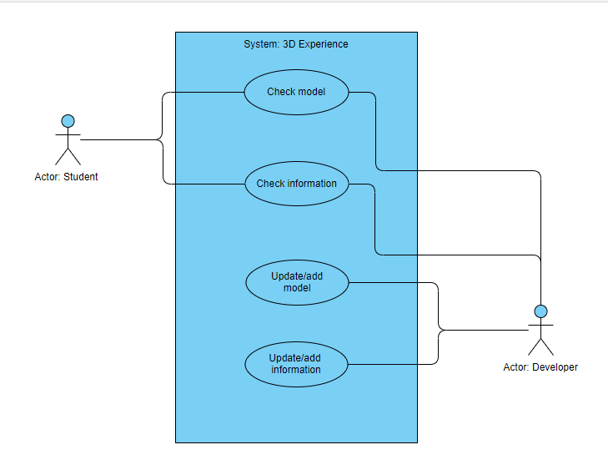

This is a generalised use case for the system with the student and developer of the experience. The actors: student and developer can interact with certain use cases of the system. For the student, they can check a model which in terms allows them to look and interact with a model but without making any changes to it. Furthermore, the student can check information within the 3D experience, which would be text or pictures etc. The developer on the other hand can is able to perform/interact the same as the student but has links to other use cases which allows for the update of a model or the addition of a model, this also applies to the information as well.

## Chemistry and physics use case-

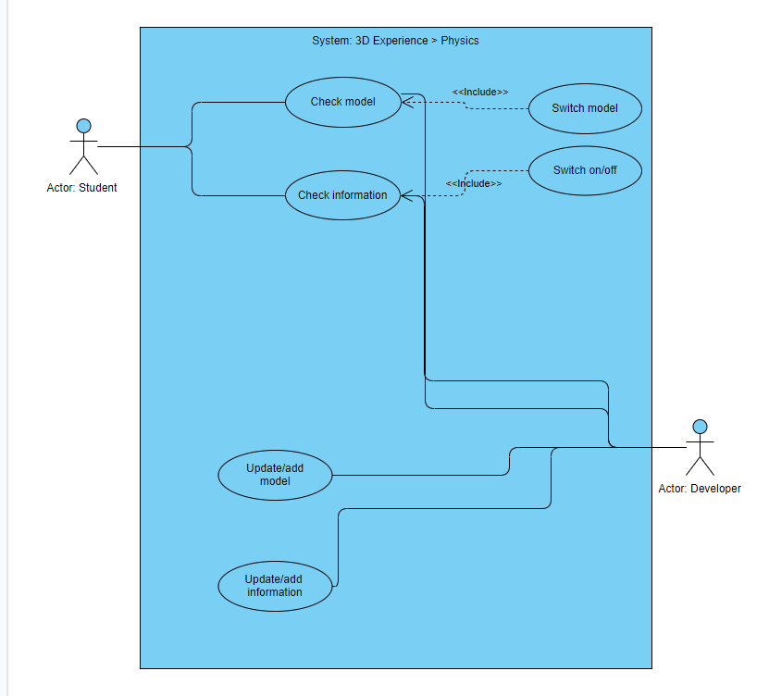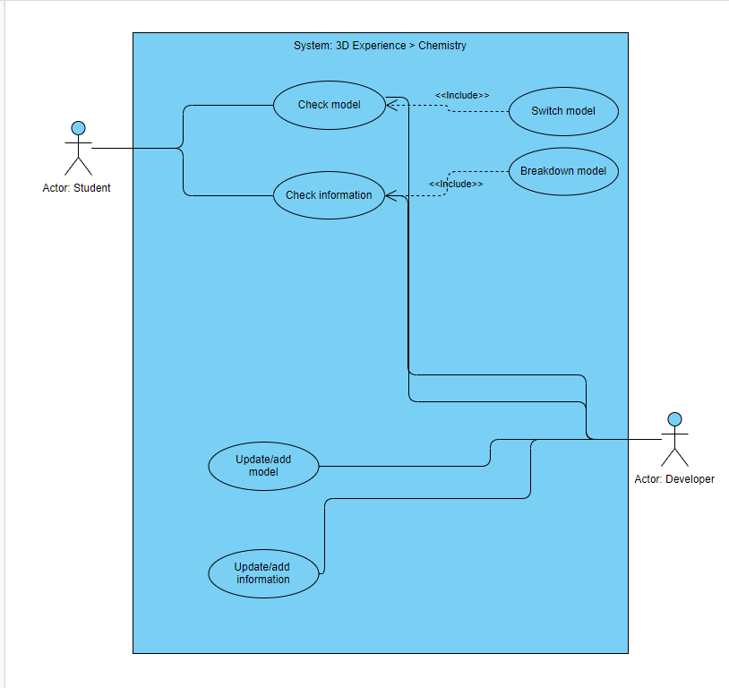

This is fundamentally the same as the generalised use case with minor differences, the student and developer actor can still preform the same things. Additional use cases have been made which use “Include” this allows the check model, to use the function of the switch model use case allowing the student when examining a model to switch between them. Physics and chemistry have different use cases linked to the “check information” use case, for physics it allows for the switching on and off of the model, in regards to chemistry it will allow for a breakdown of the model which will allow for the users to see every part of it easier.

## Biology use case-

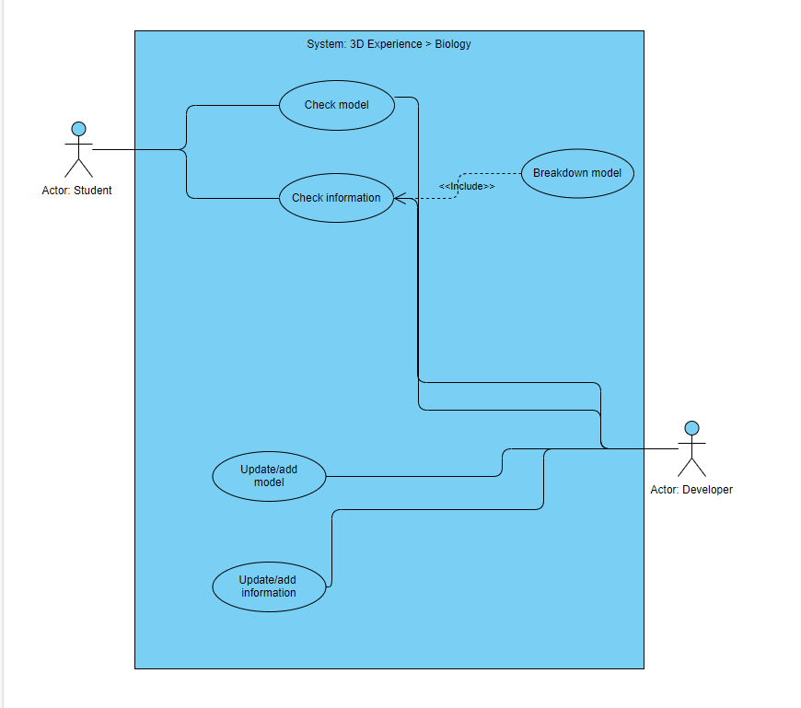

This is still using the generalised use case, with a breakdown model use case using the include relationship link. This allows for the actors to break down the model of the biology branch to further see it in greater detail.

# Wireframes of 3D experience

These wireframes are simple design early on used to make the foundation of the 3D experience which will map out the general layout, this will help for the structure further in the stages of development to create a high-fidelity prototype of the 3D experience. However, these can be easily modified to adjust with changes made.

## Start menu:

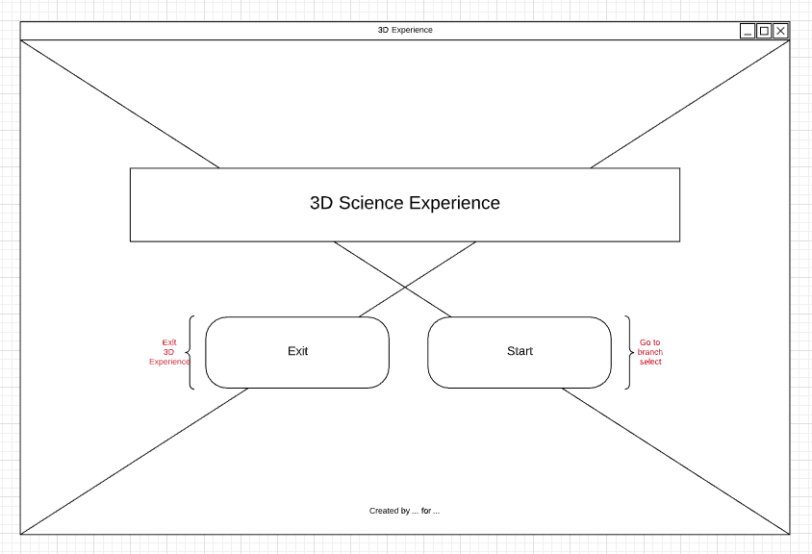

This is the start screen for when the 3D experience launches which acts as a landing page for the users, the title has been made to clear state what it is and there are 2 buttons which allows you to “Start” the 3D experience or exit out of it. The background will be an image which could combine all 3 branches of science together.

## Branch selection / Sub-menu:

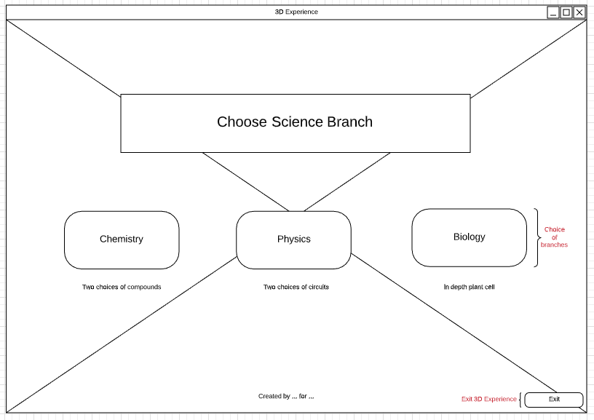

This comes after the start menu; it uses an image as a background but state that a choice needs to be made. The 3 branches/choice are in the middle of the application to be the centre of attention which will provide a brief description below each button to give better context to the user. An exit application is in the far-right bottom of the screen as its their if needed but minimise the focus on it.

## Biology:

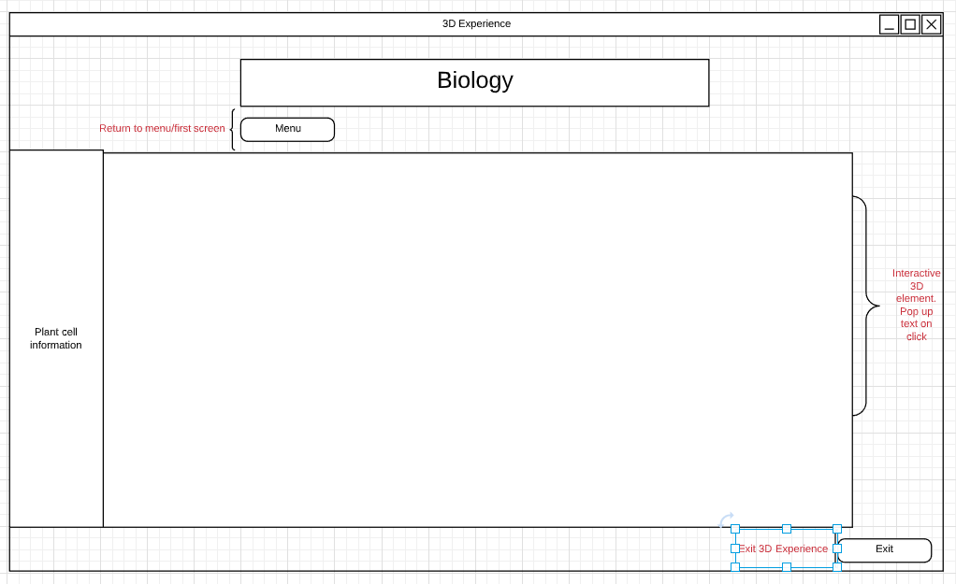

This is the biology screen, the main focus would be the interactive 3D element which has a high screen space ratio, allowing for the focus to be on the visual stimulation of the model and the information along with it within the element, left side there will be a larger chunk of information to read but this has a small screen ratio, making it something the user will come back to as it is less in focus. A menu button is placed below the title for easy finding and navigation. No background image is used for this page as it could be a distraction when there is a clear focus on information and interaction to occur Exit button is still residing in the same location as on the previous wireframe for consistency.

## Chemistry and Physics:

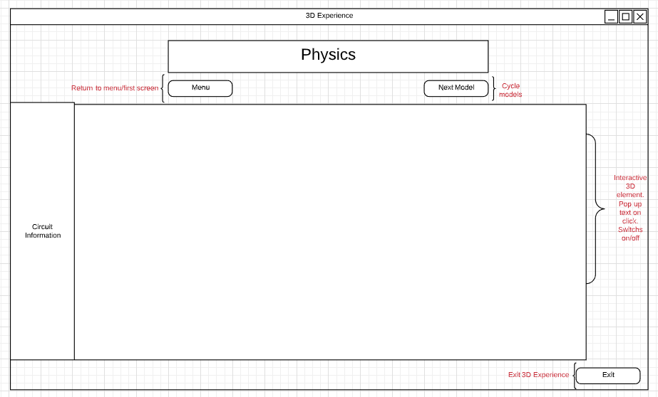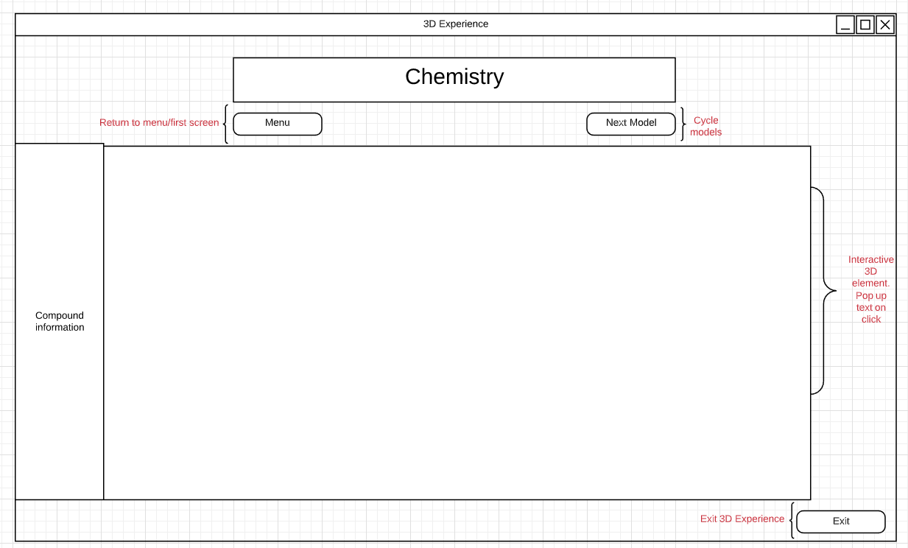

The physics and chemistry wireframes follow the same design of the biology page to keep the overall design consistent which will help with usability of the experience. The defining change between these and the biology wireframe is a button on the right below the title, which would allow for the cycling of a choice of models for the user to interact with.

(Babich, 2017), (10 Practical Tips on Sketching Your Wireframes, 2018)

# 3D models:

All models are low fidelity with minimal details, this will be reiterated with high fidelity models and/or final piece models to use in the 3D experience.

## Chemistry:

### Sulfuric Acid -

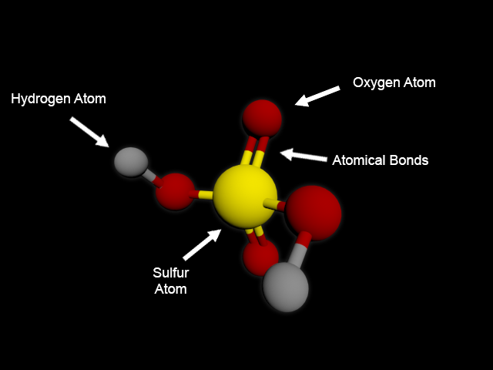Chemical compound, Sulfuric Acid or Oil of vitriol. This has been colour coded to make the atoms and bonds more visible to the students/users. References have been used to ensure accuracy of structure.

### Sulfuric Acid image reference -

(Sulfuric Acid, 2020)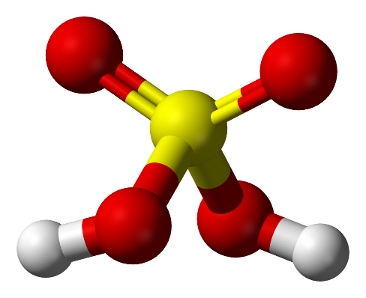

### Sodium Bicarbonate -

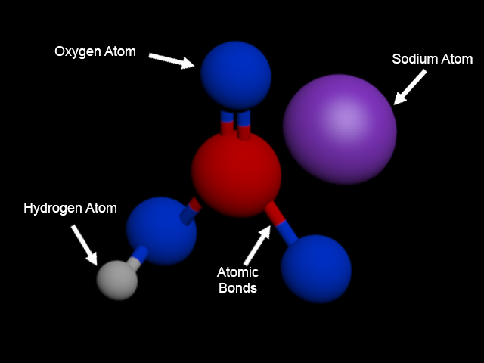Chemical compound, Sodium bicarbonate or Baking powder. This has been colour coded as well with approx. atom sizing.

References were used to ensure correct structure.

### Sodium Bicarbonate image reference -

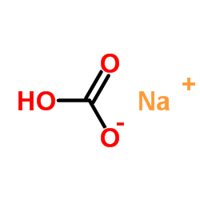

(ChemSrc, 2020)

## Physics:

### Series circuit -

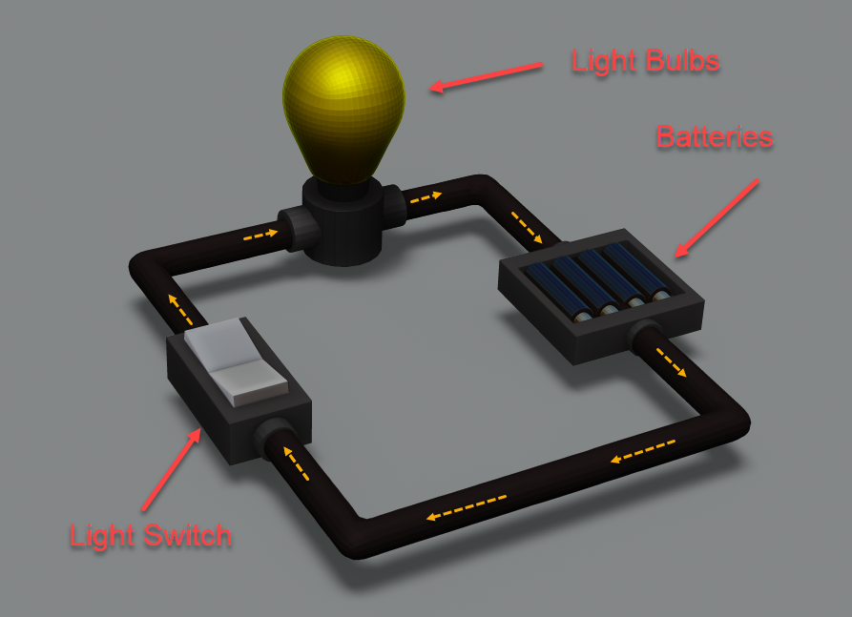

A basic series circuit, with current flow show and 3 components, references were used to create a base circuit.

### Series circuit image reference -

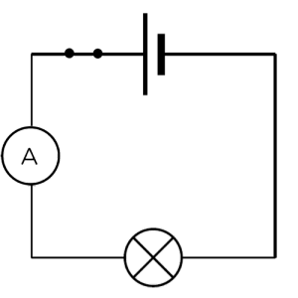 (Physics Tutor Online, 2020), (Hewes, 2020)

### Parallel circuit -

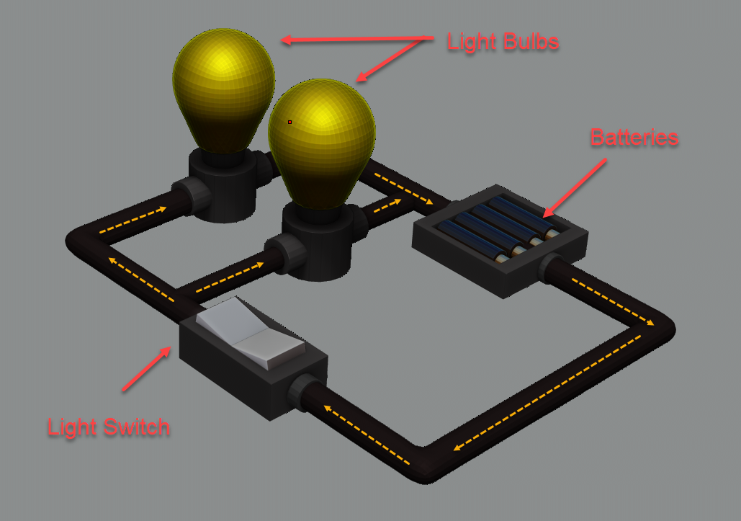

A simple parallel circuit, to show current and how the circuit works, reference has been used to ensure a parallel circuit has been correctly modelled.

### Parallel circuit image reference -

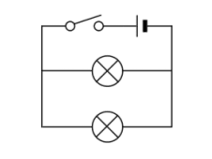

(Parallel circuit, 2016), (Hewes, 2020)

## Biology:

### Plant cell -

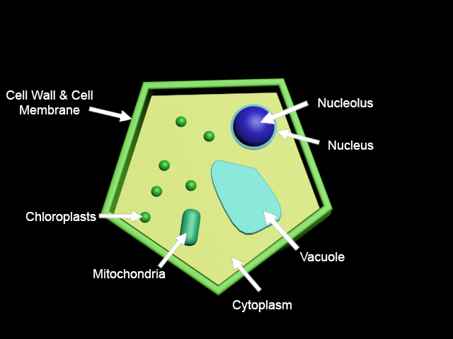

A basic plant cell, which could be greatly detailed in later stages of the project. References used to ensure accuracy of plant cell.

### Plant cell image reference -

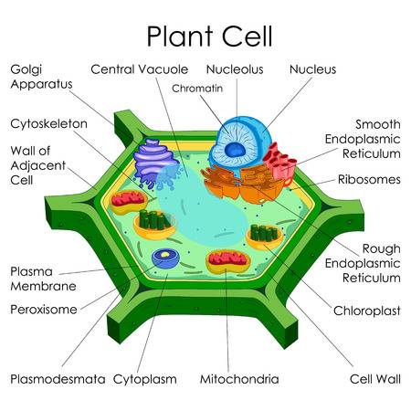

(123RF, 2020)

# Selection and justification:

## Proposed methods:

### How the developing project will continue -

The next steps within this 3D experience is the review of wireframes, use cases and 3D models to see if everything meets standards and seems like it would be functional, if they are the project can move on to the next stage where more information can be gathered and high-fidelity mock-ups can be made resembling the final experience as close as possible unless changes are made. These new mock-ups will allow for a more realistic view of the experience including interaction objects, interfaces and all the content present. After this has been completed and review the final product can be made and shipped.

## Tools and techniques:

### Applications being used -

Unity to develop experience – Unity will be used to make the 3D experience but not the models within it. This is because Unity is a strong visual platform allowing for display and interaction of models simple and easy to execute. Further in the deployment of the experience would be considerable easier to achieve in Unity than anything else, alongside everything else the stability it can provide is exceptional with high performance and low errors. One of the downsides is that some documentation within it is slightly outdated which may cause issues during development. But a robust choice for the base of the 3D experience. (Pros and Cons To Consider When Using Unity | #YGD, 2017), (Waran, 2020)

3ds Max to model – 3ds Max has been chosen to make the base models with little detail as it is relatively straight forward to do and the user friendliness of the application and tools provided will allow for a fast development, this can also be used to create texture as the material editor within it and is extremely easy and intuitive to use. Therefore, it has been chosen to create the models. (What Is 3ds Max | Advantages and Various Subsets of 3ds Max, 2020)

Zbrush to sculpt/finer details – Zbrush is used for sculpting, similar concept is clay modelling in real life. This allows for the utmost control on creating high-poly detailed models which will be useful to show all the details of per say a plant cell and how in-depth it is. This will help with creating amore visually appealing model which would be more engaging for the students. However, the downside to choosing this is that it has a steep learning curve and the UI on it is not very friendly. A large community which has plentiful of resources are their which can balance out any issues present. (Kutz, 2018)

### Modelling techniques -

Sculpting- This allows for users to “sculpt” something out of clay using brush-based interactions by the user which can produce high-res models which show incredible details. Once proficient in sculpting fast development of sculpts can be achieved. Sculpting should be typically used for organic like structure/materials as hard surfaces are hard to recreate. this technique will most likely be used in the final development. (Taylor, 2016)

Box/sub-division modelling- This is when a basic shape is used, and through iteration and manipulation from the artist more form and overall shape will be established. This is a simple but incredibly quick method to utilise due to this nature it lacks greater details than NURBS modelling. This can be used in conjunction with a low poly mesh to add further refinement to the models. This method will be utilised to create a foundation where it can progress into a more advance technique or sculpting. (3D Modeling Techniques in Games, 2020)

## Design principles used:

### Wireframe design principles -

Page hierarchy- Sequential order with a layout which can be understood, content is grouped close by utilising white space as well to maintain to reduce the chance of overwhelming.

Simple concept - Simply laid out with simple wording to lessen confusion, minimum wording has been used to keep the focus on the design itself and all elements within the wireframes can be easily identified.

No fancy colours or fonts - A wireframes purpose it to focus on the organisation and functionality opposed to the design. Red has been used for small notes not directly linked to the design. (N., 2019)

### UX design principles used:

Consistency - Consistency is used through all designs to make it uniform and familiarity between different experiences allows for the students to learn it navigation quicker. A basic pattern has been used to keep it straight forward.

Clarity - All design is as clear as possible which greatly reduces the chance of user confusion but can also save them time with navigation in general use. Furthermore, this helps reduce cognitive load on the users assisting in a sleek experience and simplified functionality. (Barua, 2019), (Grass, 2019)

# References:

|  |
| --- |
| (2016) Parallel Circuit, [Online]. Available at http://milliemakesphysicseasy.blogspot.com/2016/03/28-explain-why-series-or-parallel.html. |
| 123RF (2020) Stock Photo - Education Chart Of Biology For Plant Cell Diagram, [Online]. Available at https://www.123rf.com/photo_80713899_education-chart-of-biology-for-plant-cell-diagram.html. |
| 3D Modeling Techniques in Games (2020) 3D-Ace Studio, [Online]. Available at https://3d-ace.com/press-room/articles/3d-modeling-techniques-games. |
| Barua, S. (2019) 5 Principles of UX Design, Medium, [Online]. Available at https://uxplanet.org/5-principles-of-ux-design-d1579e7267db. |
| Grass, J. (2019) The 5 Key UX Design Principles You Need To Know, Careerfoundry.Com, [Online]. Available at https://careerfoundry.com/en/blog/ux-design/5-key-principles-for-new-ux-designers/. |
| Hewes, J. (2020) Electronics Club - Circuit Symbols, Electronicsclub.Info, [Online]. Available at https://electronicsclub.info/circuitsymbols.htm. |
| Kutz, S. (2018) Zbrush: pros, cons, quirks, and links, Medium, [Online]. Available at https://medium.com/imeshup/zbrush-pros-cons-quirks-and-links-9f48d01ddd99. |
| N, B. (2019) Wireframe - How To Make A Wireframe with Design Principles For Success, Gbhackers On Security, [Online]. Available at https://gbhackers.com/wireframe-design-principles/. |
| Pros and Cons To Consider When Using Unity | #YGD (2017) #YGD, [Online]. Available at https://youngstowngamedevelopers.com/pros-and-cons-to-consider-when-using-unity/. |
| Taylor, J. (2016) MODELING vs SCULPTING: how do you know which to use?, METHOD: J, [Online]. Available at https://www.methodj.com/modeling-vs-sculpting/. |
| Waran, M. (2020) 11 Pros & Cons to Know Before Choosing Unity 3D - GreatSoftLine.com, Greatsoftline.Com, [Online]. Available at https://www.greatsoftline.com/11-pros-cons-to-know-before-choosing-unity-3d/. |
| What Is 3ds Max | Advantages and Various Subsets of 3ds Max (2020) EDUCBA, [Online]. Available at https://www.educba.com/what-is-3ds-max/. |