SCDT41 – Programming and software fundamentals

GitHub: <https://github.com/TobyBluck/SCDT41-Programming_and_SoftwareFundementals>

In this module we have started looking at C# and the basic syntax such as “;” at the end of every line etc.

We have looked at public and private data types and how to access them, string handling.

We started to look at conditional statements as well as switch case statements to replace the if else statements in certain scenarios

Looking over multiple types of loops such as for, while and do as well as they types of arrays.

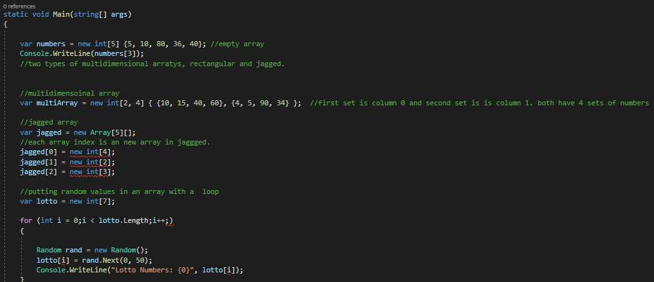

This is the arrays we covered in the class to help us learn how to set they up and how they function logically.

We moved on to dictionaries which can allow you to store data, an example of a dictionary we done in class.

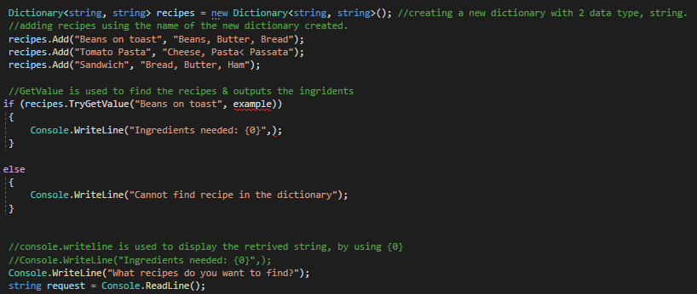

We done some basic data validation and error handling, in class and made an example

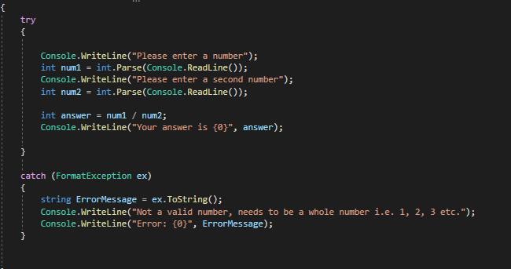

We used a try, catch to execute the code, and then catch any potential errors that many occur using exceptions and writing to a string so you can read the exception error.

I also learnt how to overload a variable

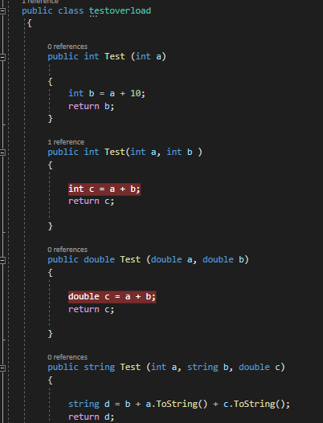

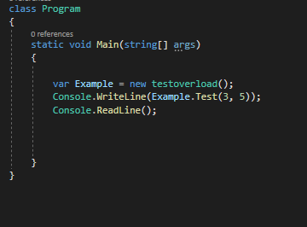

After everything I have learnt I have received coursework 1

This allowed me to learn many new things within C# especially enumeration which work well for a user type I found

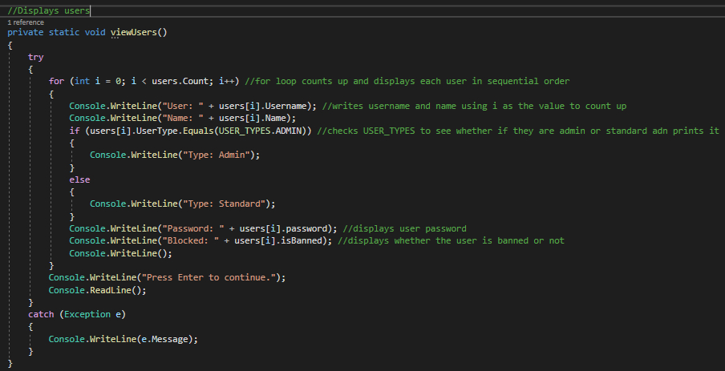

I did not use streamreader or streamwriter within this as I placed the user data within the login system.

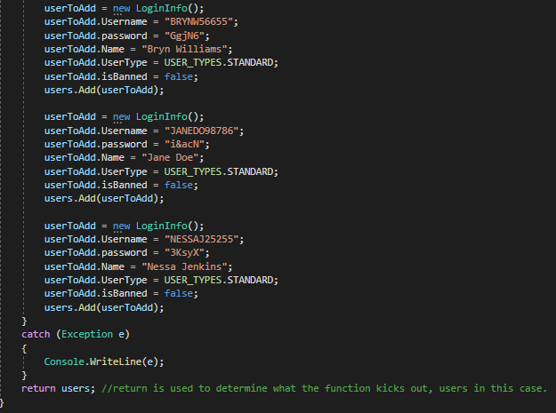

I periodically make notes within lessons when I am stuck on something or I want to learn it quicker

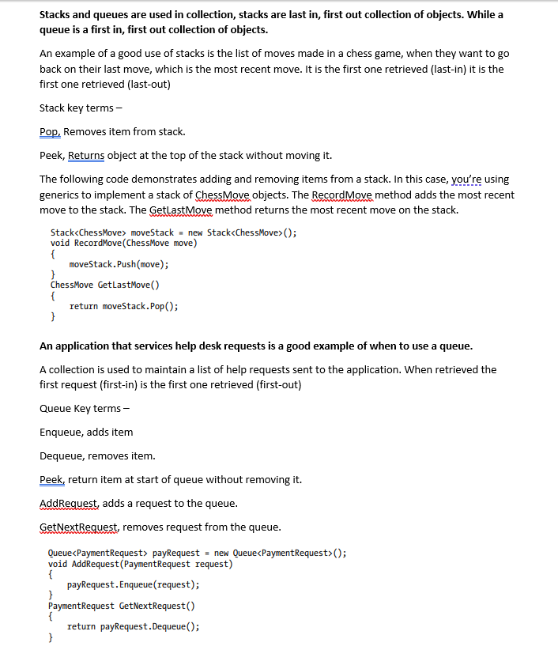

We have spent a lot of time learning theory and researching on how to do accurate diagrams however, it is something I need to keep trying as I struggle to think of all the possible components within the chosen diagrams.

In coursework 2 I have tried to create a solid use case and class diagram as you can see below

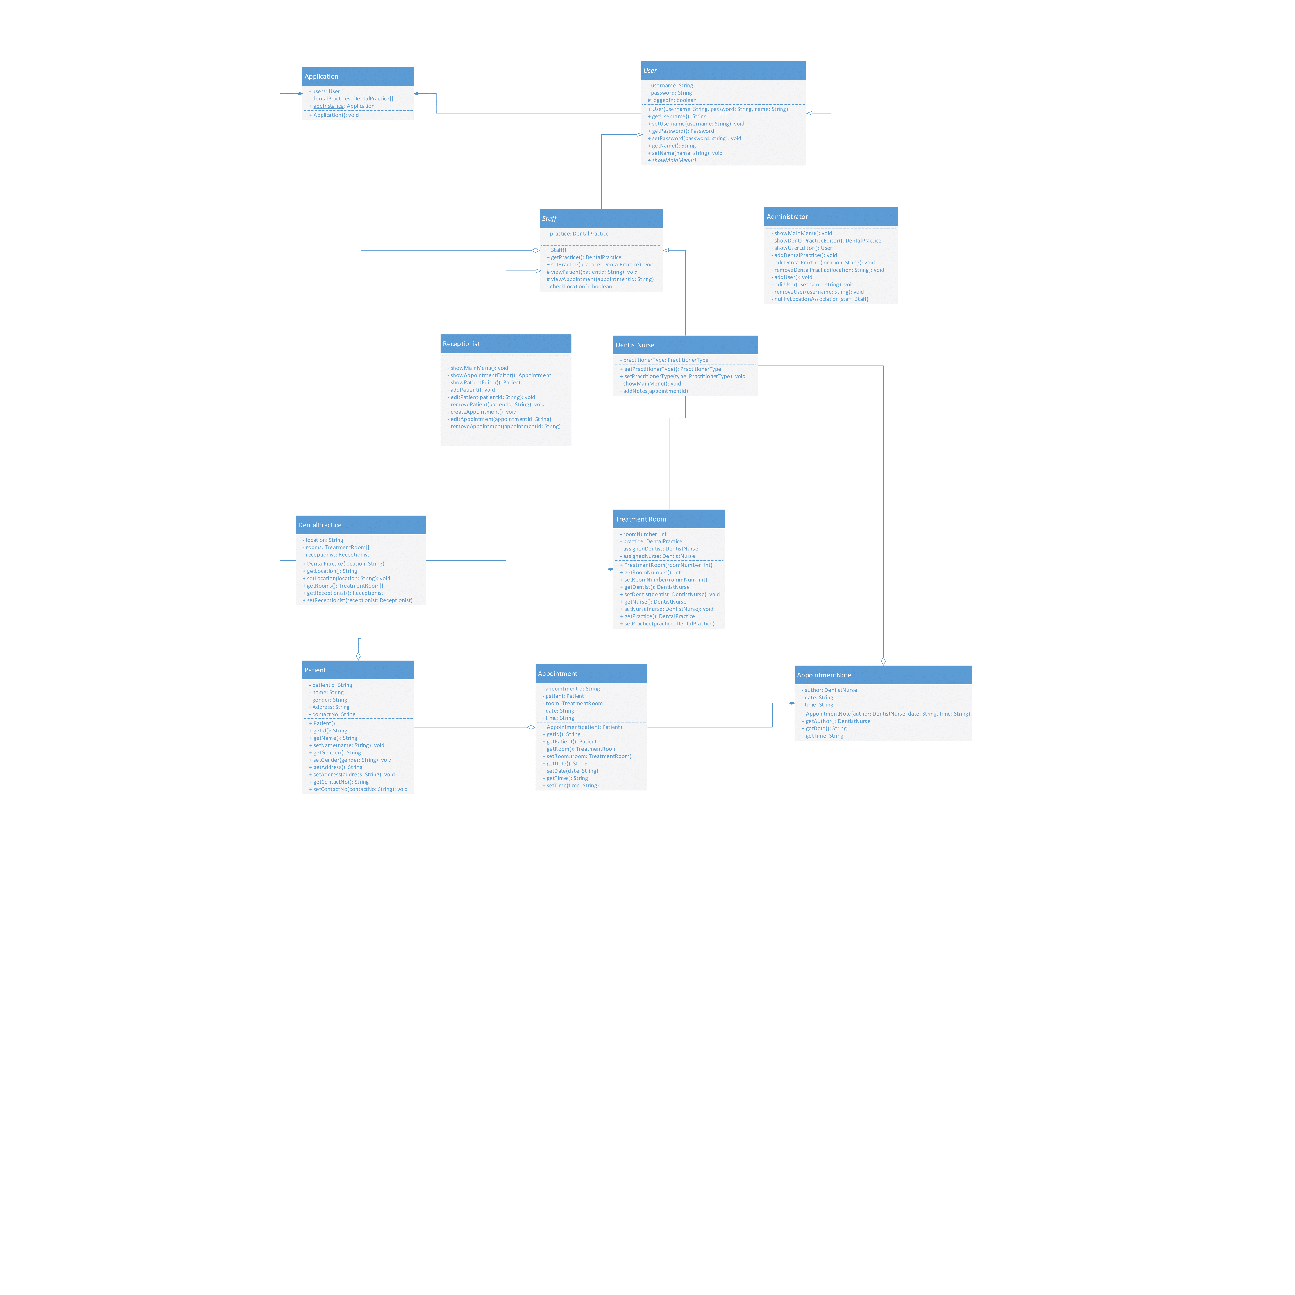

Class diagram from CW2

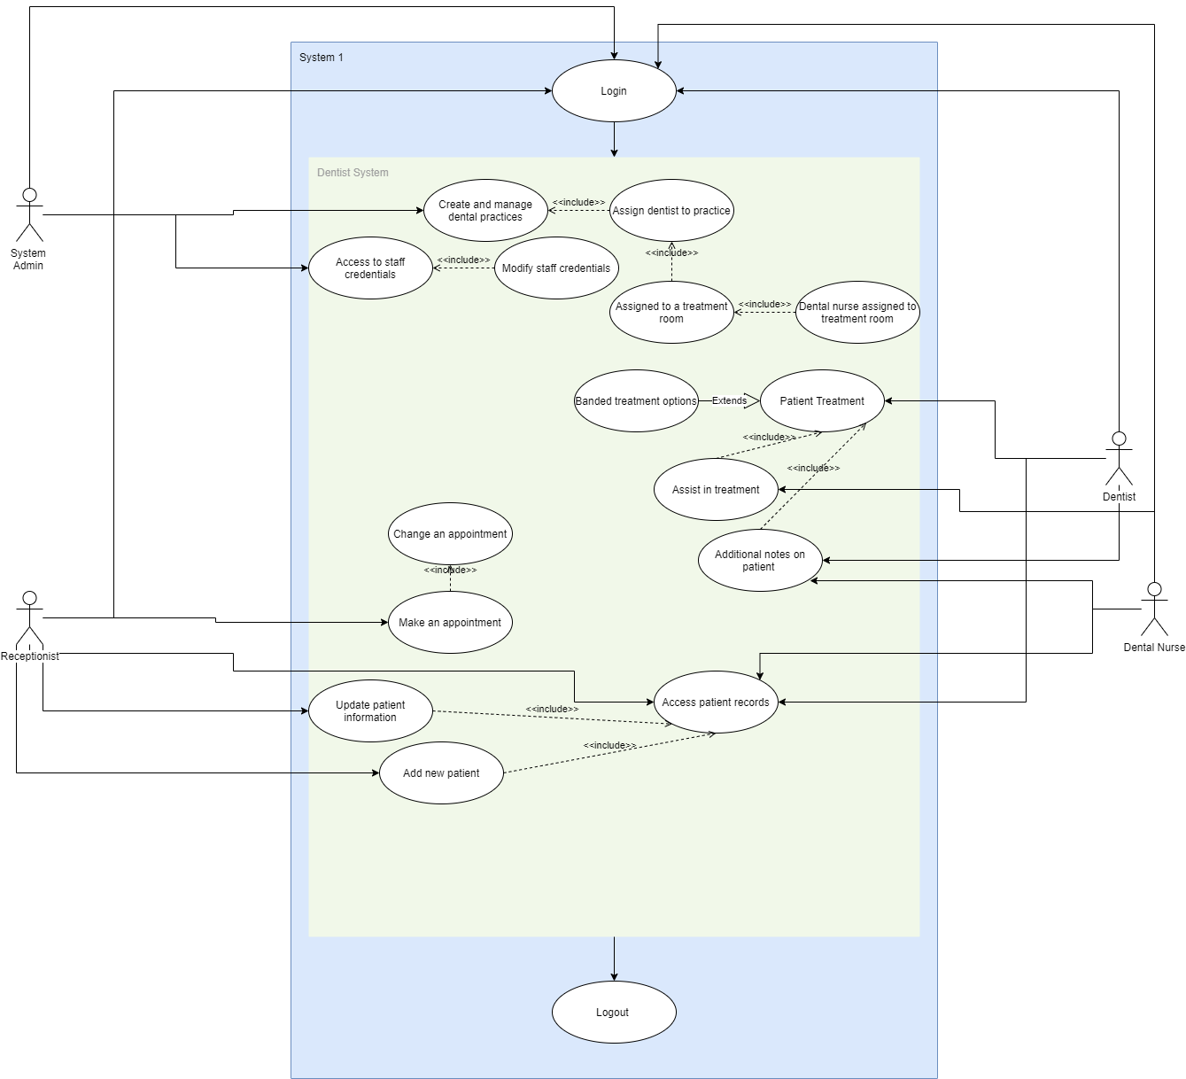

Use case diagram from CW2

I think I have improved greatly but could still improve more of both diagrams especially use case.

We missed a lot of lessons due to covid-19 which has hindered the learning other than self-learning.