SCDT42 Web Application Development

GitHub: <https://github.com/TobyBluck/SCDT42-Web_Application_Development>

In web development we have started learning HTML basics, learning the bare bones on how to make the skeleton of a website and do basic element manipulation to tags, such as increase font size and change colour based on keyword colour instead of hex.

I do have prior exposure to web development, so I am a bit more confident but it not something I thoroughly enjoy.

We have covered CSS and manipulation of elements through that which allows for a more diverse range of modification to the HTML elements. The best way Simon described it is, the HTML is the skeleton and the CSS is the skin to make it pretty, JavaScript is the stuff to make us function/move.

We have gone deeper into the HTML and CSS and building more intermediate skill for web development ready for our coursework 2.

Coursework one is released, in this we make plans for a local sports bar to rework their website and make improvements on it. We look at their overall business, their current website and propose recommendation based on out findings

Here is the presentation slide for the analysis of the allStars website.

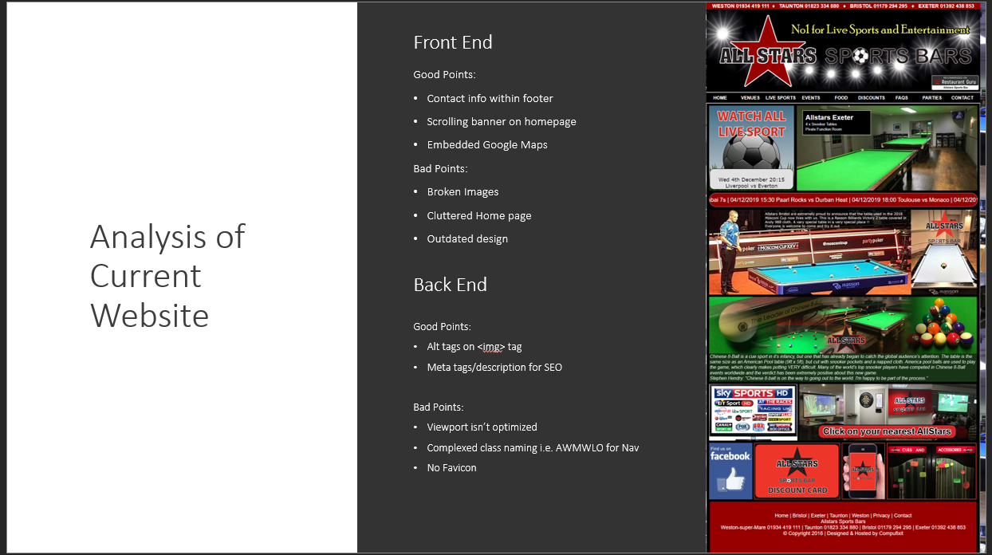

And the recommendation I thought would be applicable.

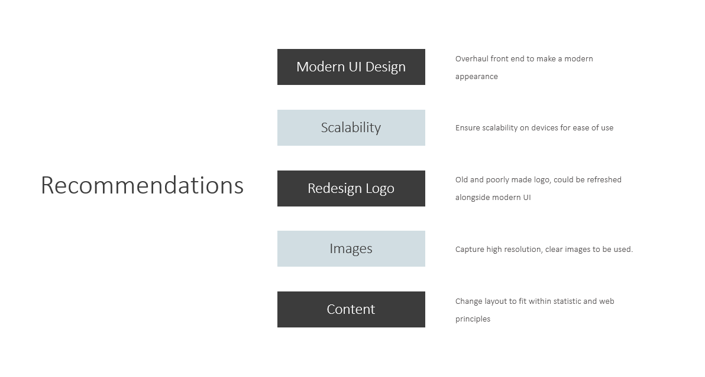

This is the notes on the analysis of the website

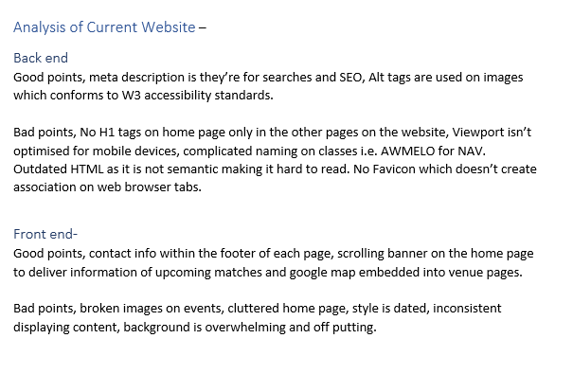

We are looking at more advance web design and the use of frameworks such as: Twitter Bootstrap and seeing how that can be implemented and utilised within a project to make it a mobile first development.

This is very beneficial to me as I find it easier to use bootstrap to assist in the development than I do starting from a blank slate.

We have also started to cover some PHP and made a basic contact form using PHP

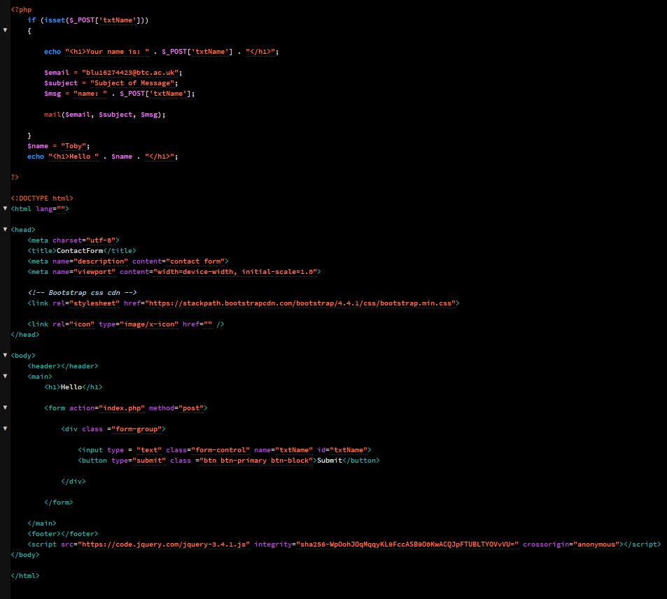

This also covered using jQuery but not using a file/s for it we used a CDN (Content delivery network) which means the files are hosted on a server and you access them as you would a if they were in the directory.

We have also done APIs in jQuery, for this we used a news API and we used it to insert articles into a set of HTML elements to get the top 10 news article within the UK.

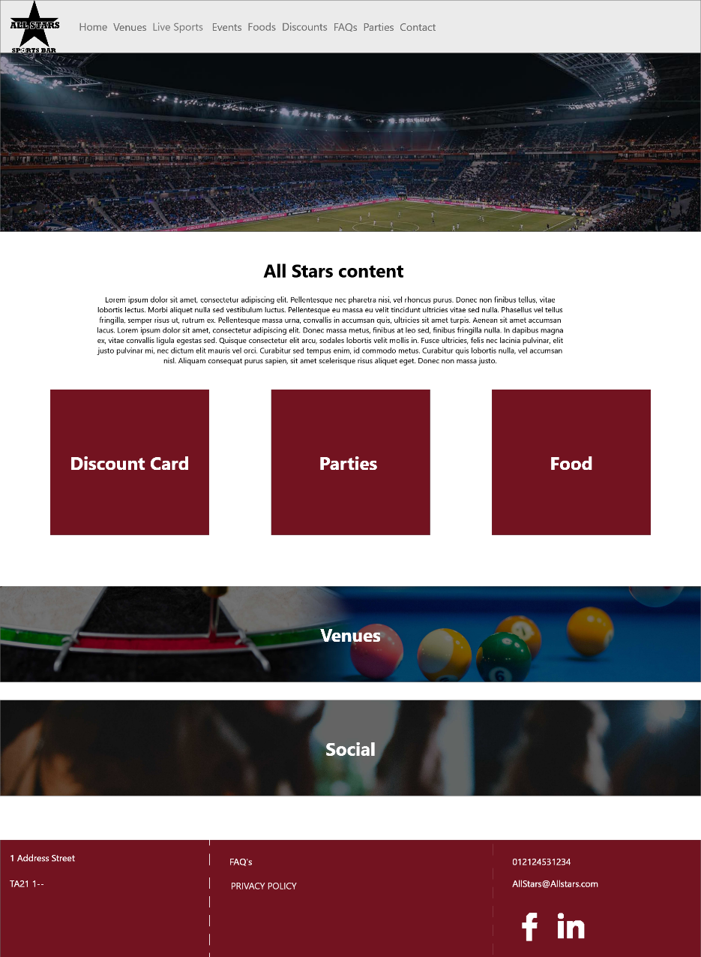

In coursework 2 I made high fidelity prototypes of the website and modelled the allStars website around these wireframe.

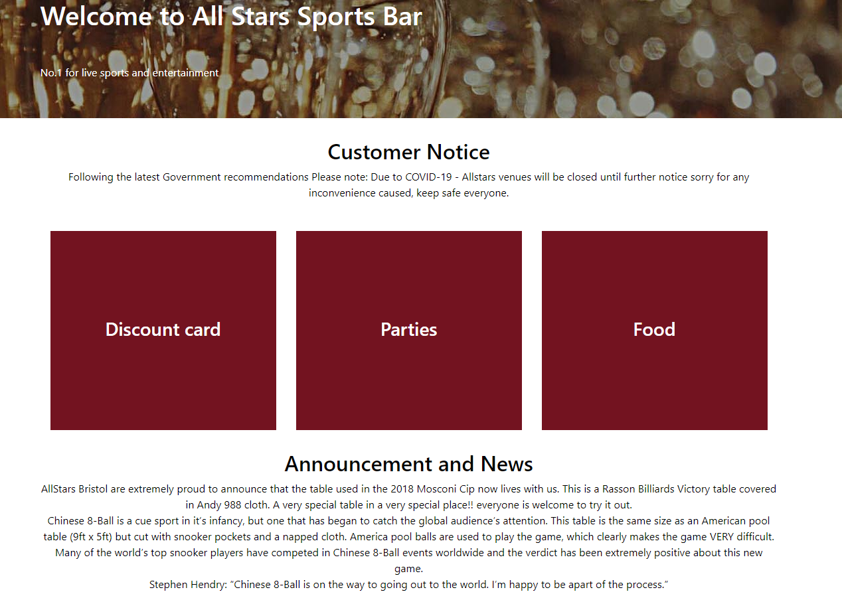

Actual website, although some design areas may change this is still as close to the wire frame as I could get it.

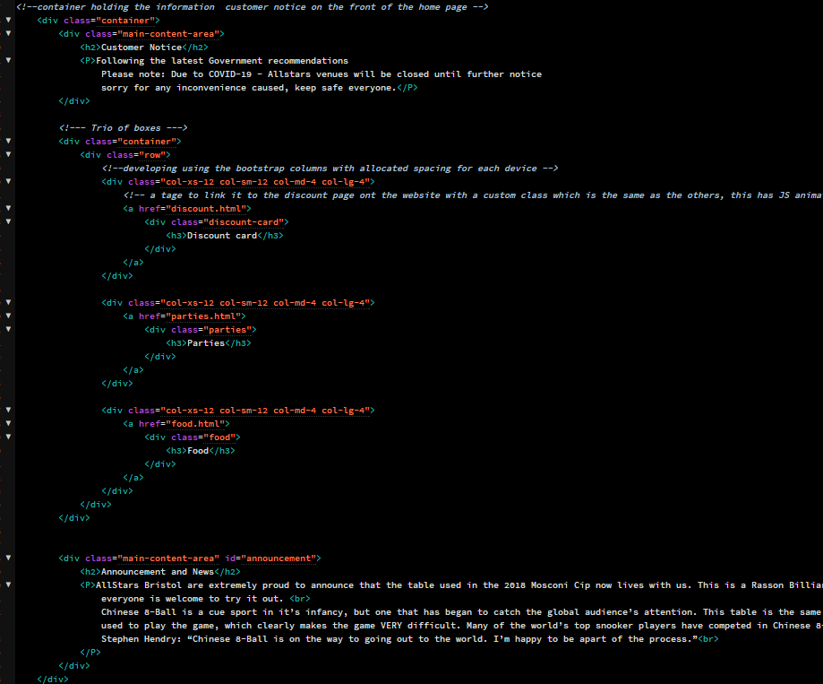

This uses a bootstrap framework to help achieve the scalability on all platforms.