SCDT43 Networking and Cyber Security Fundamentals

Github: <https://github.com/TobyBluck/SCDT43-Networking_and_CyberSecurity_Fundementals>

In this module it is looking at networking and security within networks, this also covers CCNA.

In the first few weeks of this module we have looked at the various types of networks that can be found throughout home, university, and larger companies.

A few of these are:

WLAN (Wireless Local Area Networks) this is limited to a smaller area, such as a house or large room.

WAN (Wide Area Network) Managed by ISP typically like, Virgin Media and BT.

Here are example network diagrams I made:

WAN

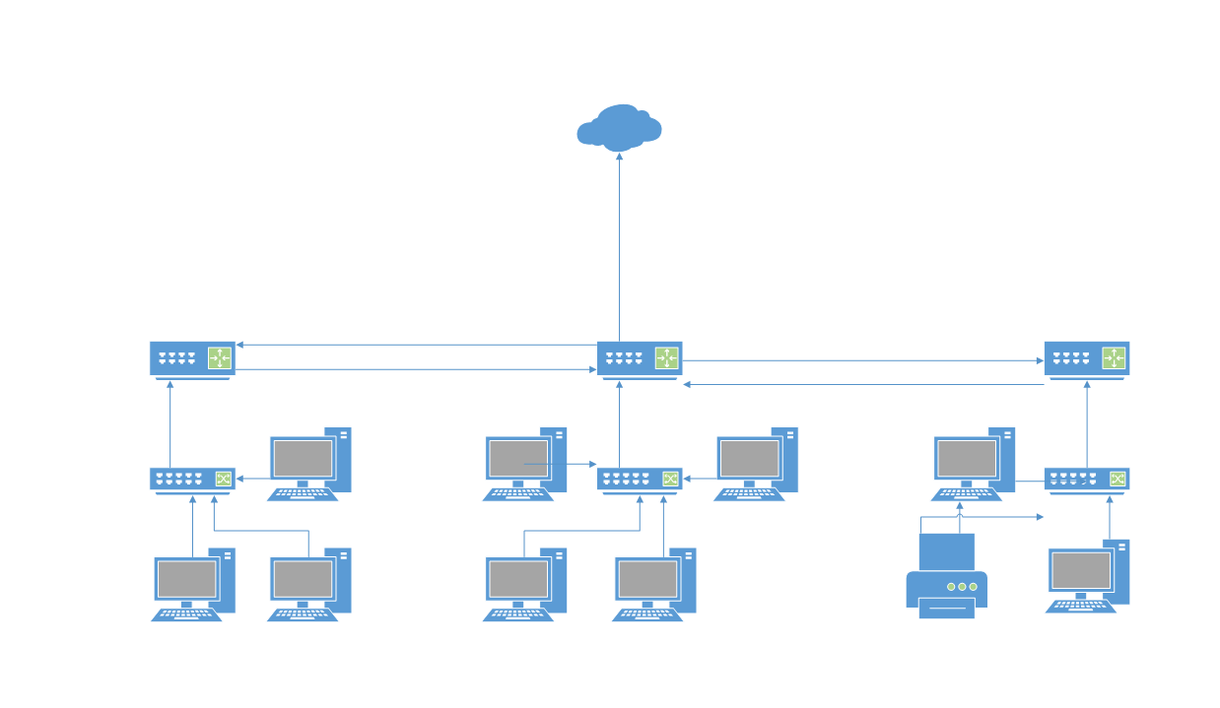

LAN

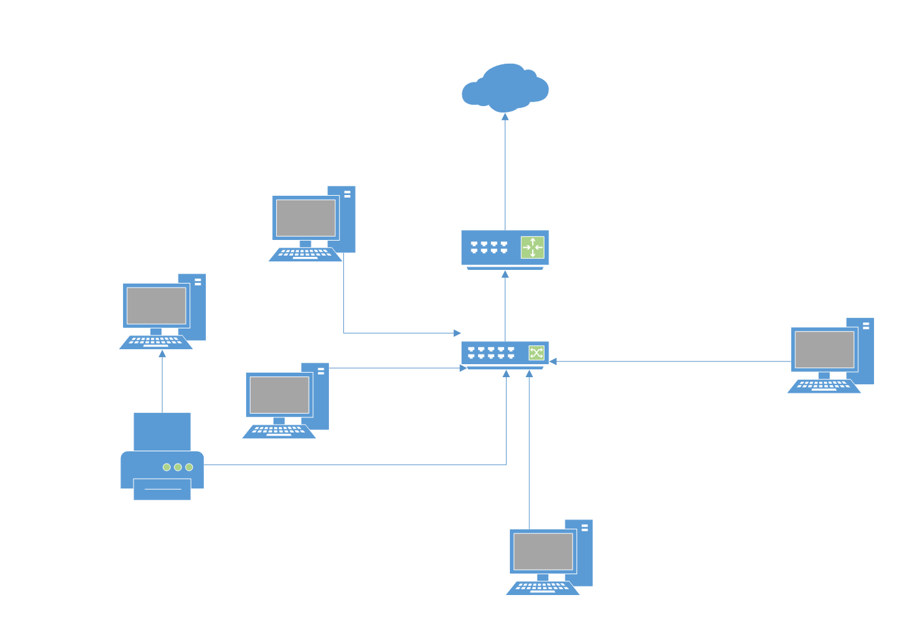

Learning about vulnerabilities business face when having a network, some of the dangers I have learnt during this time are misconfigured firewall ports allowing traffic that typically would be rejected.

User group having incorrect privileges on the network can cause issue when they are able to access files, they shouldn’t be able to and general viruses and trojans etc.

We have proceeded on to addressing within a network, this is mostly about IP (Internet Protocol) local IP addresses are typically similar to this 192.168.1.1x; the devices that typically require an IP to have functionality or have additional functionality.

We also learnt about the IP versions so IPv4 and IPv6, and the difference in how the address devices and the total unique combinations of address which I found thoroughly interesting but hard to comprehend when it comes to the amount of IPv6 total possible addresses. This is the total available IPv6 Addresses: 340,282,366,920,938,463,463,374,607,431,768,211,456

During this time, I have been working towards my CCNA and have been making networks ready for the coursework one

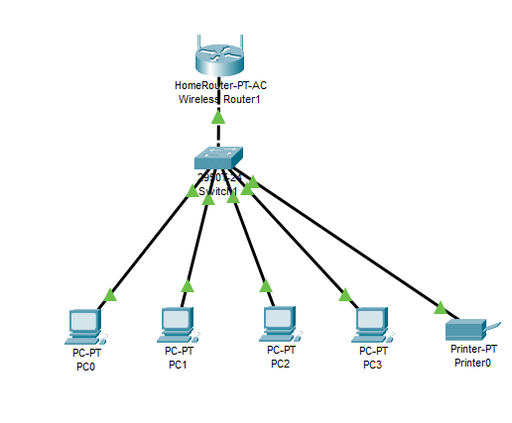

This is a basic LAN network which will be able to send packets of information to each other.

During this module on some topics I have struggled with I have produced notes to allow me to try and get a better grasp and to reiterate my knowledge to develop in the networking

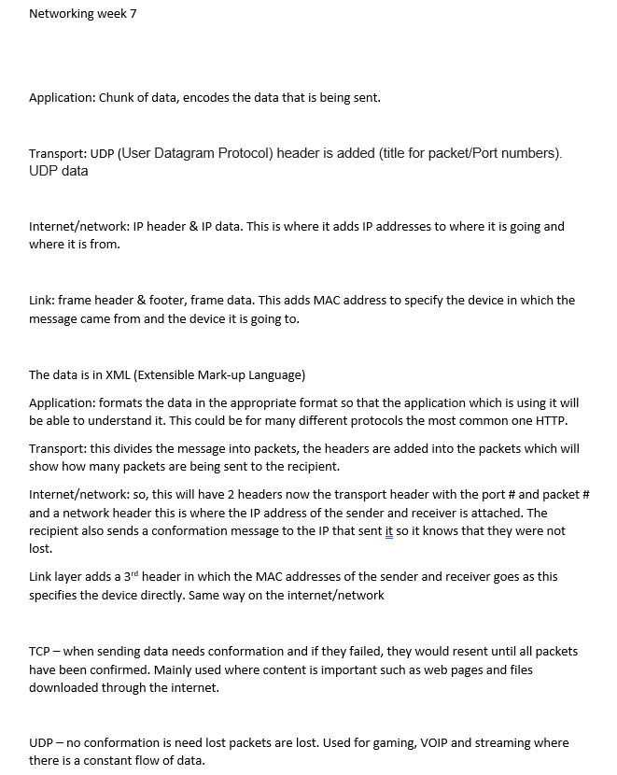

During this module we have also been learning about the Physical data links in networking, this is something I did struggle to understand but have got a better grasp after bens lessons.

We have also delved into the cable specifications for network such as fibre optic cable and what main 3 issues they have if anything arises, alongside the different specification of fibre cabling.

We also receive coursework one, which we made a packet tracer network which really helped with my overall knowledge and confidence using packet tracer as well diving into network architecture

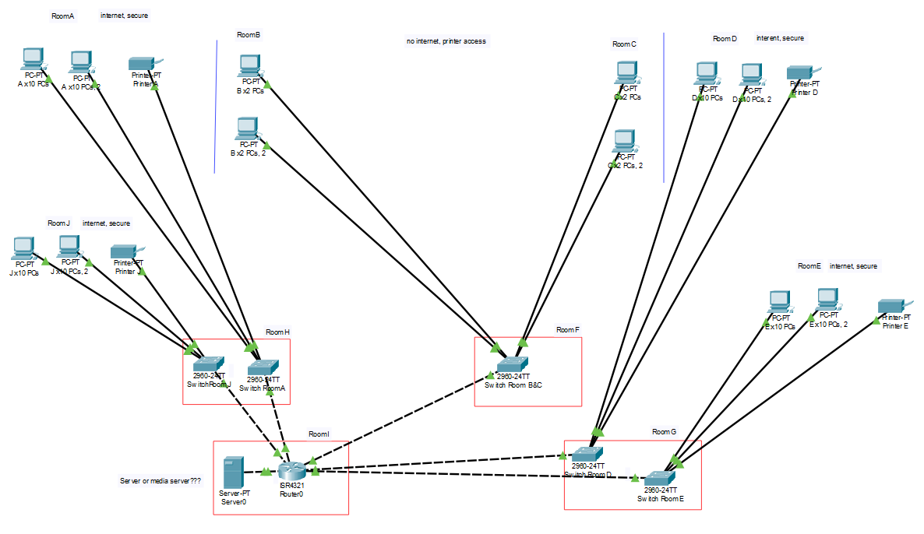

This is the packet tracer network I made based on the course work specification.

This is some written work from this assignment which demonstrates my knowledge of topology

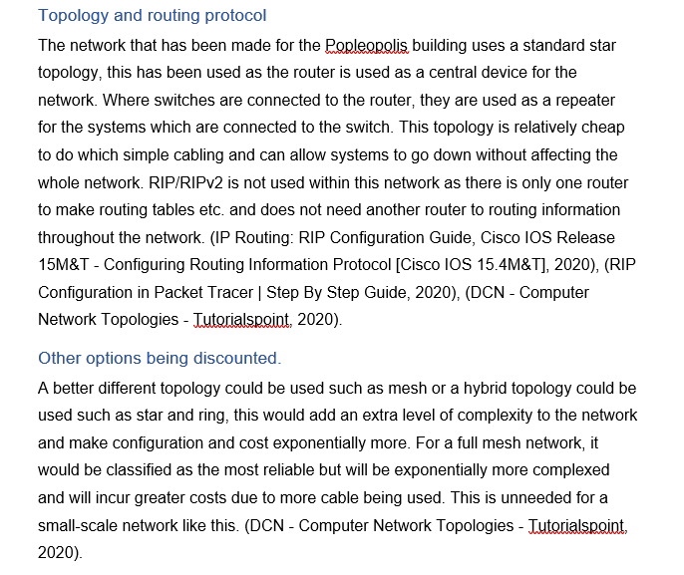

We have also covered routing protocol with this module this year. I tried to recreate in within packet tracer as a lesson task but I couldn’t achieve it.

We have also covered subnet masks, furthermore, we learn to apply AND logic to subnet masks and IP address to get the actual network address.

In coursework 2, you can see how I have developed and progressed within this module in terms of knowledge and presenting well formulated diagrams, although I could further improve in this module it was cut short due to covid-19.

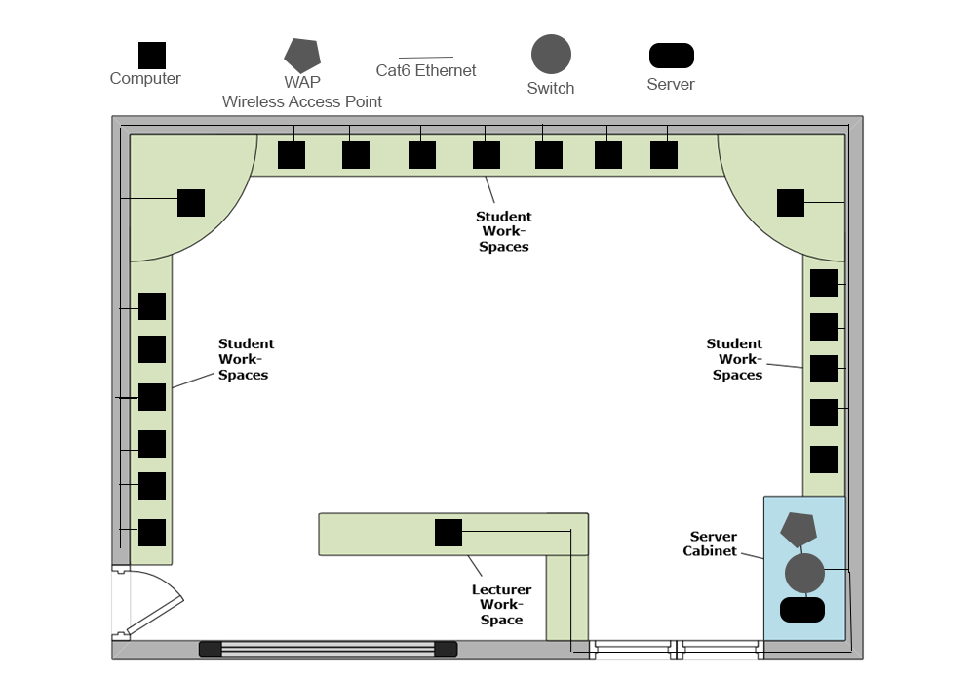

This diagram from coursework 2 is the layout plan of computers, cabling and switch, server, and wireless access point.

When made into a simpler format to demonstrate the topological design it would like this. w

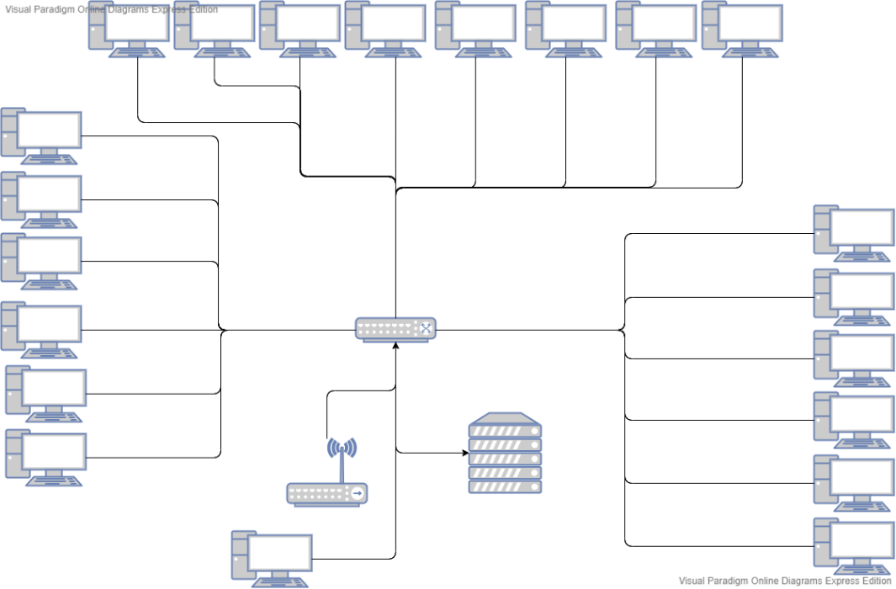

I also used packet tracer again to make a functional network based on these two diagrams.

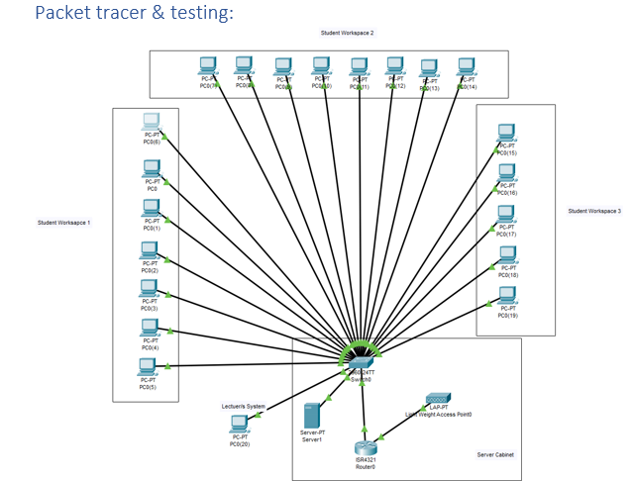

This had DHCP assigned address and was able to send an email from system to system.

The overall development of my writing between coursework 1 and coursework 2 has steadily improved in this module as you can see. 