SCDT45 – Module progression

Github: <https://github.com/TobyBluck/SCDT45-3D-Visualisation_and-_IntercationDesign>

Throughout the course of the year, in 3D interactive design we have covered a plethora of topics and learnt many skills using various software/s.

So far, we have primarily used Autodesk 3ds Max to create models and create UVW maps on them. Within 3ds Max we have used many different techniques to model land structures such as the London bridge.

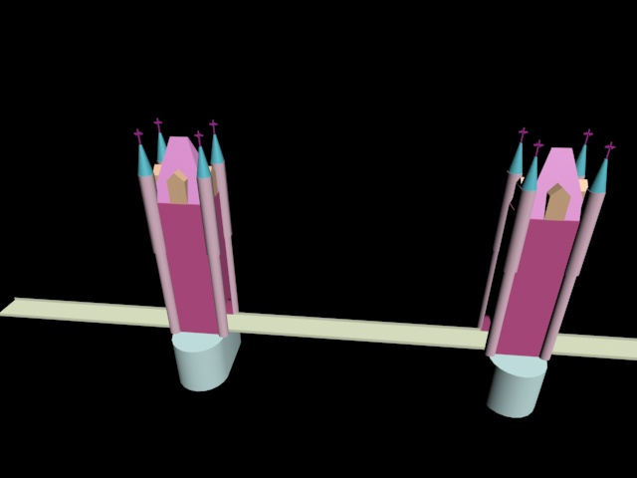

We have also made weapons

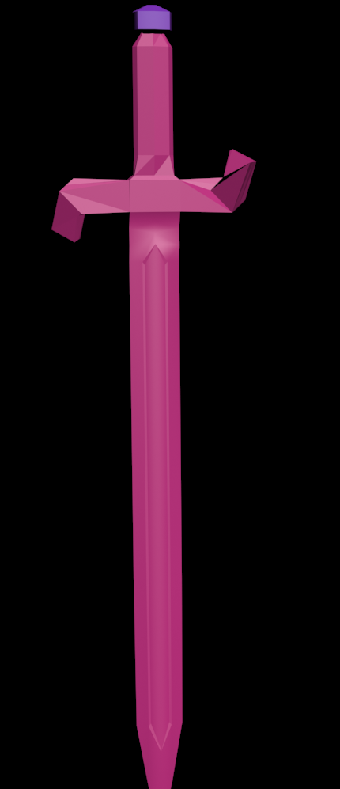

Create environment assets such as a wash basin and a few others different types of models.

Some modelling techniques we have covered are:

Box modelling this is one of the most basic way you can model, this is done by using a square or cylinder (primitive shape) and extruding and scaling the faces or polys of the object itself.

In class we covered spline modelling, the example we were given to complete was a cup, this is where we learnt more techniques to make a model look better and increase our efficiency. We used turbosmooth to make the sharp edges and the poly groups smooth around the model giving it a more round appearance, this could be done again to reiterate over it which dramatically increased the faces and load within the application.

Extrusion modelling , this can be used to duplicate the selected faces, or vertices on an object, this is what we used to create the Rubik’s cube, which we then added a chamfer to the edges to round them off slightly.

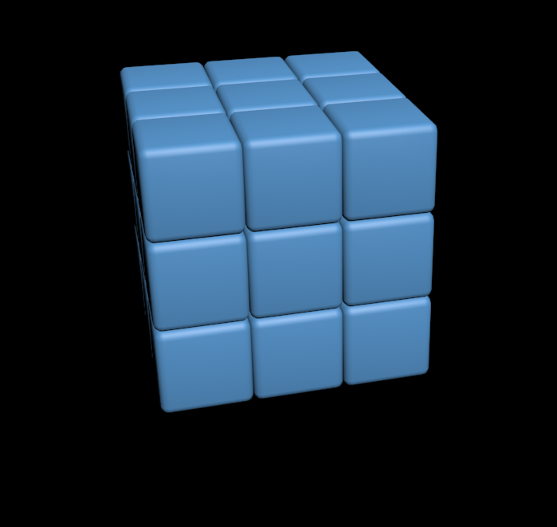

Other than practical work, we have done theory on interaction design and have been consistently reading from the Interaction Design 4th Edition which has helped us understand the reasoning behind decision regarding interaction to both virtual and real-life objects.

We have covered it to the extent of bringing forth emotions when users interact with objects, which will increase likeability towards the object is it arouses positive emotions.

We have also learnt about designing in general and how to elicit requirements from activities such as: interviews (closed or open), questionnaires and feedback. Furthermore, we have learnt about forms of prototyping designs which consists of low and high-fidelity design.

With the first coursework set for this module, we had to make low fidelity models and designs of an interactive 3D application. These are some examples of low fidelity models and interface designs.

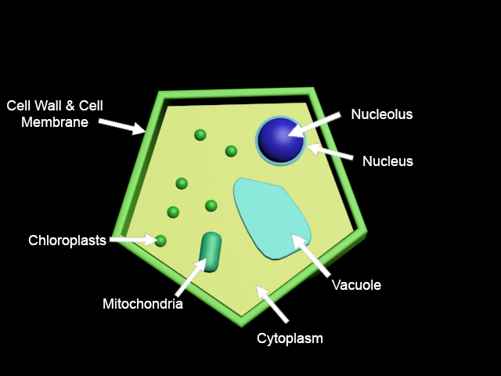

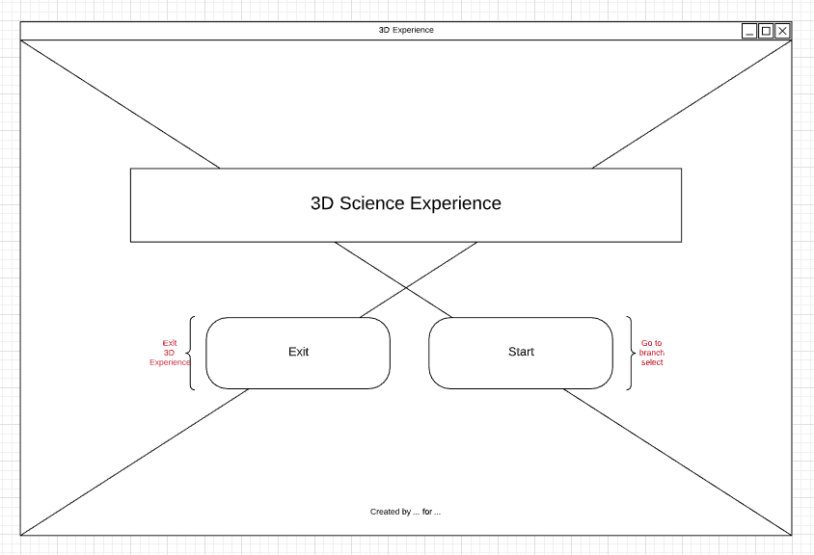

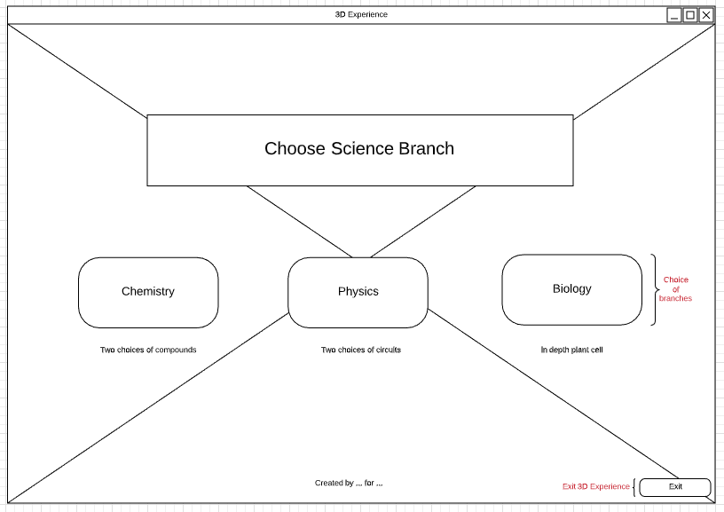

After this assignment, we have spent a considerable amount of time within unity getting a general grasp of the functioning and how to use the software ready for coursework2.

Areas we covered in unity within this module, is learning the layout of the unity interface and learning how to control the scene view and navigate around the application itself.

Creating environments and understanding how to manipulate the environment and adding assets into them and aligning them up to our in-game camera view.

Learning how to preform interactivity with objects within unity, this would be scripting for the rotating of a cube based on user keyboard input.

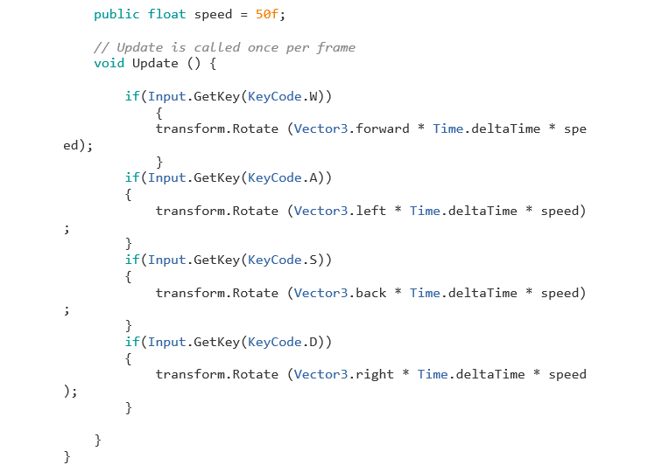

We have also learnt to make custom UIs within unity which is setting up canvases to show screens for buttons on the screen.

Another thing we learnt in unity is how to change the material of a game object based on a script and then creating a set of material to change based on key input.

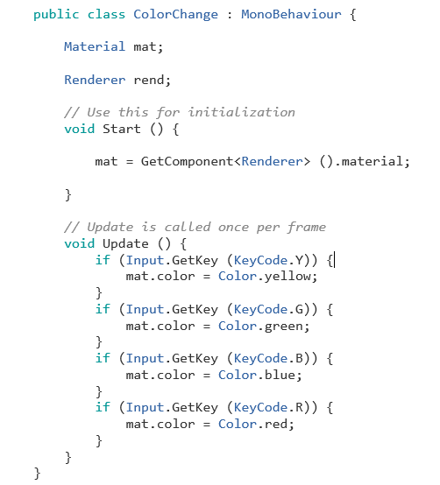

We also reviewed how to use the build setting to arrange a scene order which also correlates to the building and exporting of the unity project once complete and learning how to target the desired platform.

We got the coursework 2 as well which is making an 3D interactive app for secondary school students. This coursework has allowed me to apply the theory I have learnt throughout the year to elicit accurate and relevant requirements from the given scenario. 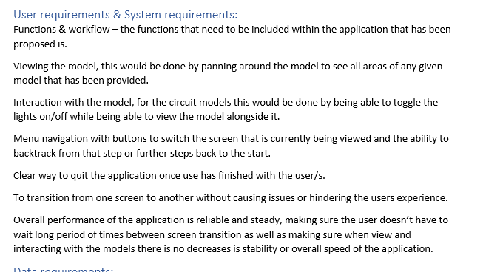

Due to covid-19 the module was closed early and coursework 2 was released, I spent some time on this and learnt many new things and picked up new software and experimented to see what I was comfortable with as I am still not overly confident in my 3D modelling skills which I need to improve on in time.

Furthermore, this course work has allowed to explore develop myself personally by challenging myself with new software to produce something desirable. In this I learnt a lot about unity and scripting, alongside picking up a material painter called Substance Painter.

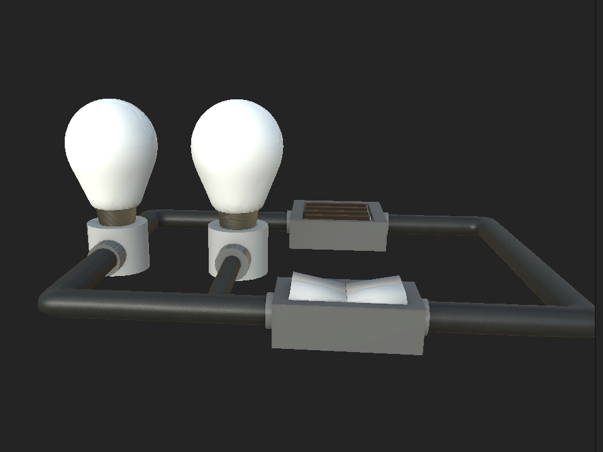

This is SP model window

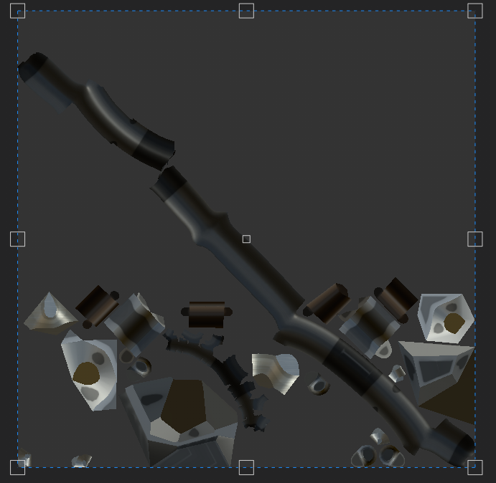

SP Maps

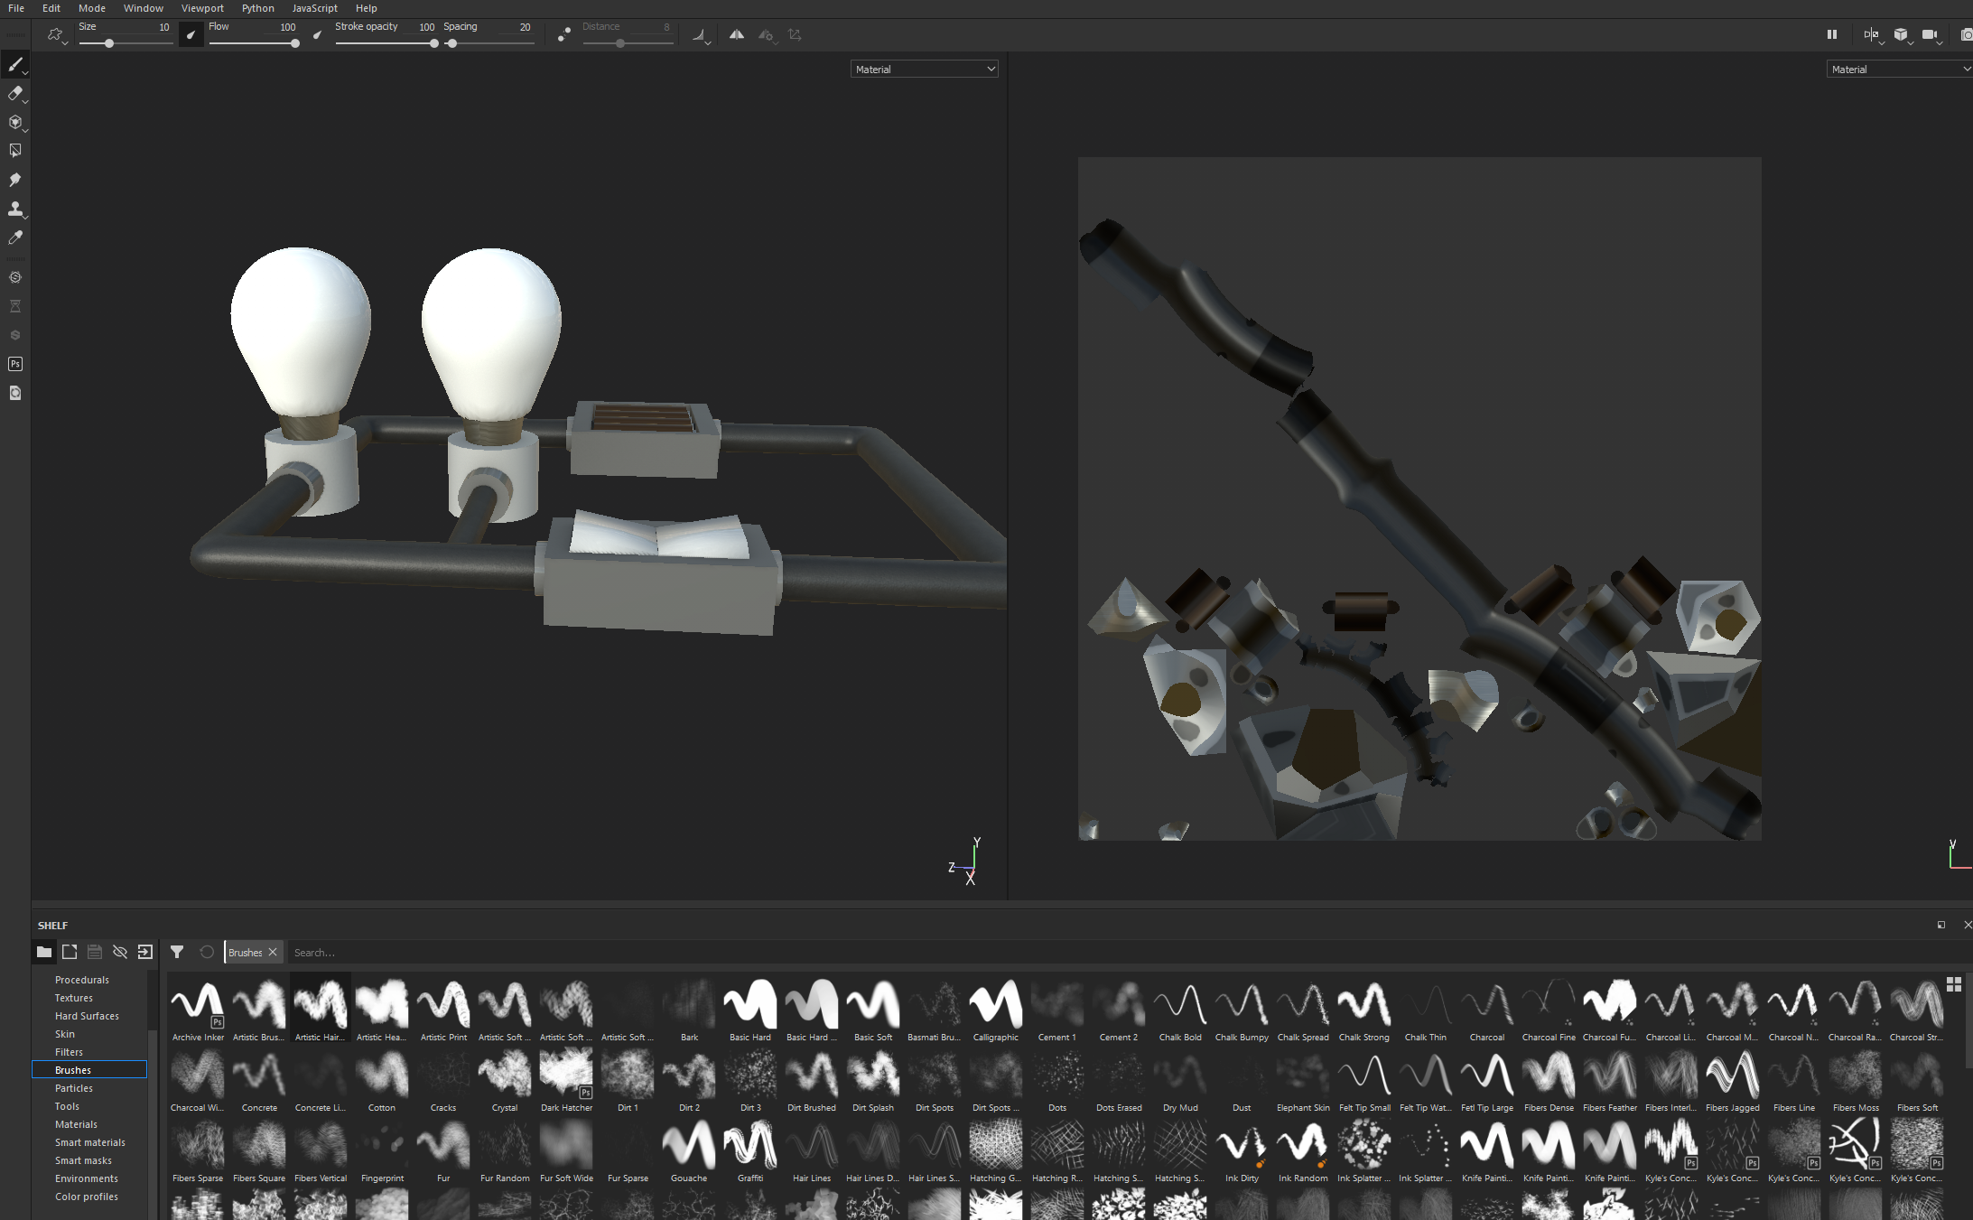

Picking this up during the coursework 2 has been very beneficial to my workflow as well as learning an industry standard tool, this does not work the best when exporting to unity, but it still retains decent quality. I would like to further my skills within this software as well progress though 3D interaction development.