Toby bluck

BLU16274423

2689 words

SCDT46 professional Skills

CW1

# Task 1:

## Framework:

### Scrum:

Overview- Scrum utilises Scrum teams, Scrum masters and the client to product iterations of the software. Scrum masters are used to oversee and to handle any issues within the project as well as communicate with the client. The scrum teams are used to do the development, testing and documentation. Sprint backlogs are used to define tasks for each sprint which varies from approximately 1 week up to 4 weeks, the backlog is derived from the product backlog requirements.

A daily scrum is carried out to check the progress of each task that is being worked on, after each sprint a sprint review occurs, these reviews allow for the client to see a increment of the software and can request alterations to it etc. (Srivastava et al., 2017), (State of Scrum 2017 - 2018, 2017)

#### Pros-

* Adaptability
* Strong control of schedule
* Estimates are easier to calculate
* Logical process of work

#### Cons-

* Drive for team members is highly important
* Little cooperation will cause problems within the project
* Little documentation

(Mahalakshm & Sundararajan, 2013)

How well does it work: a case study was carried out on why Scrum works, 1/3 out of 100 project managers in 2010 have used Scrum. It points to the following: distributing the work within the team, meeting structure allows for communication within the team and allows for a fast and easy to track progress within the project.

### Feature Driven Development (FDD):

Overview- This is like Scrum due to iterations and the frequency of releases; however, clients attend initial planning/design meeting and iteration releases.

FDD has a base set of 8 best practices used to develop.

Domain Object Modelling, Developing by feature, Features are small, Feature are client-valued, Class (code) ownership, Feature teams, Inspections, Regular build schedule, Configuration management, Visible results/reporting progress

When using a large team for a large product it follows 5 steps to utilise all the roles to create an outstanding product.

Develop the overall model, documentation for the problems for the software to solve for the client, scope and context with the system and domain model.

Features lists, identifying features based on client importance.

Plan by feature, sort the features by evaluating any issues, risks associated and work amount, followed by assigning features to teams and individuals within the teams.

Design by feature, a design review is typically made, and the chief developer/programmer prioritises the features for development and oversees them in the iterations.

Build by feature, everything required for features to function are implemented and reviewed and tested, if completed moves on to being implemented in the build for the clients.

(What is feature-driven development (FDD)? - Definition from WhatIs.com, n.d.), (Palmer & Felsing, 2002 pg. 36-54)

#### Pros-

* Strong understanding of scope
* Excellent for large scale projects
* Features are chunked into regular releases

#### Cons-

* Little to no documentation to clients
* Relies on lead programmer highly
* Doesn’t work well for smaller projects

(Why (and How) You Should Use Feature-Driven Development, 2020)

### Extreme Programming (XP):

Overview- an agile framework where its design to be specific in design and execution, this allows for a high standard. XP focuses on 5 values when developing: Communication – focuses on the transfer of information from team members, Simplicity – this aims to focus on the outlined requirements made, while trying to keep the software as effortless to maintain and modify, Feedback – focuses from the clients regular feedback which allows for the team to work on any outlined issues, Courage - to address any issues within the team, development methods which are non-functional and moving to a different method, taking feedback and working with it and Respect – to respect all the team members as equals. (What is Extreme Programming (XP)?, n.d.)

#### Pros-

* Strong contact with client/s
* Continual testing allows for stable software
* Allows for changes to be made with little notice

#### Cons-

* Cost are likely high
* Time investment is very high
* High client interaction

(Extreme Programming, 2019)

How well XP works: a case study was carried out following a development team within an airline company to test the effectiveness/efficiency of XP. Previous projects were then compared projects using XP and the statistic shown an approximate total of 50% productivity improvement, 65% quality increase in pre-release and 35% post-release. (Layman et al., n.d.)

## Management tools:

### Trello:

Overview- Project planning software which allows for the use of boards for a project, lists are then used to organise the project into stages which stores cards. Cards are the main use, which can be used to breakdown tasks in a project or add ideas into an existing project with a comment/s attached to cards to further breakdown potential tasks, real-time notifications and checklists can be added within Trello for additional functionality or tracking of project progression. (Trello 101 | Getting Started with Trello, n.d.), (Trello Tour, n.d.)

#### Pros-

* Simplicity of usability
* Real-time updates
* Uses principles from the Kanban system

#### Cons-

* Lacks for larger projects
* No Gannt charts
* Paid extras for extended functionality

(Hall, 2016)

A paper was made, analysing a selection of near 85 thousand tweets on project management tools used within companies. This occurred autumn 2014 to spring 2015, the results concluded that Trello was tweeted most approximately receiving 19 thousand tweets. It demonstrates that it is the most popular project management tool, even though a small scope on a social media site. (Matta & Marchesi, 2015)

### JIRA:

Overview- JIRA is a collection of software, this is used for project and software management, which is used commonly in agile teams. This supports MySQL, Oracle, GIT etc. Overall, this software is used for: bugs & issues tracking, help support i.e. ticket creation and resolution, project management, task creation and tracking, process and workflow management. (Jira | Issue & Project Tracking Software | Atlassian, n.d.)

#### Pros-

* Good for agile methodologies
* Extremely customisable
* Works for all users within a project

#### Cons-

* Complexed UI
* Limited file upload size
* Complex migration from different applications to JIRA

(Santos, 2019)

A study into project management tools/software was carried in which it a case study of a company in which used JIRA to manage projects and development of software. The overall conclusion was that it JIRA was able to check all the requirements needed of typical project management with tools and functionality from start to finish to assist and manage the project effectively. (Hoang & Shrestha, 2014)

### Azure DevOps:

Overview- DevOps is a combination of development and operations which allows for a better collaboration between teams to improve the overall product made. Azure DevOps is typically know as a DaaS (DevOps as a Service) which is feature rich, it allows for web portals to be used, team members which can have access levels or permissions set to them etc. workflow features storyboards or backlogs to be made and feedback on work through requests. Allows for the tracking of bugs and features within a project. VCS for code and building of a project which can have a graph display or summary. Automation of deployments and release logs alongside testing including unit testing. Overwhelming choice of customisation for any project, which allows for onsite and offsite access as well. Support ALM extremely well. (What is DevOps? DevOps explained | Microsoft Azure, 2020), (Feature overview for Azure DevOps - Azure DevOps, 2019)

#### Pros-

* Ease of collaboration through use of the cloud.
* Excellent and quick deployment and testing of a product. Partly due to automation.
* High quality control and good documentation of the product as teams will use the same data set.

#### Cons-

* Overall security when using it as a cloud-based system.
* Good knowledge on software development to make sure integration through the modules is correctly done.
* Number of features provided may not be fully utilised as it could be confusing for the teams.

(Korkishko, 2018), (Fedak, 2018)

# Task 2:

## Project management and scale of business analysis:

project management is the collective of knowledge, skills, methods and experiences to accurately achieve a set of defined objectives that are within a budget and time constraint to manage and create a deliverable product to a client. Project management is normally broken up into 5 steps: Initiating identifies client wants and needs and setting a time and budget. Planning utilises information to create a plan for the deliverable product with a defined timescale. Execution/development initiates development to be made in a time frame alongside necessary documentation. Control and monitoring happen early on till the end of the project or time constraints and budgets do not get overrun and controlling any issues or risk associated with the project. Closing/closure is the final check and approval of the project alongside delivering of the product to the client. (What is Project Management?, n.d.), (What is project management?, n.d.)

## Good project management:

in regards to good project management there is many factors: Proven methods, techniques and tools which allows for a solid robust deliverable but also allows for flexibility due to risks, Effective command where leadership is able to cope with responsibilities and liaising with all people involved to reduce miscommunication, Planning and review on project is imperative to make sure realistic timeframes are set, regular monitoring during the project for risk management and review after completion. (Datz, 1977), (Conditions for Project Success, 2020)

## Bad project management:

Bad project management could be due to the PM (project manager) or aspects within the project not being defined or completed at all or incorrectly. Failure to identify changes in processes or requirements can cause large issues with the project or development. PM does not sustain good relations with stakeholders/clients can cause issues. in a report by IBM over 65% of project failure was due to poor project management. (Abbasi et al., 2014), (Rongala, 2016)

## Scale of business analysis:

Business analysis is comprised of typically 7 steps although it can be less or more:

Get acclimatised, prepared and take your time to understand the project

Identify business objectives/requirements, find why the clients wants it and how to make objectives/requirements clear.

Analysis, using the information gathered to structure it by requirement modelling and/or data modelling

Any additional specifications, this add detail to the collected requirements i.e. priority of each requirements and difficulty involved in implementation of requirement.

Documentation, clear to read, minimal use of complexed technical terms and use of graphics will greatly benefit for all involved.

Management and validation checking validate and the monitoring of requirements.

Management of changes, the monitoring of changes throughout the project.

(Business analysis process guide in 7 stages | BAjobs.ca, n.d.), (Brandenburg, n.d.)

### Mobile app:

With the mobile app for the hairdressers it is somewhat a small-scale project as it is a local company opposed to national level. An unstructured interview would be best to generalise the ideas, ideals and problems of the hairdresser and what they want, a structured interview should be used with prepared questions able to elicit requirements from the client. These should be documented and should be relatively in-depth. Furthermore, prototyping an app would be necessary to demonstrate the app in general context which would help the client to further add input to add additional requirements until enough information has been gathered to form a set of imperative requirements. (Nagar, 2015)

### Shopping platform:

The shopping platform is a large-scale project due to it being a national retailer, an observation of multiple stores could be done to see what people purchase or the demographic as well as the current system to gather requirements. Document analysis could then be conducted after observing the current system to view the functionality and requirements that were originally proposed. A structured interview could then be made to develop on the information gathered from the observation and document analysis this will help create more concrete requirements alongside prioritise most important ones. After all information and requirements have been gathered, a prototype mock-up can be developed to show overall workings of the platform and functionality to then gather more input and adjust or add any new requirements elicited. (Nagar, 2015)

## Methods/software & techniques for project management:

Project management methods: many methodologies can be used such as agile, lean or waterfall. Two most notorious methods are PMBOK and PRINCE2. PRINCE2 (PRojects IN Controlled Environments) focuses on organisation of the project from start to end while PMI’s PMNOK (Project Management Book Of Knowledge) focuses on creating a structured approach for analysing and scheduling for a project. (What is PMBOK in Project Management?, n.d.), (PMI PMBOK® Guide Method, n.d.), (PRINCE2 Methodology, 2020), (What Is PRINCE2 Methodology?, n.d.)

Project management techniques: PERT (Performance Evaluation and Review Techniques) is used as a graphical representation to break down which shows a timeline which allows for individual task to be mapped and analysed. (Izanhour, 1982)

Project management software: trello, JIRA or Azure DevOps would be one of the best project management software which have been previously mentioned.

# Recommend and justify a suitable software development methodology:

## Mobile app-:

Methods: Scrum would be the best method to develop this application.

* Analysis: communication driven meaning interview are highly sought to gather requirements, changing of requirements through iterations is rapidly adapted.
* Design: prototyping and initial design wireframes will be made in a weekly sprint which will be delivered allowing for clients to make changed before full development occurs to solidify important requirements and prioritise them.
* Development: Sprints up to 2 weeks will focus on small iterative build of the mobile app allowing for constant communication and changes to be rapidly adapted with regular feedback
* Testing: daily sprint meets will focus on testing and a sprint will occur to test and unit test application which will then focus on fixing it in the next sprint.
* Evaluation: scrum is a solid agile framework, due to the high iterations it would be more suitable for the local hairdresser as they can see on a bi-weekly basis the progress and be actively involved to get the desired app they need. All client’s requirements will be met due to regular communication and can be adapted to fit their needs.

(Correa, n.d.)

### Software:

Project management: JIRA would be optimal for this project as it well rounded for agile development, this includes the use of scrum boards, backlog creation and version management for Scrum. Furthermore, the use of reports can be used after each iteration release to the client to gain feedback and track new features or requirements needed. (Agile tools for software teams - Jira Software | Atlassian, n.d.

Development: Visual Studio would be best suited for this project as during development the use of Hyper-V would allow you to emulate an Android device to test functionality etc. furthermore, the support of multiple languages allows for a simpler development and can work in conjunction with Unity. This is the robust development software which has high amount of documentation alongside it. (Studio, n.d.)

Techniques: SWOT can be used to find the threats lingering throughout the project and opportunities that may arise from it. A Gantt chart allows for the schedule of the project to be planned and displayed with clear time frames. (Programme and project management tools and techniques | Department of Finance, n.d.)

## Shopping Platform:

Methods: FDD would be most applicable as this would be a large-scale project which would have a plethora of features.

* Analysis: once the initial requirement gathering from the business analysis is done the requirements can be used within the domain object model to further identify what features are to be made from the requirements. Sequence diagrams are then made and developing by feature is carried out by using all information and prioritising the features required most suitable for the requirements. Without this, the significant and insignificant feature will not be clearly stated which could hinder the communication between development.
* Design: is a stage in which FDD focuses on making all features small and timely and focuses on the impact they will have towards a client. This is important for the shopping platform as the core functionality will be composed of a multitude of features which would have the largest impact on the company. All features will be put in English so that the retailer will be able to understand all features and add or alter them which greatly benefits information exchange.
* Development: ownership of code and classes ensure that a clean development and everything function correctly within it, these developers belong in feature team where they specifically focus on a set few features and make them as robust and stable as possible which is imperative for the retailer as it would have high amounts of traffic meaning it needs to be extremely stable.
* Testing: as features are developed individually, they can test them individually for functionality so any alteration can be made if functionality isn’t as desired. As well as testing when the features are added to the main build which will further highlight any issues and make it wholly robust for the retailer.
* Evaluation: overall the suitability of FDD for the shopping platform is excellent as the retailer is a large-scale company and would have a large amount within their platform which benefits the overall methodology of FDD. The retailer would be able to see each feature in the preview build and test the it to see if the features meet expectation or requirements recorded.
* (Palmer & Felsing, 2002 pg. 36-54)

### Software:

Project management: Azure DevOps would be suitable used due to cloud for large teams to collaborate easily and VCS with Git, team dash boards helps the organisation of all teams. (Feature overview for Azure DevOps - Azure DevOps, 2019)

Development: Visual Studio live share to actively collaboration for the development of features with feature teams, PerfTips to actively manage the efficiency of the software. (Feature overview for Azure DevOps - Azure DevOps, 2019)

Techniques: RACI (Responsibility, Accountability, Consulted, Informed) creates a table of roles and tasks and assigns them a corresponding letter (R, A, C, I) on the task to the role which outlines who does that task, those that are accountable for the task, who was asked for info etc, who are informed on progression. (Programme and project management tools and techniques | Department of Finance, n.d.)

## Gantt Chart plan w/ pdf download:

(Phases and processes in Scrum project| SCRUMstudy, n.d.), (Coad et al., 1999, pg. 185-196)





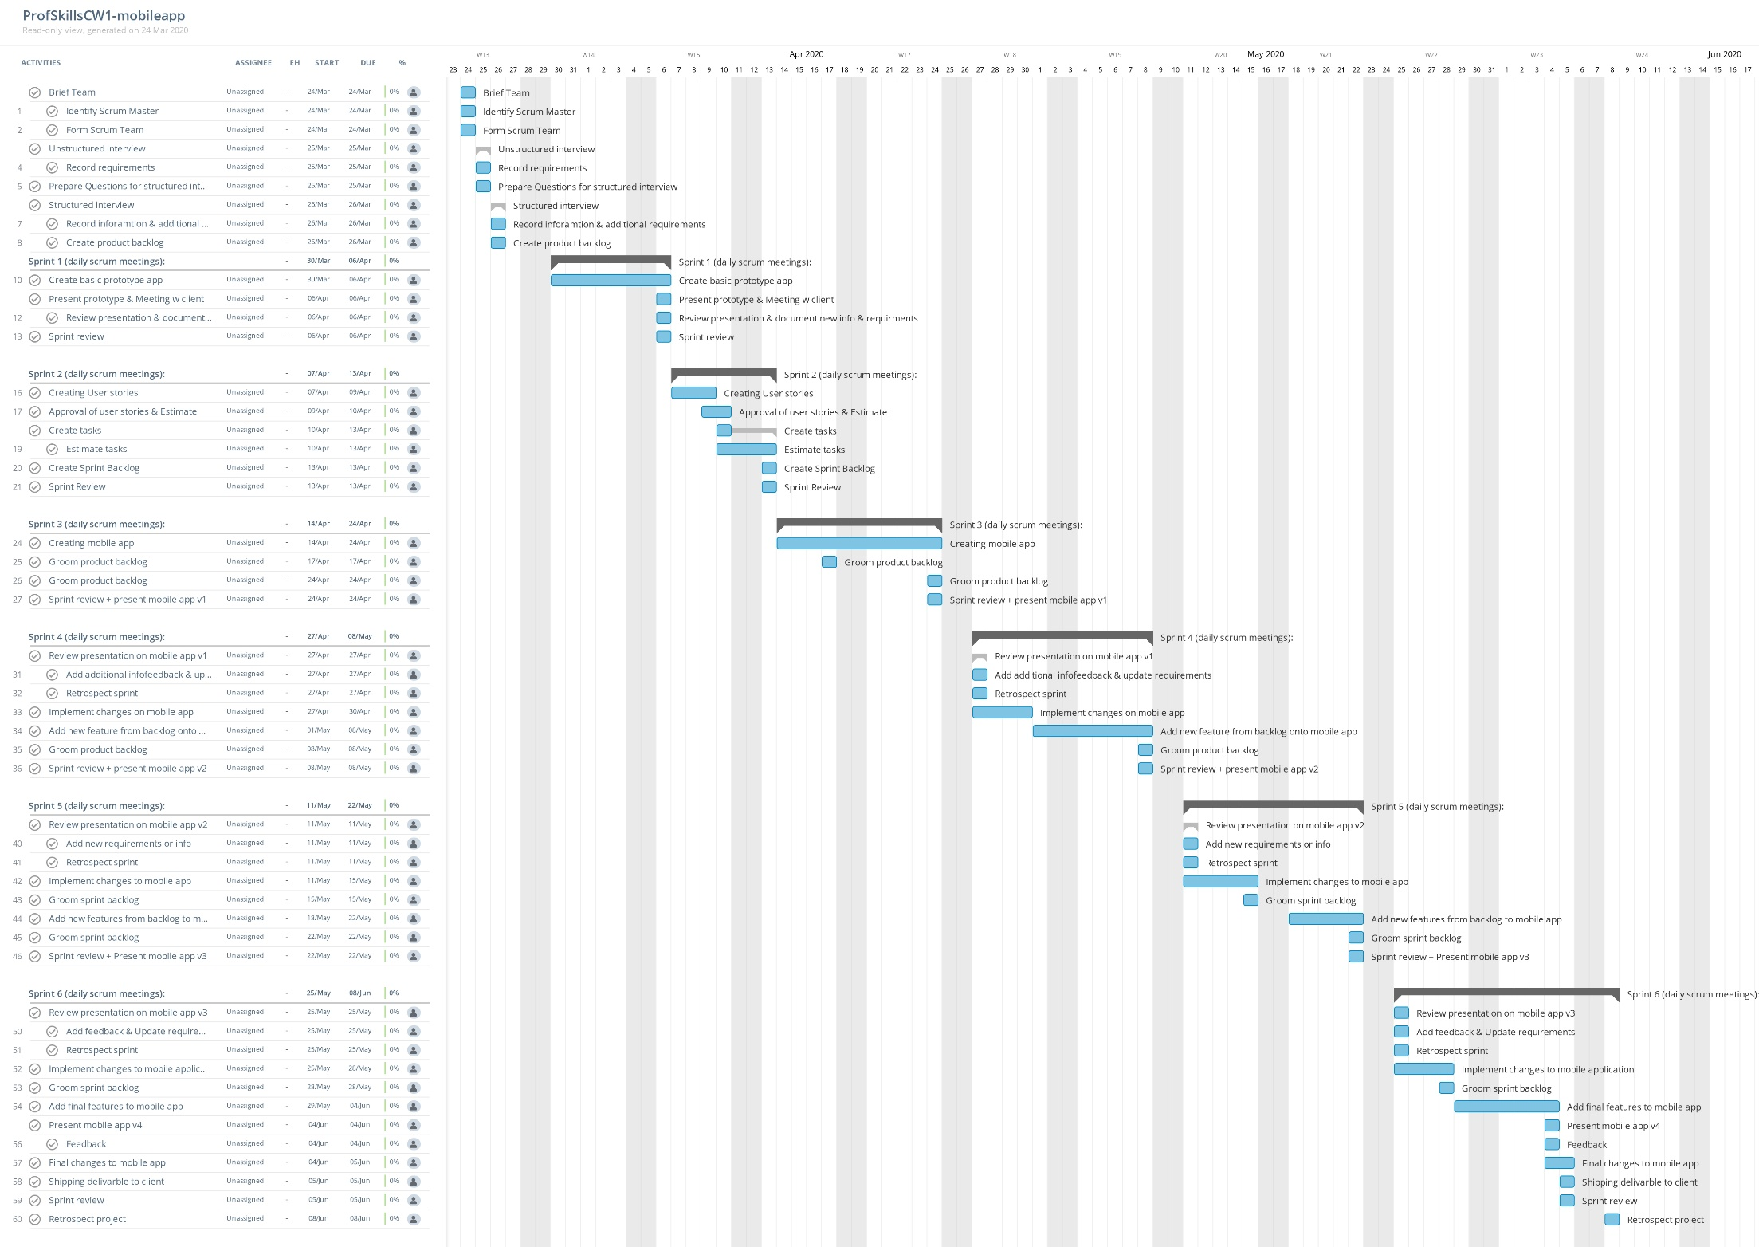

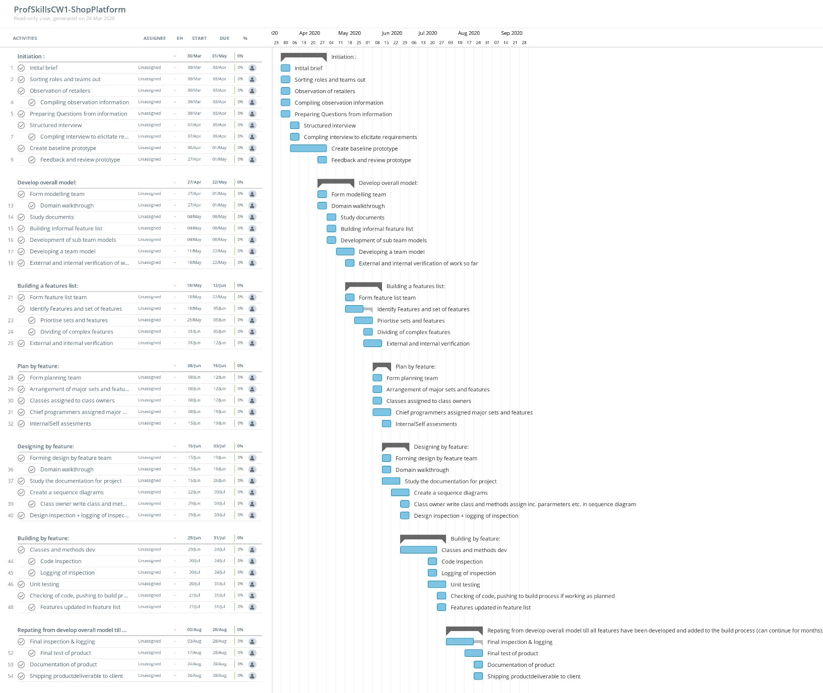

# References:

Abbasi, N., Wajid, I., Iqbal, Z. and Zafar, F. (2014) Project Failure Case Studies and Suggestion, International Journal Of Computer Applications, vol. 86, no. 6, pp. 34-39.

Brandenburg, L. (n.d.) The Business Analysis Process: 8 Steps to Being an Effective Business Analyst, Bridging-The-Gap.Com, [Online]. Available at https://www.bridging-the-gap.com/business-analysis-process/.

Coad, P., Lefebvre, E. and De Luca, J. (1999) Java Modeling In Color With UML, Upper Saddle River NJ, Prentice Hall PTR. Pg. 185-196

Datz, M. (1977) What is good project management? Managing Effectively and Successfully, Pmi.Org, [Online]. Available at https://www.pmi.org/learning/library/what-good-project-management-effectively-successfully-5675.

Fedak, V. (2018) Pros and Cons of DevOps-as-a-Service, Medium, [Online]. Available at https://medium.com/swlh/pros-and-cons-of-devops-as-a-service-a40b8796533c.

Hall, L. (2016) Pros and Cons: Microsoft Planner vs. Trello | Awecomm Insights: The C-Level Source to Navigate Business Tech, Awecomm.Com, [Online]. Available at https://awecomm.com/Blog/2016/12/08/pros-and-cons-microsoft-planner-vs-trello/.

Hoang, N. and Shrestha, S. (2014) PROJECT MANAGEMENT SOFTWARE AND ITS UTILITIES, Bachelor’s LAHTI UNIVERSITY OF APPLIED SCIENCES.

Izanhour, P. (1982) How to Determine when Project Management Techniques are Required, Pmi.Org, [Online]. Available at https://www.pmi.org/learning/library/project-management-techniques-determination-10335.

Layman, L., Williams, L. and Cunningham, L. (n.d.) Exploring Extreme Programming in Context: An Industrial Case Study, Agile Development Conference, .

Mahalakshm, M. and Sundararajan, M. (2013) Traditional SDLC Vs Scrum Methodology –A Comparative Study, International Journal Of Emerging Technology And Advanced Engineering, vol. 3, no. 6, [Online]. Available at http://citeseerx.ist.psu.edu/viewdoc/download?doi=10.1.1.413.2992&rep=rep1&type=pdf.

Matta, M. and Marchesi, M. (2015) Understanding approval rating of agile project management tools using Twitter, 2015 10Th International Joint Conference On Software Technologies (ICSOFT), [Online]. Available at https://ieeexplore.ieee.org/abstract/document/7521122.

Nagar, S. (2015) Requirements Gathering Techniques for IT Business Analyst, Linkedin.Com, [Online]. Available at https://www.linkedin.com/pulse/requirements-gathering-techniques-business-analyst-swadeep-nagar.

Palmer, S. and Felsing, J. (2002) A Practical Guide To Feature-Driven Development, Upper Saddle River, NJ, Prentice Hall PTR.

Rongala, A. (2016) The Impact of Ineffective Project Management - Invensis Learning Blog, Invensis Learning Blog, [Online]. Available at https://www.invensislearning.com/blog/the-impact-of-ineffective-project-management/.

Santos, J. (2019) The Pros and Cons of Using Jira Software, Project-Manger, [Online]. Available at https://project-management.com/the-pros-and-cons-of-using-jira-software/.

Srivastava, A., Bhardwaj, S. and Saraswat, S. (2017) SCRUM model for agile methodology, 2017 International Conference On Computing, Communication And Automation (ICCCA), .

Studio, V. (n.d.) Mobile App Development | Visual Studio, Visual Studio, [Online]. Available at <https://visualstudio.microsoft.com/vs/features/mobile-app-development/>.

Agile tools for software teams - Jira Software | Atlassian (n.d.) Atlassian, [Online]. Available at <https://www.atlassian.com/software/jira/agile>.

Business analysis process guide in 7 stages | BAjobs.ca (n.d.) Bajobs.Ca, [Online]. Available at <https://www.bajobs.ca/en/tools-and-resources/business-analysis-process-guide-7-stages/>.

Conditions for Project Success (2020) Apm.Org.Uk, [Online]. Available at <https://www.apm.org.uk/media/1621/conditions-for-project-success_web_final_0.pdf>.

Correa, H. (n.d.) Introduction to Scrum, Codemag.Com, [Online]. Available at <https://www.codemag.com/Article/0805051/Introduction-to-Scrum>.

Feature overview for Azure DevOps - Azure DevOps (2019) Docs.Microsoft.Com, [Online]. Available at <https://docs.microsoft.com/en-us/azure/devops/user-guide/alm-devops-features?view=azure-devops>.

Feature overview for Azure DevOps - Azure DevOps (2019) Docs.Microsoft.Com, [Online]. Available at <https://docs.microsoft.com/en-us/azure/devops/user-guide/alm-devops-features?view=azure-devops>.

Jira | Issue & Project Tracking Software | Atlassian (n.d.) Atlassian, [Online]. Available at <https://www.atlassian.com/software/jira>.

Phases and processes in Scrum project| SCRUMstudy (n.d.) Scrumstudy.Com, [Online]. Available at <https://www.scrumstudy.com/whyscrum/scrum-phases-and-processes>.

PMI PMBOK® Guide Method (n.d.) Smartsheet, [Online]. Available at <https://www.smartsheet.com/content-center/best-practices/project-management/project-management-guide/pmi-pmbok-method>.

PRINCE2 Methodology (2020) Prince2.Com, [Online]. Available at <https://www.prince2.com/uk/prince2-methodology>.

Programme and project management tools and techniques | Department of Finance (n.d.) Finance-Ni, [Online]. Available at <https://www.finance-ni.gov.uk/articles/programme-and-project-management-tools-and-techniques>.

State of Scrum 2017 - 2018 (2017) Scrumalliance.Org, [Online]. Available at <https://www.scrumalliance.org/ScrumRedesignDEVSite/media/ScrumAllianceMedia/Files%20and%20PDFs/State%20of%20Scrum/2017-SoSR-Final-Version-(Pages).pdf>.

Trello 101 | Getting Started with Trello (n.d.) Trello.Com, [Online]. Available at <https://trello.com/en-GB/guide/trello-101>.

Trello Tour (n.d.) Trello.Com, [Online]. Available at <https://trello.com/en-GB/tour>.

What is Extreme Programming (XP)? (n.d.) Agilealliance, [Online]. Available at <https://www.agilealliance.org/glossary/xp/#q=~(infinite~false~filters~(postType~(~'post~'aa_book~'aa_event_session~'aa_experience_report~'aa_glossary~'aa_research_paper~'aa_video)~tags~(~'xp))~searchTerm~'~sort~false~sortDirection~'asc~page~1)>.

What Is PRINCE2 Methodology? (n.d.) Lucidchart.Com, [Online]. Available at <https://www.lucidchart.com/blog/what-is-prince2-methodology>.

What is project management? (n.d.) Apm.Org.Uk, [Online]. Available at <https://www.apm.org.uk/resources/what-is-project-management/>.

What is Project Management? (n.d.) Pmi.Org, [Online]. Available at <https://www.pmi.org/about/learn-about-pmi/what-is-project-management>.

Why (and How) You Should Use Feature-Driven Development (2020) Lucidchart.Com, [Online]. Available at <https://www.lucidchart.com/blog/why-use-feature-driven-development>.