How to Run IncModelling

*Contents*

What is this program?............................................................................................................1

Making the Models……………………………………………………………………………………………………………2

IncModelling Demo Models……………………………………………………………………………………………...2

*What is this Program?*

Through study of shallow surface slope movement in Britain, and globally, a python script was developed to be able to create a contour model to represent inclinometer data. These models provide more clarity to understanding the slope conditions as well as the program created gives the user flexibility in relaying on data they have collected in the field. This was a research carried out by Toby Cumins, Cardiff University, Bsc Geology.

*Making the Models*

1. **Download** “IncModelling”, obtained at: *github.com/TobyJACumins/IncModelling*
2. **Run** “IncModelling.exe”, found in the “IncModellingSoftware” folder. Anti-virus software may scan this file, allow this scan to proceed and some time for opening the program for the first time.
3. The layout of the program is very progressive. First enter a .CSV file that you collected from the field by either browsing or pasting. This file is **required to be formatted**, as shown in .CSV files provided, allowing the program to operate. (Can be done in excel)
4. You can **customize** the presentation of said model by altering the display title, contour resolution and gradient colour.
   1. Resolution works by increasing the interval count between each gradient count. The default count is 10, and the additional options mathematically apply to this default value. For example, “Double” gives a 20-interval count (10x2=20).
   2. Gradients can slightly change the presentation of models and four have been selected to give a broad range of uses. These can be observed below.
5. The **save** output by default will save the model with the same file name within the same directory as the .CSV file provided. You can browse or paste to simply change the name and/or directory.
6. Finally **hit** the “Generate Contour Graph” button for your model to be constructed.

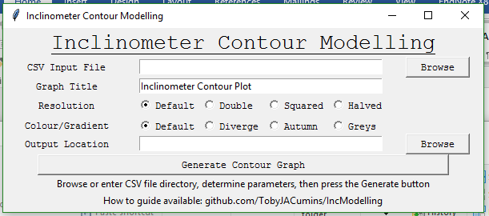

iii.

iv.

a.

b.

v.

vi.

IncModelling Demo Models - SampleData(a-Axis).csv

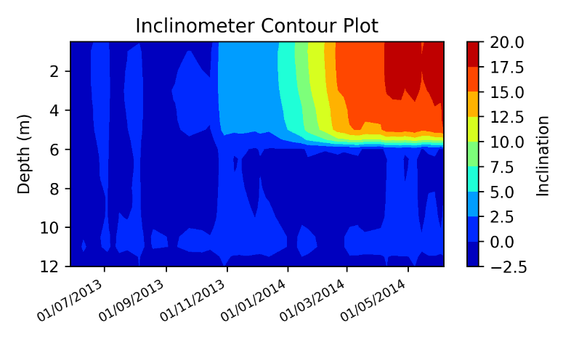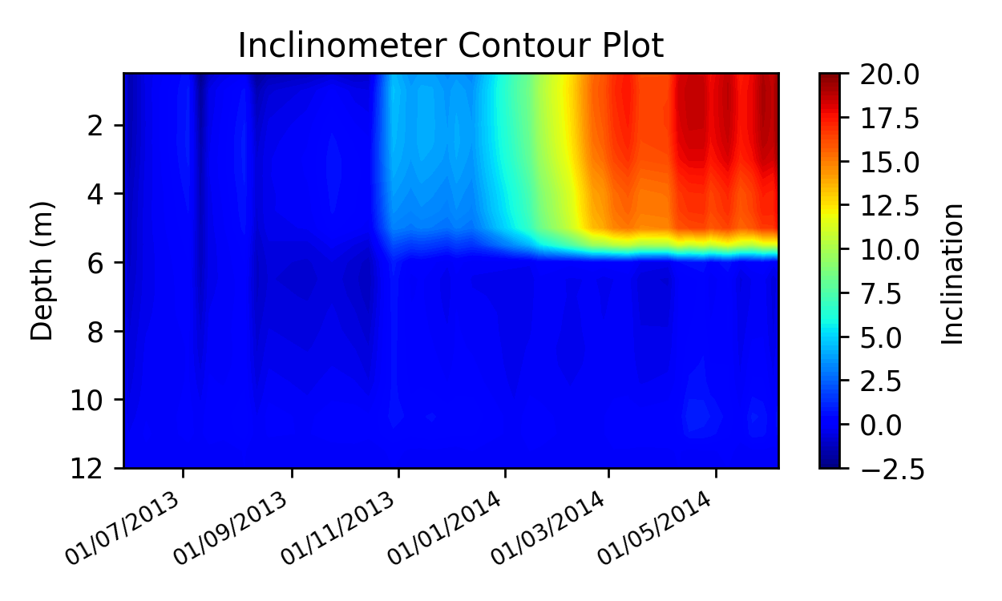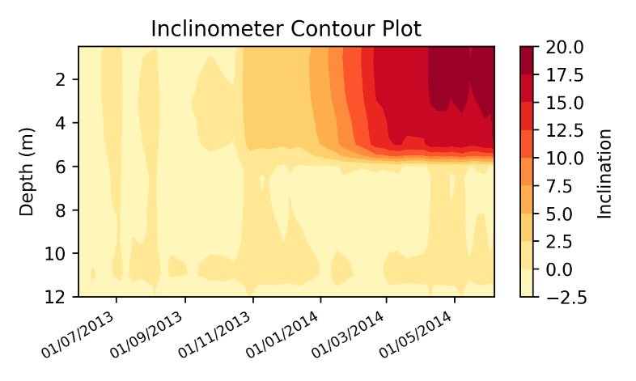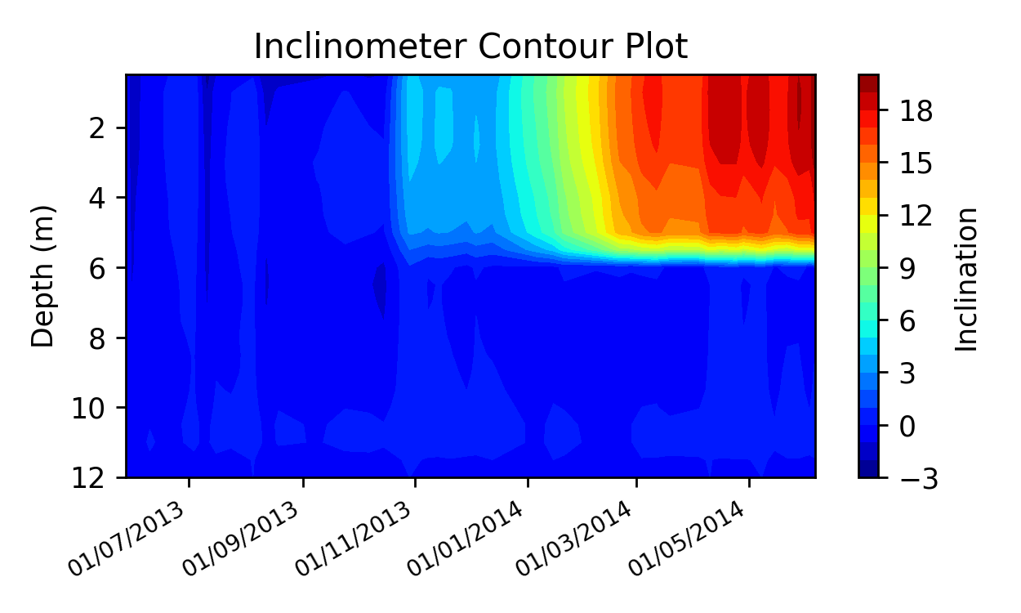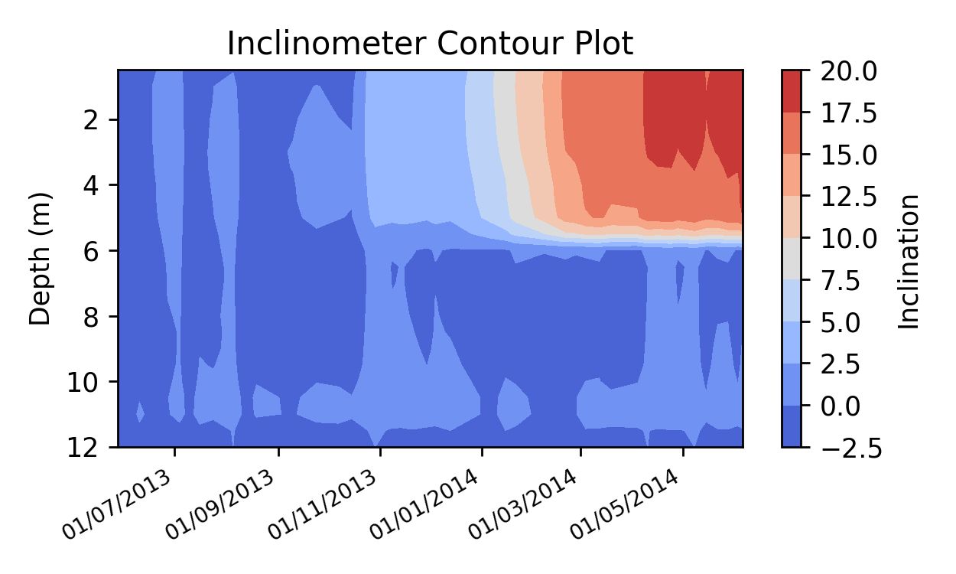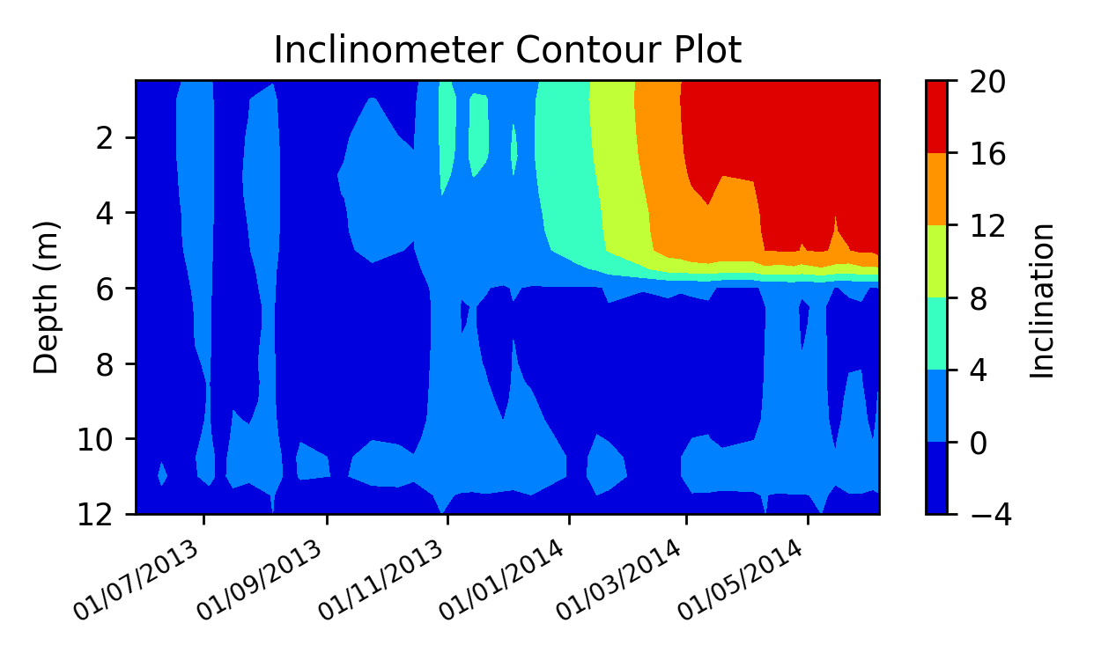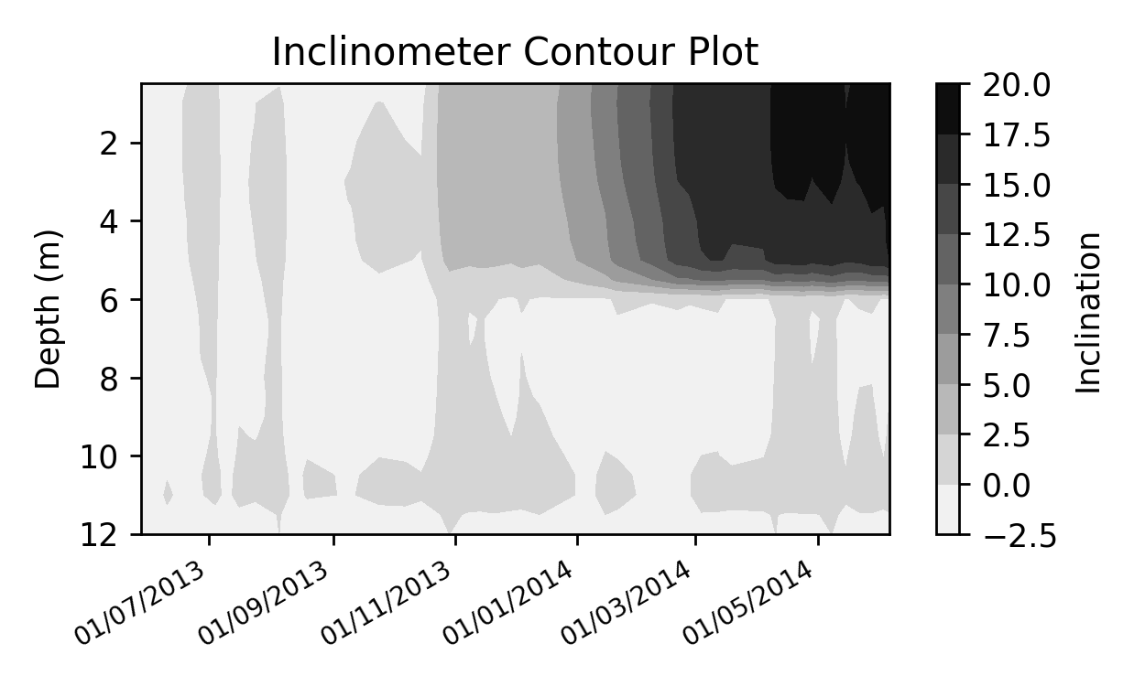

Inclinometer Demo Default/Default

Inclinometer Demo Double/Default

Inclinometer Demo Squared/Default

Inclinometer Demo Halved/Default

Inclinometer Demo Default/Default

Inclinometer Demo Default/Diverge

Inclinometer Demo Default/Autumn

Inclinometer Demo Default/Greys