**Lab 7 NAND Design and Simulation**

**I.Purpose:**

Design a two input NAND gate. Simulate the NAND gate, check wave form, delay.

**II. Introduction to steps:**  
We have learned how to create inverter schematic and generate netlist describing the nodes connection in the circuit as well as describe transistor size (width). In this lab, you will design NAND schematic. The main steps to design NAND schematic are similar to the steps creating inverter which are listed here for your convenience:

1. Using Putty Xming: *www1.chapman.edu/~zhao/CPSC330/Labs/Putty-Xming-VPN.pptx*  
 Create Working directory  
2. Inverter Schematic using Virtuoso:  *www1.chapman.edu/~zhao/CPSC330/Labs/SchematicInv_CadenceSetup_freePDK45.docx*

2.a) Starting Virtuoso

2.b) Library Manager

2.c) Creating Schematic

2.d) Create symbol

3. Inverter Simulation using HSPICE: **this step will generate netlist**  
 *www1.chapman.edu/~zhao/CPSC330/Labs/Simulation_of_Schematic.docx*

3.a: Creating Test Circuit

3.b: Exporting Hspice netlist

4. Waveform: *www1.chapman.edu/~zhao/CPSC330/Labs/Waveform-verification.docx,   
 Note:when opening the waveform, look for a file with extension “.tro “.*

**III. Two input NAND schematic design** Based on the above steps, design the following:

* **A two input NAND schematic**  
  For NAND with 2 inputs, PMOS width is 180nm, NMOS width use 180nm (The reason of using 180 nm for NMOS: 2 NMOS transistors are in series, so electrons need to move more distance. NMOS width needs to be larger such that NMOS has more driving strength in order that NMOS and PMOS will have similar switching time).   
  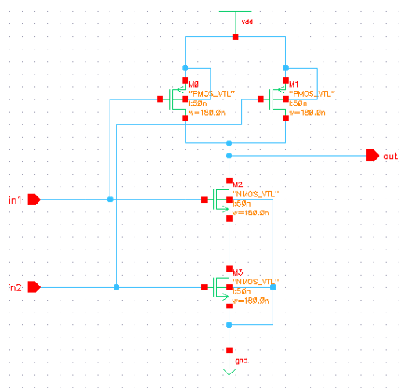
* **Symbol of the above circuit  
  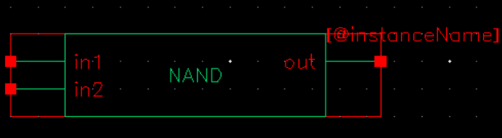**
* **A test circuit based on the test circuit in inverter lab**. For your convenience, the test circuit for NAND is showed here:

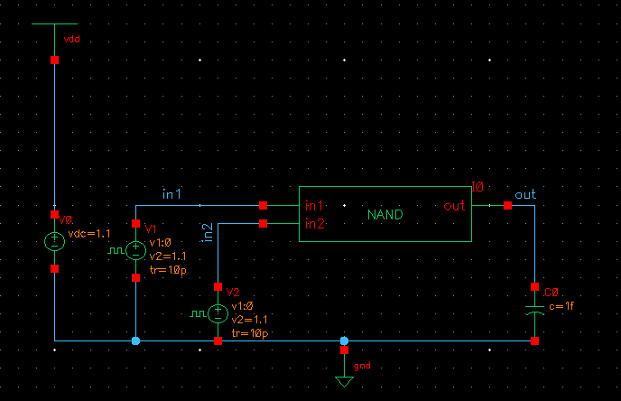

* **Hint:** setup proper inputs to test 4 states in truth table:

The following truth table shows the necessary states :   
VA VB NAND OUTPUT   
0 0 1

0 1 1

1 0 1

1 1 0

In order to cover the four cases; 00, 01, 10 and 11, you need to figure out how to create two pulses something like the waveforms as follows, the width and period of the second pulse will be doubled comparing with the first pulse. The start time of the two pulse could be different. In ADL window, you may choose 400ps as “stop time”in *Analysis/Choose*.   
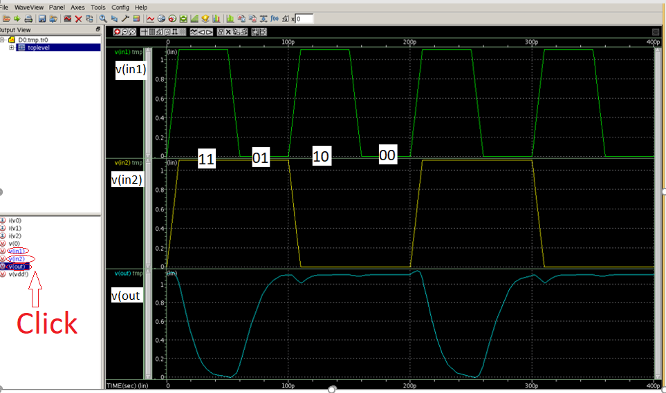

**Note*: in the above input waveforms of in1 and in2, the pulse width and period of in2(90p, 200p) are about two times of those of in1(40p,100p).***   
  
The fall time delay and rise time delay are showing as follows. You can drag the delay measuring points to 50% of the input and output value, respectively. Steps in delay measure is in previous lab about Waveform. You need to click **Tools→Measurement** to bring out the Measurement Tool window. Click Delay in that window:

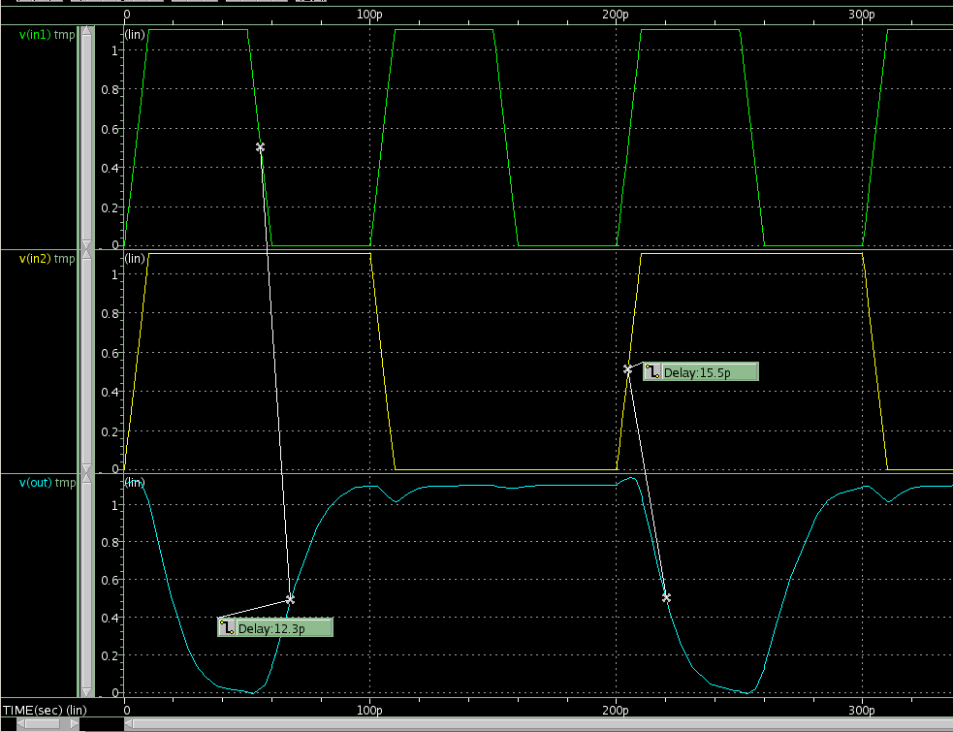

***IV. Lab report:***

* *Check waveform and measure delays, record two delays (****output rise delay, output fall delay****) in a paper, you need to identify which input causes output to change and then measure the delay between the two signals. Note you can drag the delay line to get delay between different signals.*
* Change NMOS width to 180nm, record two delays.
* Compare the output rise delays between NMOS using 90 nm and 180 nm, then compare the output fall delay of NMOS using 90 nm and 180 nm, explain what you observe and why.
* Lab report requirement is here: **www1.chapman.edu/~zhao/CPSC330/Labs/report_Lab.docx**

P.S.

1. Part of the netlist is copied here for your reference:

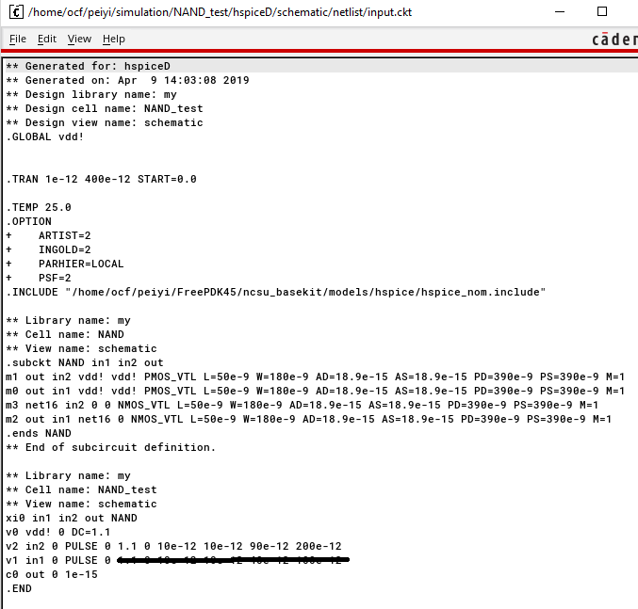

2. There is a NAND schematic in the top part of the following link: <https://www.eda.ncsu.edu/wiki/Tutorial:Layout_Tutorial2>

3. *Hotkeys:*

* *Undo: press ‘u’; redo: press “shift + u”*
* *Select an object: press 'ESC' and then click it, the object will be highlighted*
* *Move an object: Select it first (see the above Select step), then drag it*
* *Delete an object: Select it first, then press Delete on keyboard*
* *Press “f”: full view of current circuit*
* *Edit the properties: press 'q' and then click the object*
* *Un-select an object: press 'ESC' and then click the background*
* *Create instances: press 'i'*
* *Create narrow wires: press 'w'*
* *Name wires: press 'l'*