**CPSC390  
Artificial Intelligence Spring 2020**

**Assignment #4 (Reasoning under Uncertainty) Due: 5/7/20**

**I. Probabilities and Action Planning**

Consider the simple robot environment of Figure 1, in which square (2,2) is an obstacle.

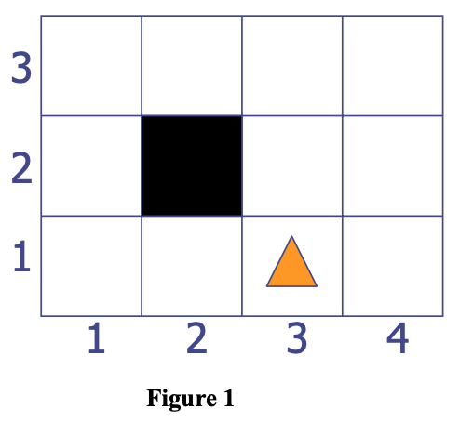

At any position, the robot can execute any one of the 4 actions: **Up**, **Down**, **Right**, and **Left**.

Each action has the intended effect with some probability; but with some probability, it may also result in a motion of the robot perpendicular to the intended direction. More precisely, if the robot executes **Up**, then:  
- With probability 0.8, it moves up one square, except if an obstacle prevents it from doing so, in which case it stays in the same square.  
- With probability 0.1, it moves right one square, except if an obstacle prevents it from doing so, in which case it stays in the same square.  
- With probability 0.1, it moves left one square, except if an obstacle prevents it from doing so, in which case it stays in the same square.

The other three actions – **Down**, **Right**, and **Left** – are defined similarly, with the same probability values.

From the initial position (3,1) with the yellow mark, the robot wants to execute the plan (**Left**, **Left**, **Up**). What are the possible positions of the robot after executing this plan, and with what probabilities?

(2,1) = 0.001+0.064+0.064+0.064+0.064+0.001 = 0.258

(4,1) = 0.001+0.001 = 0. 002

(3,2) = 0.008+0.001+0.008+0.008 = 0.025

(1,1) = 0.008+0.008+0.064+0.008 = 0.088

(3,1) = 0.008+0.008+0.008 = 0.024

(3,3) = 0.008+0.064+0.008 = 0.08

(4,2) = 0.001+0.008 = 0.009

(1,2) = 0.512

(2,3) = 0.001

(4,3) = 0.001

**II. Adversarial Search**

Consider the following game tree, in which static scores indicated besides the tree leaves are from the first player’s point of view:

(A (B (D (J(-2) K(1)))

(E (L(0) M(8)))

(F (N(-3) O(5))))

(C (G (P(-2) Q(-1)))

(H (R(1) S(-3)))

(I (T(1) U(2)))))

A is the root. Its children are B and C. B’s children are D, E, and F. Etc ... The score (value of the static evaluation function) of J is -2, that of K is 1, ...

1. Suppose the first player is the maximizing player MAX. What move should MAX choose?

MAX should choose B since value of B is 1 and value of C is -1

1. What nodes would not be examined by MAX using the alpha-beta pruning technique? (Assume that at each level the nodes are considered in the order listed above.)

Branch C would not be visited since MAX finds a winning path along branch B (Nodes that would not be visited: H, I, R, S, T, U).

1. Assume that alpha-beta technique keeps track of the tree path that is responsible for the final alpha value of the root of the tree. This path connects the root of the tree to some leaf node ***x***. What is this node?

***x*** = K since the value of K is the same as the value of the final value of roots.

1. Assume MAX generates a sub-tree (singular extension) from ***x*** and gets the following sub-tree:

(**x** (X (X1(-2) X2(1)))  
(Y (Y1(-1) Y2(1) Y3(2))))

Should MAX change decision? [Answer yes or no.]

No, K still ends up with a value of 1 so MAX should make the same move.