Toby Chappell

CPSC 392

02/17/20

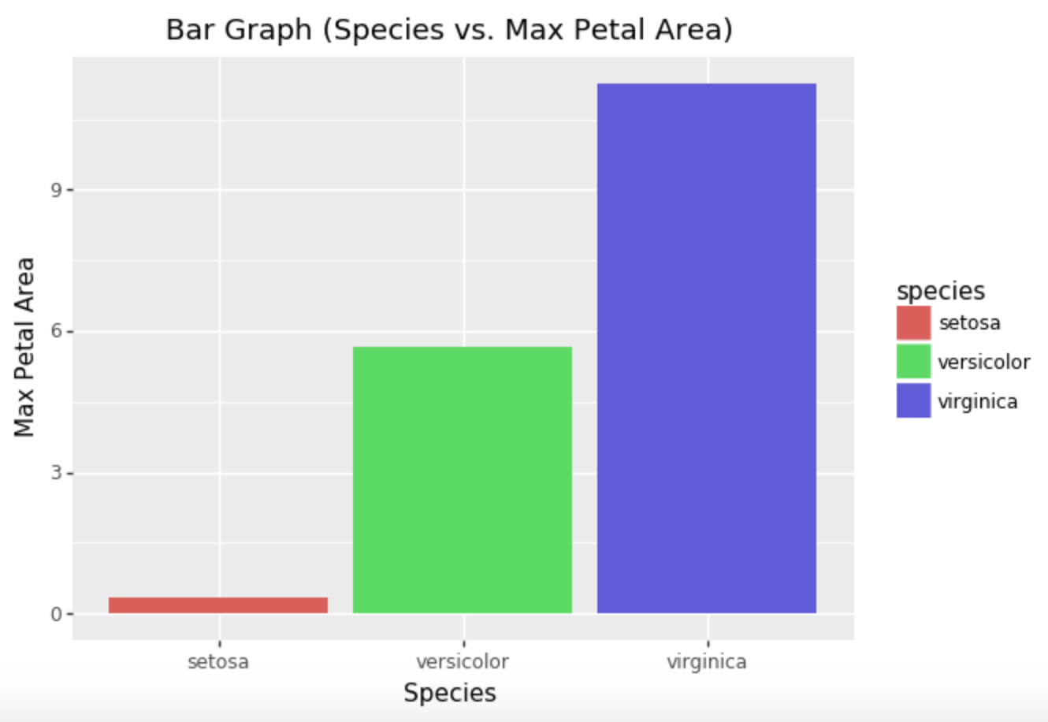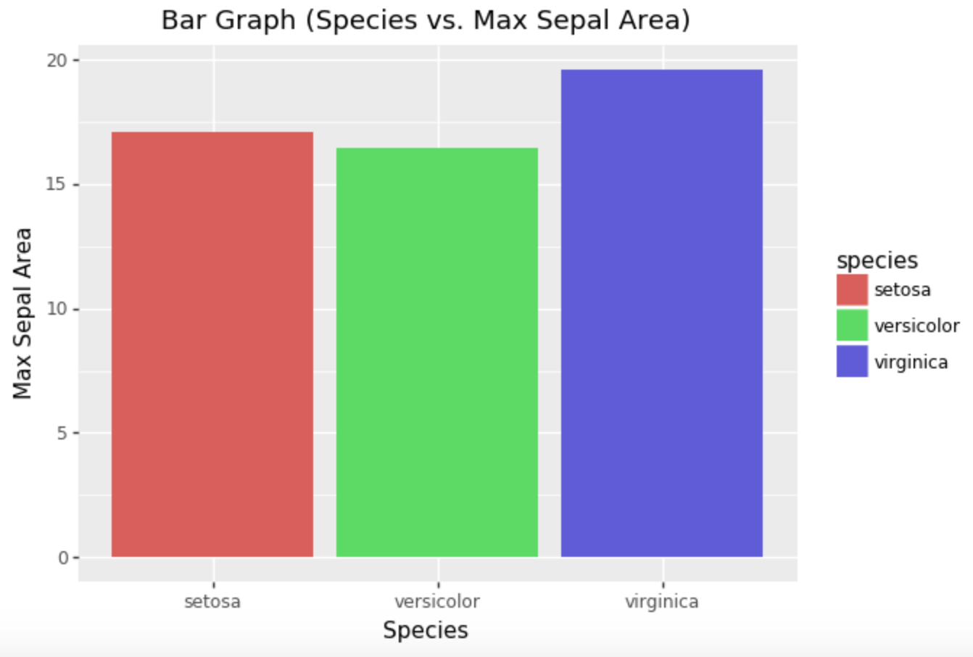

**Note:**

The max area calculated is an average of the area for each species of iris. It multiplies the average length by width and thus assumes that each petal and sepal are rectangular. This is highly unrealistic and thus is why it is termed "max" area since it’s the largest area possible. Nevertheless, it gives a good approximate in how area is related between different species. For instance, based on the bar charts, virginica has a significantly larger max petal area on average, making it less affected from any approximations taking place. Additionally, virginica has a larger max sepal area on average. However, it has a value that is relatively close to the other species, differing only by 4 units squared in total. Thus, it would be fair to say that each species has roughly the same sepal area due to the approximation of area.