Unix laboratory.

SYSTEMS SOFTWARE.

Release Date: 28 January 2019
Submission Date: 23 May 2019

This element of coursework takes the form of practical exercises to be carried out in the laboratory.

ASSIGNMENT TO BE SUBMITTED VIA A DROPBOX WITHIN BLACKBOARD AS A WORD FILE.

N.B.
Certain sections of the lab book provide learning exercises and do not require answers, however when an answer is expected the question will appear in bold text, will be underlined, and will have a question number against it.

Each practical requires the student to provide answers or show evidence that they have completed it. Certain parts of each practical are simply instructions or information to help the student in their work. Each practical therefore has a total of 99 expected answers.

Laboratory Log Book

Student name:
Registration No :

PRACTICALS 1 TO 7.

UNIX

The following book may be useful and is available on-line via the Library Safari Online Books collection (via Athens).
“Sams Teach Yourself Unix in 24 Hours, Fourth Edition”, Dave Taylor, 2006, Sams Publishing, ISBN 978-0-672-32814-5 (pearsontechgroup);
 | PRACTICAL 1.
- The document on the page http://scm.ulster.ac.uk/technicalsupport.php
details how to use Virtual Box.

Virtual Box is available with a Ubuntu virtual machine. Run Virtual Box and double click the existing Ubuntu machine. Instructions and passwords are available as usual at the technical support page:

http://scm.ulster.ac.uk/technicalsupport.php

- Oracle VM Virtual Box
  - • €Run Oracle VM Virtual Box from the desktop
  - • €Click on the Ubuntu machine and use the green arrow to start it
  - • €The username for Ubuntu is user1
  - • €The password for Ubuntu is user1pwd1
  - • €The virtual machine will disappear on logout
- Use cursor to move over Applications, then Accessories, and select Terminal. A new window will appear. This is where you will work with files, run scripts etc.
- Please use the filenames as suggested as you will need to refer to some of these files in later practical sessions.

2. | - A simple editor to use is gedit but others may be available (for example nano, pico). A more sophisticated one is vi.  - In Unix, files may have an extension (for example ‘.txt’) which is usually indicative of content but this is not mandatory.  - Using a simple editor, create and save the 3 files as described below. To invoke the editor simply type gedit filename and press Return. This opens up an editor window that allows text to be entered. Help will show the commands available.  (i) File hello should contain one line echo Hello there.  (ii) File niceday should contain three lines  echo The time and date are now :  date  echo Have a nice day.  (iii) File whenandwho should contain two lines  date  who
3. | (i) Type ls and press Return. Write down what this command does.
4. | Run each of the simple scripts contained in the files hello, niceday and whenandwho. To do this:  (i) type sh hello and press Return;  (ii) type sh niceday and press Return;  (iii) type sh whenandwho and press Return;  (iv) What do you think sh is short for ?
5. | List the contents of each of the three files hello, niceday and  whenandwho, in turn, on your screen . To do this  (i) type cat hello and press Return  (ii) type cat niceday and press Return  (iii) type cat whenandwho and press Return
(i) What does the command date > rubbish1 do ?
(Hint : any new files created ? )

(ii) What does using > do in the above command?
(Hint : compare with output of date )

(iii) When would you use the < in this context ?
(Hint : opposite of output ? )

- You can also create a file using cat >
(i) Type in the following, noting that the last line means press the Ctrl and D keys together.
cat > rubbish2
Are you enjoying your
first taste of Unix?
Ctrl-D
(ii) What is the outcome?

- Note: If you make a mistake on a previous line, you cannot go back. In this situation you have to finish using cat > and then use an editor to correct error.
8. | - When you need to check on the syntax of a particular command you can use the man command to read the manual page for it.  (i) Type man cat to find information on cat command.  - Some versions of Unix will page output from man by default. If there is more information than can fit onto one screen then you can ‘page’ the information if this is not done automatically.  (ii) Type man ls | more  (iii) Press the spacebar key to view another page and the return key to see  another line.  (iv) By using the man command find out how to list the names of your files with  extra information such as filesize, date of modification etc. Write down and  explain the command.
- If you are unsure which command you need to use, type man –k followed by a keyword relating to the task. You will be given a brief description of all commands indexed by that keyword.
(i) What command could you use to find who else is logged on?

(ii) Issue the command man ls again.

(iii)What is the significance of the 1 in brackets in first line of output?

- What does cat < rubbish2 do?

(ii) What is the difference between the output of the above command and the command cat rubbish2 ?

 | - What is the effect of cat rubbish1 rubbish2 ?
(i) Create a file called rubbish3 and type in echo This is file rubbish3
(ii) Now save the file.
(iii) Create a file called rubbish4 and type in echo This is file rubbish4
(iv) Now save the file.
(v) What is the effect of cat < rubbish3 > rubbish4 ?
(Hint: examine both files)

(i) What is the difference between these two commands?
date > rubbish1
date >> rubbish1

(i) What is the effect of who | tee rubbish5
(Hint: examine rubbish5)

(i) Write a shell script (store in file named additiontable ) which produces on screen the following information AND stores a copy in a file called additiontable_copy.
(Hint : consider 14 above ).
3 plus 0 is 3
3 plus 1 is 4
3 plus 2 is 5
3 plus 3 is 6

Write the shell script below.

(i) Issue the following two commands
ls -1 > rubbish6
wc -l < rubbish6
(ii) Check using the man command to find out what these options on ls and wc
commands do . Write down your answer.

(iii) What is the combined effect of these two commands?
(Hint : there are 2 outcomes to consider.)

(i) Issue the following command
ls -1 | wc -l
(ii) What is the effect of this command?

(iii) How does it differ from the two commands in previous question?

- The | symbol is referred to as a pipe.
- Deleting files is done using rm command.
- It is recommended that you use option –i so that you are prompted before the deletion occurs.
(i) Issue the following command and note how it runs.
rm – i rubbish6

Explain below what this command does.

 | (i) How would you list the contents of a file on screen with each line being numbered automatically?
 | - Summarise new Unix commands that you have learnt in this practical as well as techniques and new features of Unix.

 | PRACTICAL 2.
1. | - When you first logon you will automatically be in your home directory.  - If at any stage you are not sure which directory you are in, issue the command pwd .  (i) While you are in your home directory, issue the command  mkdir directory1 to create a directory called directory1  (ii) Stay in your home directory, issue the command  mkdir directory2 to create a directory called directory2  (iii) Move to directory1 using cd directory1 then issue the command  mkdir directory3 to create a third directory called directory3 which is in  directory1, as shown in diagram below.  (iv) Go back to your home directory by typing cd  Typing cd .. takes you up one level.  home  directory1  directory2  directory3  - Directory is same as folder and .. means parent.  (v) What does ../.. mean ?  (vi) From your home directory how can you go directly to directory3? Write down your answer.  (vii) Create a file called relativeandabsolute in directory3 which contains one line as follows  echo It is convenient to have this file here.  (viii) The name given to this file in (vii) could be used in another directory but each will have a unique absolute name. Write down the absolute name of this file that you have created in directory3.  (HINT: you may need to use pwd command to help you. )
2. | Input and Output Streams  - Once you have typed in a command, and the command begins to be executed, you may be requested to type in data as input to the command, and it will send messages as output.  - Output consists of the stream of characters usually sent to the screen.  - Some commands eg ls, date and who give output but require no input.  - For simple commands which require input, the input is formed by the characters you type in on the keyboard.  - Each command has associated with it three streams. They are called standard input, standard output and standard error (often abbreviated to stdin, stdout and stderr ).  - Normally, standard input will be taken from the keyboard, and standard output and standard error will both be sent to the terminal screen.  - A command may in addition have other input and/or output streams.  - Each input/output stream is also given a number: 0 for standard input, 1 for standard output and 2 for standard error.  - Commands that require input will usually take it from standard input, and the normal output of a command will go to standard output.  - Standard error is used for other messages, typically warning messages if the command could not be executed as intended .  - Thus the output from a command and the diagnostics can be separated.
3. | Redirection of input and output  - It is possible to redirect input and/or output.  - Instead of input coming from the keyboard, it can be the contents of a file or the output of another command.  - Similarly output from a command can be sent to a file or used as input to another command.  - The symbol < indicates that standard input should come from a file. The standard output can be directed to a file using >.  - Beware that you do not take input from and send output to the same file - it won't work. The file you try to take the input from will be destroyed in preparation for receiving the output before anything is read from it.  Pipes  - The syntax for pipes is similar to that for file redirection, except that the symbol | is used instead of < and > .  - If we have a command X whose standard output is to be used as the standard input to a command Y, we could have  X > tempfile  Y < tempfile  storing the output of X in a temporary file tempfile. However this is not  elegant and by means of a pipe we can join the two streams together, thus :  X | Y  - Using > or < different input or output streams can be specified, but pipes only connect standard output to standard input, and cannot be used with the standard error stream.  Scripts  - A method of performing several commands, one after the other, is to create a file containing those commands, one per line, and then 'execute' that file ( also known a shell script.)  - When you are logged in, you will be communicating via a program called a shell. The shell which is run from the moment you login to the end of your session is your login shell.  - It is possible to run further copies of the shell by typing the command sh. In order to execute a shell script, the program sh is run, but instead of taking standard input from your terminal, the input comes from the file. Thus while the script is executing there will be two copies of sh running. The login shell will be running one command, namely sh, and this shell will execute the commands in the file.
4. | (i) Make sure you are in your home directory. (How ?) Write down your answer.  (ii) Now issue the command ls –l  (iii) How are directories denoted? Write down your answer.  (iv) Find out using the man command how to display ‘hidden’ files ( ie files starting with a dot.) Write down your answer.  (v)Why are these files not normally displayed when using the ls command?  - When a file is created, space to store it is found on the disk. That space is given a unique number, called an inode, which remains with that file until it is deleted. At creation , the file is also given a name. The file is created in a directory which is updated to contain the name of the file and its inode.  (vi) How do you check which inodes are allocated to which files?  (vii ) How do you find the inode of your home directory?  - Sometimes it is useful to give a file several different names. ( Eg if you have data that needs to be accessed in several different directories and any changes to it need to be made consistently. If you create several copies, then updates would have to be made one per copy which can lead to errors. ) We can use the concept of an inode to good effect.
5. | - Make sure that you are in your home directory.  - Create and save a file called mydata which has the following 2 lines  echo This is a file which will be used to show how files can be linked  echo Data is 1,2,3 ,4 ,5  - While still in your home directory issue the command  cp mydata mydata2 ( ← note that a completely new file is created with a new inode but contents of file are not changed.)  - Copy ( using cp ) file mydata to directory1 which you created earlier. This means you will have 2 files called mydata.  How does this differ from (iii) ?  - Change directory to directory1 and then rename the file called mydata in  directory1 by issuing mv mydata mydata1  - Move the file mydata2 into directory2 and do not rename it. Write down the command you used to do this.  - On the diagram below, please identify where each of the files mydata, mydata1 and mydata2 are located in your filesystem.  Home  directory1  directory2  directory3  - Create a link between the file mydata and a new, as yet non-existent, file (mydata3) in directory3 by using the ln command followed by the name of the existing file and then the new file. Write down the command you used.  - NOTE: A file can be named relative to the current directory or given a unique absolute name starting from the root directory. Since you are linking 2 files in different directories , it will be necessary to use at least one absolute name.)  - This edit must be performed using the vi ( or pico , jpico, nano ) editor. Edit file mydata3 and modify the last line so that it reads  echo Data is 1,2,3,4,5,6,7,8,9  If you choose the vi editor ask for help to make the above change. Now save and close the file.  - Now list file mydata. Explain below any changes to the file.  - The kernel will keep track of how many names (links) an inode has  and when this drops to zero, the filespace allocated to that inode is released for use elsewhere.  - Does making changes to mydata affect mydata3 ?  - How does Linux record that 2 files are linked (as per above  process )?
6. | Summarise new Unix commands that you have learnt in this practical as well as techniques and new features of Unix.
 |  | PRACTICAL 3.
- Unix has a flexible way of protecting files. Each file divides the users into 3 categories:
the files’s owner
a group of users
other users
- For each of these categories of user, that user may be given or denied the following access privileges:
read, write, execute
- Access privileges for directories have a different meaning than for ordinary files. If a directory has write permission, files in that directory may be created or deleted. If it has read permission, it is possible to see what files are contained in that directory. If it has execute permission it is possible to cd to it.

(i) Under what circumstances would you want to give one of your
directories execute access but not read access?

(ii) Issue the command ls –l from your home directory and identify each of the fields which appear for each file and directory. Write them down in the order they appear in space provided.

(iii) When you create a file, what are the default access privileges? Write them down in space provided.

(iv) When you create a directory, what are the default access privileges? Write them down in space provided.

(v) Find out which files are linked use the ls –il

- The most frequent change you are likely to make to a file, apart from its actual contents is to the access privileges, using the chmod command.
- This command uses the addition symbol + to add, the subtraction symbol – to take away permission(s) and equals sign = to set permission(s).
- It also makes use of who symbols ( u for user, g for group, o for other, a for all. Permission symbols are r,w,x or - .
- Eg the command chmod go-w myfile will deny write permission to group and to others for the file myfile.

- What effect does the following command have, assuming there is a file called myfile?
chmod g=rx myfile

(ii) Create a file called unreadable which no-one can read and confirm that you yourself cannot read it. Write down the command you used.

- Unix treats a file as a sequence of bytes.
- A file named myfile.c does not necessarily contain a program written in C. The file command can help in determining what a file contains but is not infallible.
(i) Try out this command on a file you have created. Explain the outcome.
Does it make sense?

- There is another way to change a file’s permissions which is based around treating the presence of each r,w,x as a 1 and treat the absence of each r,w,x as a 0 and working out the octal value.
- The chmod command allows you to specify the new permission settings as an octal number. Eg If you wanted rubbish1 to have the following permission settings:
rwxr-x---
then the octal permission setting would be 750 ( see table ) .
The command to achieve this is chmod 750 rubbish1
(i) Create a new file called filepermission with one line
echo This is to allow permission settings to be changed.
(ii) By specifying the appropriate octal value in conjunction with the chmod command, change the permissions on this file so that absolutely anyone can read , write or execute filepermission. Write down the command you used.
 | User | Group | Others
setting | rwx | r-x | ---
binary | 111 | 101 | 000
octal | 7 | 5 | 0

- Again, by specifiying the appropriate octal value in conjunction with the chmod command, change the permissions on this file so that everyone can only read filepermission. Write down the command you used.

(iv) Who can change ownership of one of your files?

awk - provides more sophisticated processing of files divided into records and fields

cmp – like diff but stays silent if files being compared are the same and gives a short message if they are different. Can work with files of any type.

cut – is a very useful utility for extracting columns and can distinguish between fields and specify delimiters ( option –d)

diff - gives you details of differences between 2 text files

du - displays file space usage.

grep – is a utility which allows you to search for a pattern ( regular expression ), possibly in a list of files. If no files are specified it searches standard input instead. All lines that match the pattern are displayed to standard output. The –w option restricts matching to whole words. To search all files with extension .c for the string x you could issue the command grep –w x *.c

head - can list the first number of lines of a text file ( can specify number or accept default number).

paste - useful when you have two or more files containing what can be thought of as columns in a table and you require corresponding lines from the files to be concatenated so as to actually produce a table

sort - sorts its input into alphabetical order line by line. It has many options and can sort on a specified field of the input rather than the first or numerically (option –n )
tail - can list the last number of lines of a text file ( can specify number or accept default number).
uniq – with no options, this filters out consecutive repeated lines but only if they are consecutive ( can use option –u). Options exist to indicate how many times a line is repeated, output only repeated lines or only lines which are not repeated.
wc – can count number of lines , words and characters ( can use options –c, -w , -l to select only one of these counts.) This command does not work on directories.
(i) Create a new file in your home directory called bloggs and type in the following 3 lines containing date of birth, surname, first name
17.04.1981 Smith Fred
22.01.1983 Jones Susan
03.11.1982 Bloggs Joe
(ii) Use the cut command with options to produce only the surnames from the file bloggs. Write down the command you used.

What happens when surnames vary greatly in length?

(iii) Use the cut command with options to produce only the year of birth for each of the three people listed in the file bloggs. Write down the command you used.

(i) Find the most recently modified file (excluding ‘dot’ files) in the current directory. This will involve several commands using pipes.
Write down the command you used.

(i) Find out how many separate inodes are represented by
the files ( excluding ‘dot’ files) in the current directory.
Write down the command you used.

 |  | (i) Write a script below which will list the files in the current directory (excluding ‘dot’ files ) in long format (i.e. including the information that ls provides with option –l ) and in increasing order of size.
 |  | - Summarise new Unix commands that you have learnt in this practical as well as techniques and new features of Unix.

 |  | PRACTICAL 4.
  - You can find out which processes you have, either running or stopped, by issuing the command ps.
  - Issue the command ps and write down what each of the fields in the output means.

  - Processes can be run in the foreground (system must complete it before another command can be issued) or in the background ( another command can be issued immediately).
(i) Issue the command sleep 30 and then try to issue the date command.
What happens?

(ii) Issue the command sleep 60 & and then issue the command date.
(iii) Issue the ps command , identify the sleep process and use the
kill command followed by its PID to get rid of it.

  - It is not always desirable that scripts be executed immediately. The at and batch commands are useful when you want to schedule jobs to run later.
  - The at command is useful when you want to schedule jobs to run at a particular time whereas batch can be used when the time of execution does not have to be specific.

  - The at command accepts the time for execution of program in a variety of formats – check manual pages for details. Write down 3 different formats which are acceptable. HINT: see below for one such acceptable format.

Jobs on the at queue can be examined using the atq command and removed using option atrm followed by job number.
(ii) Create another at job, view the queue and then delete that job.
  - There is a crontab command , currently disabled , which allows you to run specified jobs at regular times.
- Another communication mechanism employed by Unix is that of the environment – a collection of variable names together with an associated value for each one. You can view all the variables set for you by use of command env.
(i) Issue the command env | more .
Here are just a few useful variables.

LOGNAME has as its value your username,
HOME gives the absolute pathname of your home directory,
PATH gives a sequence of pathnames separated by colons (the System Administrator will have set up PATH to contain the directories that you will typically need ) which
determine the search path for commands,
TERM is the type of terminal or window you are using,
SHELL specifies which shell is used by default.

- By default you are using the C Shell. There is another shell available called the Bourne shell. There are features supported in both shells as well as features which are supported by only one shell. There are usually workarounds even when a particular feature is not available in a shell.
(i) to start a new Bourne shell type sh
(ii) to start a new C shell type csh
(iii) to leave a shell type Ctrl-D

- Use an editor to create a file called assigningvalues which has the following lines
echo What is your surname?
read SURNAME
echo Your surname is $SURNAME
(i) Run this script, noting the technique for reading in and assigning a value to a variable. (There is a convention which says that variable names should be uppercase.)
- It is possible to read several variables at once in a single line of input.
(ii) Create a file called readseveralvariables containing the following lines.
echo Please type in 3 integers separated by spaces on the same line
read X Y Z
echo X=$X Y=$Y Z=$Z
(iii) Run this script. Write down the values of X, Y and Z.

(iv) Edit second line of file readseveralvariables and delete Z. What happens
when you rerun this file? (HINT what are the values of X, Y and Z this time?)

(v) Write a script and store in a file called controlspeed which prompts the user
for the names of two files, lists the first file on screen and waits for user to press
any key before second file is listed on the screen.
Write down your script below.

- A number of characters are understood by the shell to have a special meaning, for example $, > and <.
- The purpose of quotes and backslash is to enable characters which are part of the shell's reserved characters to be used in a context where they are not recognised as such. Three such characters are
    - ' (single quote) usually on the same key as the @ symbol,
    - " (double quote) usually on the same key as the 2 and
    - \ (backslash).
- Other reserved characters include & [ ] ; and more than a dozen more.
- If you want to use any of these reserved characters in any context other that which the shell defines for them, they must be either quoted or escaped.
(i) Change to Bourne shell by typing sh
(ii) Type X='hello<$LOGNAME>'
(iii) Type echo $X. What is the outcome?

(iv) Type PROMPT="$LOGNAME's prompt"

(v) Type echo $PROMPT. What is the outcome?

(vi) Exit back to C shell by tying Ctrl-D.
- Please note that if you want to set the value of a variable in the C shell you can issue the command set X = 42
- Unix treats devices exactly the same as files. Every device may be thought of as a file.
- Now type tty to discover what the name of your current terminal (or window) is.
Write down your answer.

- Change directory to /dev/pts and use ls to examine which files are in it.
Write down your answer.

(iii) Look closely at the entry corresponding to the output from (i) by typing ls -l
followed by the name of your current terminal ( or window). This looks very
much like an ordinary file, except that the first character in the output is c -
indicating that the file is a character special file. (used to describe devices
such as terminals ) If you have several windows open on your terminal you will
normally be allowed to write to those windows.
(iv) Start up a second terminal window and type into it the command
date > followed by the name given in (i) above

What is the effect?

- You may redirect output to a file(device) known as /dev/null. This discards the output. So use with care!
(v) Write a script, stored in a file message_if_readable, which will prompt the user for the name of a file and if the file is readable no further action is taken but if the file is unreadable the system ( not your script) will cause a message be displayed to the effect that the file cannot be read. Write down your script and the system message displayed.
(HINTS: What happens when you try to read a file you cannot read? Where do error messages go? )

- Sometimes you need to set the value of a variable to be the output of a command.
(i) Using the date command in combination with cut can you cause just the current
year to be displayed on screen? Write down the command you used.

(ii) Explore options available with date to produce the same result as in (i).
Write down the command you used.

- However neither of the above will allow the year to be assigned to a variable. If you enclose a command in backquotes (generally on the key to the left of 1), that command is executed and its standard output becomes a string which is then passed to the shell in place of the original command. This is command substitution.
(iii) Change to Bourne shell by typing sh.
(iv) Issue the command YEAR=`date +%Y`
(v) Issue the command echo Year is $YEAR
(vi) Change back to C shell by typing csh.
- Remember this can be done within the C shell remembering to use the set command for assigning value to YEAR.
(i) Write a script that creates three background processes, waits for them all to complete and then displays a simple message that all three jobs have finished ?
( HINT: Would there be a useful command available that helps you to achieve this wait? ) Write down your script.

(i) Find out what the command basename does and how it is used. Write down your
Answer.

- Make sure you are in the Bourne shell and issue the command echo $PS1. What is the output?

(iii) Reset your shell prompt to the name of the default shell followed by a > symbol.
Write down how you did this.

 |  | - Summarise new Unix commands that you have learnt in this practical as well as techniques and new features of Unix.
 |  |  |  | PRACTICAL 5.
1. |  |  |  | - NOTE: The shell allows you to check on  - success and failure of commands,  - state of filesystem,  - values of environment variables  and to process this knowledge.  - It is a programming language but is tailored for use in conjunction with an operating system. It contains built in features that allow the user to get the maximum amount of information from the kernel in an easy manner.  - It is not an ideal language for doing complex numerical calculations. It is possible to write a program in another language and call it from the shell.
2. |  |  |  | - NOTE: A script is a file containing commands that the shell is able to interpret. It is good practice to include comments in your scripts.  - Simply start a line with # and the shell will ignore that line. Alternatively you can add a comment on the same line as a command – simply remember to include a # before the comment starts.  - The sort of information that should appear in comments includes  who wrote the script  when it was written  what the script does  what the individual parts/ lines of the script do
3. |  |  |  | - You can have several commands on the same line separated by ; or &.  (i) Issue the command date; sleep 5 ; date  (ii) What would be the difference between issuing the 3 commands on separate lines compared to (i)?  (iii) Issue the command date& uname& who&  - The commands in (iii) will be sent to run in the background. (In (i) the commands were run in the foreground).
4. |  |  |  | - NOTE: A utility is the name of a program, such as wc, date … . A command is an instruction to the shell to perform a task. There are 5 types of command  simple command  pipeline  list command  function definition  compound command  (i) Give an example of a simple command.  (ii) A pipeline is a sequence of commands separated by the pipe symbol( | ). What does the following pipeline do? who | cut –c1-8  - A pipeline may contain several pipes.  - Remember that using pipes removes the need for temporary files and makes scripts easier to understand.  - Every time a Unix command terminates, a number called the exit status is returned to the shell which caused it to run. The shell can then take action dependant on that value.  - Exit status is 0 if command was successful. If a command fails, a value other than 0 ( typically 1 ) is returned.  - The exit status of a pipeline is the exit status of the last command in that pipeline.  - To find the exit status of a command type echo $? immediately after the command has been run.  (iii) Check the exit status after running date  (iv) Issue the command cat < unreadable ( ← this is a file that you created in a  previous practical and changed access to it so that you cannot read it ). Now  check exit status.
5. |  |  |  | - NOTE: A list command is a sequence of pipelines separated by either || or &&.  - Consider an or-list  pipeline1 || pipeline2  - In this case pipeline1 is run and if a non-zero exit status is returned, pipeline2 is run. If the exit status from pipeline 1 is 0 then pipeline 2 is not run.
6. |  |  |  | - Consider an and-list  pipeline1 && pipeline2.  - In this case pipeline 1 is run and if exit status is zero then pipeline 2 is run. If exit status of pipeline 1 is non zero then pipeline 2 is not run. An and-list succeeds if both its components succeed.  - Parentheses can be used to group list commands e.g. command 1 || (command 2 && command 3) Using && allow commands to be sequenced so that subsequent commands will only run if earlier ones have been completed successfully.  (i) Suppose we wanted to check whether a command has or has not completed successfully and output to screen a suitable message in either case. Make use of || and && to achieve this. Write down the command you used.
7. |  |  |  | - The shell itself does contain some arithmetic facilities available through bc and expr .  - Typing bc allows the user to perform as many calculations as needed ( + for addition, - for subtraction, * for multiplication, / for division, % for integer remainder and ^ for raising to the power of as well as various trigonometric functions and more… ).  - Expressions can also be piped into bc e.g. echo 1 + 2 | bc
8. |  |  |  | - The expr utility can be used for addition (+), subtraction(-), multiplication (\*), division (/), remainder(%) as well as various other logical and comparison functions and some string operators.  (i) Change to the Bourne shell.  (ii) Type X =`expr 2 + 3 \* 5` ( ← note the backquotes! )  (iii) Type echo value of X is $X. What is the result and is this what you expected?  (iv) Type echo `expr length “cat”`. What does this do?  (v) Type echo `expr \( 4 \> 5 \ )` What does this do?
9 |  |  |  | (i) Compare two files and if they are identical delete the second file. Otherwise take no action. Write down the command you used.  - WARNING: For the purposes of testing your script, make sure that you do not delete/rename any of the files that you have been asked to create in any of the previous questions). Store script in file compare2filessame.
10. |  |  |  | (i) Use bc to calculate the number of seconds in a day. Write down the command  you used.
11. |  |  |  | (i) Write a script which will read in two numbers and display their product,  making use of bc. Store script in file productof numbers_bc. Write down  your script.
12. |  |  |  | (i) Write a script which will read in two numbers and display their product, making use of expr. Store script in file productof numbers_expr. Write down your script.
13. |  |  |  | (i) Write a script which will prompt the user for two numbers, representing the width and height of a rectangle in centimetres and output the area of the rectangle in both square metres and square inches ( one inch = 2.54 centimetres). Please comment your script liberally, storing it in file rectanglearea.  NOTE: All scripts that you write from now on MUST be sufficiently commented.  Write down your script.
14. |  |  |  | - Summarise new Unix commands that you have learnt in this practical as well as techniques and new features of Unix.
 |  |  | PRACTICAL 6.
1. |  |  | - We need to be able to compare numbers (such as file sizes), strings (such as values of environment variables) and to interrogate easily the existence and access permissions of files.  - The test utility accomplishes this and will give an exit status of 0 if the arguments evaluate to true. There are 2 ways of invoking test  - test arguments  - [ arguments ]  - Use man test command to find the options available to check files for various properties. There are also options available for string operators and arithmetic operators. Don’t try to remember syntax but note the sorts of things that test can be used to do.  (i) Type in the following and find out what it does (Note that testfile is the name of a file and you should run this command TWICE, firstly replacing testfile with a file which does not exist and secondly with a file which does exist).  test –e testfile && echo testfile exists  (ii) Type in the following and find out what it does (Note that testfile is the name of a file and you should run this command TWICE , firstly replacing testfile with a file which does not exist and secondly with a file which does exist.).  [ -e testfile ] && echo testfile exists
2. |  |  | (i) Write a script that reads in the name of a file and prints out a message indicating whether or not it is a directory. Store this script in a file testdirectory. Write down your script.
3. |  |  | (i) Create a file called checklines which contains the following script ( Bourne shell )  FILESIZE=$( wc –l niceday | cut –c1-2 )  ( [ “$FILESIZE” -gt 10 ] && echo File too big) || cat niceday  (ii) Create a file called morethan10lines with at least 11 lines.  (iii) Edit checklines, replace niceday in line 1 AND line 2 with morethan10lines  and save file as checklines2  (iv) Run these two scripts.  Explain what the checklines script does.  Explain what the checklines2 script does.
4. |  |  | (i) Write a script which will request a user to type in an integer and then guess its  square. The script will then either congratulate the user or inform the user what the  correct answer is . Store script in guesssquare. Write down your script.
5. |  |  | - By enclosing a list of commands in parentheses, a new invocation of the shell is formed to execute that list of commands, just as if you had placed those commands in a file and run that file as a separate shell script.  (i) Without creating any temporary files, and using a single shell command, instruct your shell to display the names of files in the current directory, preceded by an explanatory message and paged ( in case you have a large number of them).  Write down the command you used.
6. |  |  | - In the Bourne shell, here is an example of how the if statement works  if mycommand  then echo mycommand ran ok  else echo Cannot run mycommand  fi  (i) Write a script, which will run using the Bourne shell, and store it in file  morethan100k which will inform the user if they have used more than 100k of  disk space. Write down your script.  (ii) Write a script, which will run using the Bourne shell, which prompts user for an  integer and outputs a statement indicating whether that integer is positive or  negative. Store it in file integercheck. Treat zero as a positive integer. . Write  down your script.
7. |  |  | - Here is an example of how a for loop works using the Bourne shell.  (i) Type the following script and save it in file forloop  for i in $ ( ls )  do  [ -r $i ] && more $i  done  (ii) What does this script do?
8. |  |  | - In the Bourne shell here are syntaxes for while and until loops:  while command1 ← as soon as command1  yields a nonzero exit  do command2 status, the while loop  ceases immediately.  done  until command1 ← as soon as command1  yields a zero exit status  do command2 the until loop ceases  done
9. |  |  | - Summarise new Unix commands that you have learnt in this practical as well as techniques and new features of Unix.
 | PRACTICAL 7.
1. | 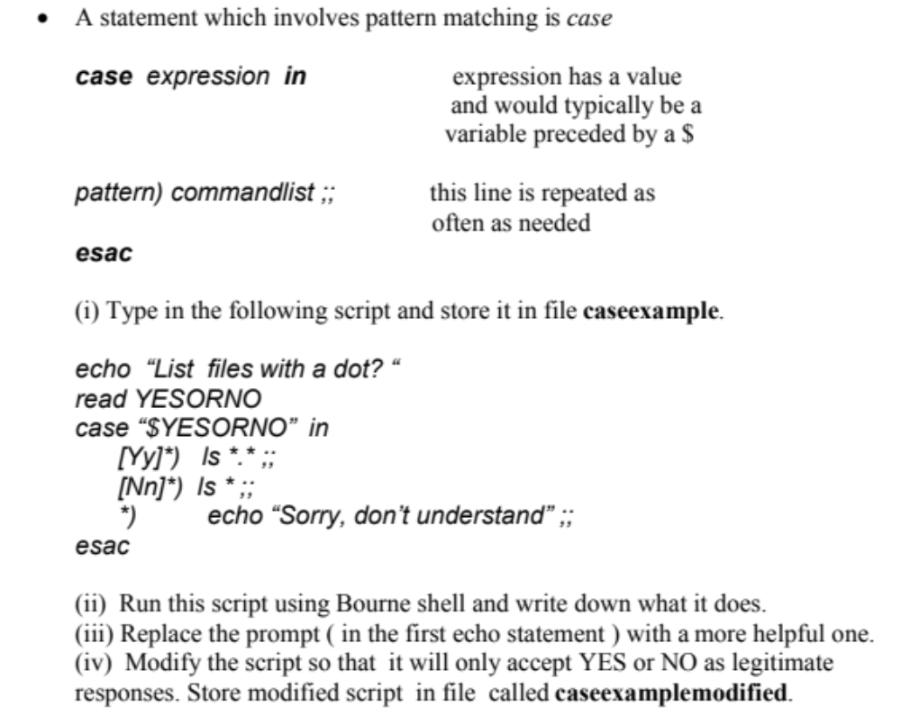  Write down your final script resulting from (ii), (iii) and (iv) above.
2. | 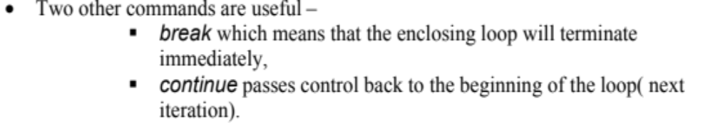
3. | 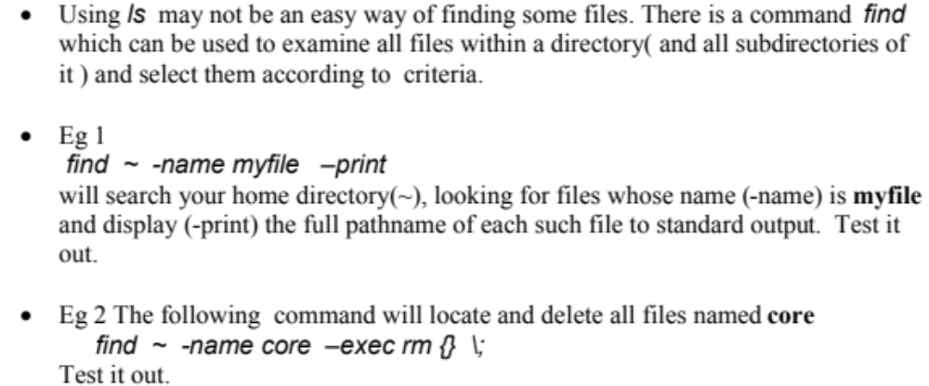
4. | 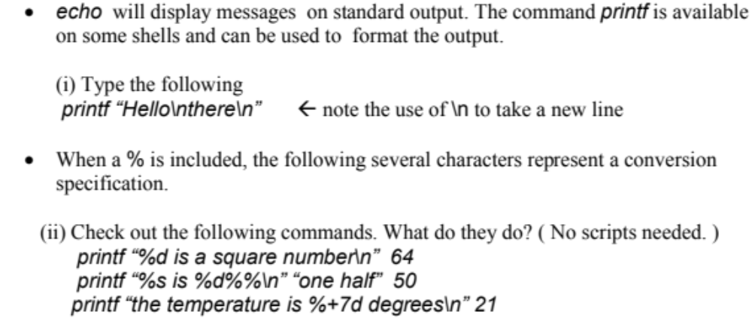
5. | 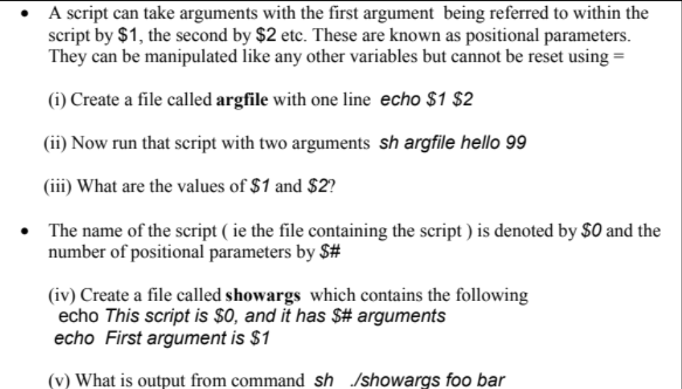  Write down your answer to (iii) and (v).
6. | 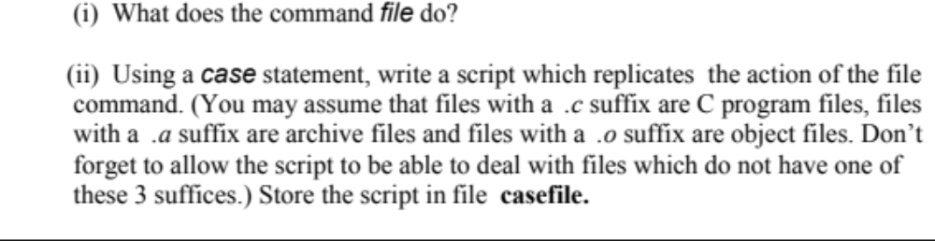  Write down your answer to (i).  Write down the script you created for (ii).
7. | 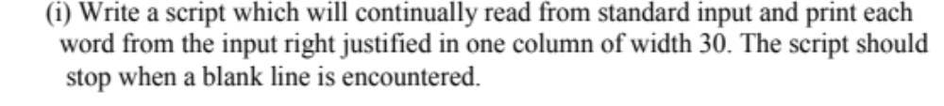  Write down your script.
8. | 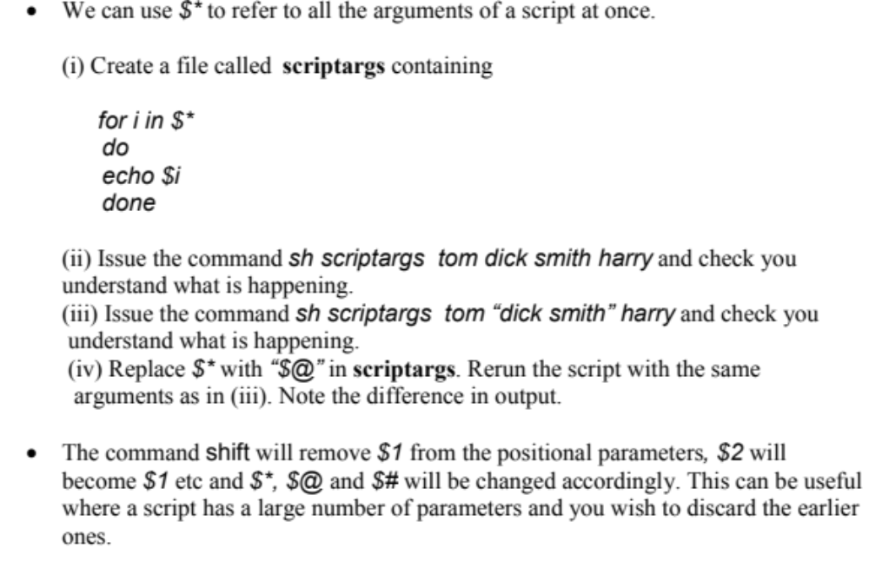
9. | 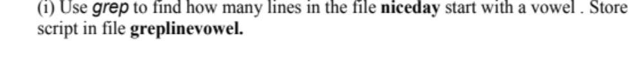  Write down the command you used.
10. | 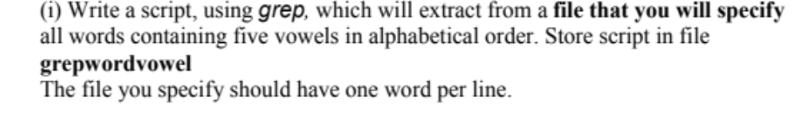  Write down your script.
11. | - Summarise new Unix commands that you have learnt in this practical as well as techniques and new features of Unix.

