ReactJS

Why is important? JS and jQuery don’t really scale. They are only suitable for smaller apps/dapps.

Stackoverflow survey. Answer = React (Framework and Lib).

Learn:

1) New language - markup included.

2) State management (reacting to user input).

3) API

Use VS Code.

NodeJS. Only stable. - JS on the server. Write Webservers. Automated trading bots.

NPM is used for development.

<https://2019.stateofjs.com/other-tools/>

We will use Axios.

node -v

npm -v

 the **DOM** **is** a set of interfaces and objects designed for managing HTML and XML documents.

Babeljs.io

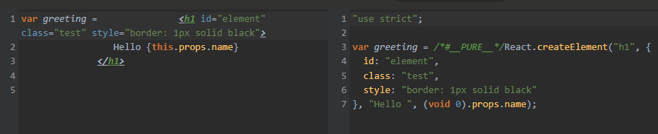

This is JSX - Javascript and XML

Classes in JS:

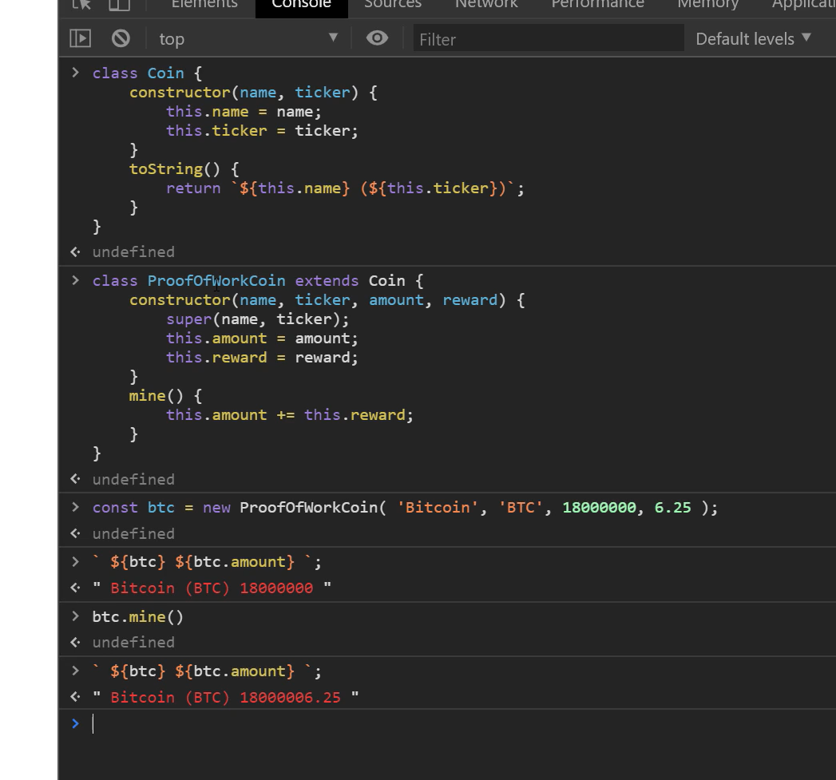

Prefixed numbers can be handled like this:

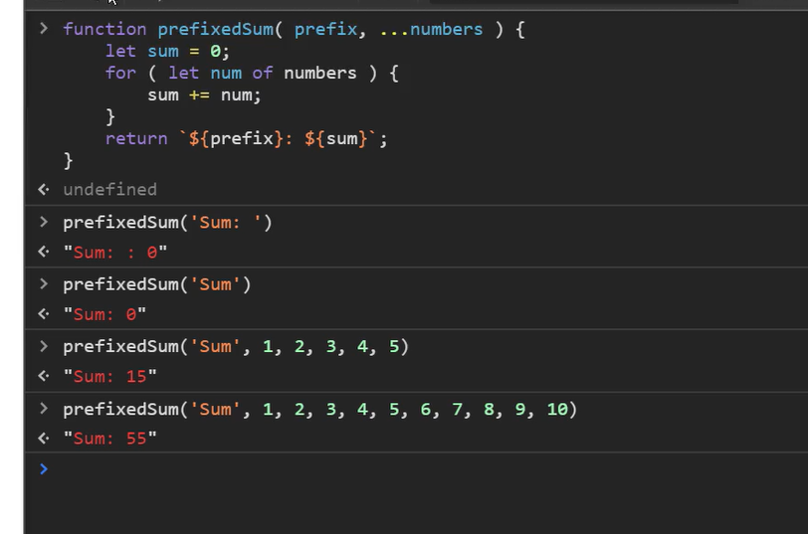

Arrow functions:

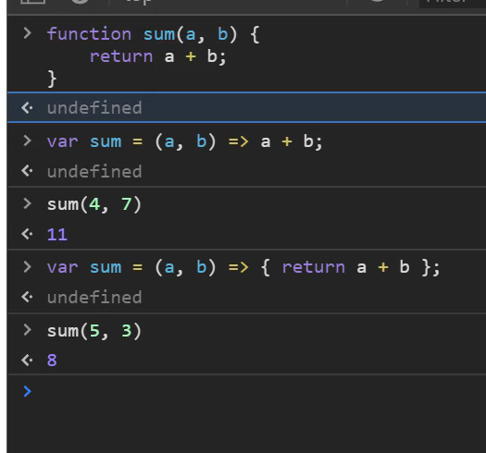

Deconstruction:

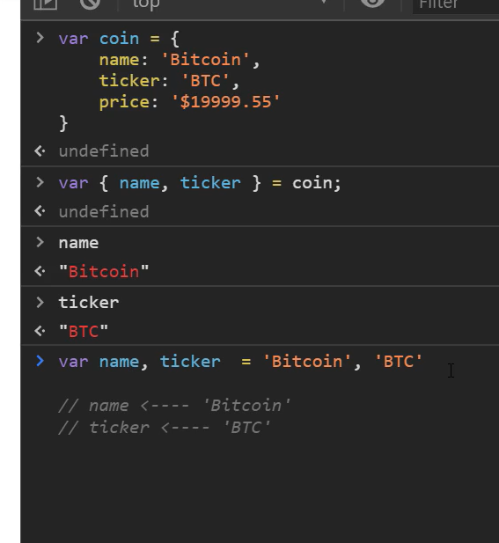

VS Code: Alt+Click allows cursor in several places.

Functional Components:

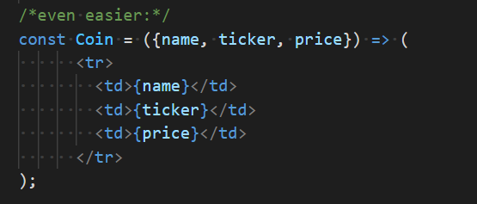

First destructured then just use attributes without $

React - by Facebook

Angular - by Google

<https://github.com/facebook/create-react-app> => shows the environment.

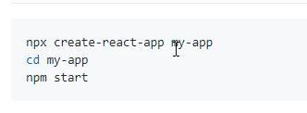

npx runs a package without downloading it!

npm start will initialize the localhost on port 3000.

Install Git for Windows as a shell.

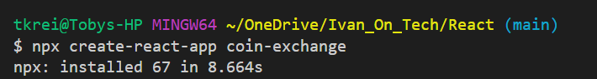

Installing VS Code extensions recommended is:

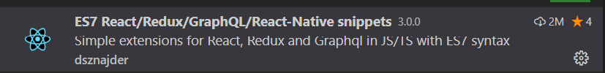

flex-direction: row // in CSS items side by side.

CSS flexbox properties.

Attributes in HTML are always strings <img class=’two’/>

Props in React can be many things <h1 className={123}></h1>

Typescript is a programming language built on top of JS. It would allow checking types in props.

Alternative: prop-types library in React.

‘this’ needs to be bound within a handler:

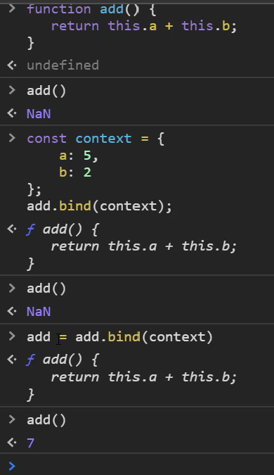

For state hooks:

<https://reactjs.org/docs/hooks-state.html>

<https://forum.ivanontech.com/t/event-binding-dan-abramov-conference-talk/19187/28>