A3 report
1. Fig1 raw data
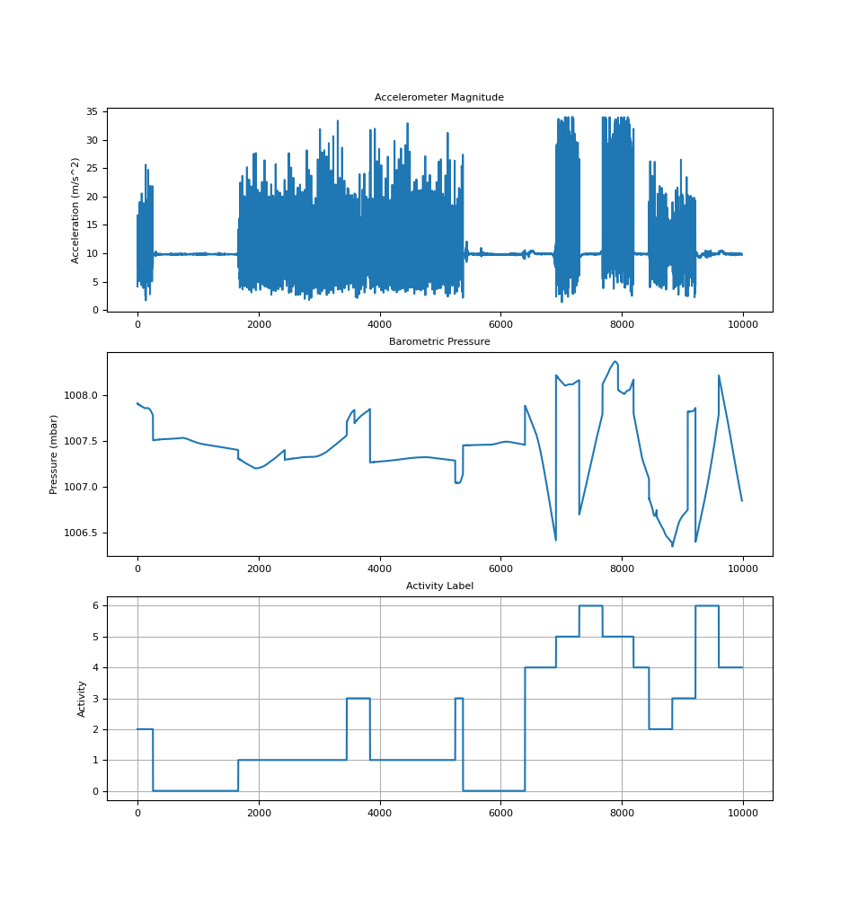

2.
features[0] is the mean magnitude of acceleration

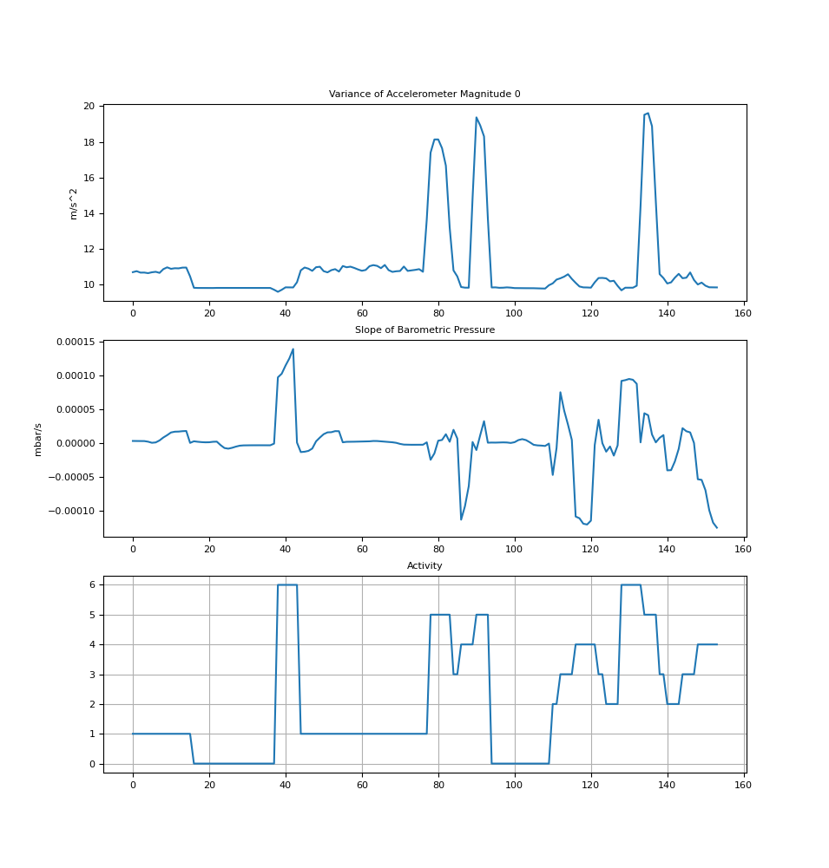

- features[1] is the variance of acceleration
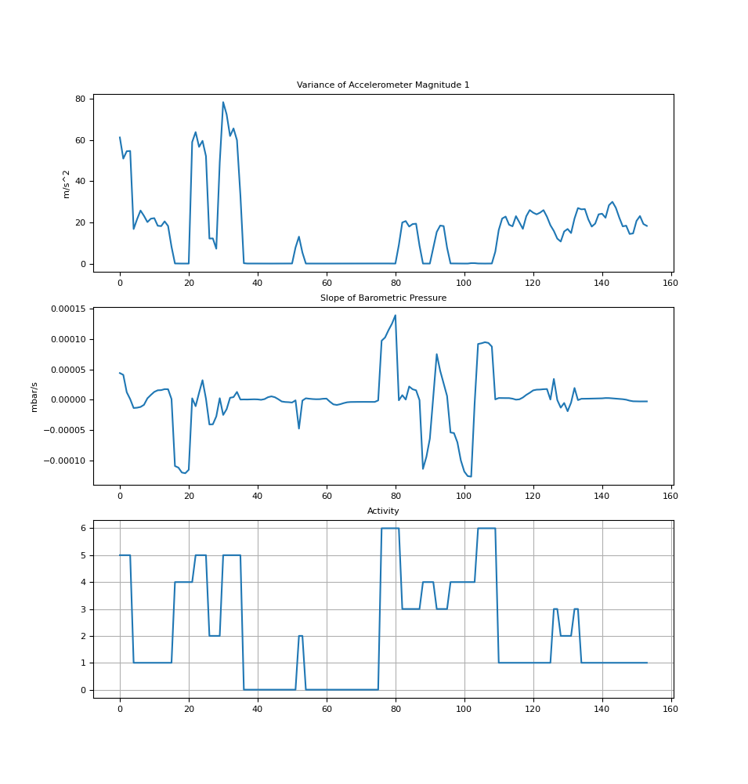

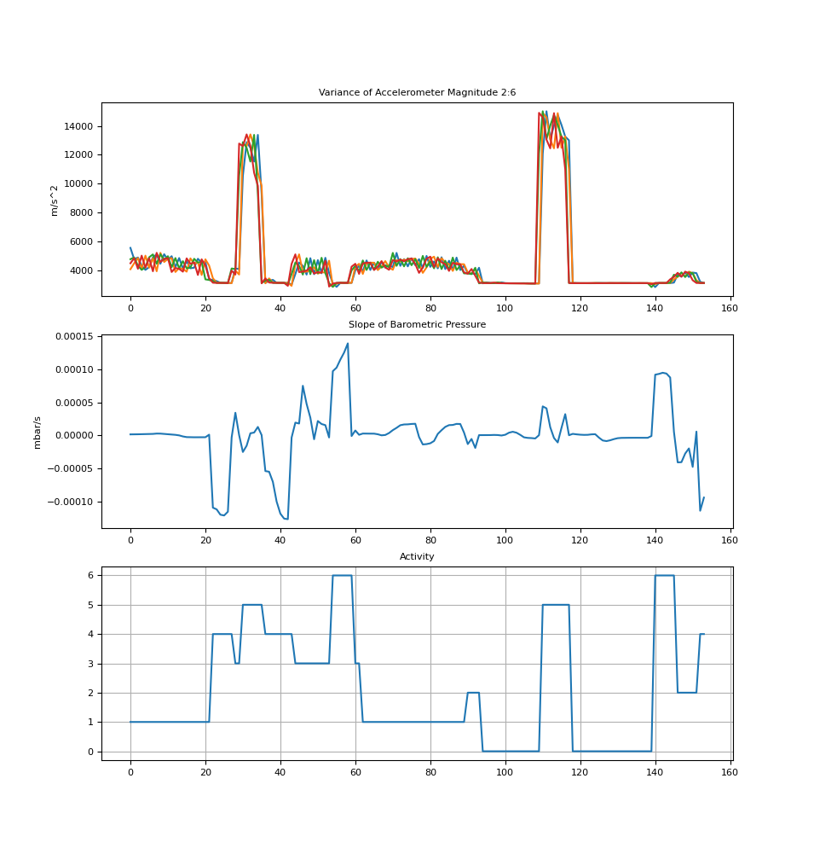
- features[2:6] is the fft power spectrum of equally-spaced frequencies

- features[6:12] is the fft power spectrum of frequencies in logarithmic scale
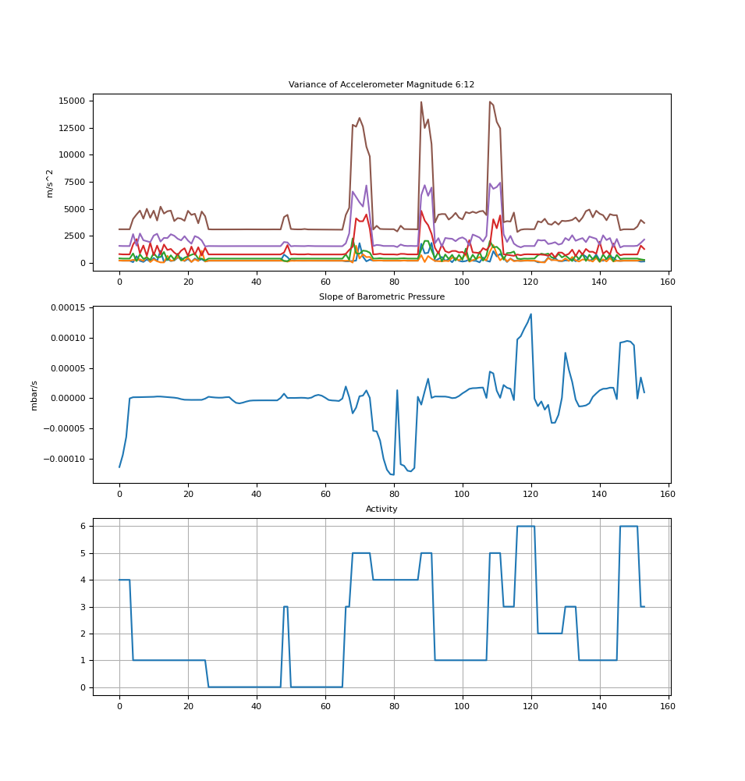

- features[13] is the slope of pressure
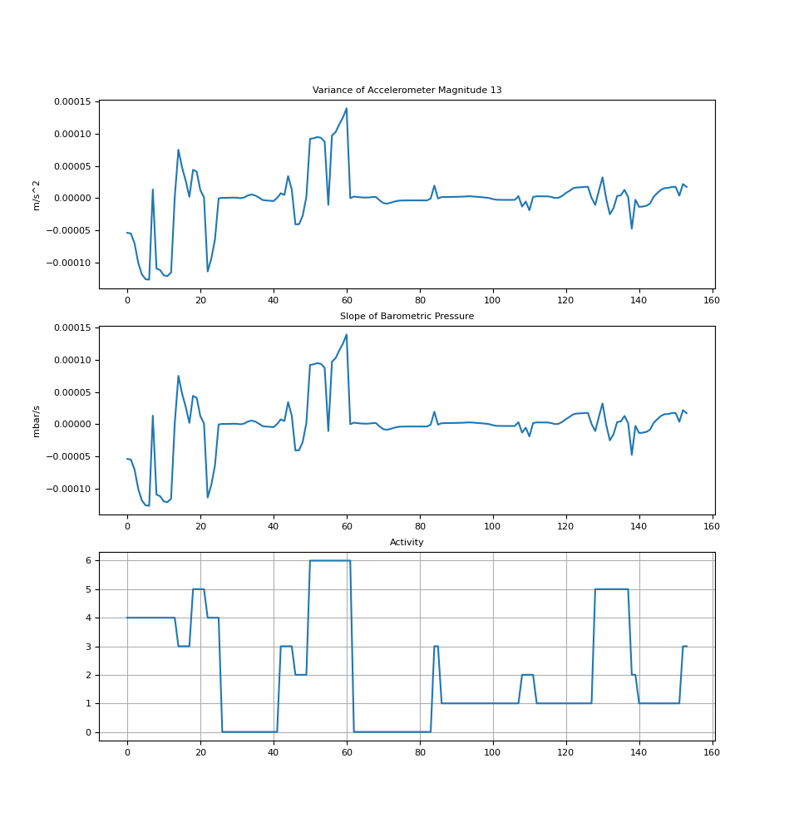

3.

Accelerometer Magnitude Variance
The accelerometer values can be interpreted in to show the following conclusions:
- Stationary: Shows very low variance (stable readings)
- Walking (flat surface): Shows moderate, consistent variance
- Walking (up/down stairs): Shows higher variance than flat walking
- Running: Shows the highest variance of all activities
- Elevator (up/down): Shows short spikes in variance during initial acceleration/deceleration
The variance feature is useful for distinguishing high-movement activities like running from stationary or low-movement activities like walking or standing in a lift. For example, in the 6:12 features extraction, we can see clear peaks in accelerometer variance during running activities (values reaching ~15,000 m/s^2).

Barometric Pressure Slope
The slope of barometric pressure effectively captures vertical movement:
- Walking up stairs: Shows consistent positive slope (pressure decreasing)
- Walking down stairs: Shows consistent negative slope (pressure increasing)
- Elevator up: Shows sharp positive slope during movement
- Elevator down: Shows sharp negative slope during movement
- Flat activities: Shows minimal slope changes (close to zero)
The pressure slope is helpful for vertical movement activities. In features[6:12], there are clear spikes in both directions, likely representing going up and down on stairs or in a lift

Activity
The activity graphs can be used to determine the severity of a movement.
- Flat/steady: Shows a constant level of movement
- Spikes: Shows a sudden movement, e.g. running or sudden acceleration from a change in height
The height of a spike can be helpful to determine which movement is happening. A flat low rated line would symbolise walking while a higher one could show movement at high speed while running.

4.
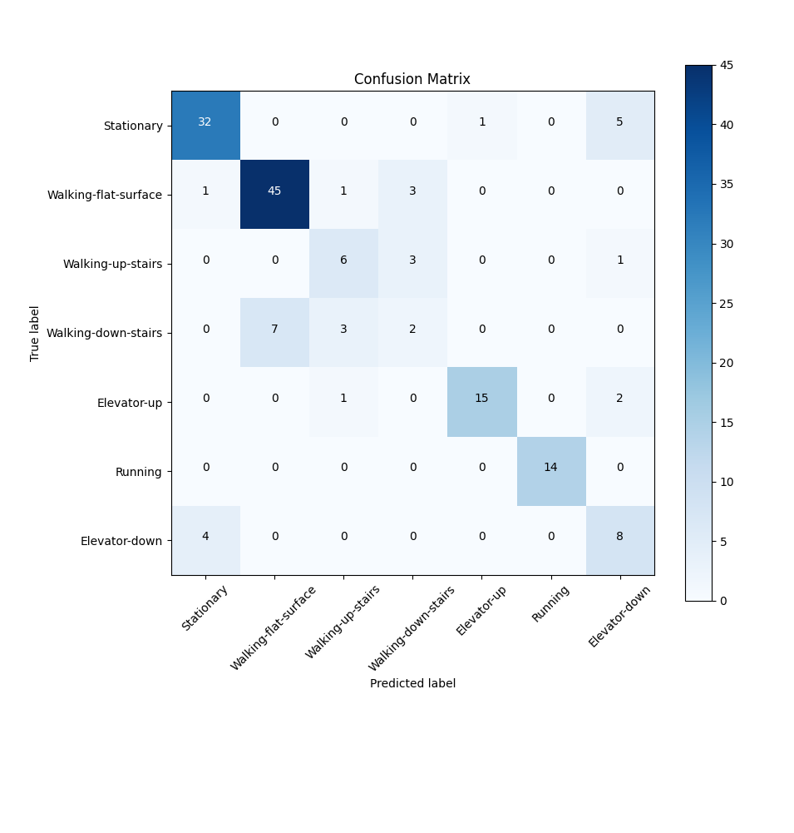

Precision = True Positives / (True Positives + False Positives)
Recall = True Positives / (True Positives + False Negatives)
Accuracy = (True Positives + True Negatives) / Total Samples

Activity | Precision | Recall | Accuracy
Stationary | 86.5% | 84.2% | 92.9%
Walking-flat-surface | 86.5% | 90.0% | 92.2%
Walking-up-stairs | 54.5% | 60.0% | 94.2%
Walking-down-stairs | 25.0% | 16.7% | 89.6%
Elevator-up | 93.8% | 83.3% | 97.4%
Running | 100.0% | 100.0% | 100.0%
Elevator-down | 50.0% | 66.7% | 92.2%
Overall | 70.9% | 71.6% | 94.1%

5.

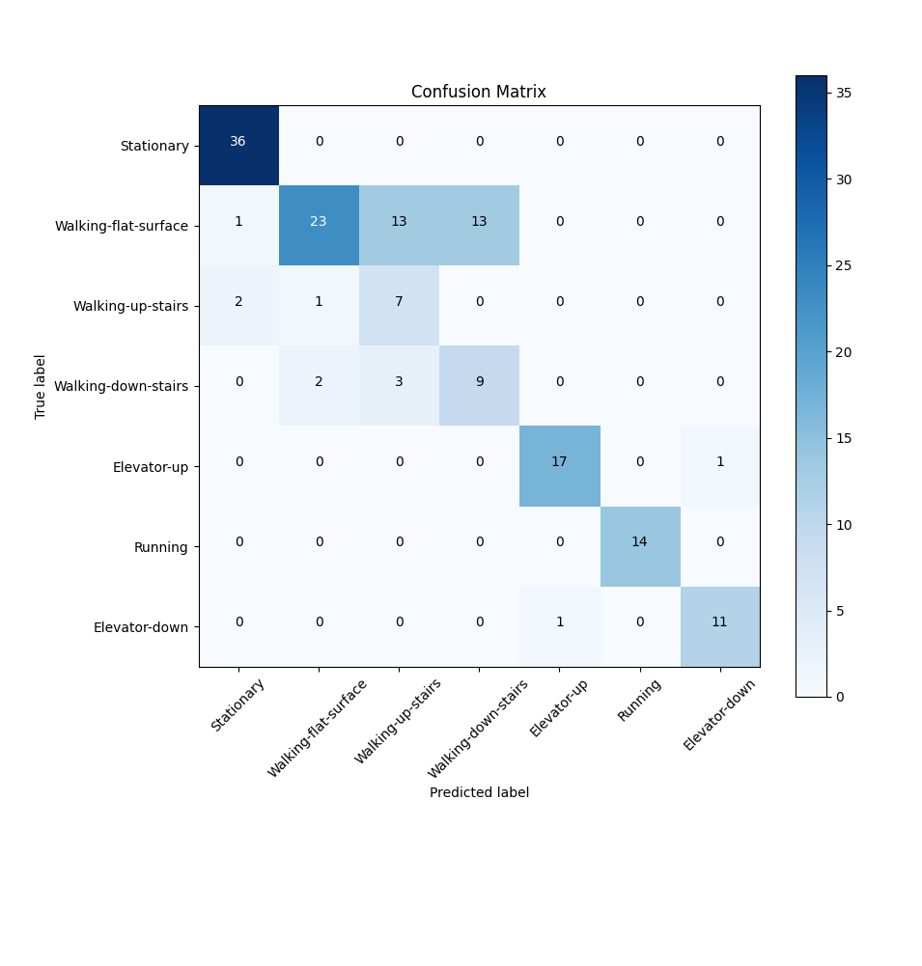
Activity | Precision | Recall | Accuracy
Stationary | 92.3% | 100.0% | 98.1%
Walking-flat-surface | 88.5% | 46.0% | 80.5%
Walking-up-stairs | 30.4% | 70.0% | 91.1%
Walking-down-stairs | 40.9% | 64.3% | 93.3%
Elevator-up | 94.4% | 94.4% | 98.7%
Running | 100.0% | 100.0% | 100.0%
Elevator-down | 91.7% | 91.7% | 98.7%
Overall | 76.9% | 80.9% | 94.3%

The model performs similarly on both data sets, but experiences trouble when predicting stair based movement. I believe this is because the stairs nearest to the lab have 2 stair sections with a flat portion in the middle. The flat portion is of course present in walking on a flat surface, but also in both directions of the stairs. The same movement data being in 3 different classifications is bound to cause faulty conclusions. While I did try to only collect data while on actual stairs, others likely did not which is why particularly in the walking up stairs class, the model performed better on my data compared to the larger data set.
The model is very good at predicting running, scoring 100% on both data sets. This is likely because running is the only class that includes a faster than walking pace, making it much more distinguishable than the others.

DO 6 and 7

use SHAP to find best features

