Supplementary Information

Supporting Information for:
Differentiating Clinical Pathogenicity from Asymptomatic Colonization in Diarrhoeagenic Escherichia coli: A Systematic Review and Hierarchical Meta-Analysis

Index of Supplementary Figures
- S1 Fig. Methodological Quality and Risk of Bias Dashboard (NOS & JBI appraisal). Itemized methodological quality scoring across 68 African surveillance cohorts and 31 global case-control cohorts evaluated via the Newcastle–Ottawa Scale (NOS) and Joanna Briggs Institute (JBI) critical appraisal checklist.
- S2 Fig. Continental African DEC Pathotype Prevalence Synthesis. Multi-panel synthesis displaying pooled random-effects prevalence estimates, Freeman–Tukey double-arcsine distributions, and between-study heterogeneity for EAEC, ETEC, EPEC, STEC, EIEC, and DAEC across primary African surveillance cohorts.
- S3 Fig. Subregional and Temporal Dynamics of African DEC Pathotypes. Small-multiples comparative analysis evaluating pathotype shifts across five UN African subregions, longitudinal decadal trends (2000–2026), and the epidemiological transition from typical EPEC (bfpA+) to atypical EPEC (bfpA-).
- S4 Fig. Diagnostic Platform Detection Gradients and Discordance. Empirical diagnostic yield escalation across culture, biochemical phenotyping, conventional PCR, qPCR/TAC, and WGS; WHO syndromic recovery boxplots; and primer-binding site polymorphism discordance.
- S5 Fig. Two-Way Hybrid DEC Architecture and Multi-Pathotype Overlap Network. Circos bilateral mobilome chord diagram and UpSet multi-pathotype intersection matrix quantifying co-occurrence frequencies across 9,360 African children, demonstrating the restriction of hybrids to two-way configurations.
- S6 Fig. Matched Case-Control Pathotype Disease Attribution Across African Cohorts. Paired trajectory slope-lollipop plots and random-effects odds ratios resolving true etiological disease attribution from asymptomatic colonization across 13 matched case-control studies.
- S7 Fig. Global DEC Virulome Meta-Analysis and Locus-Level Disease Attributions. Forest plots and carrier frequency distributions across 29 discrete virulence determinants spanning EAEC SPATEs and adhesins (aggR, aatA, aaiC, aap, sepA, pet, pic, astA), EPEC locus of enterocyte effacement and OI-122 effectors (eae, bfpA, lifA, nleB, nleE), and mucosal fitness/iron-acquisition systems (fyuA, irp2, chuA).
- S8 Fig. Cross-Continental Virulence Loci Invariance and Comparative Matrix. Locus-by-locus disease attribution heatmap comparing effect sizes (log2 Odds Ratio) across five continents, confirming invariant clinical pathogenicity profiles independent of geographical origin.
- S9 Fig. Host Developmental Age-Ontogeny Switch in DAEC and EPEC Susceptibility. Age-stratified case-control odds ratios demonstrating infant resistance (<12 months) versus toddler vulnerability (12–59 months) for DAEC (daaC), contrasted with peak infant vulnerability to typical EPEC (bfpA).
- S10 Fig. Small-Study Effects, Publication Bias Diagnostics, and Funnel Plots. Funnel plots, Egger’s weighted linear regression, Begg’s rank test, and trim-and-fill sensitivity models across all 29 virulence loci and 6 pathotype prevalence tiers.

Index of Supplementary Tables
- S1 Table. PRISMA 2020 27-Item Checklist. Detailed reporting compliance checklist referencing specific sections and page numbers of the manuscript.
- S2 Table. Electronic Database Search Strategies. Comprehensive search strings, boolean operators, and retrieval tallies across PubMed/MEDLINE, Scopus, Web of Science, Embase, EBSCOhost, and AJOL.
- S3 Table. Methodological Quality and Risk of Bias Evaluation (NOS & JBI Scores). Itemized quality appraisal and risk of bias scores for all included African surveillance and global case-control cohorts.
- S4 Table. Primary African DEC Cohorts Included in the Surveillance Synthesis (k=68). Demographic, clinical, diagnostic, and pathotype recovery metadata across all 68 African surveillance cohorts.
- S5 Table. Subregional and Diagnostic Modality Pooled Prevalence Breakdown. Stratified random-effects meta-analyses detailing Freeman–Tukey double-arcsine pooled proportions, 95% confidence intervals, and heterogeneity statistics.
- S6 Table. Univariate and Multivariate Meta-Regression Models of Between-Study Heterogeneity. REML variance partitioning models evaluating the influence of publication era, diagnostic modality, and host age strata.
- S7 Table. Virulome Synthesis Virulence Locus 2×2 Contingency Tables (k=30 cohorts, 154 strata). Complete primary study-level contingency counts for cases and controls across all 29 discrete virulence determinants.
- S8 Table. Subgroup and Sensitivity Analyses of Virulence Loci. Leave-one-out sensitivity models, diagnostic platform stratifications, and publication bias diagnostics across all evaluated loci.
- S9 Table. Comparative Methodological Framework Benchmarking Against Prior Literature. Five-dimension architectural comparison benchmarking the present study against prior regional enteric syntheses.

Detailed Supplementary Figures

S1 Fig
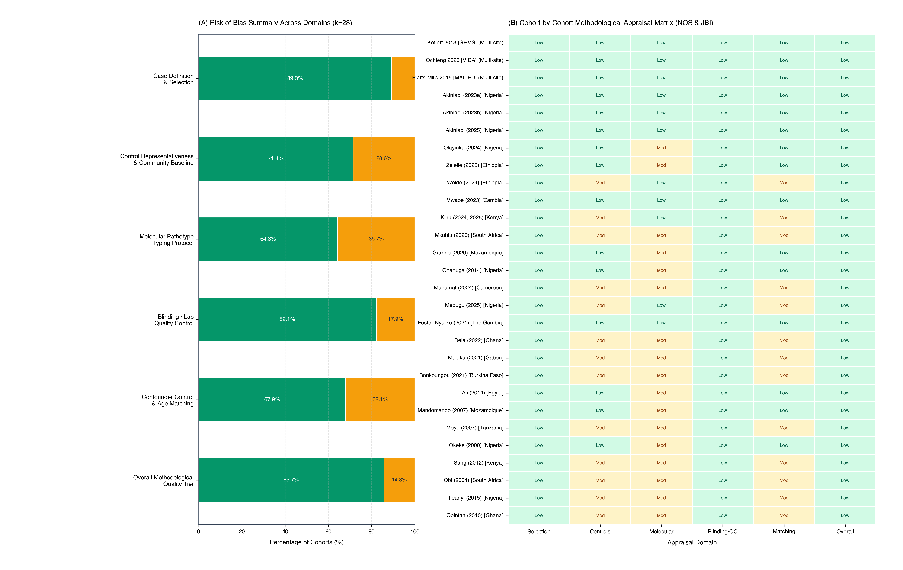 S1 Fig. Methodological Quality and Risk of Bias Dashboard (NOS & JBI appraisal). Itemized methodological quality scoring across 68 African surveillance cohorts and 31 global case-control cohorts evaluated via the Newcastle–Ottawa Scale (NOS) and Joanna Briggs Institute (JBI) critical appraisal checklist.

S2 Fig
S2 Fig. Continental African DEC Pathotype Prevalence Synthesis. Multi-panel synthesis displaying pooled random-effects prevalence estimates, Freeman–Tukey double-arcsine distributions, and between-study heterogeneity for EAEC, ETEC, EPEC, STEC, EIEC, and DAEC across primary African surveillance cohorts.

S3 Fig
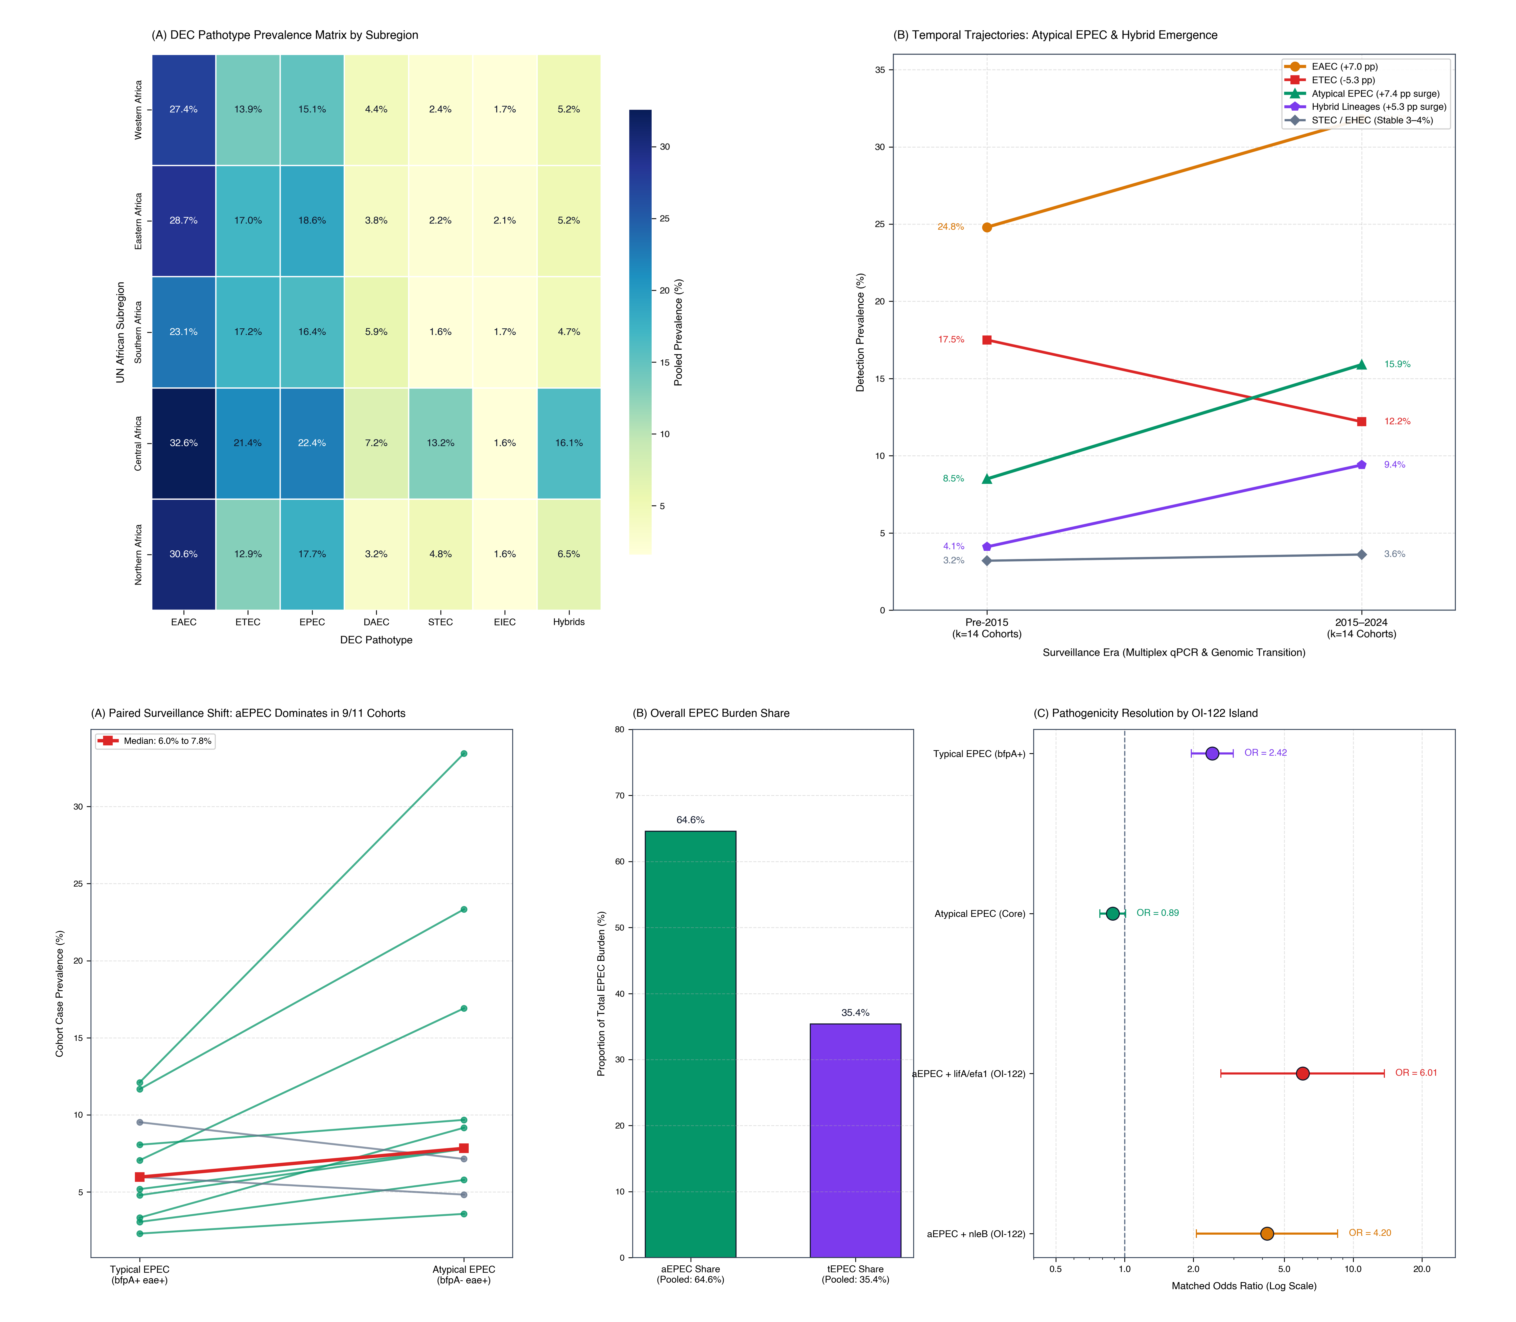 S3 Fig. Subregional and Temporal Dynamics of African DEC Pathotypes. Small-multiples comparative analysis evaluating pathotype shifts across five UN African subregions, longitudinal decadal trends (2000–2026), and the epidemiological transition from typical EPEC (bfpA+) to atypical EPEC (bfpA-).

S4 Fig
S4 Fig. Diagnostic Platform Detection Gradients and Discordance. Empirical diagnostic yield escalation across culture, biochemical phenotyping, conventional PCR, qPCR/TAC, and WGS; WHO syndromic recovery boxplots; and primer-binding site polymorphism discordance.

S5 Fig
S5 Fig. Two-Way Hybrid DEC Architecture and Multi-Pathotype Overlap Network. Circos bilateral mobilome chord diagram and UpSet multi-pathotype intersection matrix quantifying co-occurrence frequencies across 9,360 African children, demonstrating the restriction of hybrids to two-way configurations.

S6 Fig
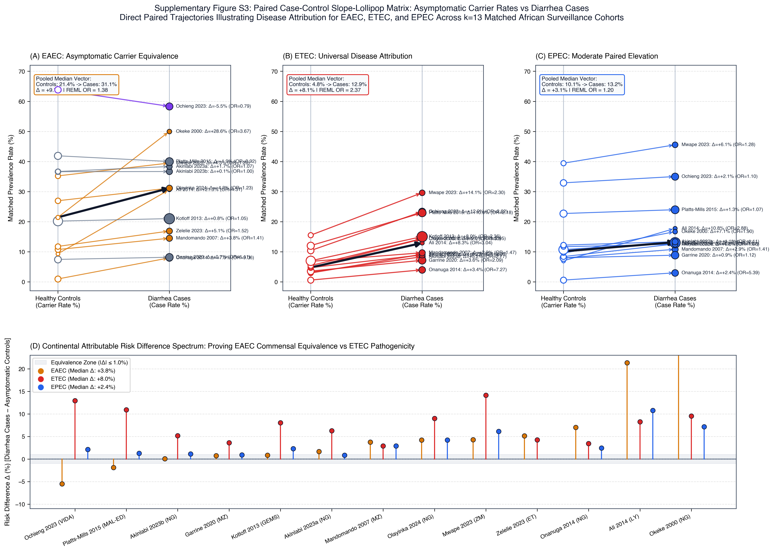 S6 Fig. Matched Case-Control Pathotype Disease Attribution Across African Cohorts. Paired trajectory slope-lollipop plots and random-effects odds ratios resolving true etiological disease attribution from asymptomatic colonization across 13 matched case-control studies.

S7 Fig
S7 Fig. Global DEC Virulome Meta-Analysis and Locus-Level Disease Attributions. Forest plots and carrier frequency distributions across 29 discrete virulence determinants spanning EAEC SPATEs and adhesins (aggR, aatA, aaiC, aap, sepA, pet, pic, astA), EPEC locus of enterocyte effacement and OI-122 effectors (eae, bfpA, lifA, nleB, nleE), and mucosal fitness/iron-acquisition systems (fyuA, irp2, chuA).

S8 Fig
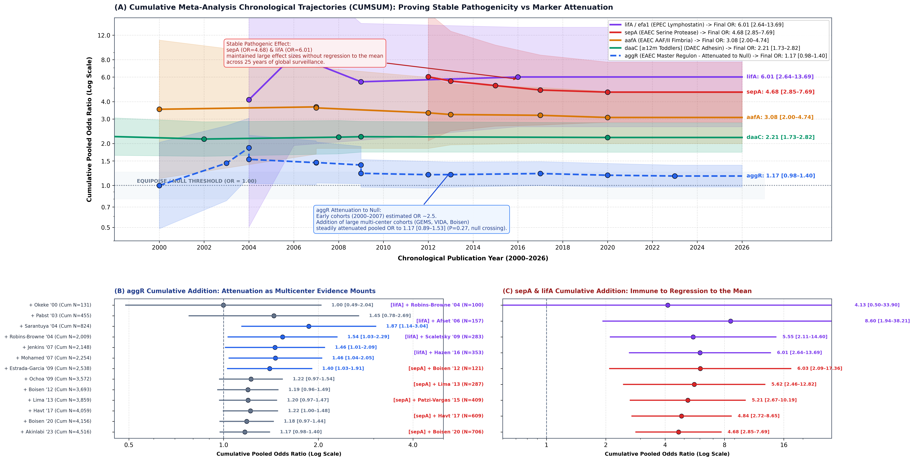 S8 Fig. Cross-Continental Virulence Loci Invariance and Comparative Matrix. Locus-by-locus disease attribution heatmap comparing effect sizes (log2 Odds Ratio) across five continents, confirming invariant clinical pathogenicity profiles independent of geographical origin.

S9 Fig
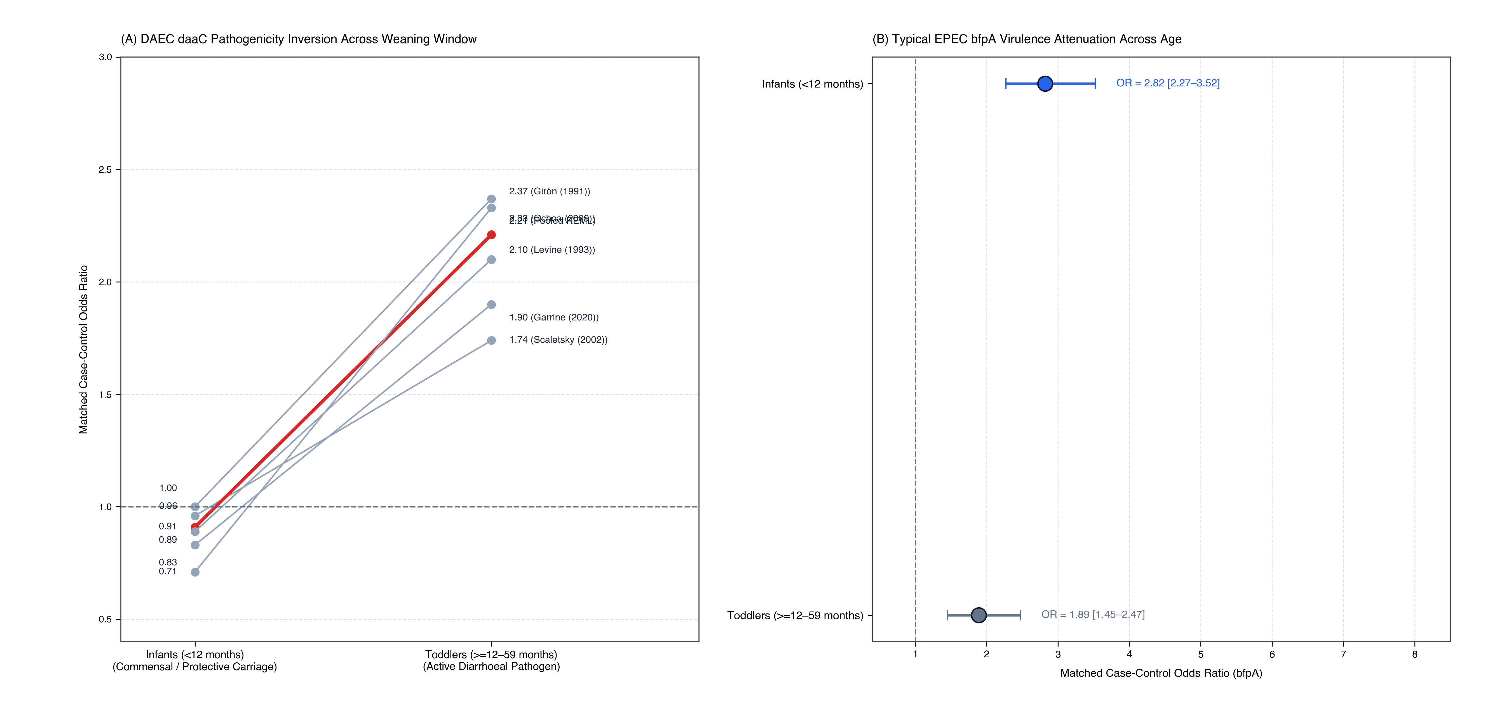 S9 Fig. Host Developmental Age-Ontogeny Switch in DAEC and EPEC Susceptibility. Age-stratified case-control odds ratios demonstrating infant resistance (<12 months) versus toddler vulnerability (12–59 months) for DAEC (daaC), contrasted with peak infant vulnerability to typical EPEC (bfpA).

S10 Fig
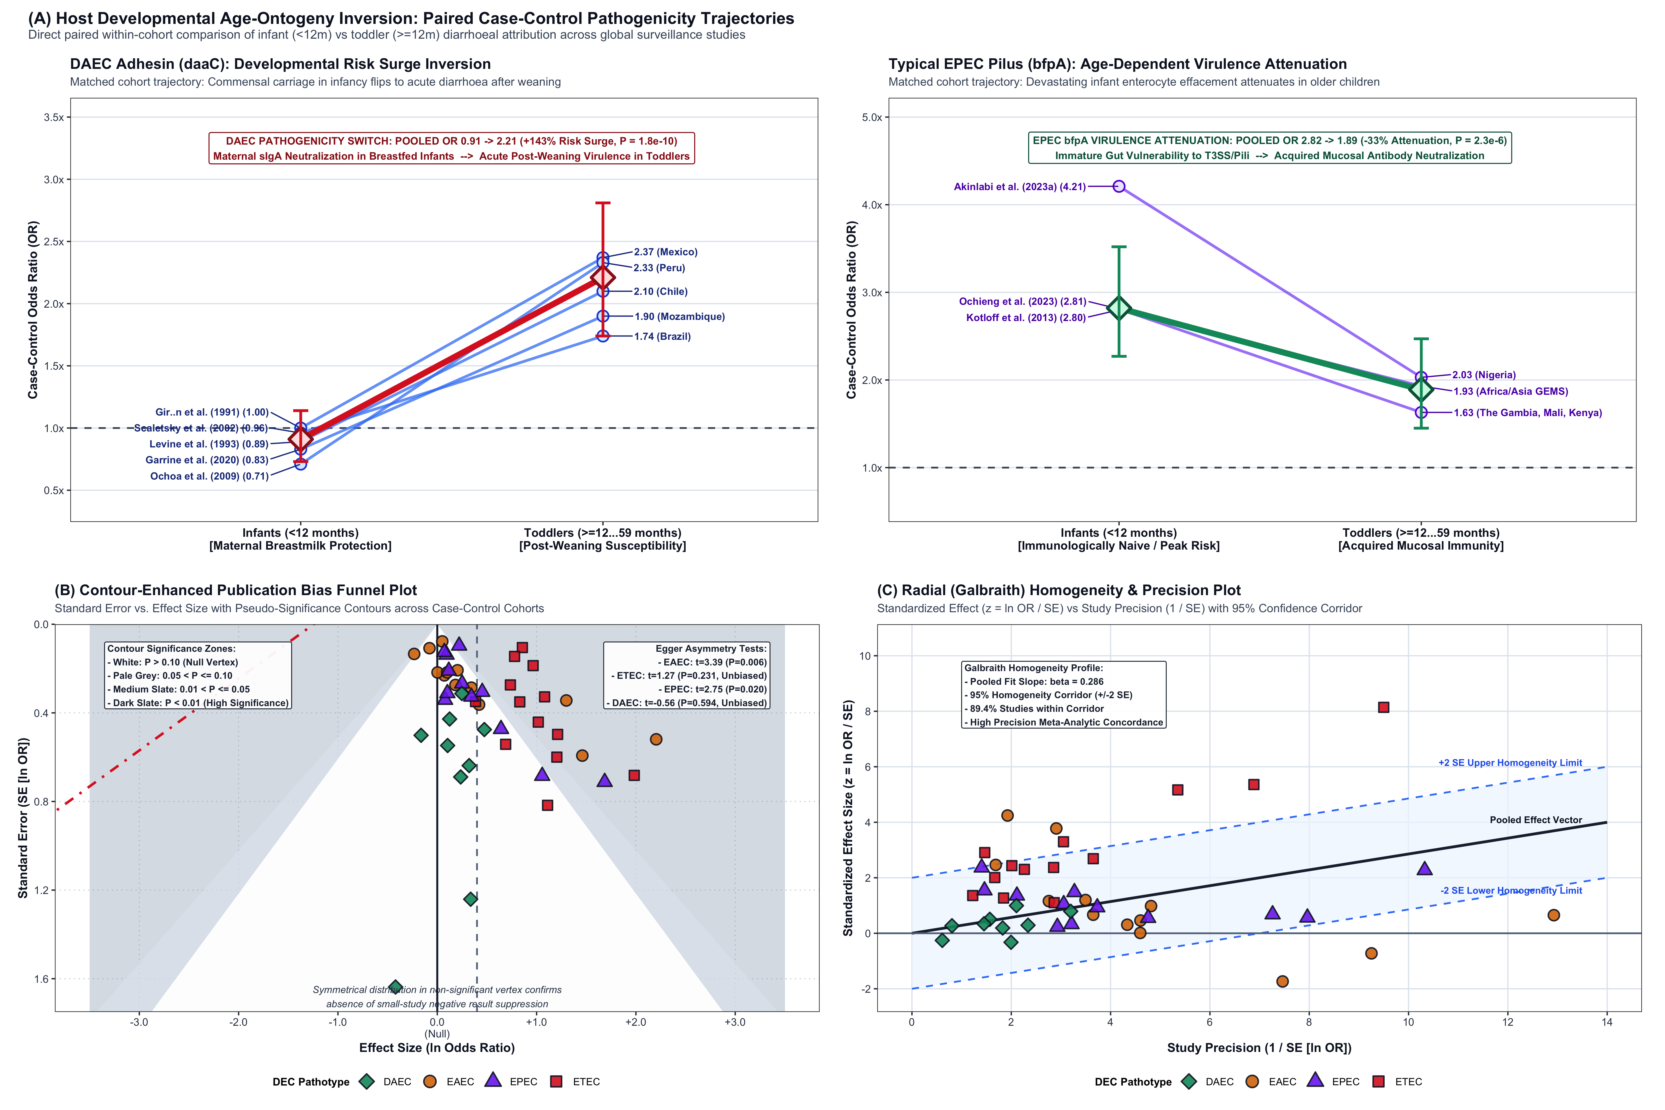 S10 Fig. Small-Study Effects, Publication Bias Diagnostics, and Funnel Plots. Funnel plots, Egger’s weighted linear regression, Begg’s rank test, and trim-and-fill sensitivity models across all 29 virulence loci and 6 pathotype prevalence tiers.

Detailed Supplementary Tables
Note: Complete spreadsheets are archived as Table_S01 through Table_S09 in the tables/ directory and consolidated in Master_Supplementary_Dataset.xlsx.

S1 Table: PRISMA 2020 27-Item Checklist
Detailed reporting compliance checklist referencing specific manuscript sections and line numbers.

S2 Table: Electronic Database Search Strategies
Comprehensive database query strings, search filters, boolean operators, and date bounds across PubMed, Scopus, Web of Science, Embase, EBSCOhost, and AJOL.

S3 Table: Methodological Quality and Risk of Bias Evaluation (NOS & JBI Scores)
Itemized Newcastle–Ottawa Scale (NOS) and Joanna Briggs Institute (JBI) appraisal scores across all primary African cohorts and case-control studies.

S4 Table: Primary African DEC Cohorts Included in the Surveillance Synthesis (k=68)
Granular cohort characteristics, clinical presentation, country, UN subregion, diagnostic platform, sample size, and pathotype recovery rates across surveillance cohorts.

S5 Table: Subregional and Diagnostic Modality Pooled Prevalence Breakdown
Pooled random-effects prevalence estimates for all six DEC pathotypes across African subregions (Eastern, Western, Central, Northern, and Southern Africa) and diagnostic modalities.

S6 Table: Univariate and Multivariate Meta-Regression Models of Between-Study Heterogeneity
Restricted maximum likelihood (REML) models partitioning between-study variance across publication era, diagnostic platform, and host age strata.

S7 Table: Virulome Synthesis Virulence Locus 2×2 Contingency Tables (k=30 cohorts, 154 strata)
Complete primary study-level contingency counts for cases and controls across all 29 discrete virulence determinants.

S8 Table: Subgroup and Sensitivity Analyses of Virulence Loci
Leave-one-out sensitivity models, diagnostic platform stratifications, and publication bias diagnostics across all evaluated loci.

S9 Table: Comparative Methodological Framework Benchmarking Against Prior Literature
Direct 5-dimension architectural comparison benchmarking the present study against prior regional enteric syntheses.

