PIZZA SALES SQL QUERIES

KPI’s

-- 1. TOTAL REVENUE

SELECT ROUND(SUM(total_price),2) AS Total_Revenue

FROM pizza_sales;

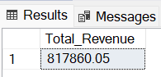

--2. AVERAGE ORDER VALUE

SELECT SUM(total_price)/COUNT(DISTINCT order_id) AS Average_order_value

FROM pizza_sales;

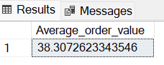

--3. TOTAL PIZZA SOLD

SELECT SUM(quantity) AS Total_Pizza_Sold

FROM pizza_sales;

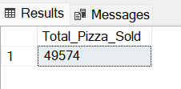

--4. TOTAL ORDERS

SELECT COUNT(DISTINCT order_id) AS Total_Orders

FROM pizza_sales;

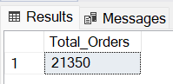

--5. AVERAGE PIZZA PER ORDER

SELECT CAST(CAST(SUM(quantity)AS DECIMAL(10,2)) /CAST(COUNT(DISTINCT order_id) AS DECIMAL(10,2)) AS DECIMAL(10,2)) AS Average_Pizzas_Per_Order

FROM pizza_sales;

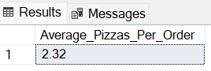

CHARTS REQUIREMENT

--1 DAILY TREND OF TOTAL ORDERSORDER

SELECT

DATENAME(DW, Order_date) as Order_Day,

COUNT(DISTINCT Order_id) AS Total_Orders

FROM pizza_sales

GROUP BY DATENAME(DW, Order_date);

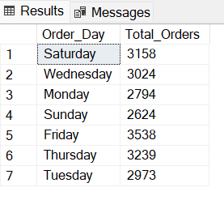

--2 MONTHLY TREND OF TOTAL ORDERS

SELECT

DATENAME(MONTH, Order_date) as Month_Name,

COUNT(DISTINCT Order_id) AS Total_Orders

FROM pizza_sales

GROUP BY DATENAME(MONTH, Order_date)

ORDER BY Total_Orders DESC;

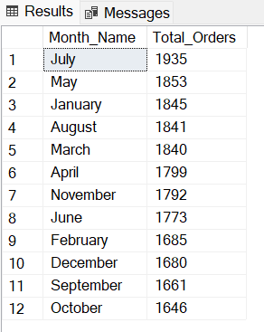

--3. PERCENTAGE OF SALES BY PIZZA CATEGORY

SELECT

pizza_category, SUM(total_price) AS Total_Sales,

SUM(total_price)*100/(SELECT SUM(total_price) FROM pizza_sales) AS Percentage_of_Sales

FROM pizza_sales

GROUP BY pizza_category;

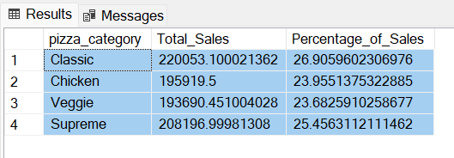

--4. PERCENTAGE OF SALES BY PIZZA SIZE

SELECT

pizza_size, CAST(SUM(total_price) AS DECIMAL(10,2)) AS Total_Sales,

CAST(SUM(total_price)*100/(SELECT SUM(total_price) FROM pizza_sales) AS DECIMAL(10,2)) AS Percentage_of_Sales

FROM pizza_sales

GROUP BY pizza_size

ORDER BY Percentage_of_Sales DESC;

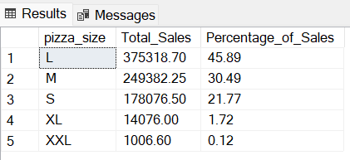

--5. TOP 5 BEST SELLERS BY REVENUE, TOTAL QUANTITY AND TOTAL ORDERS

TOP 5 BEST SELLERS BY REVENUE

SELECT TOP 5 pizza_name, SUM(total_price ) AS Total_Revenue

FROM pizza_sales

GROUP BY pizza_name

ORDER BY Total_Revenue DESC;

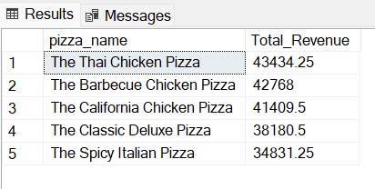

TOP 5 BEST SELLERS BY TOTAL QUANTITY

SELECT TOP 5 pizza_name, SUM(quantity) AS Total_Quantity

FROM pizza_sales

GROUP BY pizza_name

ORDER BY Total_Quantity DESC;

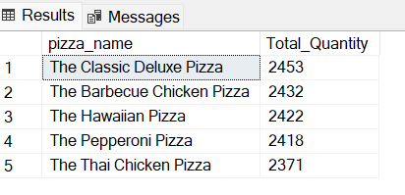

TOP 5 BEST SELLERS BY TOTAL ORDERS

SELECT TOP 5 pizza_name, COUNT(DISTINCT order_id ) AS Total_Orders

FROM pizza_sales

GROUP BY pizza_name

ORDER BY Total_Orders DESC;

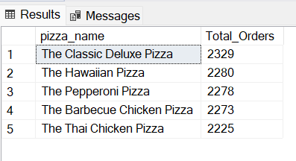

--5. TOP 5 WORST SELLERS BY REVENUE, TOTAL QUANTITY AND TOTAL ORDERS

TOP 5 WORST SELLERS BY TOTAL QUANTITY

SELECT TOP 5 pizza_name, SUM(quantity) AS Total_Quantity

FROM pizza_sales

GROUP BY pizza_name

ORDER BY Total_Quantity ASC;

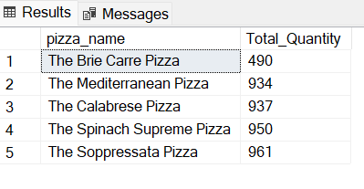

TOP 5 WORST SELLERS BY REVENUE

SELECT TOP 5 pizza_name, SUM(total_price ) AS Total_Revenue

FROM pizza_sales

GROUP BY pizza_name

ORDER BY Total_Revenue ASC;

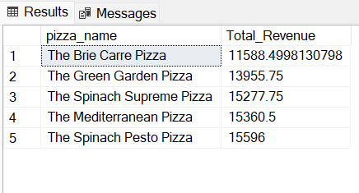

TOP 5 WORST SELLERS BY TOTAL ORDERS

SELECT TOP 5 pizza_name, COUNT(DISTINCT order_id ) AS Total_Orders

FROM pizza_sales

GROUP BY pizza_name

ORDER BY Total_Orders ASC;

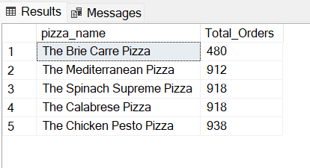

--NOTE

/*If we want to apply the Month, Quarter, Week filters to the above queries we

can use*/

WHERE clause. Follow some of below examples

SELECT DATENAME(DW, order date) AS order day, COUNT(DISTINCT order_id) AS

total orders

FROM pizza sales

WHERE MONTH(order date) = 1

GROUP BY DATENAME(DW, order date);

/*Here MONTH(order date) = 1 indicates that the output is for the month of

January. MONTH(order date) = 4 indicates output for Month of April.*/

SELECT DATENAME(DW, order date) AS order day, COUNT(DISTINCT order id) AS

total orders

FROM pizza sales

WHERE DATEPART(QUARTER, order date) = 1

GROUP BY DATENAME(DW, order date)

/*Here DATEPART(QUARTER, order date) = 1 indicates that the output is for

the Quarter 1. MONTH(order date) = 3 indicates output for Quarter 3.

SELECT pizza_category, sum(total_price) as Total_Sales, sum(total_price) * 100 /

(SELECT sum(total_price) from pizza_sales WHERE MONTH(order_date) = 1) AS PCT

from pizza_sales

WHERE MONTH(order_date) = 1

GROUP BY pizza_category;  
/*Here WHERE MONTH(order_date) = 1 filters the output for the Month of January. Also, if it is applied to the main query, it should also be used in the subquery to get an accurate result.