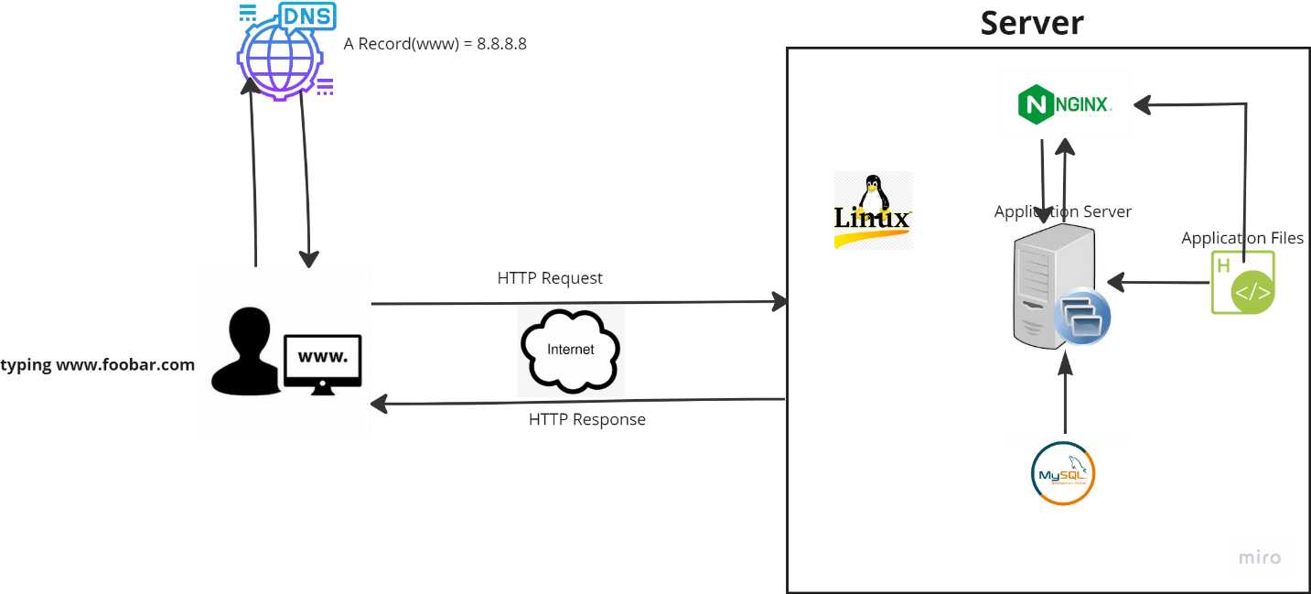

<https://webwhiteboard.com/board/Ek19OZ27ArJqXGyKKc65iOt34z5rLYP1/>

Simple Web Infrastructure

Explained some specifics about this infrastructure:

* Server: In computing, a server is a piece of computer hardware or software (computer program) that provides functionality for other programs or devices, called "clients."
* the role of the domain name: Domain names provide an easy way to recognize and memorize the names using the numerically addressed Internet resources. Example: [www.google.com](http://www.google.com) translates to 8.8.8.8
* type of DNS record www is in [www.foobar.com](http://www.foobar.com): The record type is A Record which maps website to a specific IP address.
* the role of the web server: The main role of a web server is to display website content through storing, processing and delivering webpages to users.
* the role of the application server: An application server is a software framework that provides both facilities to create web applications and a server environment to run them.
* the role of the database: A database is a store house for a large amount of data.
* the server using to communicate with the computer of the user requesting the website: Communication between the client and the server occurs over the internet network through the TCP/IP protocol suite.

The Issues Are with This Infrastructure:

* SPOF: A SPOF or single point of failure is any non-redundant part of a system that, if dysfunctional, would cause the entire system to fail. My SPOF includes the internet link, mySQL server, application server.
* Downtime when maintenance needed (like deploying new code web server needs to be restarted): During maintenance, all services are down and this is do the fact that I only have one server.
* Cannot scale if too much incoming traffic: This is because I do not have load balancer in my web infrastructure.