Geography - (Human Geography)

AQA GCSE Geography Revision Notes – Unit Two Higher Tier

Disclaimer; I made this to help me revise when the exam comes around, but while I’ve tried to make this document as accurate as possible, I can’t guarantee that the information in this document is completely correct – I may have made mistakes.

# 8 – Population Change

## 8.1 – How does the population grow?

### Definitions:

* **Birth Rate (BR):** The number of people born per 1000 people every year. Usually in the region of 5-50, but rates near 50 are rare as birth control is so advanced.
* **Death Rate (DR):** The number of people who have died per 1000 people every year. Usually around 5-20, unless there is a major disaster such as an earthquake or famine.
* **Natural Change:** The difference between the *Birth Rate* and *Death Rate.*
* **Natural Change Calculations:**

*(BR-DR)/10*

*E.g. 10.7 – 10.2 = 0.6*

*0.6/10 = 0.06% (Natural Increase)*

* **Natural Increase (NI):** This term is used to describe a country or area that has a BR higher than its DR.
* **Natural Decrease (ND):** The term given to a country or area that has a DR higher than its BR.
* **Life Expectancy:** The average number of years a person lives before death in a country or area.

### Facts:

* Since around 1600, the world population has started to grow exponentially. Now, the world population is ten times the population of 1700, this phenomenal growth took place over just 300 years.
* This exponential curve takes the form of a ‘J’ shape, but forecasts show that this curve may level off into a ‘S’ shape as the world population is set to peak at around ten million around year 2150.

## 8.2 - What is the demographic transition model?

### Definitions:

* **Replacement Rate:** A birth rate high enough for a generation to be the same size as the one before it (i.e. the new generation has replaced the old generation).
* **Rural-to-urban migration:** Moving house from a rural area to settle in a city.

### Facts

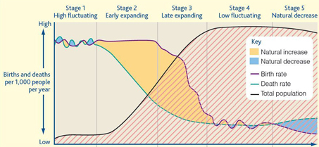

Figure : the Demographic Transition Model

* The demographic transition model (DTM) explains the birth and death rate patterns across the world and through time. It has five stages, and each country can be easily placed in one of the five stages according to its BR, DR and stage of development.
* **Stage 1:** Occurs in societies such as tribes in the Amazon rainforest where contraception is scarce (if present at all), there is little in the way of healthcare and so there is a low life expectancy. The UK was in stage one in up until around 1760. The Birth and Death Rate fluctuate (due to war, famine etc), and so the population is very young but fairly stable.
* **Stage 2:** The main factor that separates stage one from stage two is the sudden drop in the heath rate due to improvements in healthcare and basic hygiene which causes life expectancy to increase. Fewer mothers die in childbirth, so the BR may increase slightly, and children are needed to work in the fields as the societies are usually based on agriculture. Due to agricultural and industrial inventions at and around 1760, the UK started stage two around 1780. Afghanistan is a country currently in stage two of the DTM.
* **Stage 3:** The DR continues to fall, but at a more modest pace, while in contrast to stage two, the BR now starts to decrease rapidly. This sudden drop in the BR is due to the availability of contraception, and children become economic costs instead of assets as countries in the third stage usually start to move away from agriculture. India, Kenya and Brazil are all in stage three of the DTM, the UK moved into stage three in the 1880’s.
* **Stage 4:** Now, the BR and DR’s of the country are low and fluctuating depending on the current economic situation in the country. When economic times are hard, couples usually postpone having children until times are better, as in these types of society, children are definitely an economic cost. The UK is currently in stage four of the DTM, as is the USA and France.
* **Stage 5:** Many Eastern European and a few Western European countries are in this stage in the DTM, this is mainly due to an unstable economy, so mothers are put off having children as they cannot afford it, and occasionally due to mothers getting good jobs and so postponing having children in order to pursue their career.

### Major features affecting population growth:

* **Agricultural Change:** As the tech improves, manual labour decreases, which means products are cheaper and less money is given to the workforce.
* **Urbanisation (Rural to Urban Migration):** Common in poorer countries, where people believe (usually correctly), that cities have greater economic opportunities than those available in the countryside. One major reason is that children often get a far better education than that offered in rural places.
* **Education:** As families have fewer children, parents have more money to spend on each one, and most of the money goes on education. Most educational opportunities are found in cities, so that’s where the families go.
* **The status of women:** As the workforce of a country rises, fewer women stay at home, and more actively find a career. Reaching a good standard in most households requires two incomes. Over time, prejudice against women usually decrease as a country develops.

## 8.3 – Population pyramids

* A population pyramid is a type of bar graph to show the age and gender of a population.
* On one side are the males, and on the other side are the females.
* The X axis shows how many people there are and the Y axis shows the age of the people.
* Here is a sample pyramid, you can see how events have affected the population:

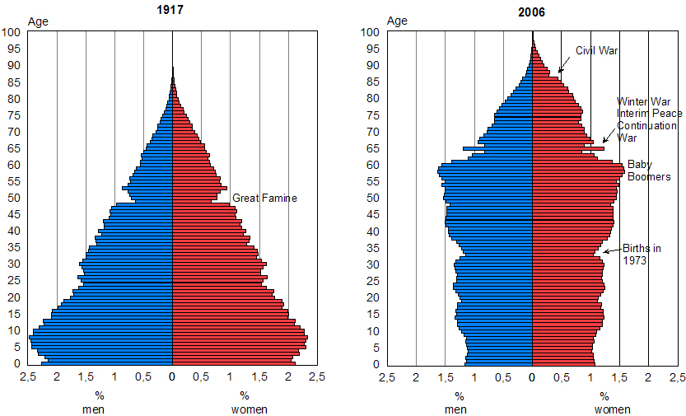

* It is possible to predict future population changes by looking at past data and predicting what events will happen in the future. Factors such as the economy, wars, migration and famine must be taken into account.

## 8.4 – How can a population become sustainable

* **A sustainable population is one who’s growth and development doesn’t threaten the success of future generations.**
* Countries at stage four of the DTM are most sustainable as they have both low birth and death rates.
* Stage five of the DTM isn’t sustainable as the age of the population is increasing and there isn’t enough young people.

### Case study: will China become a sustainable population?

* In the 70’s the Chinese government realised that the population was rising so fast that soon, there wouldn’t be enough food, electricity or water to go around. Already, the country had suffered a famine that caused around 35 *million* deaths.
* **In 1979, the one child policy was introduced.** The following policies were introduced:
  + Women cannot marry until their late 20’s
  + They can only have one successful pregnancy
  + Must be sterilised after one child, or abort future pregnancies
  + They get a 5-10 salary rise if they stick to the above rules
  + They also get priority housing, family benefits and free education if they stick to the rules
* Any couples who have more than one child have the following penalties:
  + 10% salary cut
  + A massive fine that usually bankrupts most couples
  + The family have to pay for education
  + If the child is born abroad, it’s not penalised, but it can’t become a Chinese citizen
* Sometimes, massive pressure was put on women to abort, even pay cuts for fellow-workers!
* Older women in the society would accompany women to contraception sessions to make sure they went.
* However, there were some exemptions:
  + In rural areas, sons were needed to work in the fields, so if the baby was a girl, a second chance was allowed in the hope of having a boy
  + Minority races were exempt as otherwise they could die out
* Problems and benefits:
  + Women were forced to have an abortion as late as nine months into pregnancy
  + Women were under pressure from their elders, co-workers, family, and the government
  + Local and government officials had power over people’s lives.
  + Many daughters were abandoned or killed as sons were preferred in Chinese society
  + Many children in china are overindulged as there is only one of them
  + The policy worked, around 400 million less people have been born
  + New industries have lifted millions out of poverty, partly due to the one child policy
* Changes to the policy in the 90’s and the 2000’s
  + Young couples who are both only children are allowed two children, but government officials must set an example and only have one.
  + Young couples must look after four old parents – a heavy financial burden
  + Now there is a gender imbalance, as many more Chinese men were born in the 70’s
  + Now, more people are going against the system and paying the price as they have more money to spend.

## 8.5 – What alternative birth control programmes exist

### Definitions:

* **Gross domestic product (GDP):** the total value of goods and services produced by one country in a year divided by its total population (foreign income isn’t counted)
* **Literacy rate:** the percentage of adults that can read and write well enough to be able to fully work in society.

### Case study: An alternative population policy in Kerala, India

* In 1952, India introduced the national family planning programme, the first of its kind.
* This included contraception and also social changes to encourage smaller families
* This bought massive benefits to the country, in some areas (Kerala), the GDP increased by around six times, the literacy rate increased by 40% and the infant mortality decreased by around six times.
* In Kerala, they are at stage four of the DTM, not many places are at that stage in the developing world.
* Kerala has made these massive improvements by doing the following:
  + Treating teenage boys the same as girls
  + Improving adult literacy in towns and villages
  + Educating people to see the benefits of smaller families
  + Reducing infant mortality (people don’t need to try for as many children now)
  + Improving children’s health through vaccinations
  + Providing free contraception
  + Encouraging people to get married at older ages
  + Allowing maternity leave, but only for the first two babies
* Now more university students are girls than boys, and literacy classes are always well attended.
* Now, everybody get’s the same amount of land in Kerala, this means that each family is self sufficient.

## 8.6 – What are the issues and opportunities for an aging population

### Definition:

* **Dependency ratio:** the balance of people who work and pay tax, to the people who depend on them. Found by: **(number of dependant people/number of independent people)*100**
* Now, more people are living longer due to advances in medicine and healthcare.
* Older people cost a lot of money, as they often need medical treatment, if a country has lots of older people, then the working class need to work harder to pay for them.
* Elderly people need services such as care homes and day care centres.
* Elderly people often rely on pensions for a living, which was alright when the state pension was introduced – the retirement age was 65 and the life expectancy was 67, but now people are living past their 90’s!
* Younger retired people do contribute a lot to the economy, they often participate in voluntary work, or paid work which means they are eligible for taxes. They also use public services such as transport lots which provides lots of jobs.
* In the EU, there are about 1.5 children for every woman, but 2.1 are needed for a sustainable population.
* In France, there is a policy to try and produce more children to make a better **dependency ratio**. There are a range of incentives for couples to have more children:
  + Three years of paid maternal or paternal leave
  + Full time schooling starts at the age of three fully paid for by the government
  + Day care for children younger than three is subsidised
  + The more children a woman has, the earlier she can retire

## 8.7 – What are the impacts of international migration

### Push-pull factors:

* People move homes for many different reasons, ones that attract people to a place are pull factors, ones that make them want to move away from a place is a push factor.

### The impacts of international migration

* The impacts on the country of origin and destination can be both positive and negative.
* Migrant workers often send money back to their country of origin, this means the money leaves the host economy (disadvantage) but goes to the country of origin (advantage).
* Finding accommodation can be hard, but in the UK, migrants are helped by social services. British residents are annoyed by this as they feel that they are being treated as second class citizens.
* Migrants bring labour and skills to the UK, but can also ‘nick’ jobs from us locals.
* Too many migrant children can be a burden on schools who have to teach them English on top of everything else.

### Case study: A Slovak girl works in Sussex

* In 2002, a Slovak girls aged 18 came to the UK with attached boyfriend, she worked as a cleaner for £1 cheaper than local women.
* In 2007, she had saved enough money to buy a four bedroom house in the Czech Republic, and so got off to a good start in her new married life.

### Definitions:

* **Economic migrant:** A migrant who has come to a country for economic reasons (voluntary)
* **Choropleth map:** A map that has areas shaded in different colours depending on their attributes.

### Migration within the EU

* Wealthy countries usually get workers from the poorer countries such as Poland looking for work.
* The UK get 600,000 Eastern European migrants from 2004-6, most have found formal jobs which pay far better (up to five times) than those do in their country of origin.

### Migration from outside the EU

* 8.6 of people in the EU are foreign born, and the majority of them come from Africa and Asia.
* The EU receives around 2 million immigrants each year.

### Labour migration

* Cheaper travel and more information has meant that more people are coming to do labour in Europe.
* Many EU residents don’t like the amounts of immigration, but the UN predicts that immigration into the EU will rise by 40% in 40 years.

### Case study: International labour migration to the EU – Senegal to Italy

* Many people in Senegal have relatives or friends that have gone over to Italy to work there -mostly males aged from 16-40.
* There is little to attract workers back to Senegal as the standard of living is lower, and there is little in the way of sustenance farming.
* However, when emigrants do return, they often bring enough money to build a house.

### Refugee movements to the EU

* Asylum seekers are people leaving one country to seek refuge in another as they are at risk in their country of origin.
* Some economic migrants have claimed to be asylum seekers, thinking it will give them a better chance of getting into the country, but this has served to generate hard feelings towards genuine asylum seekers.
* At the moment, most asylum seekers come from Iraq or Afghanistan as this is where the wars are going on. Sweden is very hospitable to asylum seekers, 70,000 Iraqis live there already.