Physics - (Further Physics)

AQA GCSE Physics Revision Notes – Module Three Higher Tier

Disclaimer; I made this to help me revise when the exam comes around, but while I’ve tried to make this document as accurate as possible, I can’t guarantee that the information in this document is completely correct – I may have made mistakes.

# P3

## – Moments (aka torque)

* A moment is the turning effect of a force, you can increase the moment by:
  + Increasing the size of the force
  + Increasing the length of the pivot (e.g. using a longer spanner)
* **Levers:**
  + If we use a crowbar lifting a safe as an example, then the **load** is the safe, the force pushing the crowbar is the **effort** and the place where the crowbar touches the floor is the **pivot**.

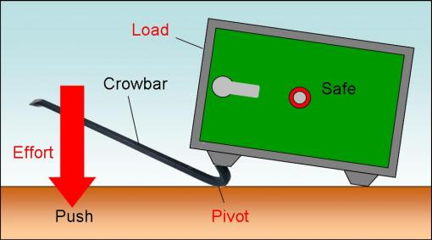

* To work out the moment of a force, use this equation:

Moment (newton meters) = force (newtons) * perpendicular distance from the pivot to the line of action of the force (meters)

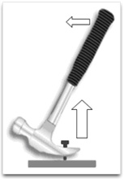

The distance from the pivot to the force. (0.2m)

The force (100N)

* 100*0.2 = 20Nm
* The equation can also be written as Fd=F*d

## 1.2 – Centre of mass

* **The centre of mass of an object is the point where it’s mass may be thought to be concentrated.**
* If an object is suspended (like a hanging basket) it will come to rest with the centre of gravity directly underneath the point of suspension.
* If an object is symmetrical, then the centre of mass is where the lines of symmetry meet (fold a rectangle horizontally, and then vertically. Where the fold lines meet is where the centre of gravity is).

## 1.3 – Moments of balance

* In a seesaw, the weight on each side must balance out for it to remain horizontal. The formula for this is: Weight(1)*Distance(1)= Weight(2)*Distance(2)
* The seesaw is an example of the **Principle of Moments**, which states that for an object in equilibrium: **the sum of all clockwise moments around a point = the cum of all anticlockwise moments around a point.**

## 1.4 – Stability

* Tractors don’t fall over when on a hill because their centre of gravity is over their wheel base.

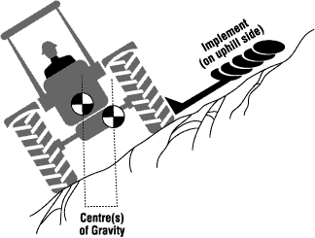

* To increase the stability of an object, you give it a wider base and make it as low as possible.
* An object will topple if its weight is outside its base.

## 1.5 – Circular motion

* Newton’s first law states that an object (not moving) will remain in a state of rest or will continue with a constant speed in a straight line unless acted upon by another force.
* This means that objects moving in a circle must be being acted on by a force. This force is called a centripetal force.
* An object that is changing direction and or speeding up is said to be accelerating.
* The direction of a centripetal force is always towards the centre of the circle.
* Centripetal forces can be caused by 1.Gravity(satellites) 2.Friction(roundabout) 3.Tension(ropes)
* The bigger the mass is, the bigger the centripetal force needed to keep it in the circle.
* The more speed the object has, to more centripetal force is needed to keep it moving in a circle.
* The smaller the radius of the circle, the tighter the turns and so the more centripetal force needed.

## 1.6 – Gravitational attraction

* Gravity is an attractive force.
* Gravity is bigger when the mass of each object is bigger.
* Gravity is bigger when the objects are closer together.
* The gravitational field strength of the earth is 10N/kg so the force of gravity of a 50Kg person is 10*50 which = 500N.
* On the moon, gravity is 1.6N/kg, so the weight of the same person is 50*1.6 = 80N

## 1.7 – Planetary orbits

* To stay in orbit at a particular distance from the sun, a planet must have the correct speed (too much and it’ll fly off and too little and it will get sizzled).
* The further away a planet is from the sun, the less its speed is as it orbits the sun, as gravity is weaker when the objects are further apart. Hence the further away the planet is, the longer it takes to orbit.

## 1.8 – Satellites

* The moon is the only natural satellite of the earth.
* As with the planets, when the satellites speed it too slow, it will fall down, but when it is too fast it will career away from the earth as gravity can no longer keep it in check.
* The higher the satellite, the slower (speed) it orbits the earth because the centripetal force (gravity) is lower.
* The period of the satellite is the time it takes for it to orbit the earth.
* **Communications satellites** are in orbit at a particular height above the equator so they have a period of 24 hours. They orbit the earth in the same direction as the earth, so they stay at the same place over the earth all the time. They are also known as **geostationary**.
* **Monitoring satellites** are fitted with TV cameras pointing to earth. We use them for purposes including weather forecasting and military use. They are in a lower orbit than geostationary satellites so we can see better detail of the earth. Orbits usually take 2-3 hours and cross the poles so we can see the whole earth every day.

## 2.1 – Reflection

* There two types of mirrors, **convex mirrors** and **concave mirrors**.[1]
* A mirror shows images as it reflects light that is hitting it.
* The **incident ray** is the ray of light going towards the mirror.
* The **reflected ray** is the ray of light bouncing off the mirror.
* The **normal** is an imaginary line that is perpendicular to the mirror.
* The **angle of incidence equals the angle of reflection.** These are imaginary angles from the incidence ray (or reflected ray respectively) to the normal.
* A **virtual image** is formed when you look at an object in the mirror and it appears to be inside the mirror. A **real image** is formed by focusing light rays onto a screen (e.g. the cinema).[2]

## 2.2 – Curved mirrors

### Image formation on a concave mirror[3]

* For a distant object, the light rays that are hitting the mirror are effectively parallel, so they are focused on to the mirrors focal point or f.
* For an object that is beyond the focal point, an inverted real image is formed, and it’s position and size depend on how close it is and where it is in relation to the mirror. The magnification for the image is: **the image height / the object height**.
* For an object between the focal point and the mirror, an upright virtual image is formed. The image is also magnified.

### Image formation on a convex mirror

* Convex mirrors give a wider field of view than normal mirrors.
* Images are virtual and diminished.

## 2.3 – Refraction

* Refraction is how light bends as it enters an object.
* When entering glass, the light ray bends towards normal, but also bends away when exiting the glass.
* Generally, when waves change speed (i.e. light waves[4] entering glass) they also change direction.
* Light travels slower in glass than air.

## 2.4 – Lenses

* A lens works by changing the direction of light that is passing through it.
* A converging () lens makes parallel rays converge to focus. The point where they focus is called the focal point.
* A diverging )( lens makes parallel rays diverge. The point where the rays appear to come from is the focal point.
* In both cases, the focal length is the distance from the centre of the lens to the focal point.
* A **real image** is formed by a converging lens is the object is further away than the principle focus.
* A **virtual image** is formed by a converging lens if the object is nearer than the principle focus.

## 2.5 – Using lenses

* A camera uses a converging lens to form a real image of an object.
* A magnifying glass uses a converging lens to form a virtual image of an object.

## 2.6 – Sound

* Vibrating objects send sound waves through the air, as air is the medium through which sound waves travel, it is impossible for sound to travel through a vacuum.
* Sound waves are longitudinal waves and vibrate along the direction they travel in. In contrast, light waves travel at right angles to the direction they travel in.
* Sound can be reflected, this is how we get an echo. If a surface is soft or fabricated, then it will absorb the sound waves instead of reflecting them. If a surface is rough, the sound wave will be broken up and so an echo will be not heard.
* At night, sound is generally louder as the air is cooler. This makes the sound waves refract off boundaries of air in the sky and bounce back down to earth. In the day, the opposite happens and sound escapes to the upper atmosphere.
* Sound can travel through liquids, gasses and solids, but not a vacuum.

## 2.7 – Musical sounds

* **Noise** consists of sound waves that vary randomly in frequency and don’t have any pattern.
* **Increasing the loudness of sound** makes the amplitude larger, and so the wave form gets taller.
* **Increasing the frequency of sound** makes the pitch get higher and the waves get closer together.

## 2.8 – Ultrasound

* **Ultrasound** is any noise that is too high for humans to hear, so that’s anything above 18,000 to 20,000Hz
* Ultrasound is used to check that babies are developing well in the womb. It is non-ionising, and can tell the difference between different organs as they have different densities.
* Ultrasound can also be used to detect flaws in metal, as any cracks partially reflect the sound waves.

## 3.1 – The motor effect

* The force of an electromagnet can be increased by increasing the current or having more turns on the wire.
* Using the above principle, we can deduce that by increasing the current in a motor, or the amount of turns the coil has, we also increase the power of the motor.
* When the motor’s coil is perpendicular to the magnets, then the force is greatest, but when it is parallel with them, there is no force at all.
* When the current or magnetic field is reversed, the motor goes the other way.
* The split ring commutator makes the motor change polarity every half turn, and so

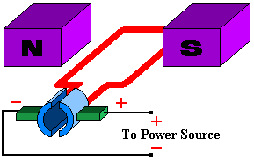

Figure the basics of an electric motor

* Loudspeakers work using the motor effect too, they make a coil of wire vibrate very quickly and so sound is produced.

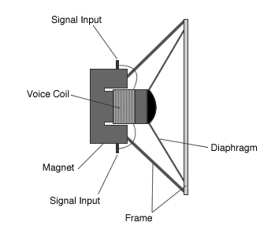

Figure the basics of an electric speaker

## 3.2 – Electromagnetic induction

* A voltage (potential difference) is induced when a wire cuts across magnetic field lines. If the wire is part of a circuit, then the electric current will pass around the circuit.
* A dynamo on a bike works by having a coil of wire turn around many times per second generating a small current each time it passes through a magnetic field line. These currents go in opposite directions which means it is an AC current.

### A simple AC generator

* A simple AC generator consists of a rectangular coil of wire which is forced to spin inside a magnetic field.
* The coil is connected to the circuit by two metal brushes that press on two metal slip rings. As the coil spins, the current alternate, as each brush comes into contact with the opposite slip ring alternately, which produces an AC current.
* The faster the coil rotates, the larger the peak value of the current and the faster the current alternates.

## 3.3 – Transformers

* Typical power stations produce energy in the form of electricity that has a voltage of around 25,000 volts. For home use, we need electricity at 230 volts. Along the way to your house, the electricity changes it's voltage a number of times:
  + First it is stepped up from 25,000 to 132,000 to be transferred around the national grid
  + Then it is stepped down to 230 volts for home use.
* **Transformers** do all the heavy lifting in this process, they are able to change the alternating pd.

### How do transformers work?

* + - A transformer has two coils of insulated wire that are both wrapped around the same iron core, as an AC current goes through the first coil, it induces a magnetic field which in turn produces current in the second coil.
    - With a direct current, there is no changing magnetic field and so the transformer won't work.
    - The iron core is made of lots of small flat layers of iron that have been stuck together, which is to cut out induced currents in the iron layers and boost efficiency.

## 3.4 – Transformers and the national grid

* The grid is at such a high voltage as otherwise, much more current would be needed to deliver the same amount of power, and so more energy would be lost as heat.
* Here is how the grid system is used to supply industry as well as homes:

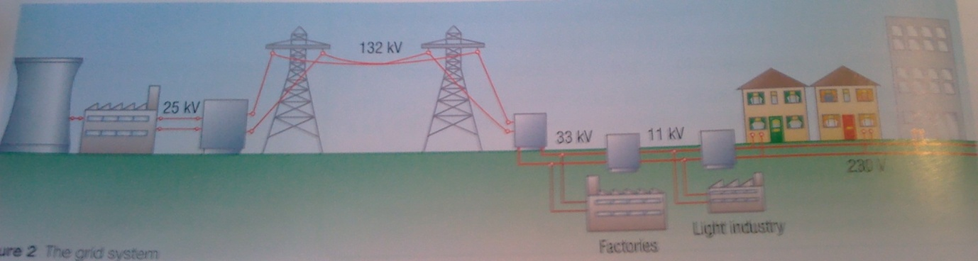

### Transformer calculations

* The secondary pd depends on the primary pd and the number of turns on the coil.
* This equation lets us calculate the values of one of the factors if we know the other ones:
  + pd across primary (Vp)/pd across secondary (Vs) = number of turns on primary (Np)/number of turns on secondary (Ns)
* For a **step up** transformer, the Ns is greater than the Np, so Vs is greater than Vp
* For a **step down** transformer, the Ns is less than the Np, so Vs is less than Vp
* Example:
  + A transformer steps a pd from 230V to 10V. The secondary coil has sixty turns, how many turns are on the primary coil?
    - Vp = 230, Vs = 10, Ns = 60
    - (230*60)/10 = 1380 turns

### Transformer efficiency

* Transformers aren't 100% efficient, they are pretty close though.
* For 100% efficiency;
  + primary current * primary voltage = secondary current * secondary voltage

## 4.1 – Galaxies

* The big bang happened 13 billion years ago
* First, quarks and electrons appeared within 0.1 seconds. After that came neutrons and protons within 100 seconds, followed by hydrogen and helium atoms after 100,000 years. It was only after a few billion years that galaxies and stars began to form.
* For the first few billion years, the universe was transparent as the radiation passed through the space between it's atoms. This continued until galaxies and stars lit up the universe.
* In it's infancy, the universe was made of 100% uncharged particles, which don't repel each other, but do attract each other due to gravity. This meant that matter tended to clump together, and go on to form galaxies.

## 4.2 – The life cycle of a star

### Birth of the star

* The stars form from clouds of dust and gas that move together under their own gravity. A **protostar** is born.
* As the protostar gets denser it also gets hotter which causes hydrogen to fues together to form helium which releases energy. A star is born.

### Shining stars

* Stars continue shining until all their hydrogen fuel has been used up, the energy released makes more nuclei fuse and so the process continues.
* The force of gravity that makes the star contract is balanced by the outward pressure (like an explosion) from the core.

### The end of a star

* When a star begins to run out of hydrogen nuclei to fuse together, it swells out, cools down and turns red (aka **red giant**)Here, helium and other elements that are heavier than hydrogen start to fuse to form even heavier elements.
* After all these elements have reacted, the star stops fusing nuclei together, and so cannot produce enough energy to keep itself from collapsing. It now becomes a **white dwarf**. This is a hot (hence the white), dense star that is very small (in diameter).
* Now, the smaller white dwarfs fade out and go cold, while the larger ones go out with a bang, the contraction reverses with a massive explosion that is called a **supernova**, which can outshine entire galaxies for weeks.

### And after that?

* This explosion compresses the core of the star into a **neutron star** which is very, very dense and has only neutrons inside. If it is big enough, it becomes a black hole that has a gravitational field so strong, that even electromagnetic radiation cannot escape.

## 4.3 - How chemical elements formed

### The birthplace of chemical elements

* Light elements are formed in stars from fusion reactions. When a star is in it's prime, it fuses hydrogen nuclei together to make helium and other light elements such as carbon.
* When the star is a red giant, it is able to fuse helium and other light elements into heavier elements (no heavier than iron).
* The really heavy elements are formed when a star explodes as a supernova. This enormous force fuses nuclei that are larger than iron. In the dust of a supernova, all the elements are usually present, and eventually, gravity pulls the dust together to form planets.

### Planet Earth

* + - The heaviest element on earth that is naturally occurring is uranium, which provides evidence that the solar system was formed from the remnants of a supernova.
    - We have been looking for life that isn't on earth, **SETI** is a search program that uses radio telescopes to scan the skies for radio transmissions possibly originating from alien life.

## 4.4 – Universal issues

* **Light years** are a measurement of distance, the distance it takes light to travel in one year. The nearest star is three light years away, and it takes six hours for light to reach pluto from us.
* In this way, we can peer 10,000 million years into the past just be looking at the galaxy that is furthest away from us.

1. In GCSE physics that is, there are other mirrors such as plane mirrors etc
2. Technically, real images are formed when the rays of light don’t cross each other so they can be formed on a screen, while virtual images cannot be formed on a screen, they are just where the rays of light appear to have come from.
3. Take a look at the images in the textbook (pages 236/237.)
4. Yes, light is poorly described by using the term wave, but it seems to fit here.