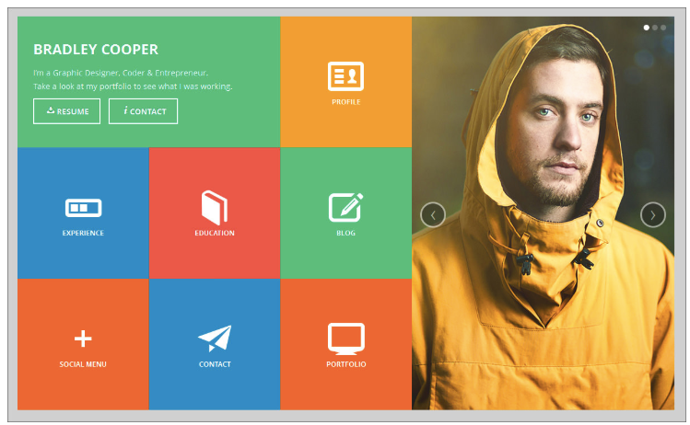

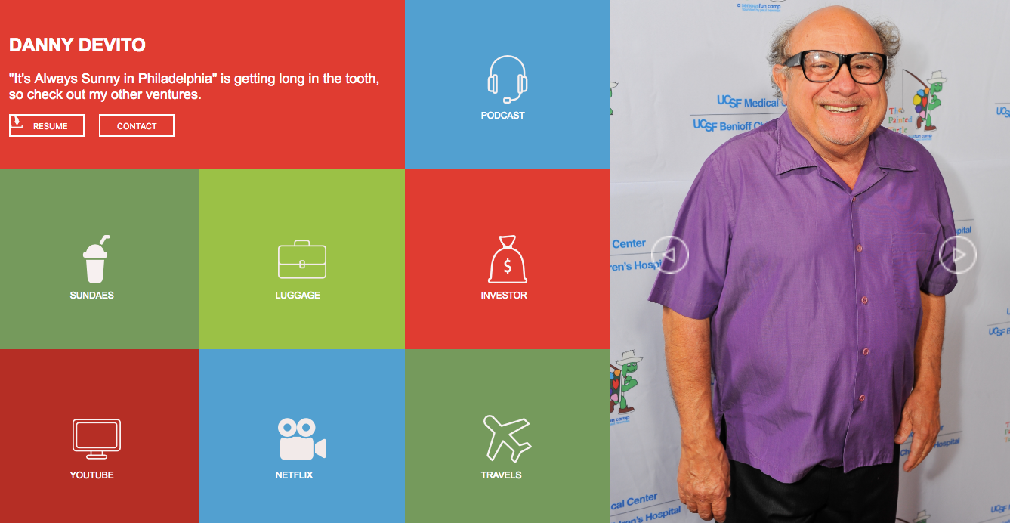

**Todd Ayres**

This is my static comp 1. I feel it was refreshing to get the layout done and get everything basically where it was supposed to be. I realize that in the past, I’ve relied heavily on images like this including all words and background images. I think my big win here was understanding grid and various background and button functionalities I had previously not known. My biggest struggle is getting text etc. to remain stationary during responsiveness and finding the exact correct breaks for media queries.