CS360 – Lab

Assignment 4

Todd Carter

V01187982

The first five screenshots are of the tables displayed by the different tabs on the home page. After those five will be five more screenshots of the individual CRUD pages, which can be accessed through the links on the nav bar on the left side of the screen. Last comes six screenshots of the database tables to show it is set up in accordance to the assignment.

Front Page Tab Screenshots

1. Pets tab:

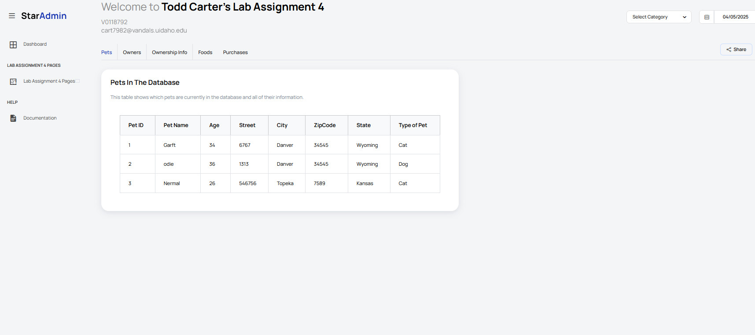

1. Owners tab:

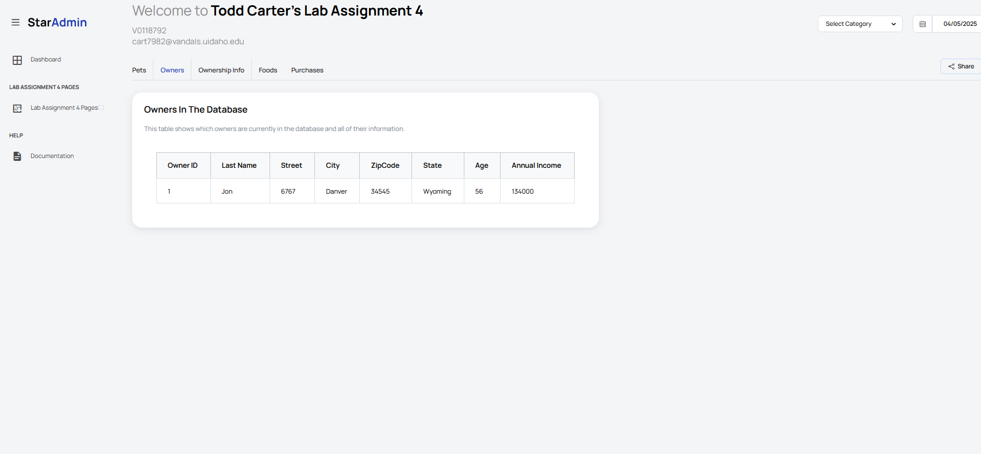

1. Owns tab

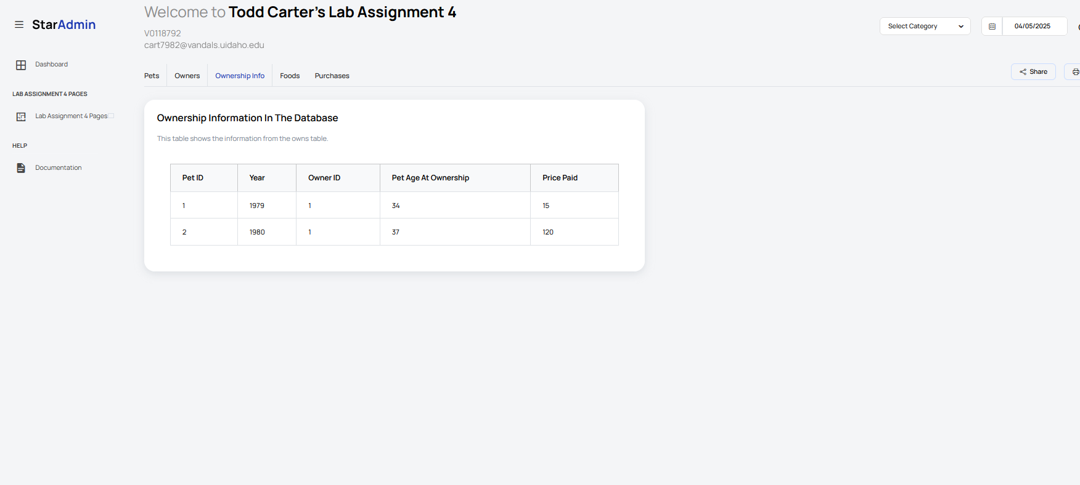

4. Foods tab

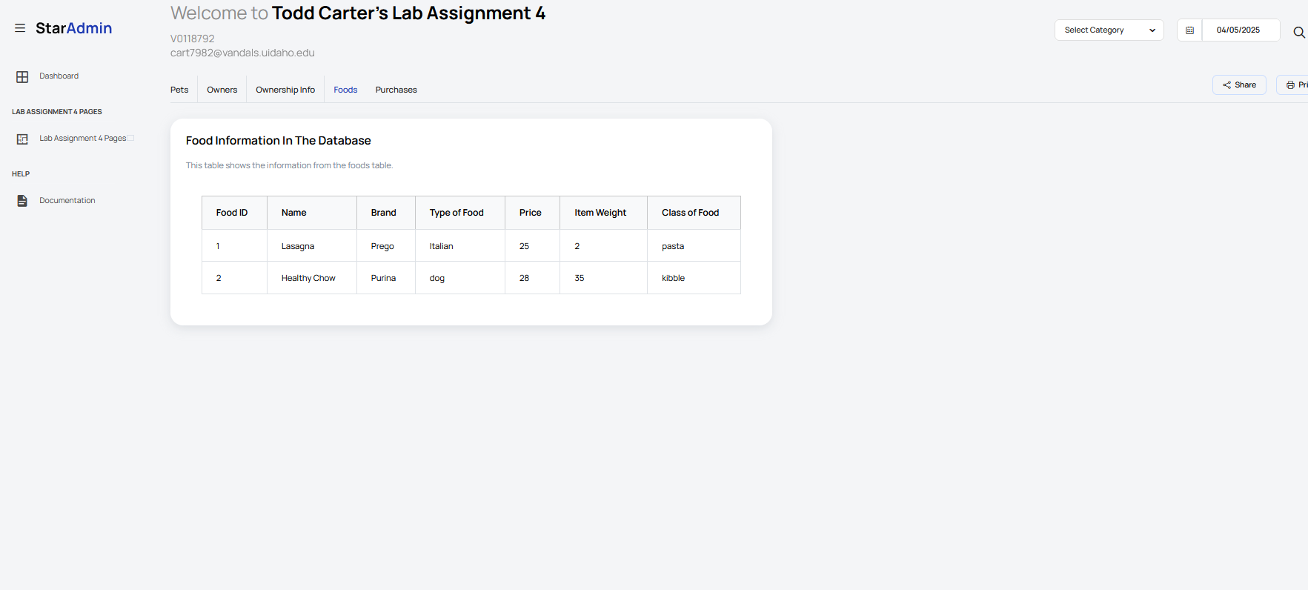

1. Purchases tab

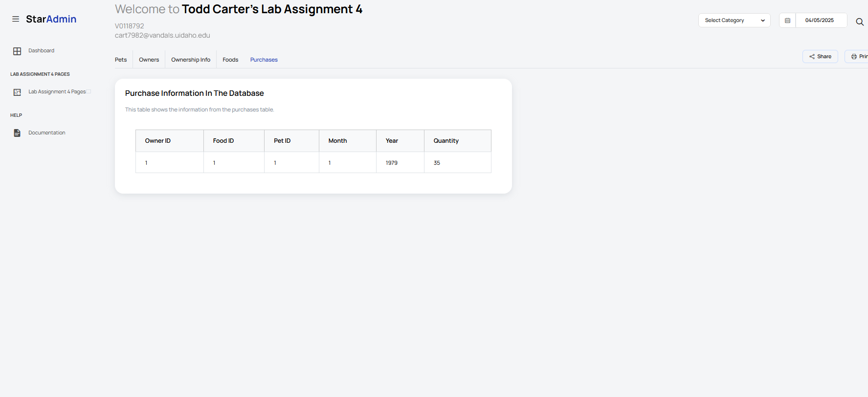

**CRUD page screenshots:**

1. Pets page

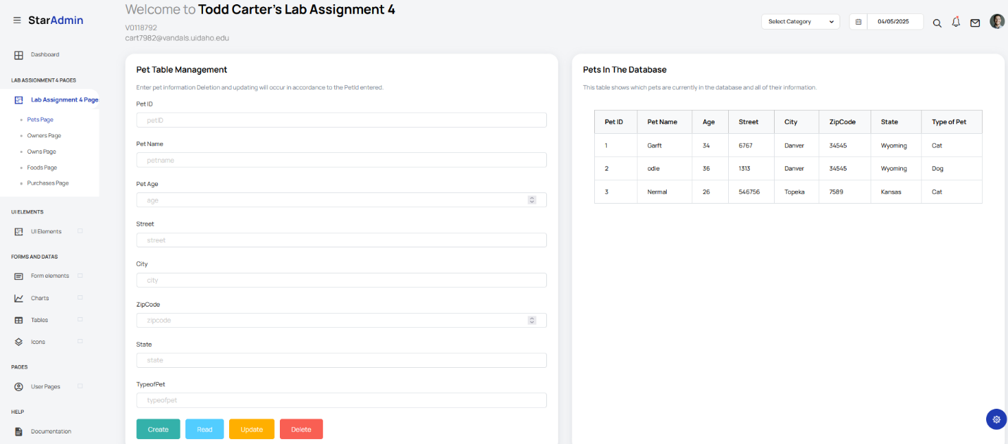

1. Owners page

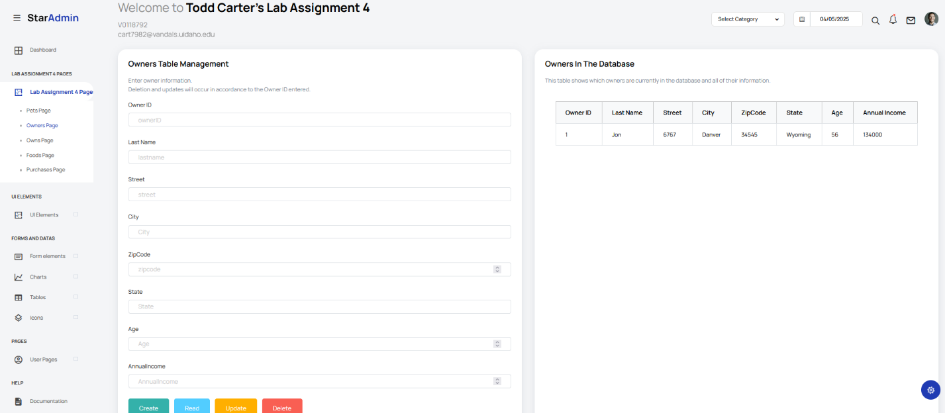

1. Owns page

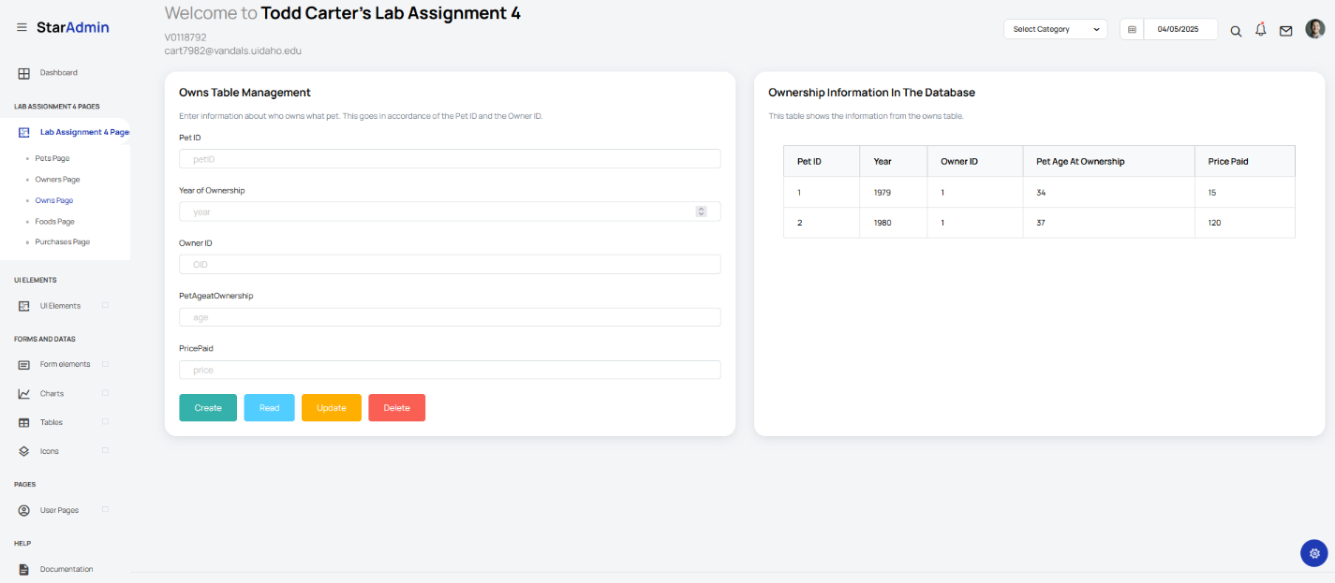

1. Foods page

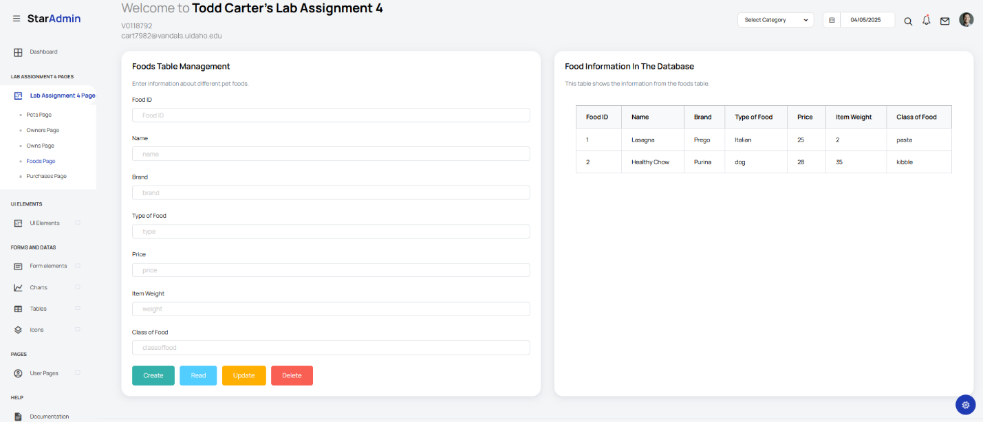

1. Purchases page

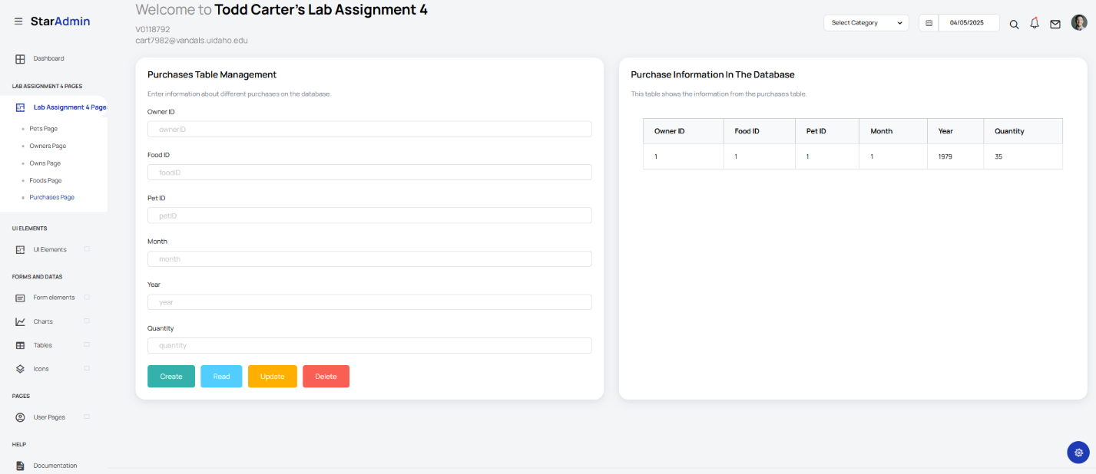

Database screenshots:

1. Pets table

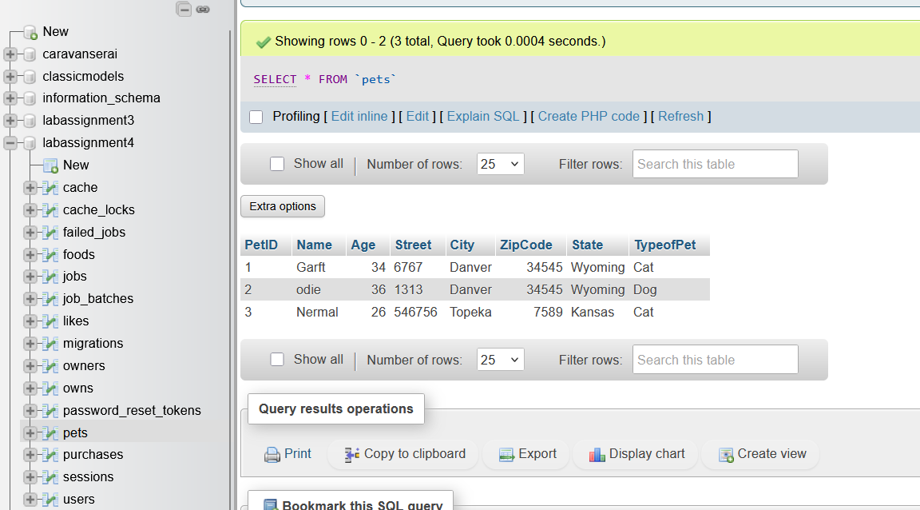

1. Owners table

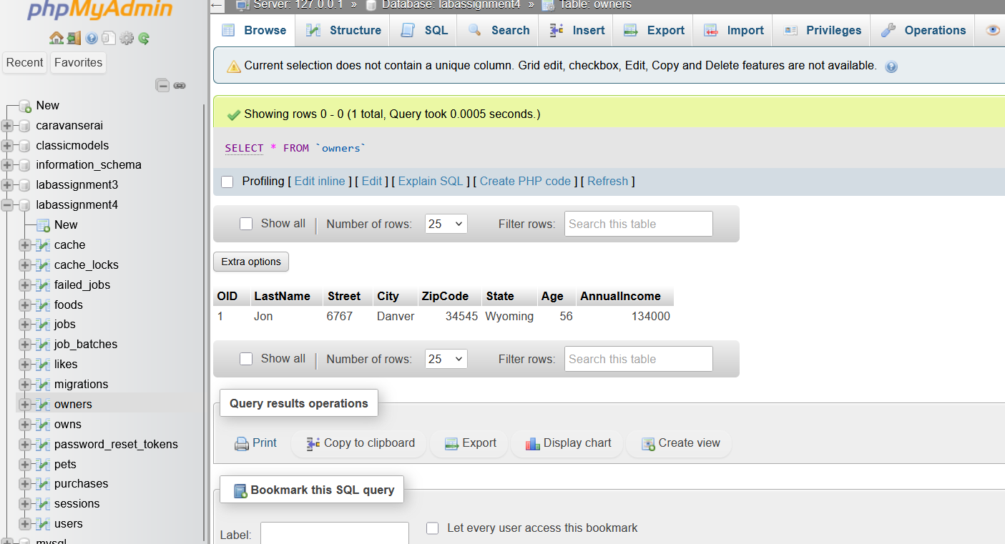

1. Owns table

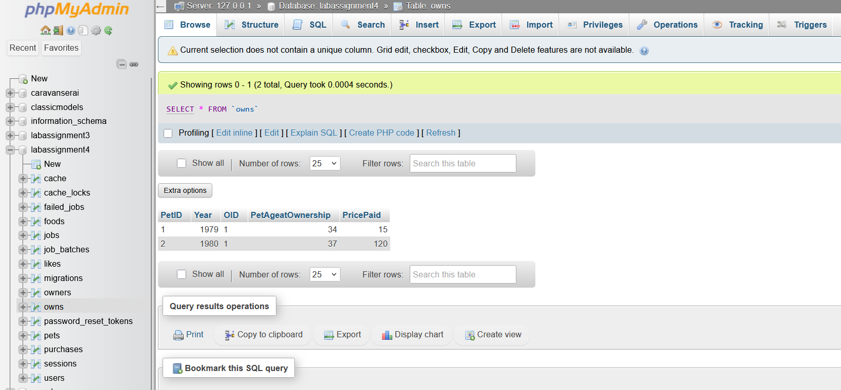

1. Likes table

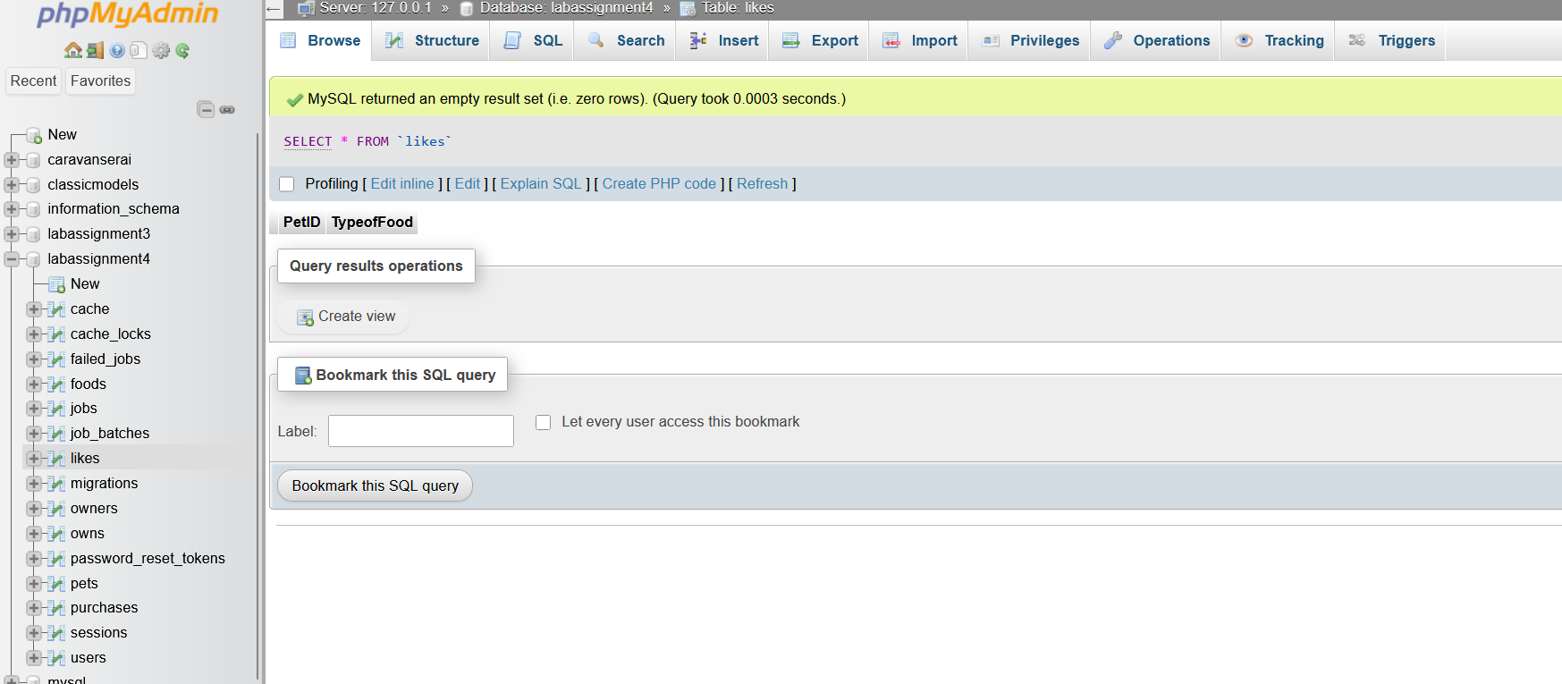

1. Foods table

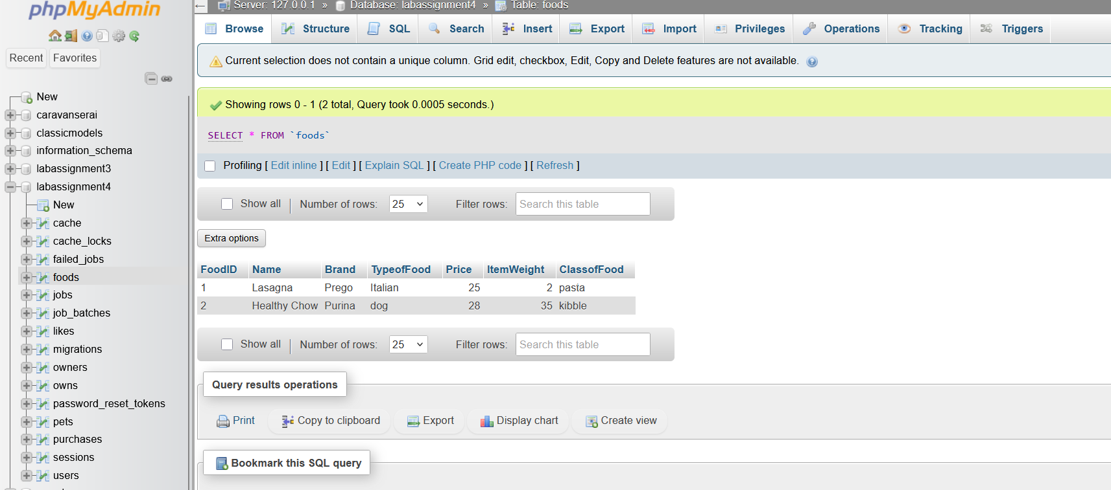

1. Purchases table