CS3185
Homework 6
Todd Carter
V01187982

Section 9.1:

4) Construct a TM that accepts: L = { a^{2n} : n ≥ 1 }.

Idea: Swap between even and odd numbers of a’s as needed.

- δ (q0, a) = (q1, a, R) – find initial a, move to ‘odd’ state

- δ (q1, a) = (q2, a, R) – find another ‘a,’ move to ‘even’ state

- δ (q2, a) = (q1, a, R)
- δ (q2, □) = (q3, □, R) – reached end of tape in the ‘even’ state, so accept

8)e) Construct a TM that accepts: L = { w : n_{a} (w) ≠ n_{b} (w) }.
Then trace inputs on aabab and ababba.

Idea: Scan through looking for an ‘a’ to mark with X, then reset the tape to next scan through and look for a matching ‘b’ to mark with Y. Repeat this scan process until either an unpaired ‘a’ or ‘b’ is found, then accept. If no unpaired letters are found, then reject.

- δ (q0, a) = (q1, X, L) – mark located a, start scanning for matching b (back to start of tape)
- δ (q0, b) = (q0, b, R) – skip other possible options
- δ (q0, X) = (q0, X, R)
- δ (q0, Y) = (q0, Y, R)
- δ (q0, □) = (q4, □, L) – no unmarked a’s, start scanning for an unmarked b for accept

- δ (q1, X) = (q1, X, L) – return to leftmost spot to start next scan
- δ (q1, Y) = (q1, Y, L)
- δ (q1, a) = (q1, a, L)
- δ (q1, b) = (q1, b, L)
- δ (q1, □) = (q2, □, R) – reset to start of string, start search for matching b

- δ (q2, b) = (q3, Y, L) – found a matching b, head back to start to check again
- δ (q2, Y) = (q2, Y, R) – skip other possible options
- δ (q2, X) = (q2, X, R)
- δ (q2, a) = (q2, a, R)
- δ (q2, □) = (q6, □, L) – no unpaired b found, so n_{a}(a) > n_{a}(b), head to accept

- δ (q3, X) = (q3, X, L) – return to leftmost spot to start next scan
- δ (q3, Y) = (q3, Y, L)
- δ (q3, a) = (q3, a, L)
- δ (q3, b) = (q3, b, L)
- δ (q3, □) = (q0, □, R) – back at start of tape, start next scan

- δ (q4, X) = (q4, X, L) – return to leftmost spot to start check for unpaired b
- δ (q4, Y) = (q4, Y, L)
- δ (q4, a) = (q4, a, L)
- δ (q4, b) = (q4, b, L)
- δ (q4, □) = (q5, □, R) – back at start of tape, start next scan

- δ (q5, b) = (q6, b, R) – Found an extra b so n_{a}(b) > n_{a}(a), head to accept
- δ (q5, Y) = (q5, Y, R) – Check rest of string for unpaired b’s
- δ (q5, X) = (q5, X, R)
- δ (q5, a) = (q5, a, R)e
- δ (q5, □) = (q7, □, L) – No unpaired b found, so n_{a}(a) = n_{a}(b), rejected

- δ (q7, □) = rejected

- δ (q6, a) = (q6, a, R) – move to end of tape to accept
- δ (q6, b) = (q6, b, R)
- δ (q6, X) = (q6, X, R)
- δ (q6, Y) = (q6, Y, R)
- δ (q6, □) = (q7, □, R) – accepted

Traces:
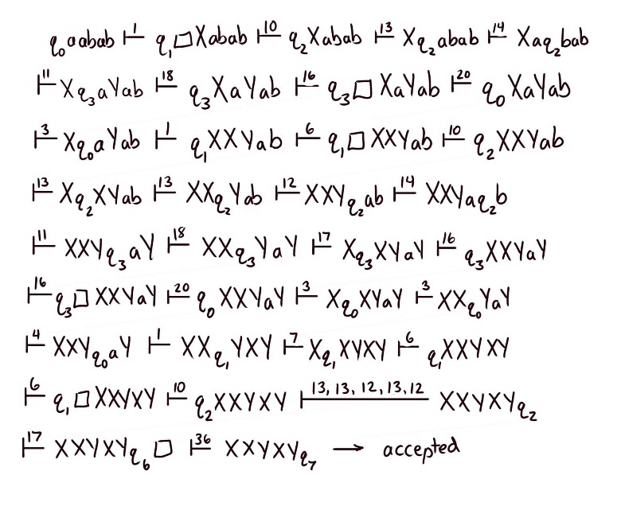

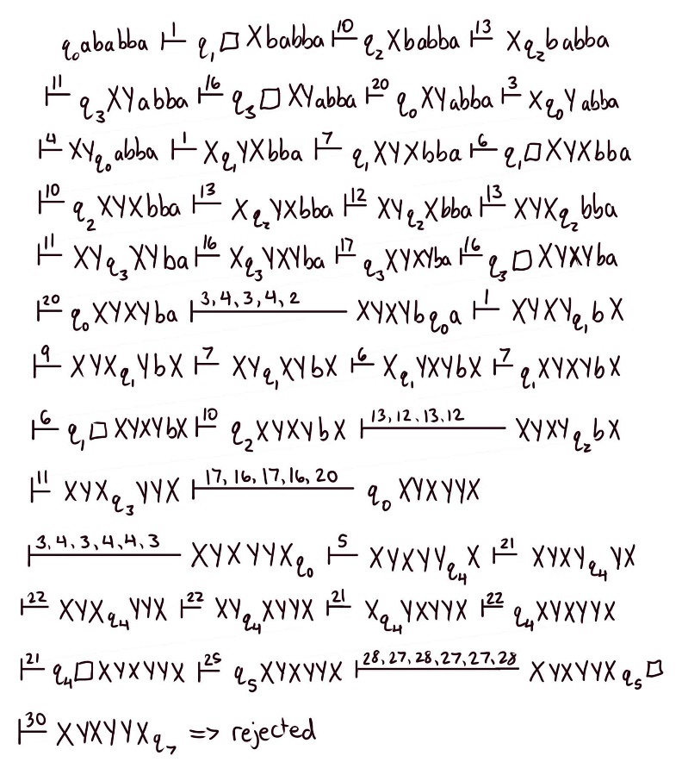

8)g) Construct a TM that accepts: L = { a^{n}b^{n}a^{n}b^{n} : n ≠ 0}.
Then trace inputs on aabbaabb and abaab.

Idea: Mark an a, then mark a b, then mark an a, then mark a b, in that order. Then reset to start of tape and repeat the process. Finally, when the end of tape is reached after the second b block, verify by checking that only X’s and Y’s are in the string.

- δ (q0, a) = (q1, X, R) – found an a, start scanning for first matching b
- δ (q0, X) = (q0, X, R) – skip already marked a’s
- δ (q0, Y) = (q0, Y, R) – skip already marked a’s
- δ (q0, □) = (q7, □, R) – if end of tape reached, accept

- δ (q1, b) = (q2, Y, R) – matching b located and marked with Y
- δ (q1, a) = (q2, a, R) – skip leftover a’s
- δ (q1, Y) = (q1, Y, R) – skip already marked b’s

- δ (q2, a) = (q3, X, R) – matching a in second block located
- δ (q2, b) = (q2, b, R) – skip leftover b’s
- δ (q2, X) = (q2, X, R) – skip already marked a’s again

- δ (q3, b) = (q4, Y, L) – matching b in second b block located
- δ (q3, a) = (q3, a, R) – skip leftover a’s
- δ (q3, Y) = (q3, Y, R) – skip already marked b’s again
- δ (q3, □) = (q5, □, L) – end of tape, all a’s and b’s are marked, move to verify

- δ (q4, X) = (q4, X, L) – return to leftmost spot to start next scan
- δ (q4, Y) = (q4, Y, L)
- δ (q4, a) = (q4, a, L)
- δ (q4, b) = (q4, b, L)
- δ (q4, □) = (q0, □, R) – back at start of tape, start next scan

- δ (q5, X) = (q5, X, L) – return to leftmost spot to start verification
- δ (q5, Y) = (q5, Y, L)
- δ (q5, a) = (q5, a, L)
- δ (q5, b) = (q5, b, L)
- δ (q5, □) = (q6, □, R) – back at start of tape, start verification scan

- δ (q6, X) = (q6, X, L) – skip only X’s and Y’s, other characters cause crash
- δ (q6, Y) = (q6, Y, L)
- δ (q6, □) = (q7, □, L) – passed verification, move to accept
- δ (q7, □) = accept

Traces:
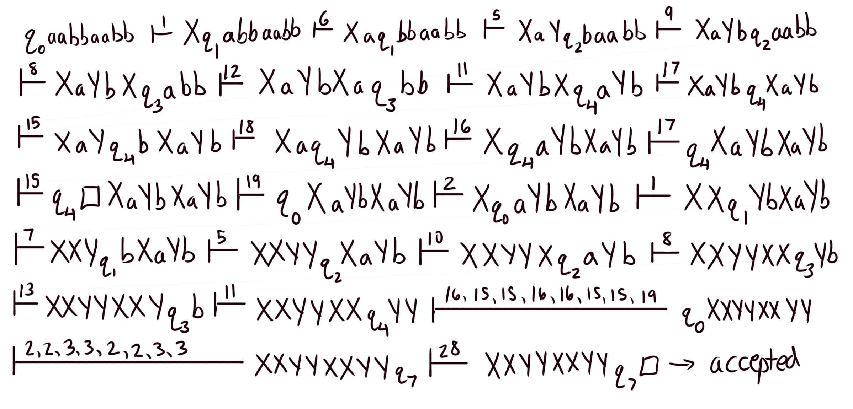

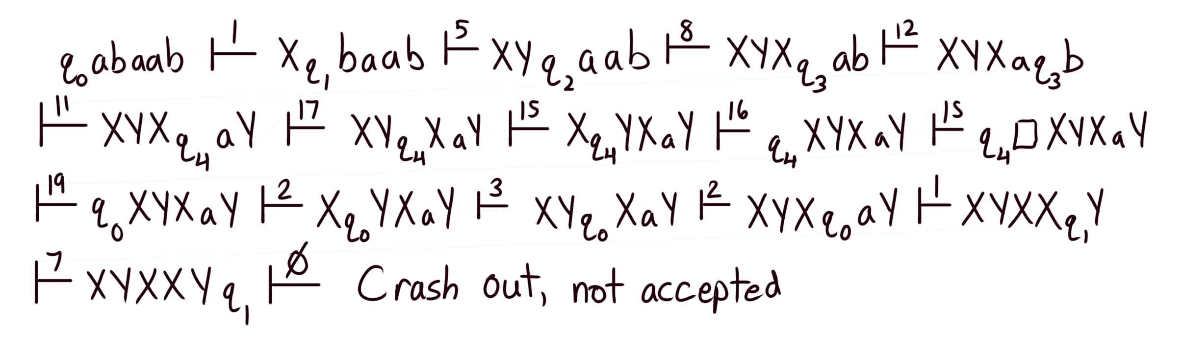

Section 9.2:

5) Provide a “high-level” description for Turing machines that accept the following on {a,b}:

b) L = { w1w2 : w1 ≠ w2 : |w1| = |w2| }

Such as: ababaa, bbbaaa

Idea:
- Check the length is even by moving along length of string while marking every other character. If the end of tape is reached instead of an unmarked character, then the length is even.
- Find the center of the string by moving the head inwards from either end. Move back and forth from the left unmarked character to the right unmarked character, marking them as the head is moved towards the center.
- From the center, mark each following character and compare them with the respective characters from the start of the string. If they are not equal, then go to accepting state. If they are equal, move on with further checks until the end of the string is reached.

d) L = { a^{n}b^{m} : n = m² , m ≥ 1 }

Such as:

Section 10.3:

2) Write programs for nondeterministic Turing machines that accept the following languages, and explain if and how nondeterminism simplifies the task:

b) L = { ww^{R}w : w ϵ { a, b }⁺ }

c) L = { xww^{R}y : x, y, w ϵ { a, b }⁺ , |x| ≥ |y| }

