WTPA2 Component Guide
(a gentle guide for the trepidatious)
First Revsion (Rev A)
December 7 2014
TMB

This is basically a big set of descriptions and pictures of WHAT and HOW MANY of those whats go into a single WTPA2 kit.
This doc isn't really about theory or about how to use WTPA2, it's just what goes into it and a very little about the components involved. So without further adieu here's what goes in WTPA2, divided up by type of component.
The component type and value explain what the thing is, and the reference designator is the part's name in the schematic and on the printed circuit board.
Quantity per board ought to be pretty self explanatory.

Note: if you like paper printouts it might help to have this list in hand while you're building the kit. Sometimes I like that.

Note: THE MOST IMPORTANT THING YOU SHOULD TAKE AWAY FROM THIS DOC if you aren't already familiar with electronics: some components are POLAR. Namely, the diodes and some of the electrolytic capacitors. POLAR components need to maintain a certain orientation with respect to voltages. What this means for the kit-builder is that although the polar components CAN fit into the board one of two ways, one way is backwards, and bad things will happen either immediately or down the road if you put them in the wrong way.

The board has markings on the caps and diodes to help you remember this.

(Note: you can always find the most recent WTPA2 notes on www.narrat1ve.com if this doc gets outdated, or just if you're curious).

(Parts in RED are for optional 5v CV mod, parts in GREEN are replaced by 100k RC Oscillator Kit Below)
WTPA2 Component List, December 10 2014

(Optional Parts Baggie for 100k RC Oscillator – Only Present On Some Kits)

Schematic Symbols:
Now, here's what all these different parts look like in schematic representation. I used to be really good about drawing pretty pictures, but now I just jack things from the Internet like everybody else:
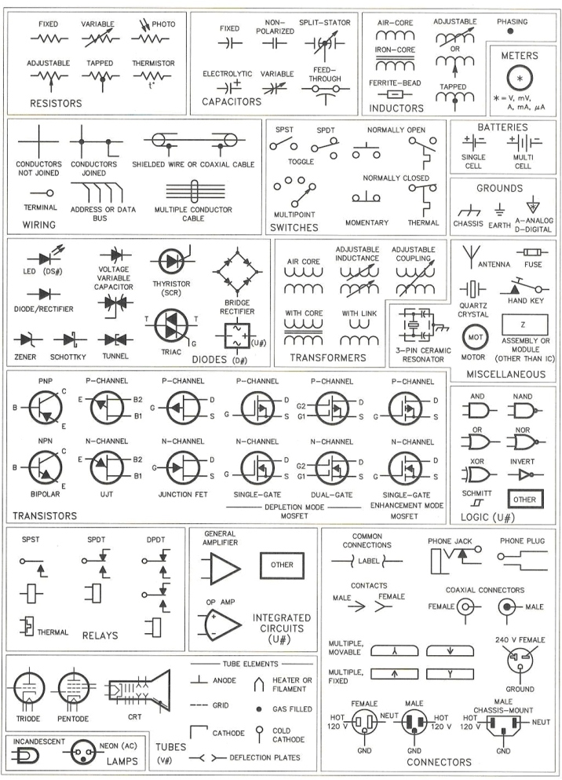

Don't take that chart too seriously, though. An op-amp hasn't had that weird curve in the back since Widlar was giving sheep to bartenders, and if you know how to use a dual-gate MOSFET, please send your resume. If you want to try and figure out what's going on in the schematics, you'll need to know these symbols. Since debugging a messed up kit often involves that, I've included that chart. If you don't know, now you know.

PHYSICAL REPRESENTATIONS:

So now I know what I've got for WTPA2 and what it looks like on paper, so what is it in real life? It all starts with:

The Bare Board:
This is the roadmap where you put all the parts, and makes all the electrical connections. It's basically two layers of flat copper, cut into traces, with a layer of fiberglass in between, and a protective soldermask covering applied (black for WTPA2 but often green) There's a silkscreen on this one, too – it helps you understand where everything goes and lets me make corny jokes. It should (probably) look like this when you get it:

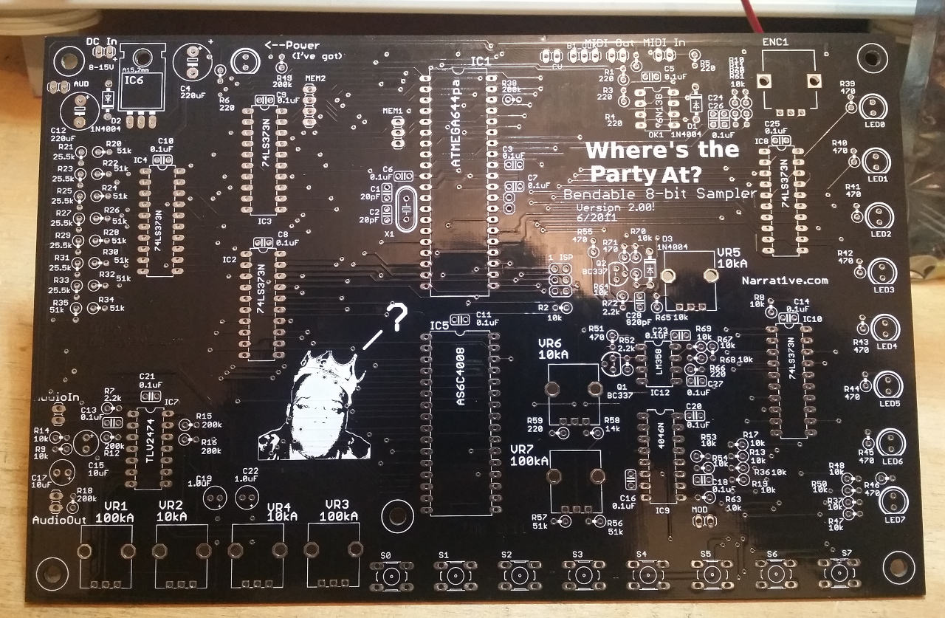

CAPACITORS:
There are two general types of capacitors in WTPA2, ceramic and electrolytic. Their names refer to what's inside of them and they imply some characteristic differences. But for our purposes, they're the little yellow guys (ceramic) and the cans (electrolytic).

Ceramic:
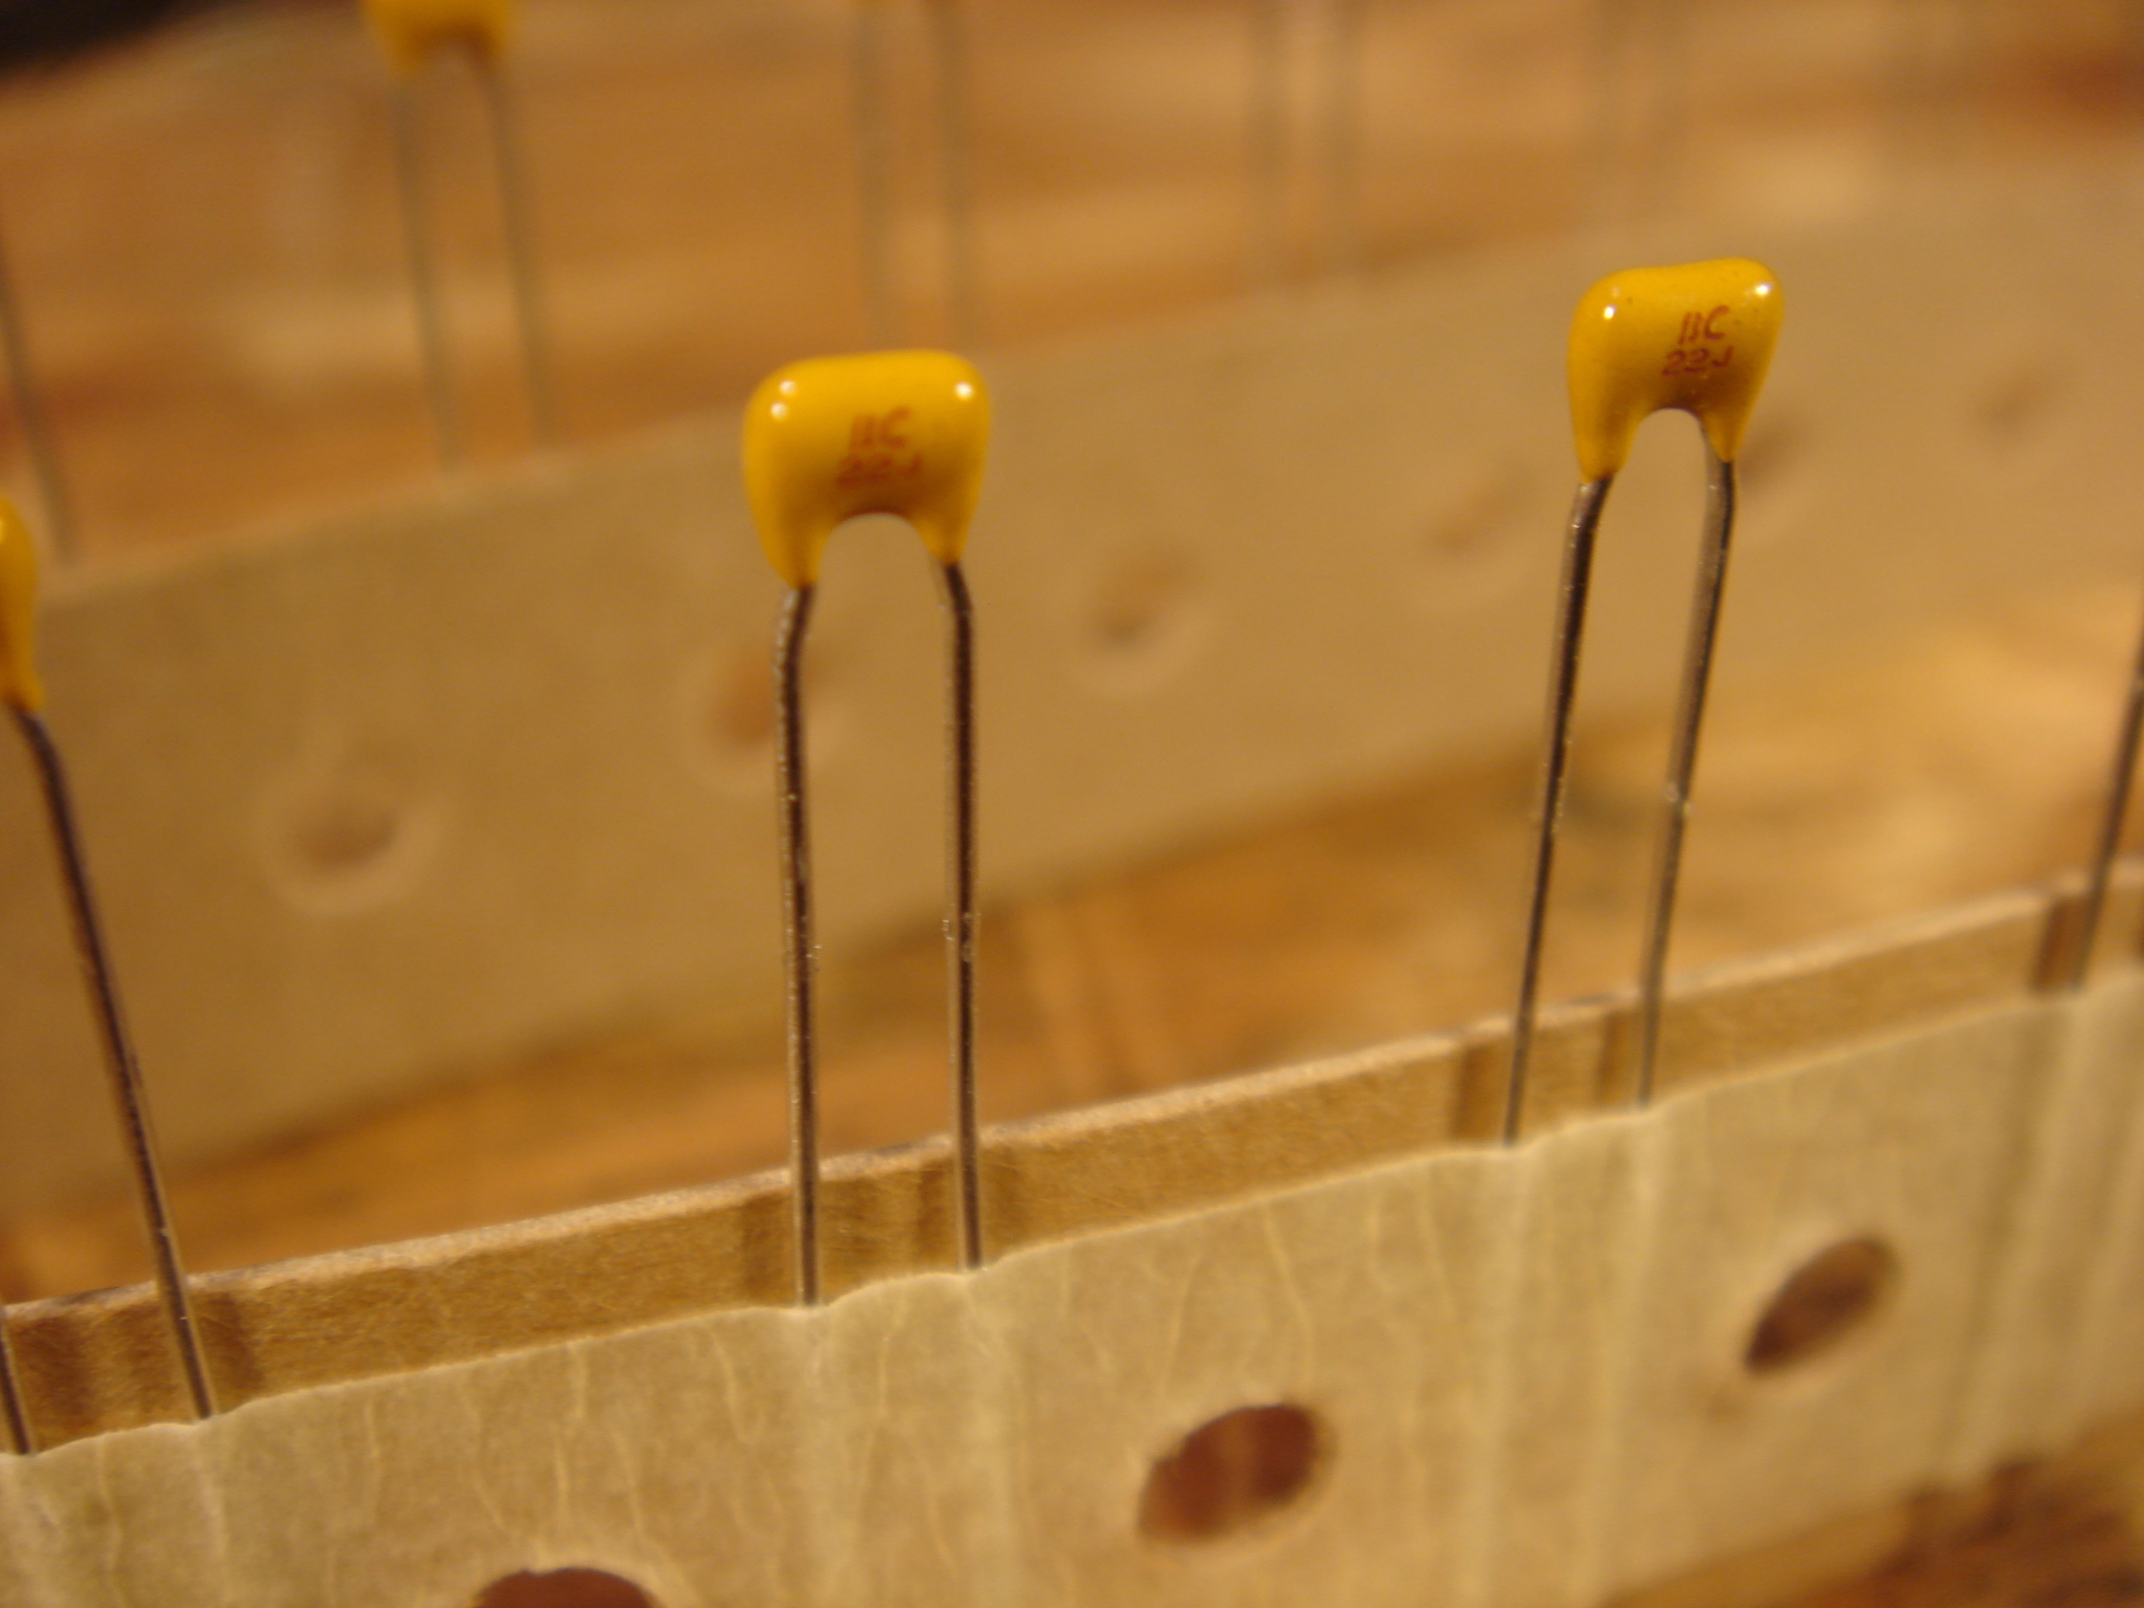
There are several values of ceramic capacitors in WTPA2. Most are 0.1uF – there are lots of them. 0.1uF caps are common on many boards – they are often used for power supply filtering (we call it bypassing). The two 20pFs are used to stabilize the crystal oscillator. Ceramic caps are never polar as far as I know.

Electrolytic:
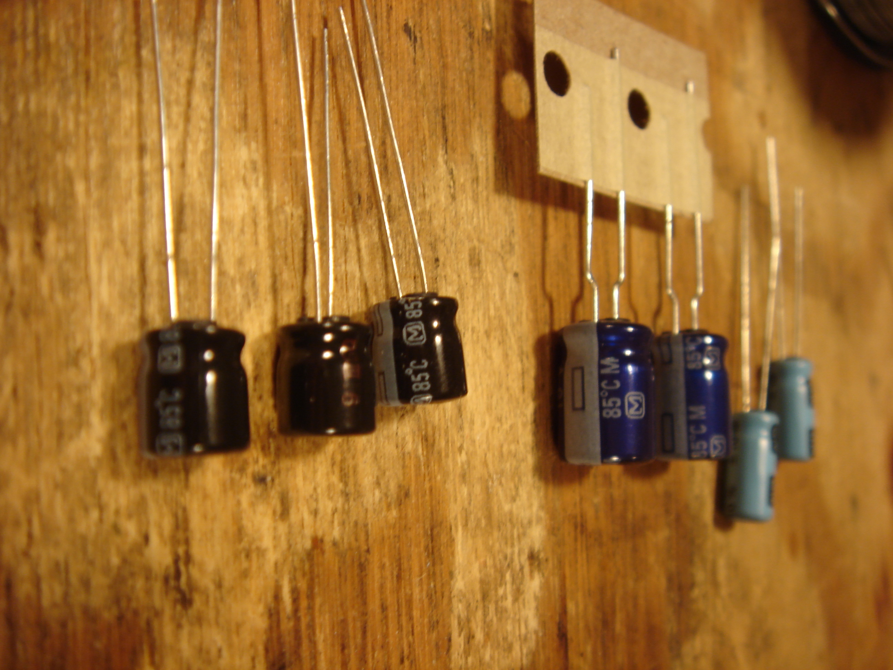
Electrolytic caps look like this. The colors aren't important, the numbers are. They'll all be labeled. The big guys are the main power supply filters, the 22uFs are filters for analog references and also the audio output AC coupling, and the 1.0uF caps are inter-stage audio coupling caps.

Most electrolytic caps are polar! Most electrolytics in WTPA2 are no exception, but the 1.0uF is not polar (fancy because I love you).

The PCBs are marked with a + where the positive lead of the cap should go, and the caps themselves have a stripe with a – running down the side above the negative lead.
Note: If you want to sound smart and impress the Swedish Bipolar Bikini Team you'll call the “positive lead” the anode and the “negative lead” the cathode.

Sockets and ICs:

Are like peas and pods. WTPA2 has one socket for the MCU. You don't NEED to use the socket at all, but if you haven't done much with electronics before I recommend that you do. Sometimes sockets are helpful, and sometimes detrimental, but the job of sockets is to allow you to change chips. They also make it impossible to damage an IC when soldering it, because you don't solder it. In WTPA2 you might change chips to try new experiments, you might change chips to upgrade firmware, or you might change chips because you broke one when bending.

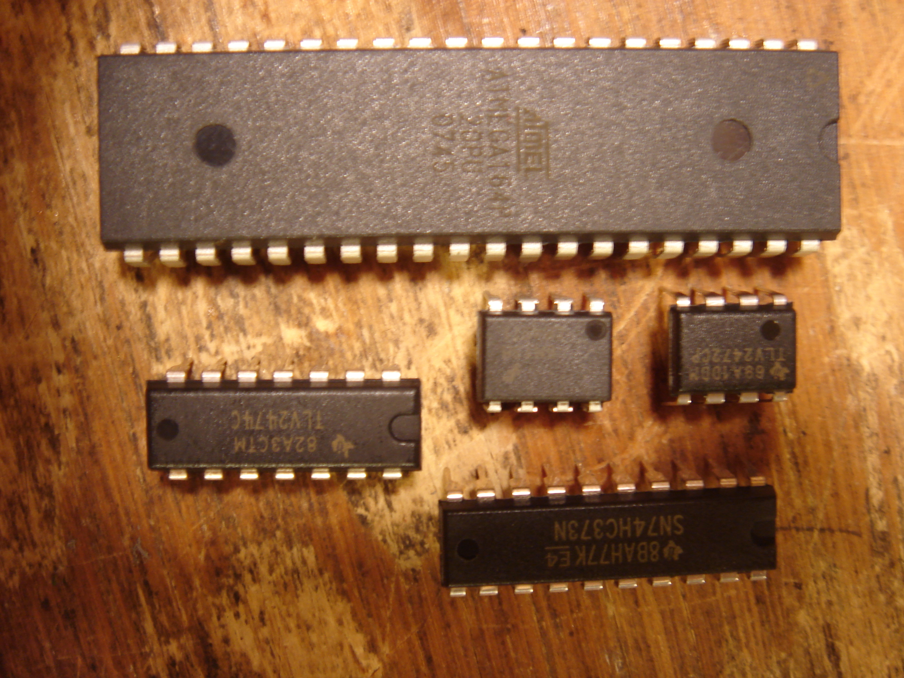

ICs look like this. IC stands for “integrated circuit”. They are more frequently called “chips”. They are basically very tiny groups of transistors organized to do very specific functions – one chip on WTPA2 might have many thousands of transistors.

The ICs themselves do all the heavy lifting in the chip. The 40-pin guy is the microcontroller (the brain), and the 20-pin guys are parallel latches which allow the microcontroller to effectively have more output pins. The 32 pin chip is the memory chip where the samples are stored (it's called SRAM – Static Random Access Memory). The 14-pin guy is a quad op-amp and is responsible for all the audio amplification and level shifting. One 8-pin IC is a dual op-amp that is configured as an oscillator and used as the alternate analog clock source, and the other 8-pin chip is an optocoupler, which lets WTPA2 receive MIDI messages. The 16-pin IC is a PLL which is a very complicated chip, although we just use it as an easy VCO.

There are two transistors in WTPA2 also. They are tiny three terminal devices, the likes of which make pretty much everything in the modern world possible. Pour one out for Bardeen, Brattain and Shockley.

Diodes, the Crystal, the Regulator, Switches:

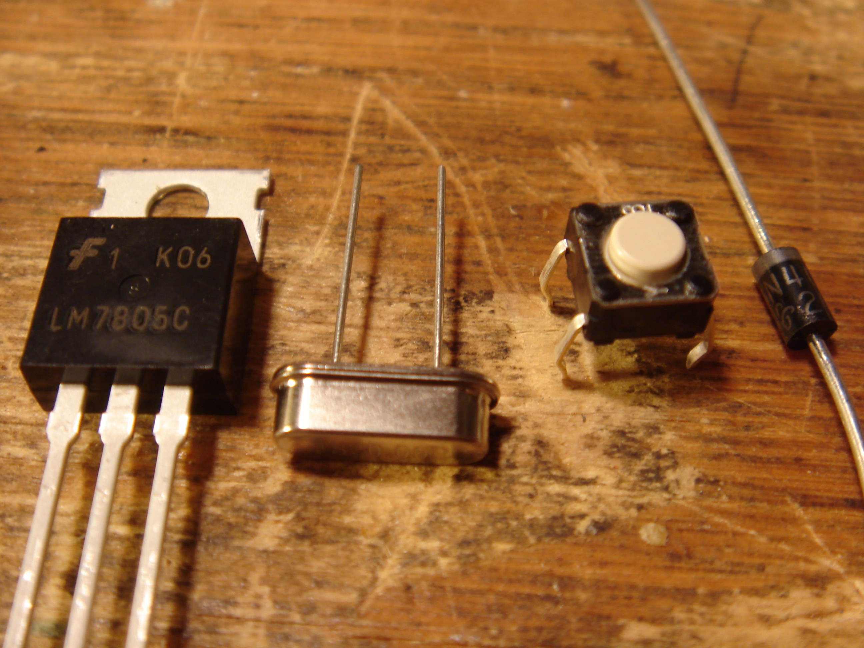
These components are sort of a miscellany. The regulator is really an IC (again) but (again) I took a picture of it because it looks different. The crystal (the silver guy) is what lets the microcontroller generate an accurate clock for its CPU. The switches are for user input (the ones in WTPA2 are taller). The diodes (WHICH ARE POLAR) are used to protect WTPA2 from hooking up power and inputs incorrectly. The bar on one side (the cathode or “negative side”) goes in the direction of the arrow on the PCB.

LEDs:

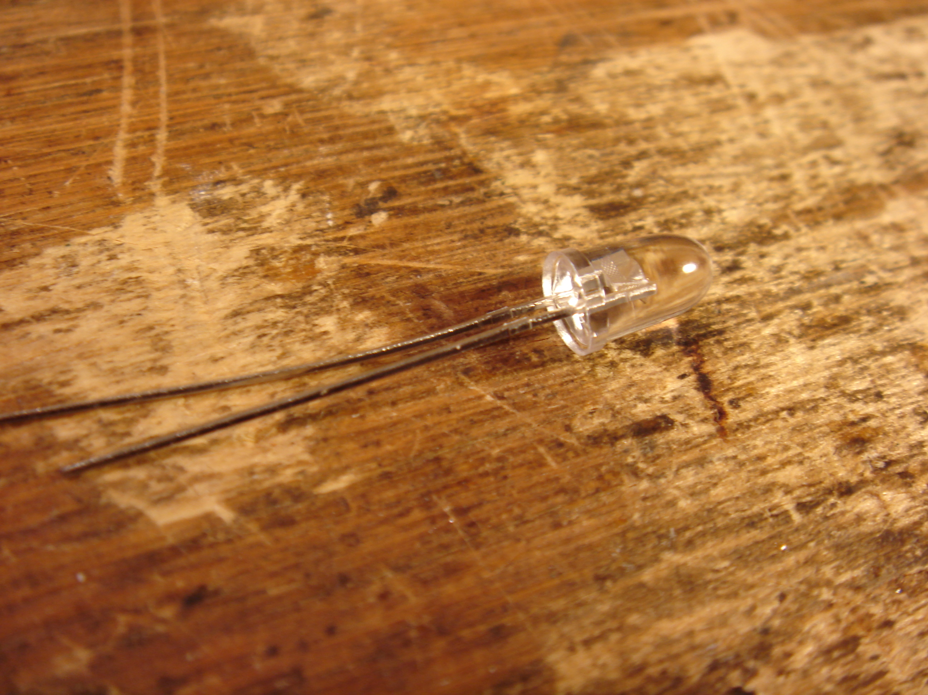
LED stands for Light Emitting Diode. Like our other diodes, it goes in one way (it's POLAR) Unlike our other diodes, it lights up!

The LONG LEAD on the LED is the anode (positive). It is oriented towards the top of the PCB everywhere in WTPA2. There is also a flat on the other side of the LED (the cathode) which matches the diagram on the PCB.
NOTE: Don't test the polarity of LEDs by hooking them up to a battery (or the power supply) to see if they glow. Backwards they won't glow, but forwards they'll burn out immediately and also not glow.

Potentiometers (and Encoders):

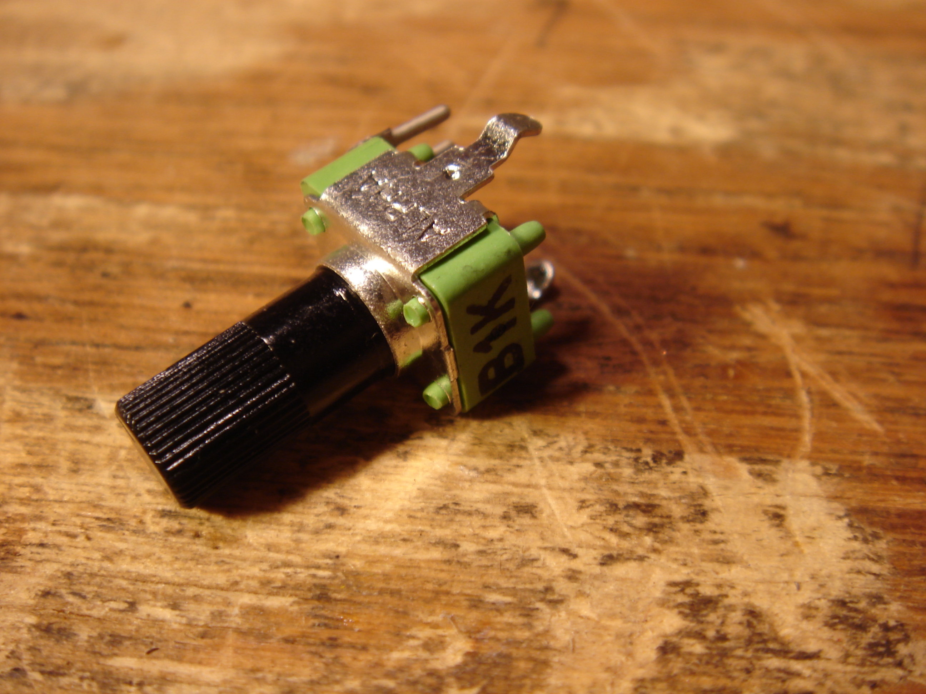
Potentiometers are often called pots. These are variable resistors which internally wipe copper leaf over a carbon strip. They let us adjust electrical parameters by changing the a resistance ratio inside the component. THERE ARE 2 KINDS OF POTS IN WTPA2 but physically they look very similar! You've got to read the text to tell them apart.

WTPA2 has 100kA pots and 10kA pots. The one pictured above is NOT actually in the kit (I just had the picture laying around). We can see that this pot says B1K (not to be confused with B2K). This means it is a linear taper 1-kilo-ohm potentiometer. The “A” part of 100kA means “Audio Taper” or “has a logarithmic resistance curve as you turn it”.

An encoder is a “digital” device. It looks like a pot but works differently. It has 2 switches inside which open and close as you rotate it. These switches send a pulse train to the microcontroller which tells it how fast and in what direction the encoder is turning. One difference between pots and encoders is that encoders usually have “endless” rotation, meaning they just keep spinning. However, they have no “absolute” value, they can only tell the MCU how much they've traveled – not where they started.

The encoder in WTPA2 is the thing that looks like a pot with a metal shaft which spins freely.

Resistors:
There are 8 kinds of resistors in WTPA2 – some are blue 1% metal film resistors and some are tan 5% carbon-film resistors. They do ALL kinds of stuff in WTPA2. The 1% resistors are less noisy (audio wise) and have a better tolerance which is sometimes important. ALL of the resistors have values which are conveyed by their color code. The resistor color code is outside the scope of this doc, but suffice it to say that the code IS DIFFERENT for the 1% and 5% resistors. It's really easy to find these codes on the internet. Do yourself a favor and memorize them. But here are some examples, just to be helpful:

220 Ohm
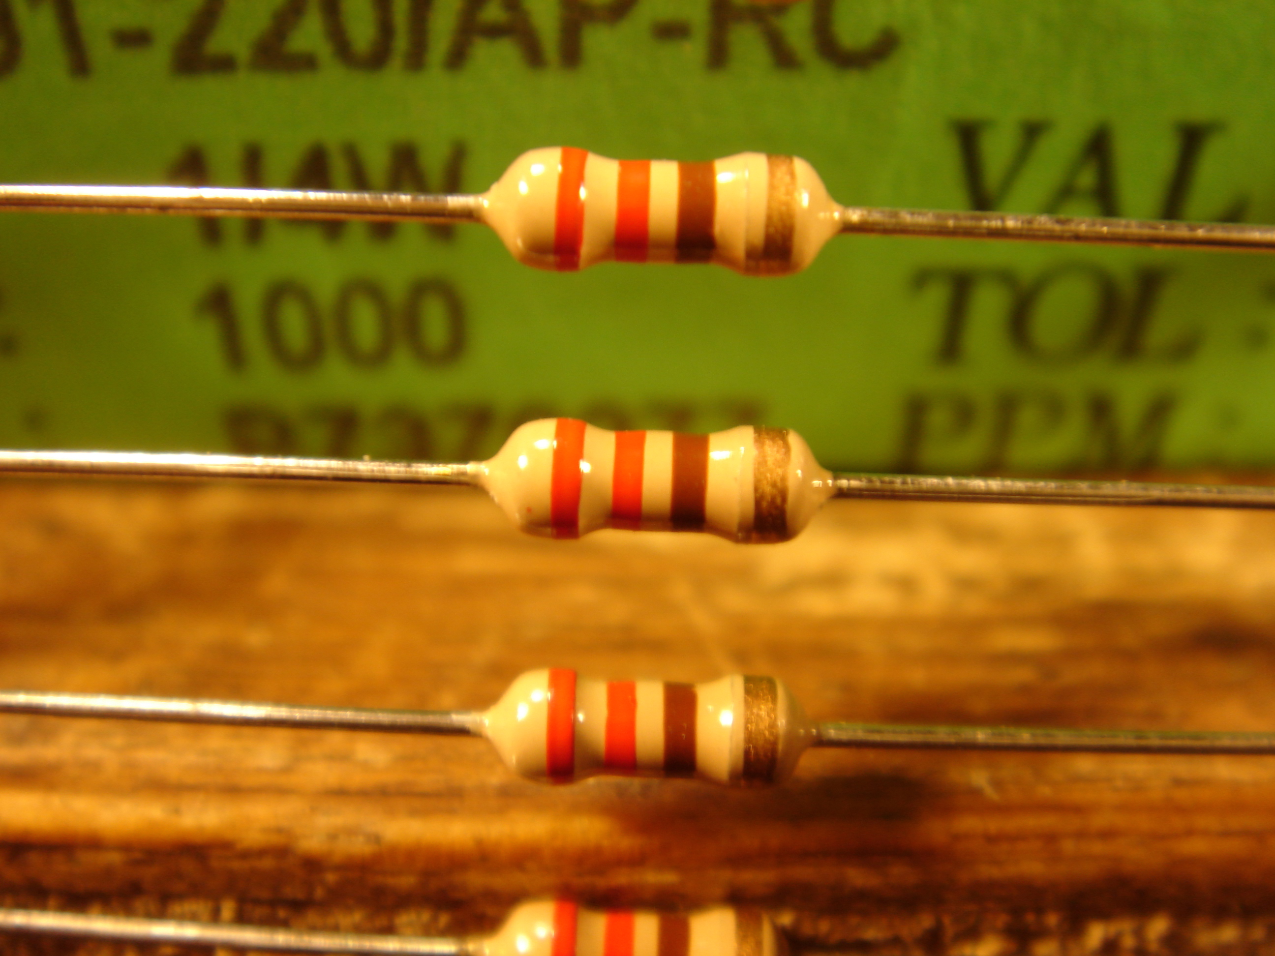
The code for these is RED RED BROWN GOLD. (22 * 10 +/- 5%)

470 Ohm:
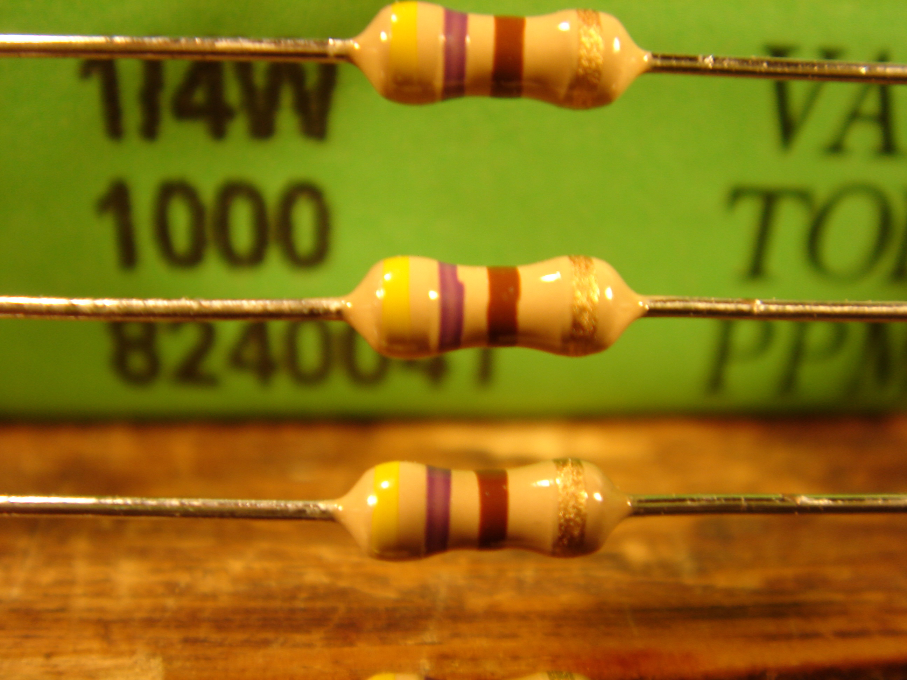
The code for these is YELLOW PURPLE BROWN GOLD. (47 * 10 +/- 5%)

200k Ohm:

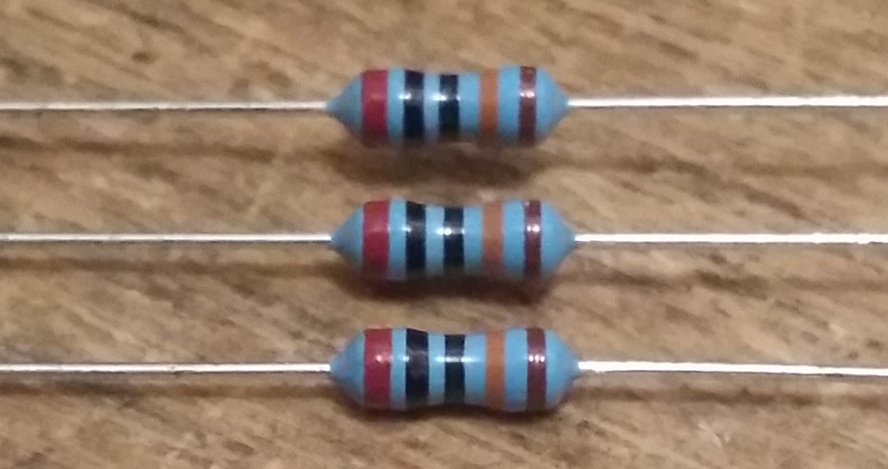

This is a 1% resistor. It has 5 bands. The code for this value is (RED BLACK BLACK) * ORANGE, BROWN. (200 * 1000 +/- 1%) = 200kOhms.

Conclusion:
So hopefully this has familiarized you with the denizens of the WTPA2 universe. You now know what's in your kit, and what it looks like, and some rules about some components. You've got some good information to start with, but there's a lot more. At www.narrat1ve.com there should be more info on ASSEMBLING the kit, using it, and perhaps most importantly, HOW IT ALL WORKS. Good luck!

--TMB, December 5 2014

