WHERE'S THE PARTY AT TOO?
Assembly Guide Revision B
Hardware Revision 1 (and Limited Green Boards)
January 2, 2015
TMB

Dear reader,
Within is a step-by-step pictorial document of how I made my own WTPA2 kit. Feel free to follow along like I did or do it your own way. There are many correct ways. Further, I assume you already know how to solder and trim leads. If you don't yet, run up on that Youtube.

NOTE: in this doc I make reference to the parts by type (capacitor) and reference designator (C1). You can familiarize yourself with the parts in the “WTPA2 Component Guide” from www.narrat1ve.com – it's probably best to read that first – It includes the explicit parts list.

NOTE: WTPA2 has add on options. There is a “main” WTPA2 kit which constitutes the sampler itself. You will at least build that. There is also an optional micro-sd card board, optional jack board, and enclosure which you may or may not have. I'll deal with those in that order, after dealing with the main sampler rig.

Finally, if you ever get stuck, hit up the forum:
http://www.narrat1ve.com/forum/

WTPA Main Sampler Assembly Instructions.................................... 2
High Res Reference Picture of Assembled Kit................................. 17
Micro SD Card Board Instructions.................................................... 21
Jack Board Instructions................................................................... 22
Acrylic Enclosure Instructions........................................................... 24

STEP 1: MAIN WTPA2 SAMPLER KIT

VERY IMPORTANT NOTE ABOUT WTPA2 ASSEMBLY PITFALLS:
ABSOLUTELY READ THIS.
or you will be annoyed later

Before you start to build WTPA2, there are three things to think about:

First: Which flavor of relaxation oscillator do you have?
In a misguided effort to use up all the fancy custom pots I bought, for the last bunch of kits I bagged I made VR5 a 100k pot (NOT 10k, like it says on the board).

IF YOU HAVE THIS BAGGIE IN YOUR KIT:
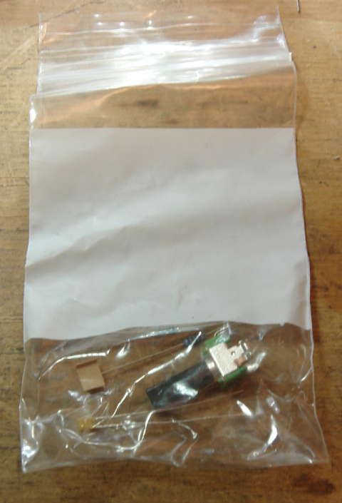
Then your relaxation oscillator uses the 100k pot, and not the 10k pot like it says on the board. In that baggie is a 100kA pot for VR5, and alternate parts for R65, R66, and C27. Functionality is the same either way. The build will be detailed in the appropriate sections below, but know whether or not you have this pot. Note – you'll also be short a 10kA pot if you have this mod. NOTE – some kits have a baggie for the 0-5v mod too, but it is labeled.

Second: Do you want your VCO to take a 0-5V Control Voltage?
WTPA2 was originally designed to take a smaller CV range. An informal poll showed that just about anybody who cared about using CVs didn't like the “Narrat1ve Standard 0-2.4v CV”, so all kits include parts to mod your unit to take 0-5V CVs. But decide before you start.
NOTE: adding the 0-5v CV mod will make the “FINE” manual control less responsive. So decide whether a really sweet “fine” is more important to you than compatibility with modular synthesizers. CV will still work without the mod, but the clock will crap out much above a 2.5v input to the VCO.

Third: Are you building this into the Enclosure Kit?
If you are, when you populate the LEDs, you'll want to put the standoffs that come with the enclosure in before you solder and snip the LED leads. If you forget your kit will look wack.

DO YOU KNOW THE ANSWERS TO THE THREE QUESTIONS ABOVE?
Good. Let's roll.

Getting Ready:
Set up your workbench. Plenty of light is important. Mine looks like this:
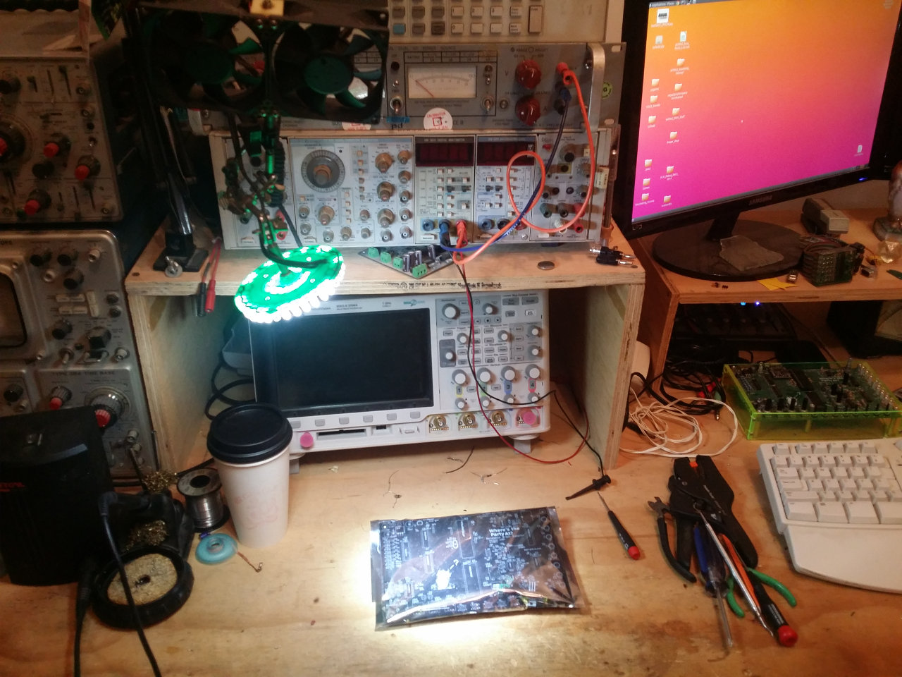

Get your hand tools together – the more the better. You'll need a diagonal cutters, a soldering iron and solder at least. You'll probably also eventually need some wire.

Crack open the treasure chest that is the WTPA2 anti static bag. Produce the board:

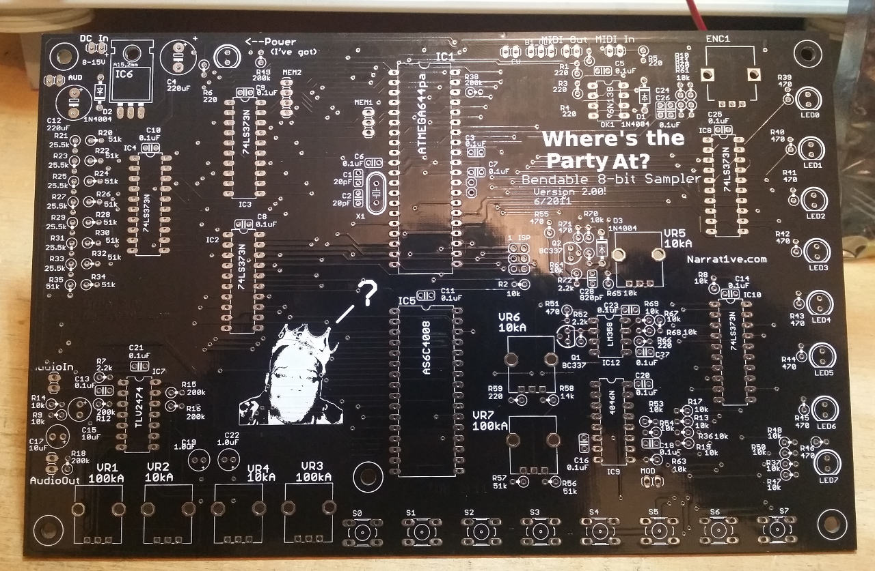
You might want to take the parts out of the bag and count them too. There might be a greater quantity of a given part than is listed, but there shouldn't be less. There's a complete parts list in the Component Guide / Parts List on the site. As of the time of writing my parts pile looks like this:
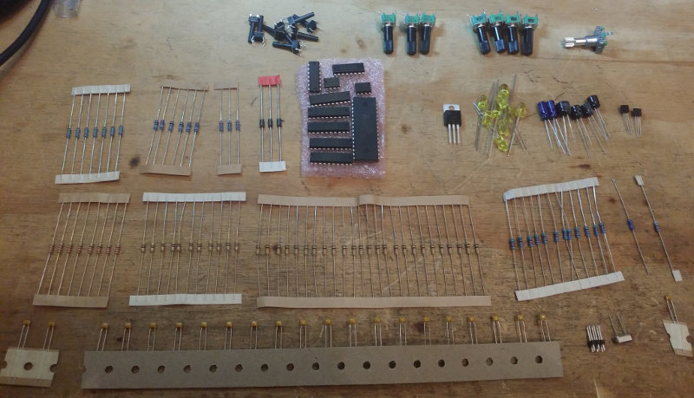
If you're missing a part, please first double check. Hundreds of WTPA1s only had a couple missing parts; odds are it's there somewhere. If not...
WTPA2 was a many-year long, deeply sloppy development process involving me and a lot of interns. Since the interns couldn't write code, they stuffed the bags. They used Social Media. They listened to Rap Music. Many of them learned the difference between a capacitor and a chiclet during this process. I apologize.

If it's a simple component, like a resistor or a chiclet, just use the next closest value or flavor if you have spares, or go to Radio Shack. I will try to make things right with you, but I almost guarantee it will be faster for you to just handle it than it will be for me to ask you a bunch of questions then dig around for parts then ship them to you. If you're missing something really important (like the MCU) then write to me or the forum and we'll figure it out.

Getting Down To It:

Generally I solder in the least obtrusive parts first. If you put the resistors in first you'll bend them a lot when you're soldering other components. I also tend to populate from RARE to COMMON components. It helps to figure out where you went wrong (if you go wrong). But do it however you like. Also, it may help to cross off these instructions one at a time as you are going.

I did the socket first:
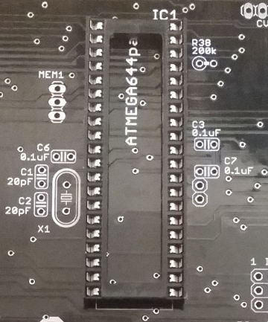

After that I put down the regulator. You'll have to bend the leads in the right spot to make it look nice:
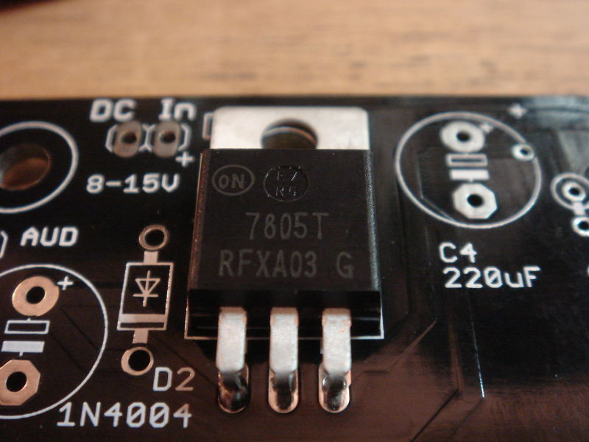

Next I did all the electrolytic capacitors. Note – there are two caps labeled 10uF on the PCB (C15, C17); the caps in the bag are 22uF. This value is not critical. On the black PCBs, C12 and C4 are also labeled incorrectly. Use the values in the parts list. These are not critical (they can be larger values) but in order to fit in the fancy enclosure, we need low profile caps. You could use other caps on the back of the PCB if you wanted.

POLARITY POLARITY POLARITY!
I might be hand-wavey about the values, but polarity is actually critical. They look like this if you solder them in right:

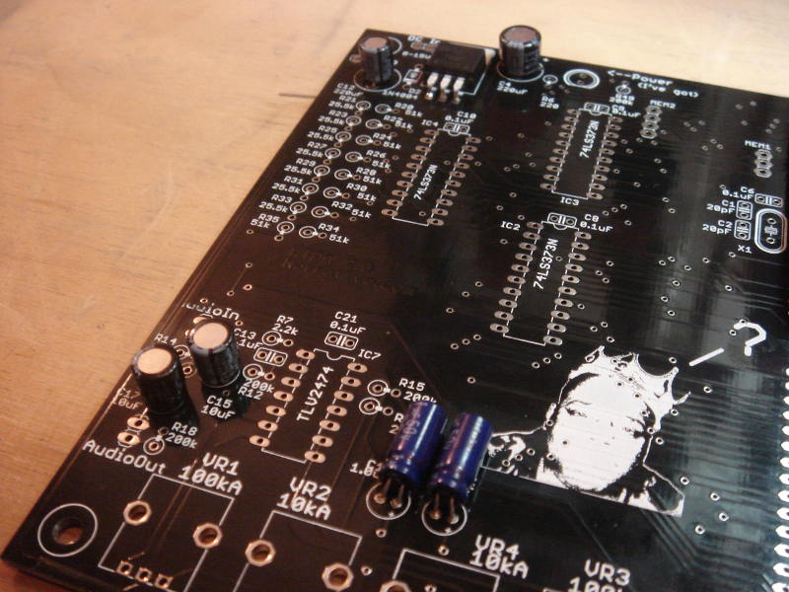

After that came all the ceramic caps. Make sure not to get the 20pF or 820pF guys mixed up with the much more numerous 0.1uF caps. I recommend populating the 20pF and 820pF first. If you have the 100k Oscillator Baggie, make sure to put the 0.01uF cap into C27. You'll have an extra 0.1uF left over. Once this is all done, populate the remaining 0.1uF caps.

Now that you're warmed up, it's IC time. IC12 is labeled LM358. It should really be an MCP6002 or TLV2462. There's an LM358 in your kit too – just set it aside and reflect on how much I love you. Here's the board with all the ceramic caps and the ICs:

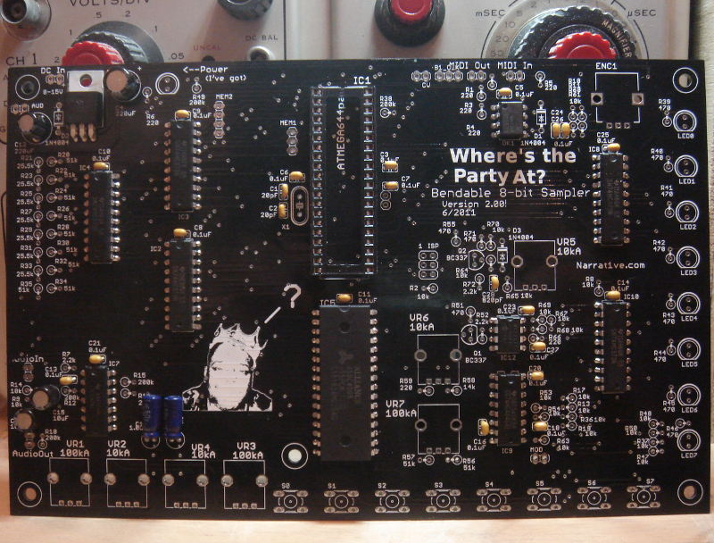

Next, crystal, diodes and transistors (POLAR!) and ISP header (the 6-pin thing). You can skip the 6-pin programming header if you are supremely confident. You shouldn't be.

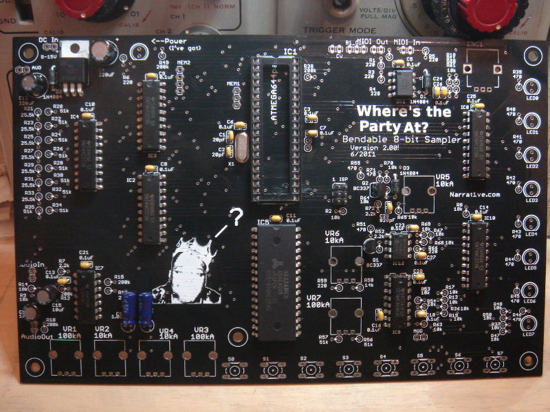

Now plow through the resistor values. Note, if you are installing either the 100k RC OSCILLATOR or 5V CV mods, pay special attention here.

If you are installing the 0-5v CV range mod, start with that.
We'll start by installing any value of resistors which don't match up with the board. Your kit should have enough resistors to do this.

1.) R55 is labeled as 470. Install a 51k instead.

2.) R58 is 15k in the parts list and in the kit, 14k on the board silkscreen, but YOU should install a 220 ohm resistor there (100 ohms would be fine too).

3.) Last, SET ASIDE that loose 47k resistor (you should have one). You will need to include this in your mod, but it is easier to do it once the other components are soldered in Don't forget it later.
Now, if you have a 100k Oscillator Mod Kit, do those resistors. There are two. From the baggie, put the 2.2k resistor into R66 (labeled 220). Put the 100k resistor into R65 (labeled 10k).

Now, move on to the normal resistors.
Put in the 15k (if you aren't doing the 5v mod), the 2.2k resistors, and the 200k resistors. The board should look about like this:

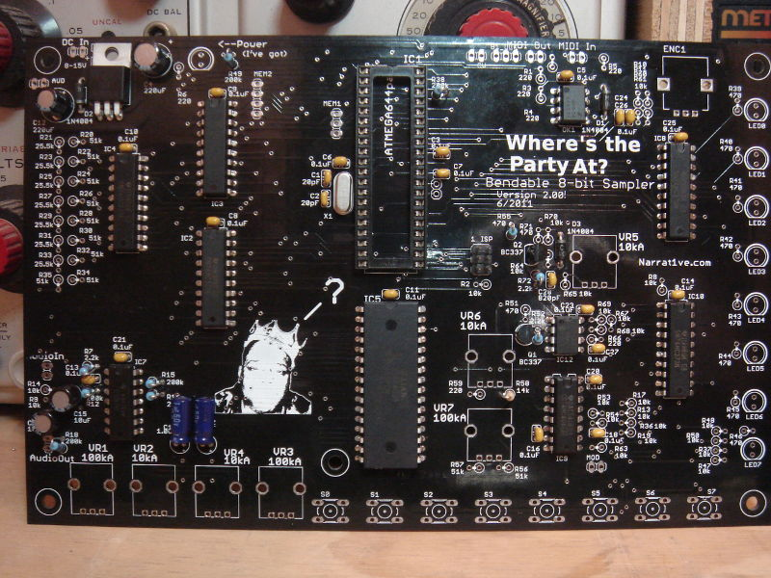

Next, the 220 ohm resistors and the 25.5k resistors. All the 25.5k resistors are in the R2R ladder on the left side of the board. There are 220s everywhere. You'll have one spare 220 if you DID NOT do the 5v CV mod.

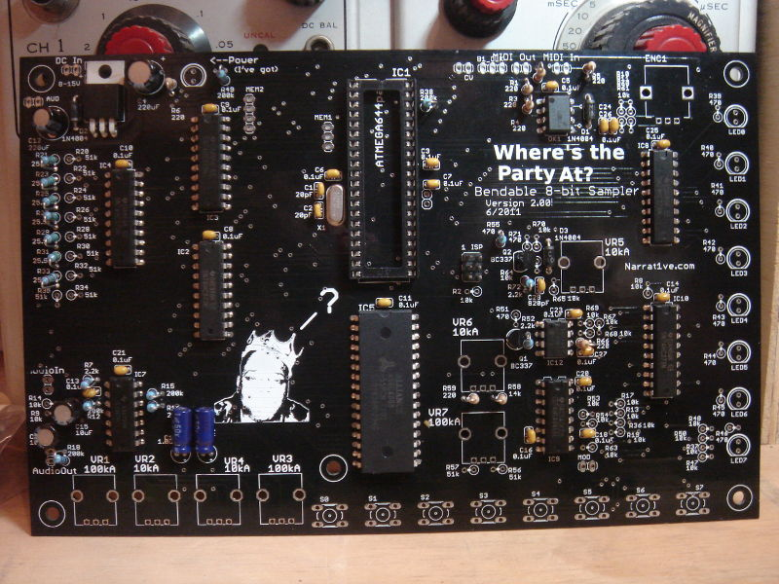

Next the 470 ohm resistors. Most are by the LEDs. The others are to the left of VR5. If you did the 5v mod, you'll have one extra at the end.
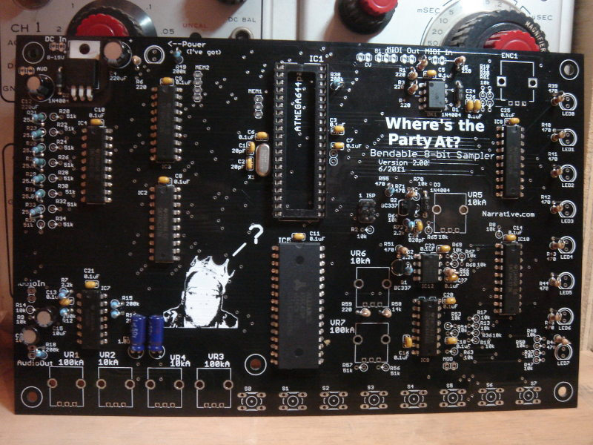

Next the 51k resistors. Most are in the R2R ladder on the left of the board, the other two are near VR7. If you DID NOT DO the 5V CV mod, you'll have one extra.
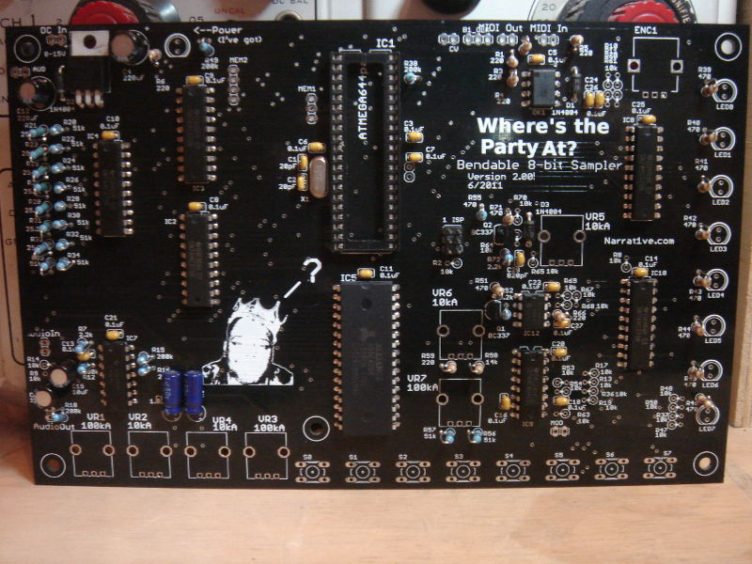

And last the 10k resistors. If you followed the directions above, all remaining unpopulated resistors are 10k. If you did the 100k Oscillator Mod you'll have a spare at the end.
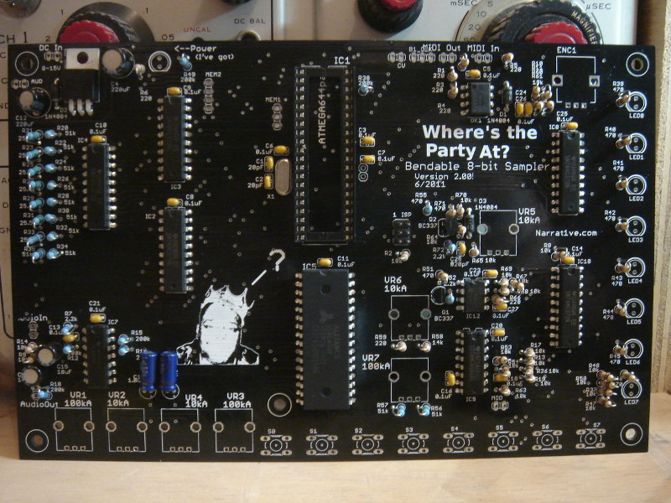

Do all the pots and the encoder next. Make sure you solder down their body contacts (the two larger legs on the sides) as well as the three electrical connections. The body of the pot provides mechanical support AND keeping it grounded reduces system noise. Note, if you have the 100k Oscillator Mod, VR5 will be 100k; otherwise it will be 10k.
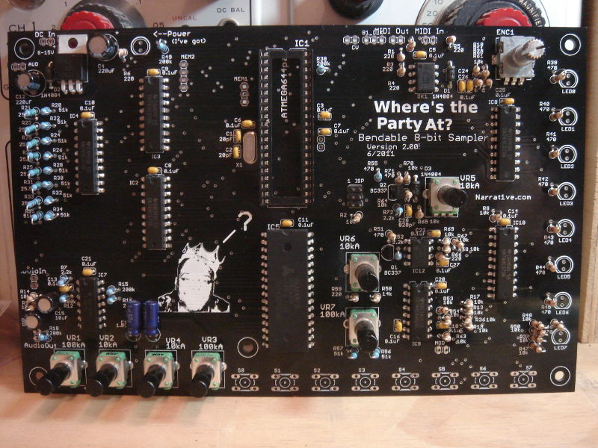
Finally do the long buttons and LEDs. NOTE – if you're building the optional acrylic enclosure, make sure you put the standoffs under the LEDs (pictured here). Consider setting the board into the top acrylic panel (if you have one) to make sure all the LEDs line up when you solder them in.

Finally, if you are doing the 5v mod, finish it now. Remember that 47k resistor you set aside? Connect it between the BOTTOM leg of R55 (the one with the silkscreened circle, or the one that is continuous with pin 3 of the dual op amp) and ground. There are a few places to connect to ground – the emitter of Q2 if you put this resistor on the bottom of the board, or the chassis of VR5. I put it on the bottom of the PCB and connected to ground at the bottom pin of Q2 (the emitter):

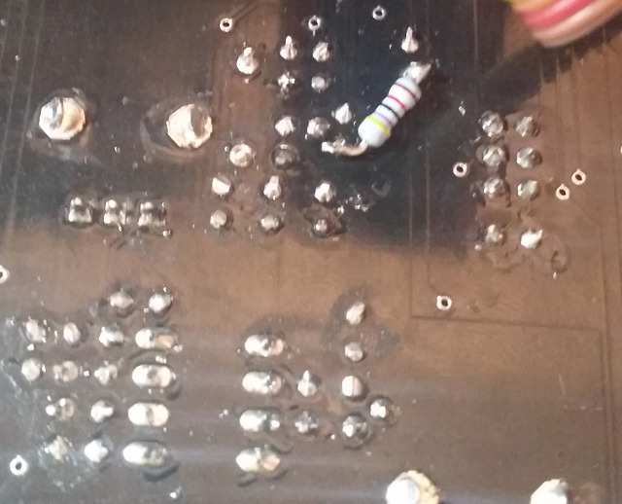

Lastly, socket your MCU. Sigh with deep accomplishment.
Your basic WTPA2 build is complete. Here's a high-res photo of what everything should look like.

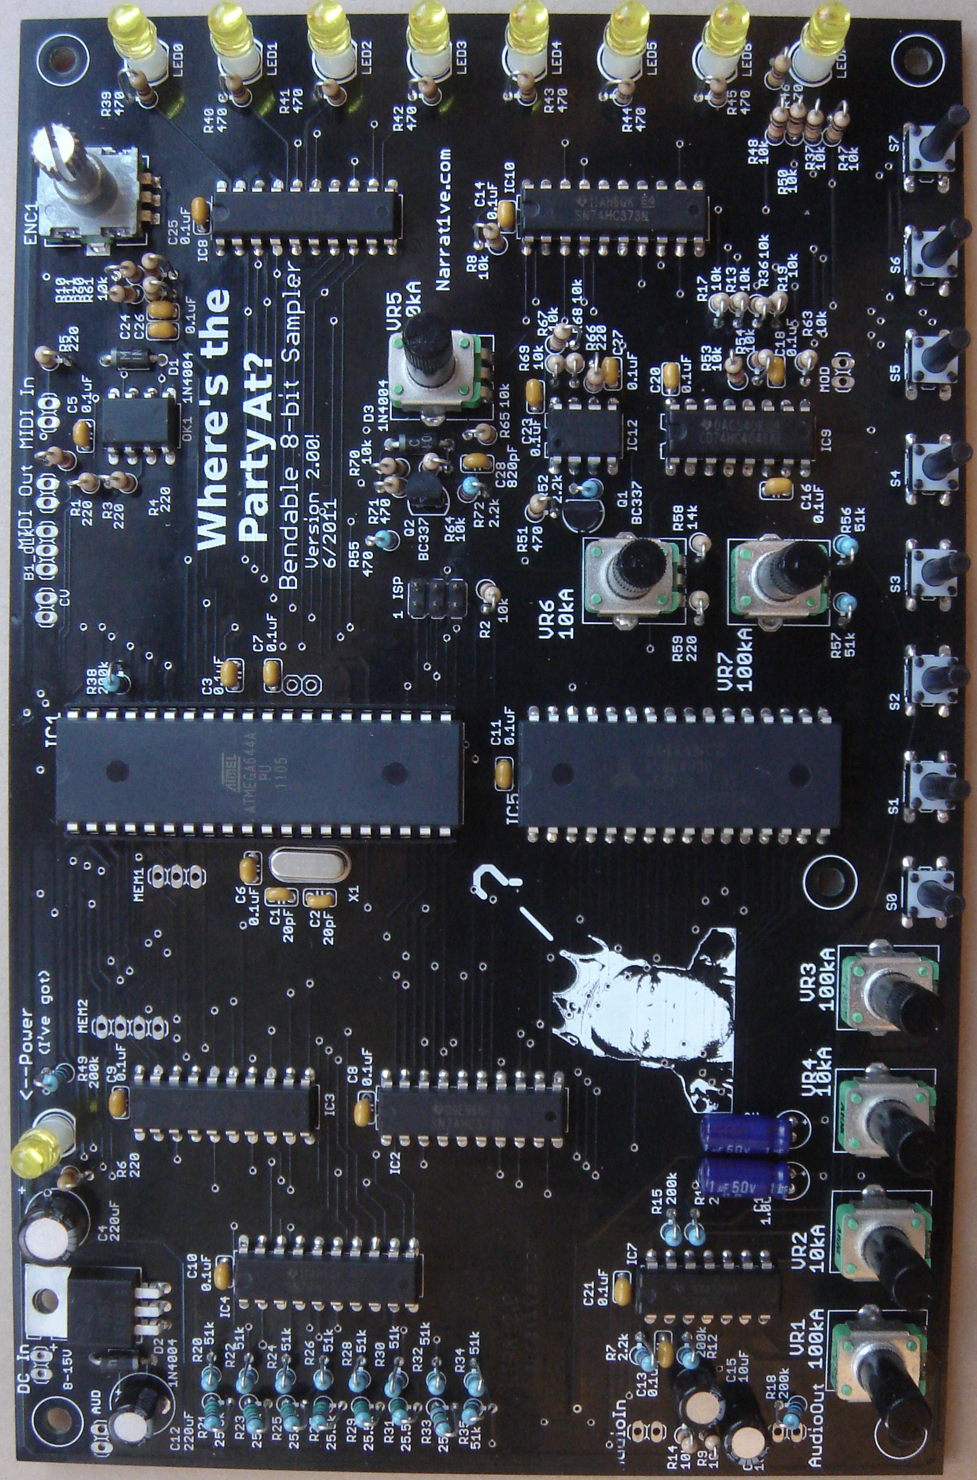

To use it, you'll need to hook up power, audio, and optionally MIDI.
There are also some connections you will either need to connect to external jacks or switches.
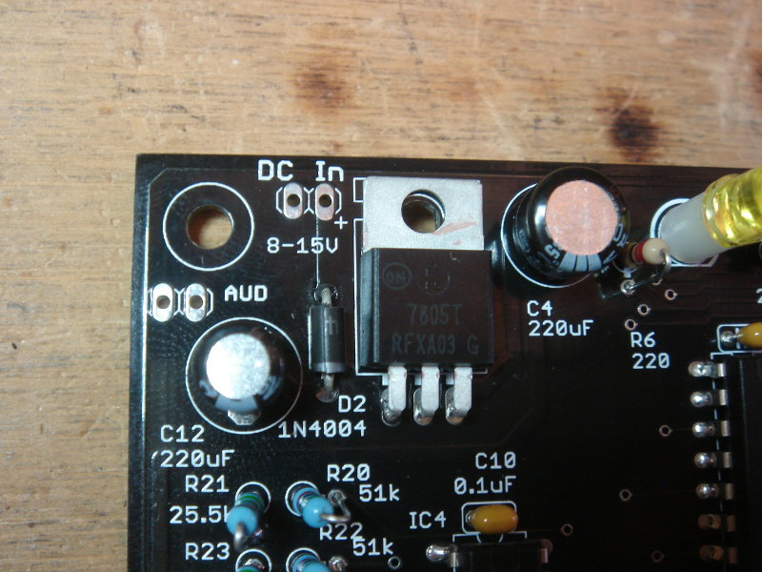
Power goes here. POLARITY MATTERS, note the + symbol. WTPA2 really is happiest with 9-12VDC, and at least 200mA of current available. You could probably get away with less if you had to; average current draw on my bench is about 75mA. Using a noisy DC supply can introduce hum into your audio path; this will depend a lot on your wiring. Ignore “AUD” for now; it's for the Jack PCB.

MIDI should be connected here. From left to right, MIDI Out would go to pins 5 and 4 on a female MIDI jack. From left to right, MIDI In would also go to pins 5 and 4.

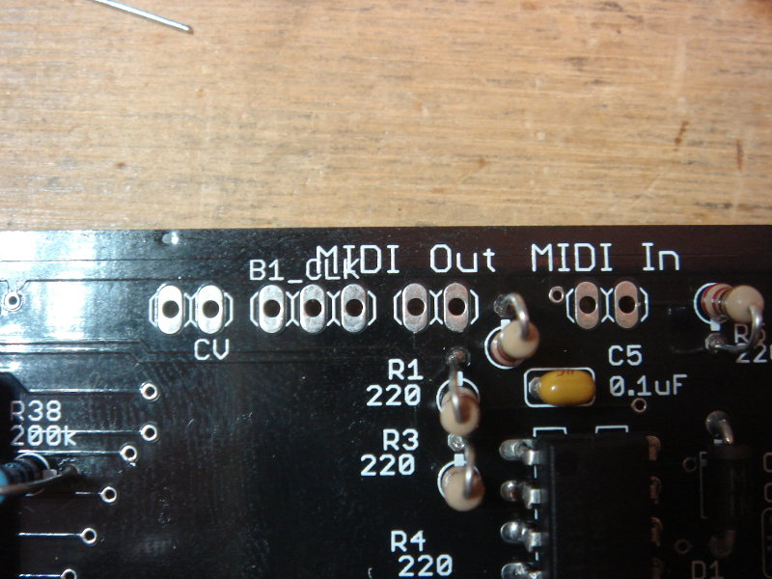

“B1 CLK” is an set of three pins which allows you to select the analog clock source for Bank 1. The center pin is the input. The output from the main VCO (which always feeds Bank 0) is on the left. The output from the auxiliary RC oscillator (controlled by VR5) is on the right. If you got the optional Jack PCB these are wired to a switch so you can pick one. If you didn't get one, you can either add your own switch or permanently jumper the center pin to either the VCO or RC oscillator. Jumpering it to the VCO will mean the main VCO controls the sample rate for both banks (and they're synced). Jumpering it to the RC Oscillator will allow independent pitch control of both banks (but they will probably never be in sync). YOU MUST PICK ONE OR BANK 1 WILL NOT WORK.

“CV” is two pins and works similarly. The pin on the left SENDS the CV out from WTPA's control pots. The pin on the right is the input to the VCO. If you got the optional Jack PCB, this goes to a switching jack, such that if you plug in a cable to the CV jack, WTPA2 listens to that input. If you unplug the cable, WTPA2 listens to its potentiometers. YOU MUST CONNECT THESE TWO SOMEHOW or your MAIN CLOCK WON'T WORK.

MOD (modulation) (not shown – it's on the bottom of the PCB) is another frequency control voltage input to the VCO; I haven't played with it much but it might be cool. On the MOD connection, GROUND is on the right if you're looking at the top of the PCB.

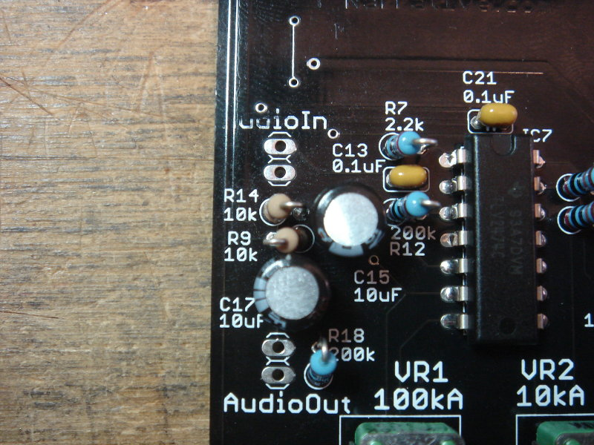

“Audio In” is a single ended connection. The top pad is the input, the bottom pad is ground.
“Audio Out” is also single ended. The top pad is the output, the bottom pad is ground.

STEP 2: OPTIONAL Micro-SD Daughter Board
This gives WTPA2 the option to save and load samples to/from a micro SD card. NOTE-- Only “Standard Density” cards will work! These are uSD cards of 2GB capacity or less. They go for a couple dollars on eBay. Since there was not a good way to make the uSD interface without using surface mount components I just built it as a daughterboard, and not part of the main kit. It should be VERY EASY to solder down.

The uSD Baggie comes with three pieces – the daughterboard itself, a 3-pin header, and a 4-pin header. It can only go down one way. Solder the 3-pin header into MEM1 by the microcontroller. Solder the 4-pin header into MEM2 by the microcontroller. Seat the daughterboard onto both headers and solder it down.

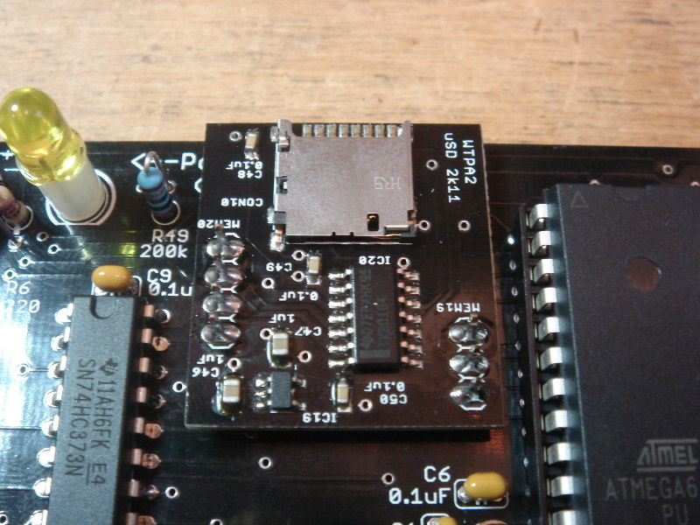

STEP 3: OPTIONAL Jack and Switch PCB

This PCB gives you all the handy I/O connectors for WTPA2 in an easy to mount PCB. It fits handily into the optional acrylic enclosure. It includes jacks for Audio In, Audio Out, DC Power, CV Input, MIDI In and MIDI Out. It also includes a switch which allows you to change the clock source for Bank 1. The CV jack on the Jack Board is a shorting jack which will connect that jack's input to the VCO if something is plugged in. If nothing is plugged in, the COARSE and FINE VCO control knobs will control the VCO's frequency (and the sampling rate of at least Bank 0, and maybe Bank 1 depending on how your B1 CLK switch is set).

Again, there aren't that many parts in this bag and it's difficult to mess up. The MIDI jacks are identical to each other, as are the 1/4” audio and CV jacks. So here's a picture of what it looks like when it is done.
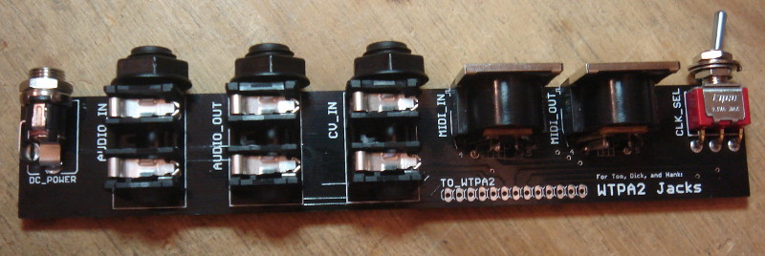
To make this useful you need to wire it up to the main PCB. If you're using the acrylic enclosure, WIRE TO THE BOTTOM OF THE WTPA2 PCB. Otherwise you'll have to thread your wiring between the board and enclosure. Use only as much wire as you need. If you use too much, you'll be prone to pick up more noise. You can fuss with connecting ground wires in other places and adding filter caps if that happens, but keep wiring neat if you can.

The jack board gets wired such that if you use a ribbon cable it lays flat. IE, the leftmost pad on the jack board goes to the leftmost pad on WTPA2 (labeled AUD in the upper left corner near the voltage regulator). There are the same number of pads on the jack board as on the WTPA PCB.

They are from left to right (looking at the top of the jack PCB):
Audio Out, Audio In, Ground, DC Power, CV send, CV return, VCO to switch, Switch return, RC to switch, MIDI out 1, MIDI out 2, MIDI in 1, MIDI in 2.

Wired up, they look like this:

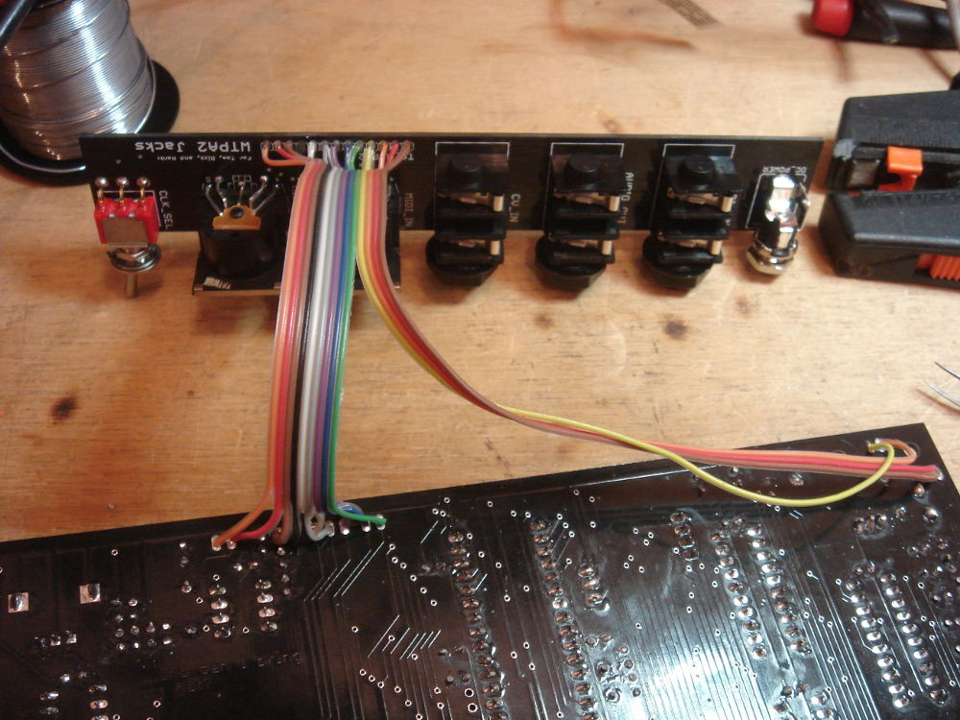

STEP 4: OPTIONAL Acrylic Enclosure

Truly, my friend, if you have picked this up, you have invested in a real Cadillac of blingdom; a sure way to make all those other dudes with lesser acrylic enclosures rage with base jealousy.

The enclosure comes with a bunch of hardware. Again, there really is only one way to put it together. But there are some caveats:

There are THREE SIZES OF SCREW. The very tiny screws are optional screws for the MIDI jacks. The smaller diameter screws are 4x40 thread and are used to attach the acrylic pieces to each other. The larger diameter screws are 6x32 thread and are used to attach the aluminum standoffs.

DO NOT OVERTIGHTEN THE SMALL SCREWS!
It is easy to strip the threads in the acrylic, and a huge PITA to repair them. Resist the urge.

Acrylic is not that tough. This enclosure, while deeply flossed out, is not bulletproof. Or wildly drop proof. I got hit by a car on my bike once with one of the prototype units, and it broke the rear panel. It sucked. So don't get doored with WTPA2.

Here's an acrylic enclosure half-open with all the hardware showing:

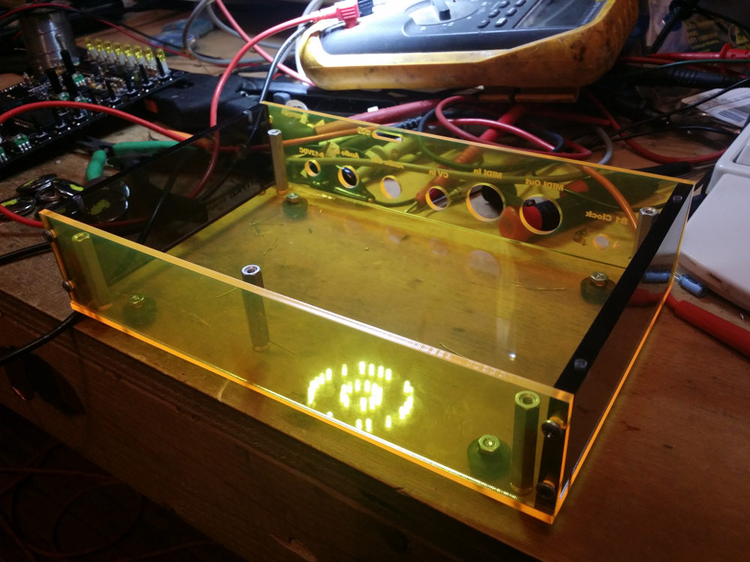

Before parting, here's a money shot of the whole thing together:

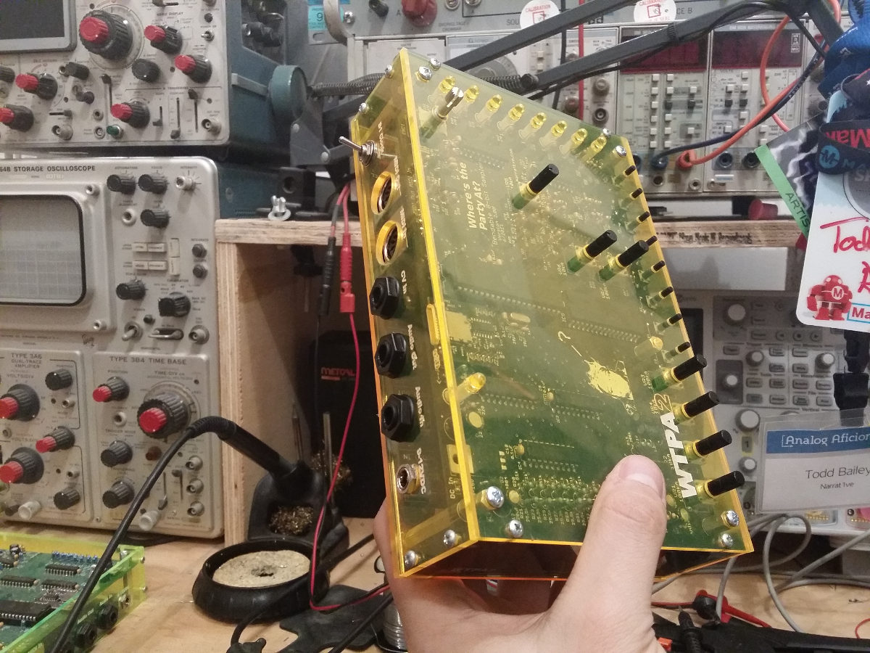

And a rare green unit, in the field:

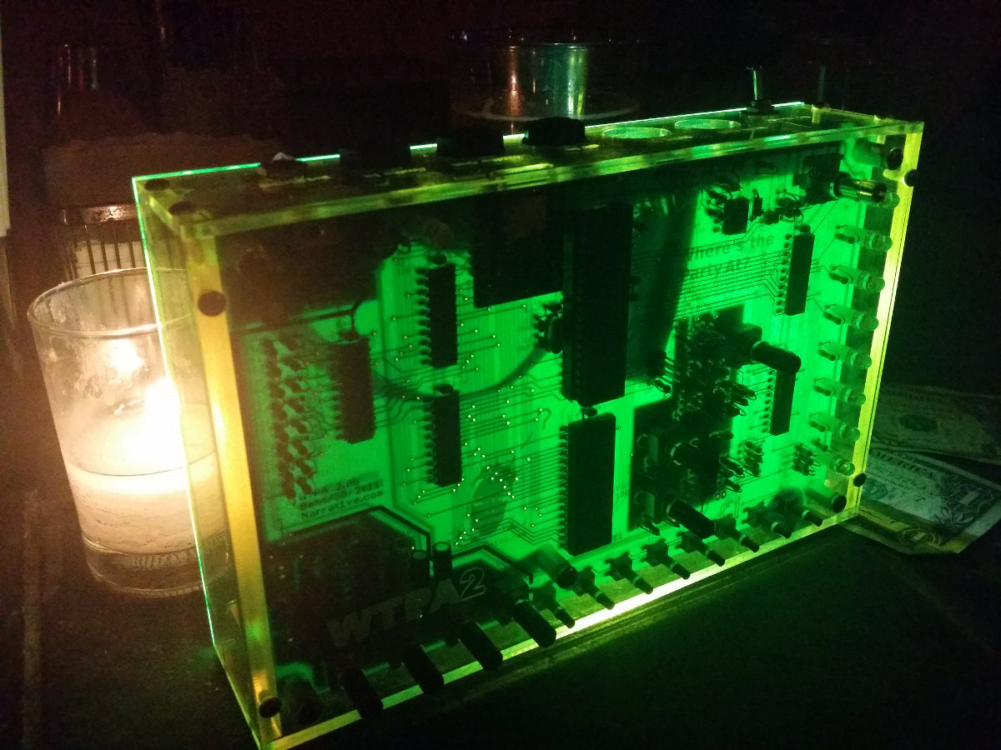

Congratulations! You've got a WTPA2.
There are, of course, lots of other things you can do or build to bling out your WTPA2, but those are up to you.

If you've had trouble, or great success, or want to brag or complain, a good place to do it is the WTPA2 / Narrat1ve forum:
http://www.narrat1ve.com/forum/

Consider me proud of you, and happy sampling,
TMB
December 2014
(Rev B, January 2015)

