PSYCHOLOGICAL ASSESSMENT REPORT

Patient ID: PT001
Generated: 2026-01-24 13:22:57

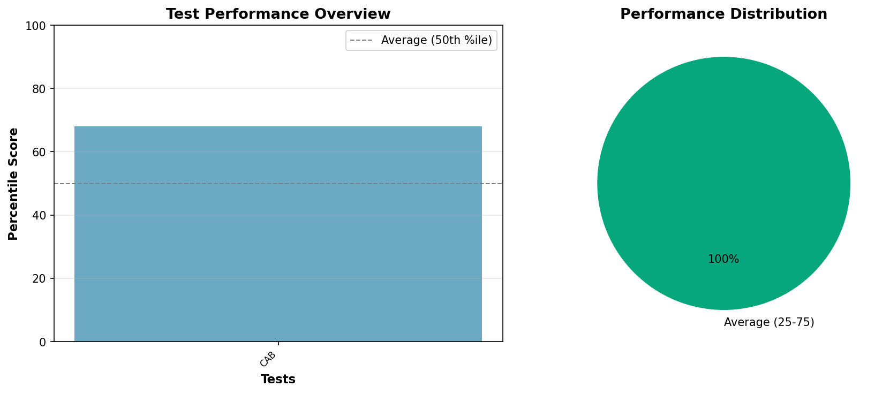

PSYCHOLOGICAL ASSESSMENT REPORT

IDENTIFYING INFORMATION:
Patient ID: PT001
Age: 45 years
Gender: Male
Date of Assessment: 2024-01-15

TESTS ADMINISTERED:
- Cognitive Assessment Battery (CAB)
- Depression Inventory (BDI-II)
- Anxiety Scale (GAD-7)

BEHAVIORAL OBSERVATIONS:
The patient presented as cooperative throughout the assessment process. Effort appeared adequate and results are considered valid.

TEST RESULTS AND INTERPRETATION:
Cognitive Assessment Battery:
Memory Recall: 82
Processing Speed: 75
Attention Span: 88
Executive Function: 79
Percentile: 68
Interpretation: Average to above average cognitive functioning
Depression Inventory:
Score: 14
Interpretation: Mild depressive symptoms present
Anxiety Scale:
Score: 8
Interpretation: Mild anxiety symptoms

CLINICAL NOTES:
Client presents with mild mood disturbance. Cognitive functions intact.

RECOMMENDATIONS:
- Follow-up assessment as clinically indicated
- Consider appropriate interventions based on findings
- Monitor progress over time
_______________________
[REDACTED], Psy.D.
Licensed Clinical Psychologist

