PSYCHOLOGICAL ASSESSMENT REPORT

Patient ID: PT002
Generated: 2026-01-24 13:24:07

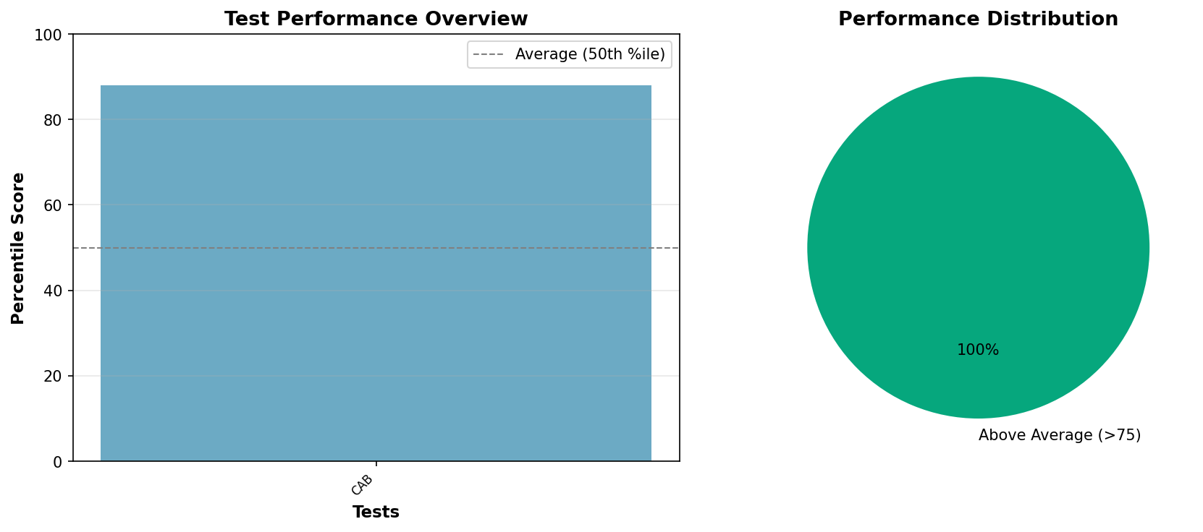

PSYCHOLOGICAL ASSESSMENT REPORT

IDENTIFYING INFORMATION:
Patient ID: PT002
Age: 32 years
Gender: Female
Date of Assessment: 2024-01-20

TESTS ADMINISTERED:
- MMPI-2 Personality Assessment (MMPI-2)
- Cognitive Assessment Battery (CAB)

BEHAVIORAL OBSERVATIONS:
The patient presented as cooperative throughout the assessment process. Effort appeared adequate and results are considered valid.

TEST RESULTS AND INTERPRETATION:
MMPI-2 Personality Assessment:
Interpretation: Elevated anxiety and worry patterns
Cognitive Assessment Battery:
Memory Recall: 91
Processing Speed: 88
Attention Span: 85
Executive Function: 92
Percentile: 88
Interpretation: Superior cognitive functioning

CLINICAL NOTES:
High functioning individual with anxiety concerns. No cognitive deficits.

RECOMMENDATIONS:
- Follow-up assessment as clinically indicated
- Consider appropriate interventions based on findings
- Monitor progress over time
_______________________
[REDACTED], Psy.D.
Licensed Clinical Psychologist

