PSYCHOLOGICAL ASSESSMENT REPORT

Patient ID: PT003
Generated: 2026-01-25 10:58:19

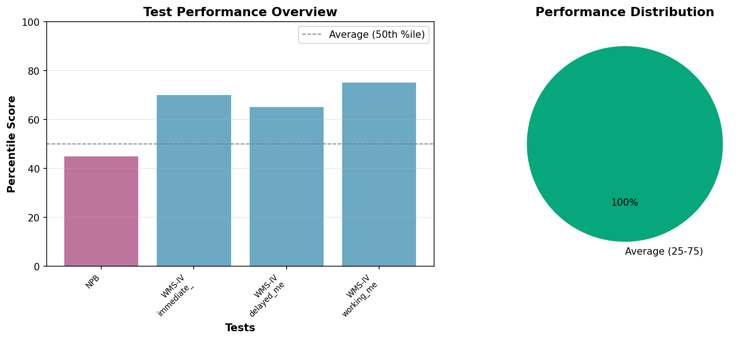

PSYCHOLOGICAL ASSESSMENT REPORT

IDENTIFYING INFORMATION:
Patient ID: PT003
Age: 58 years
Gender: Male
Date of Assessment: 2024-02-01

TESTS ADMINISTERED:
- Neuropsychological Battery (NPB)
- Depression Inventory (BDI-II)
- Memory Assessment (WMS-IV)

BEHAVIORAL OBSERVATIONS:
The patient presented as cooperative throughout the assessment process. Effort appeared adequate and results are considered valid.

TEST RESULTS AND INTERPRETATION:
Neuropsychological Battery:
Verbal Memory: 68
Visual Memory: 72
Language: 85
Visuospatial: 78
Executive Function: 65
Processing Speed: 62
Percentile: 45
Interpretation: Mild cognitive changes consistent with age
Depression Inventory:
Score: 22
Interpretation: Moderate depressive symptoms
Memory Assessment:
Immediate Memory: 70
Delayed Memory: 65
Working Memory: 75
Interpretation: Mild memory difficulties noted

CLINICAL NOTES:
Age-related cognitive changes with mood component. Recommend follow-up.

RECOMMENDATIONS:
- Follow-up assessment as clinically indicated
- Consider appropriate interventions based on findings
- Monitor progress over time
_______________________
[REDACTED], Psy.D.
Licensed Clinical Psychologist

