PSYCHOLOGICAL ASSESSMENT REPORT

Patient ID: PT004
Generated: 2026-01-25 11:06:17

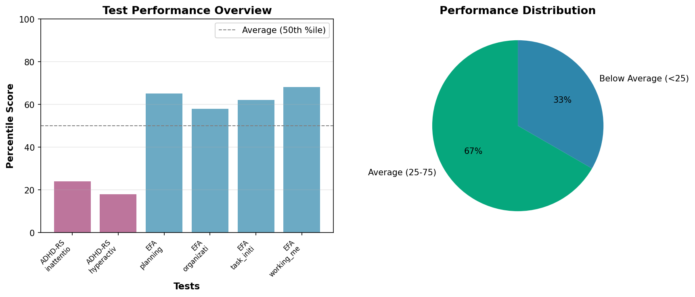

PSYCHOLOGICAL ASSESSMENT REPORT
Patient: Maria Garcia
Date of Assessment: February 10, 2024
Age: 28 years
Gender: Female
Examiner: Dr. [REDACTED]

REASON FOR REFERRAL:
The patient was referred for comprehensive psychological assessment to evaluate attention and executive functioning difficulties impacting daily functioning.

TESTS ADMINISTERED:
- ADHD Rating Scale (ADHD-RS)
- Executive Function Assessment (EFA)
- Clinical Interview

BEHAVIORAL OBSERVATIONS:
The patient presented as cooperative and motivated throughout the assessment process. She demonstrated good insight into her difficulties and provided thoughtful responses. Effort appeared adequate and test results are considered valid and reliable.

TEST RESULTS AND INTERPRETATION:
Attention Functioning:
The ADHD Rating Scale revealed clinically significant elevations consistent with attention-deficit/hyperactivity disorder, primarily inattentive presentation. The inattention subscale score of 24 indicates moderate to severe difficulties with sustained attention, distractibility, and task completion. The hyperactivity subscale score of 18 falls in the mild to moderate range, suggesting some restlessness but less prominent hyperactive symptoms.
Executive Functioning:
The Executive Function Assessment identified mild deficits across multiple domains. Planning abilities (65th percentile) and working memory (68th percentile) fell in the average range, representing relative strengths. Organization skills (58th percentile) and task initiation (62nd percentile) were in the low-average range, indicating areas of difficulty that likely impact academic and occupational performance.

CLINICAL IMPRESSIONS:
This is a well-functioning individual presenting with clinically significant attention deficits consistent with ADHD, predominantly inattentive type. Executive function challenges are present but mild, likely secondary to the attention difficulties. The patient demonstrates good self-awareness and motivation for treatment.

DIAGNOSTIC CONSIDERATIONS:
Primary: Attention-Deficit/Hyperactivity Disorder, Predominantly Inattentive Presentation

RECOMMENDATIONS:
- Psychoeducation regarding ADHD and its impact on daily functioning
- Cognitive-behavioral therapy focusing on attention and organizational strategies
- Implementation of environmental modifications and accommodations
- Consultation with psychiatry for medication evaluation
- Development of structured routines and time management techniques

SUMMARY:
Assessment findings support a diagnosis of ADHD with associated mild executive function challenges. The patient's good insight and motivation are positive prognostic factors for treatment response.
_______________________
Dr. [REDACTED], Psy.D.
Licensed Clinical Psychologist
License #[REDACTED]

