**LABP-9** Sampling, Convolution and FIR Filtering

[ Pre Lab – Tara’s Stuff ]

[ Warm up – Tara’s Stuff ]

# 3 Lab Exercises: FIR Filters

These exercises focus on the filter effects of **echoes** (“ghosts”) due to delay terms and **deconvolution** wherein one filter approximately undoes the effects of another in a cascaded system.

## 3.1 Deconvolution experiment for 1D Filters

In this section, the effects of filtering and restoration are studied.

An input signal is defined as . The function within the parenthesis is a Boolean object which checks whether the numbers in the range modulo 50 are less than 10.

A first-difference filter is defined as having filter coefficients of 1 and -0.9, resulting in:



### Plot the input signal and the result of passing it through the FIR filter .

The reason for the magnitude spikes is a form of edge-detection. Due to the ordering of the difference filter, positive edges (going from a lower value to a higher one) results in a positive spike and vice versa. However, this is a weighted difference filter, so sections of the input signal which are constant and non-zero still have residual values. In this case, 10% of their original value.

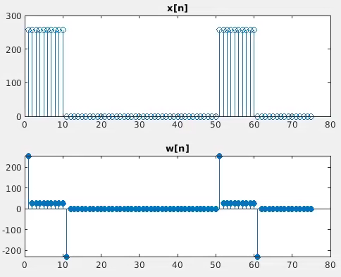

**Fig[#]. The plot at the top shows the original signal. The plot at the bottom shows the first-difference filtering of this signal.**

### Length of output

Given that the output is defined as the convolution sum of filter coefficients with a time-reversed input signal, the length is the length of the filter vector plus the input signal minus 1.

### 3.1.1 Restoration Filter

A secondary filter (**filt2**) is defined below with .



Each sample in the output is a weighted sum of M-past values of the first filtered signal. Given that , this shows that the weights samples decrease the further away from the present sample they are. To accomplish this filtering, a loop iterating through all output samples was nested with an inner loop which iterated over M-past samples. A conditional was added which exited the inner loop if was out of the index bounds – these samples would be zero otherwise and don’t affect the output.

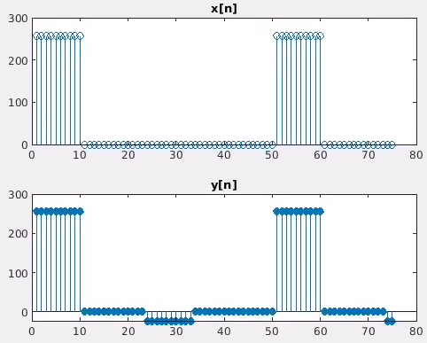

**Fig[#]. The plot at the top shows an original input signal. The plot at the bottom shows the restored signal after distortion was applied.**

### 3.1.2 Worst-Case Error

The quality of restoration is an approximation, and depending on the application could be very noticeable (or not at all). Increasing M decreases the maximum error and this is because as an FIR increases its taps, it approaches the approximation of an IIR. In order for the error to not be seen on this graph, the tap size should be .

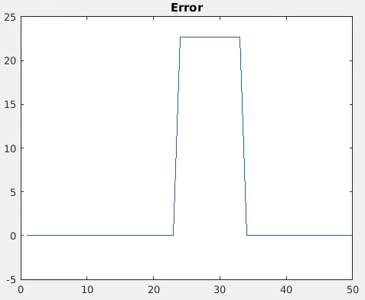

**Fig[#]. The error resulting from restoring a distorted signal.**

### 3.1.3 Echo Filter

A filter is defined below with .



#### Determine values of coefficients to obtain a 90% echo with 0.2 seconds delay

The scaling value relates directly to the size of the echo, so this should be set to 0.9. is the number of samples which represents a time-delay of 0.2 seconds. .

#### Describe the coefficients and determine the length

The coefficients are . Each sample in is a summation of the same sample in the input signal with a weighted version of a past signal samples away. The length is .

# 3.2 Cascading Two Systems

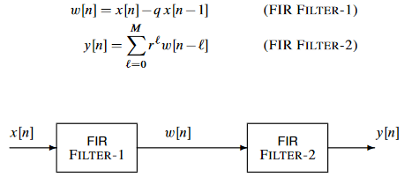

### 3.2.1 Overall Impulse Response

#### a) Plot the overall impulse of the cascaded system

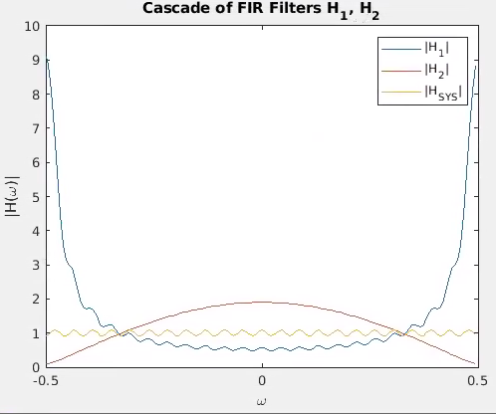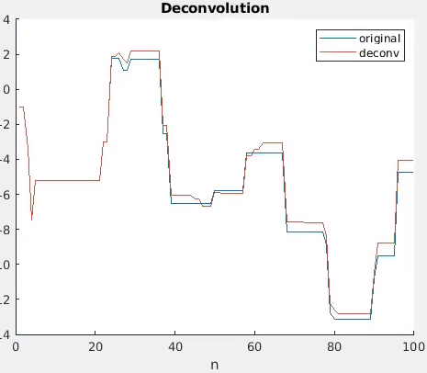

**Fig[#]. The graph on the left shows the frequency response of individual and overall system filters of a cascaded system. The graph on the left shows the results of passing a signal through these filters.**

#### b) Work out the impulse response by hand

#### c) Conditions for perfect deconvolution

For perfect deconvolution, the product of the frequency responses (or the convolution of the impulse responses in the time-domain) of the filters would have to be a constant magnitude of 1.

### 3.2.2 Distorting and Restoring Images

Because the in is less than 1, there will be distortion when applied to an image. The objective of this section is to show how removes this.

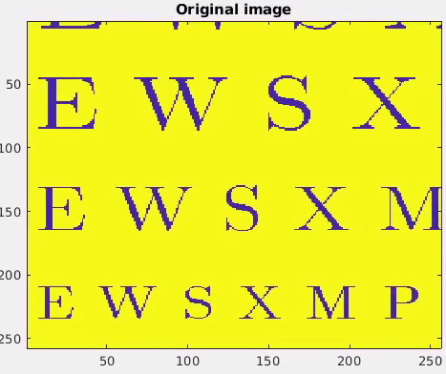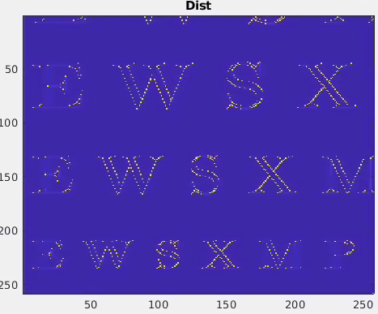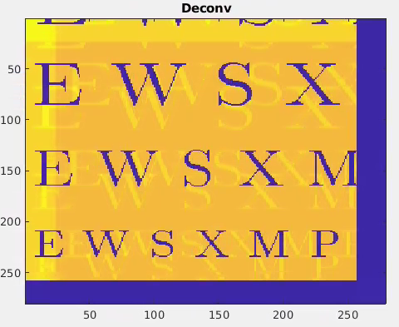

**Fig[#]. Distortion and deconvolution of an image. The image on the left is the original, the middle after a first-difference filter is applied, and the left after deconvolution is applied.**

First thing to note in this image is that “black” (representing a 0) is purple and “white” (representing 255) is yellow. Applying a first-difference results in positive values when transitioning from “black” to “white” and negative values (which are capped at 0) when doing the opposite transition. As a result, the black letters are outlined in positive values and anywhere the color didn’t change results in a subtraction of color value which should be around 25.5 (10% of 255).

With deconvolution, the most noticeable trait is the presence of ghosts. This is a result of the past samples playing a role in the value of the present sample. The location of these ghosts is directly related to ; they are separated pixels horizontally and vertically. Also noticeable is the border around the image which is samples thick.

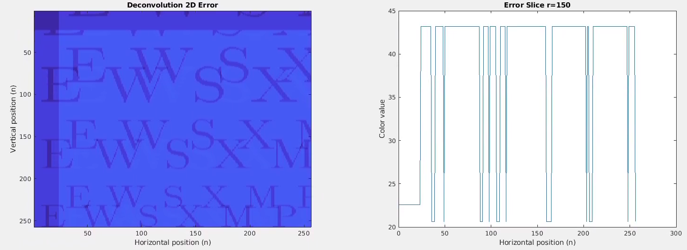

**Fig[#]. 2D Deconvolution error plots. The plot on the left shows error represented by color (the darker, the less error). The plot on the right shows a 1D horizontal slice at the 150th row.**

### 3.2.3 A Second Restoration Experiment

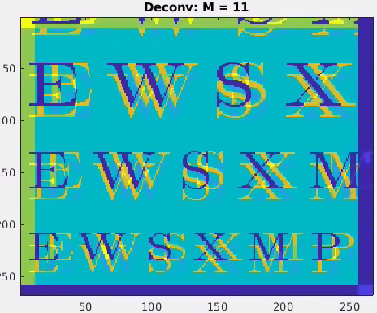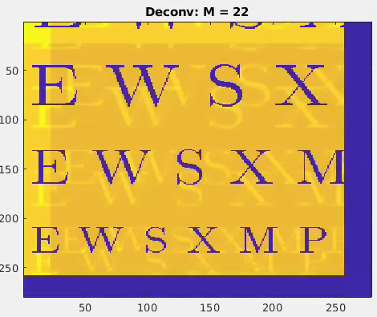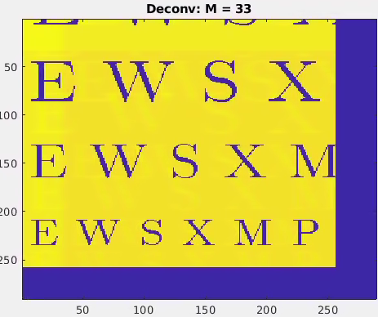

**Fig[#]. Image restoration using different filter lengths.**

As is seen in the above figure, increasing the length of the restoration filter improves image quality.This is because a larger pool of samples is used to determine local values. [More explanation needed…]

Turning back to the error plots in the previous section, the largest error seen is roughly 42. For it’s roughly 160, and for it’s roughly 15.5.

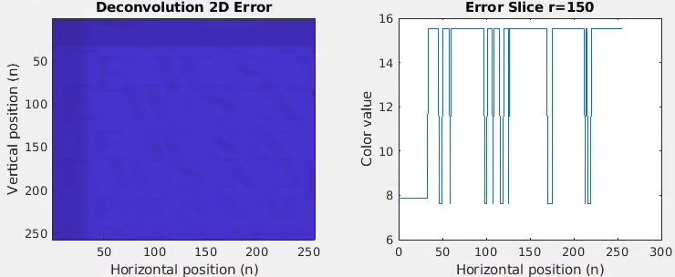

**Fig[#]. Error plots for M=33.**

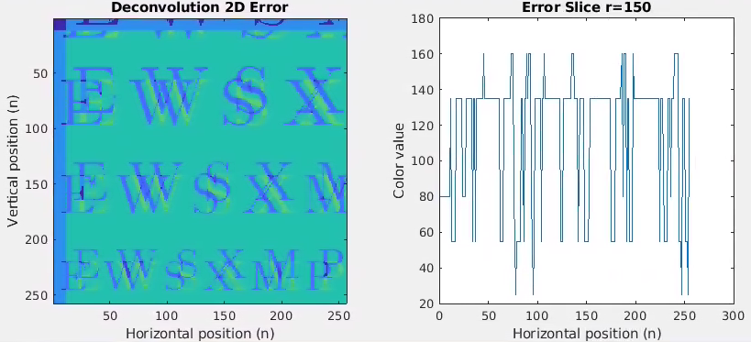

**Fig[#]. Error plots for M=11.**

# 3.3 Filtering a Music Waveform

This section was done by using an audio file of a song sampled at 44.1kHz. The goal is to produce a single echo and then produce a cascade of echoes (reverb) using the following system:



This system has an impulse response that is long with scaling coefficients for the first and last samples. Here, is selected to produce a 0.15 second delay.

Also, is selected to be 0.95 so that the filter coefficients result in audible echoing.

## Single echo

Compared to the original, the volume is lower and there is a noticeable echo that occurs. This is what we expect given the filter definition.

## Reverb

To produce reverb, multiple echoes are cascaded. In this section, a cascade of four echo filters is used. Compared to the original song and to the single echo, this is at an even lower volume but with a noticeable reverb as we expect. The echoes seem to blend more together, and I suspect that as the cascade grows, the sound will become more and more “muddy”.

## Audio Plots

To understand the plots, the signals are alternating on the vertical axis (starting with the original signal). In both plots, the reduced magnitudes discussed previously are apparently obvious. The effect of echoing and reverb is most visible as a result of the “sectioning” of the signal – which is most easily seen in the reverb plot. This sectioning is of length . The first “section” of the reverb signal is of the smallest magnitude because the only present signal is scaled four times and has zeroes (occurring at time ) added to it as “echoes”. As the sections advance, the signal has more non-zero data to fill out the echoes/reverb.

