**Arrays**

**---------------------------------------------------------------------------------------------------------------**

1) Write a C program to input 10 numbers through the keyboard into an array and

display the results of addition of even numbers and product of odd numbers.

2) Write a C program to input 10 numbers through the keyboard into an array and find the

biggest and smallest number in an Unsorted array without using any Sorting Technique.

3) Write a C program to input 10 numbers through the keyboard and find the number

of prime numbers count, store them into a separate array and display it.

4) Write a C program to find out second largest and second smallest elements of an

unsorted array without using any Sorting Technique.

5) Write a C program to reverse the elements of a given array.

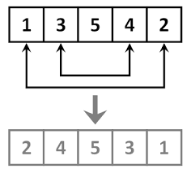

6) Write a C program to delete an element at desired position from an array.

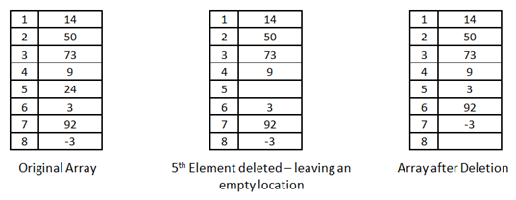

7) Write a C program to insert an element at desired position in an array.

For Example if 'A' is to be stored at '0' position then,

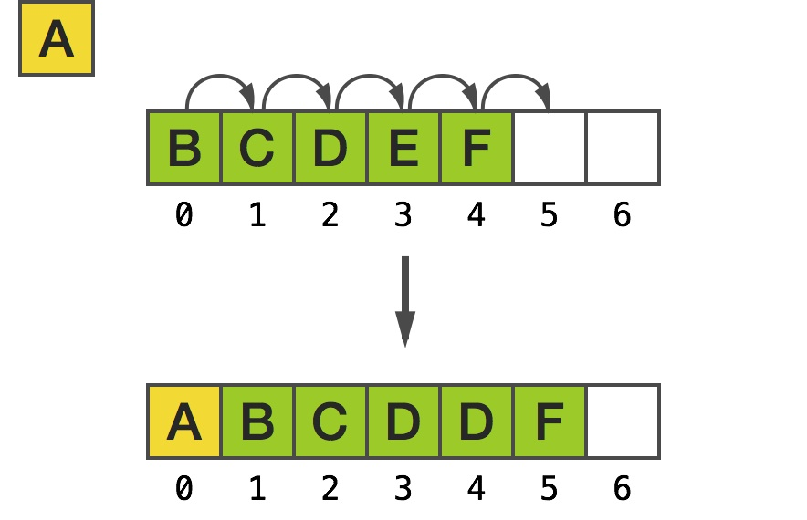

A description...8) Write a C program which deletes the duplicate elements of an array.

9) Write a C program to find the duplicate elements of a given array and find the count of

duplicated elements.

Ex: if int a[] = {0,3,1,0,5,1,2,0,4,5}

output: -

The duplicate elements are existed in an array

0 -- 3 times

1 -- 2 times

5 -- 2 times

10) Write a program to print the non repeted numbers of a given array.

Ex : if int a[] = {0,3,1,0,5,1,2,0,4,5}

Output : 3, 2, 4

11) Write a program to copy the elements of one array into another array without duplicate

items as a first slot, and store duplicate elements as a second slot.

Ex: source array {10,2,4,5,2,1,3,4,6,5,8,9,2}

destination arrays {10,2,4,5,1,3,6,8,9} , { 2,2,4,5}

first slot second slot

Take two different arrays for first and second slots.

12) Write a C program to evaluate the following series. The series contains sum of

square of numbers from 1 to 'n'. Store result of each term in an array. Calculate

value of ' S ' using array.

S = 1^2 + 2^2 + 3^2 + 4^2 + ------ n^2

= [ 1, 4, 9, 16, -------- n^2 ]

Suppose n = 4,

then S = 1^2+2^2+3^2+4^2;

S = 1+4+9+16;

S = 30.

1. Write a C program to implement the stack using arrays.

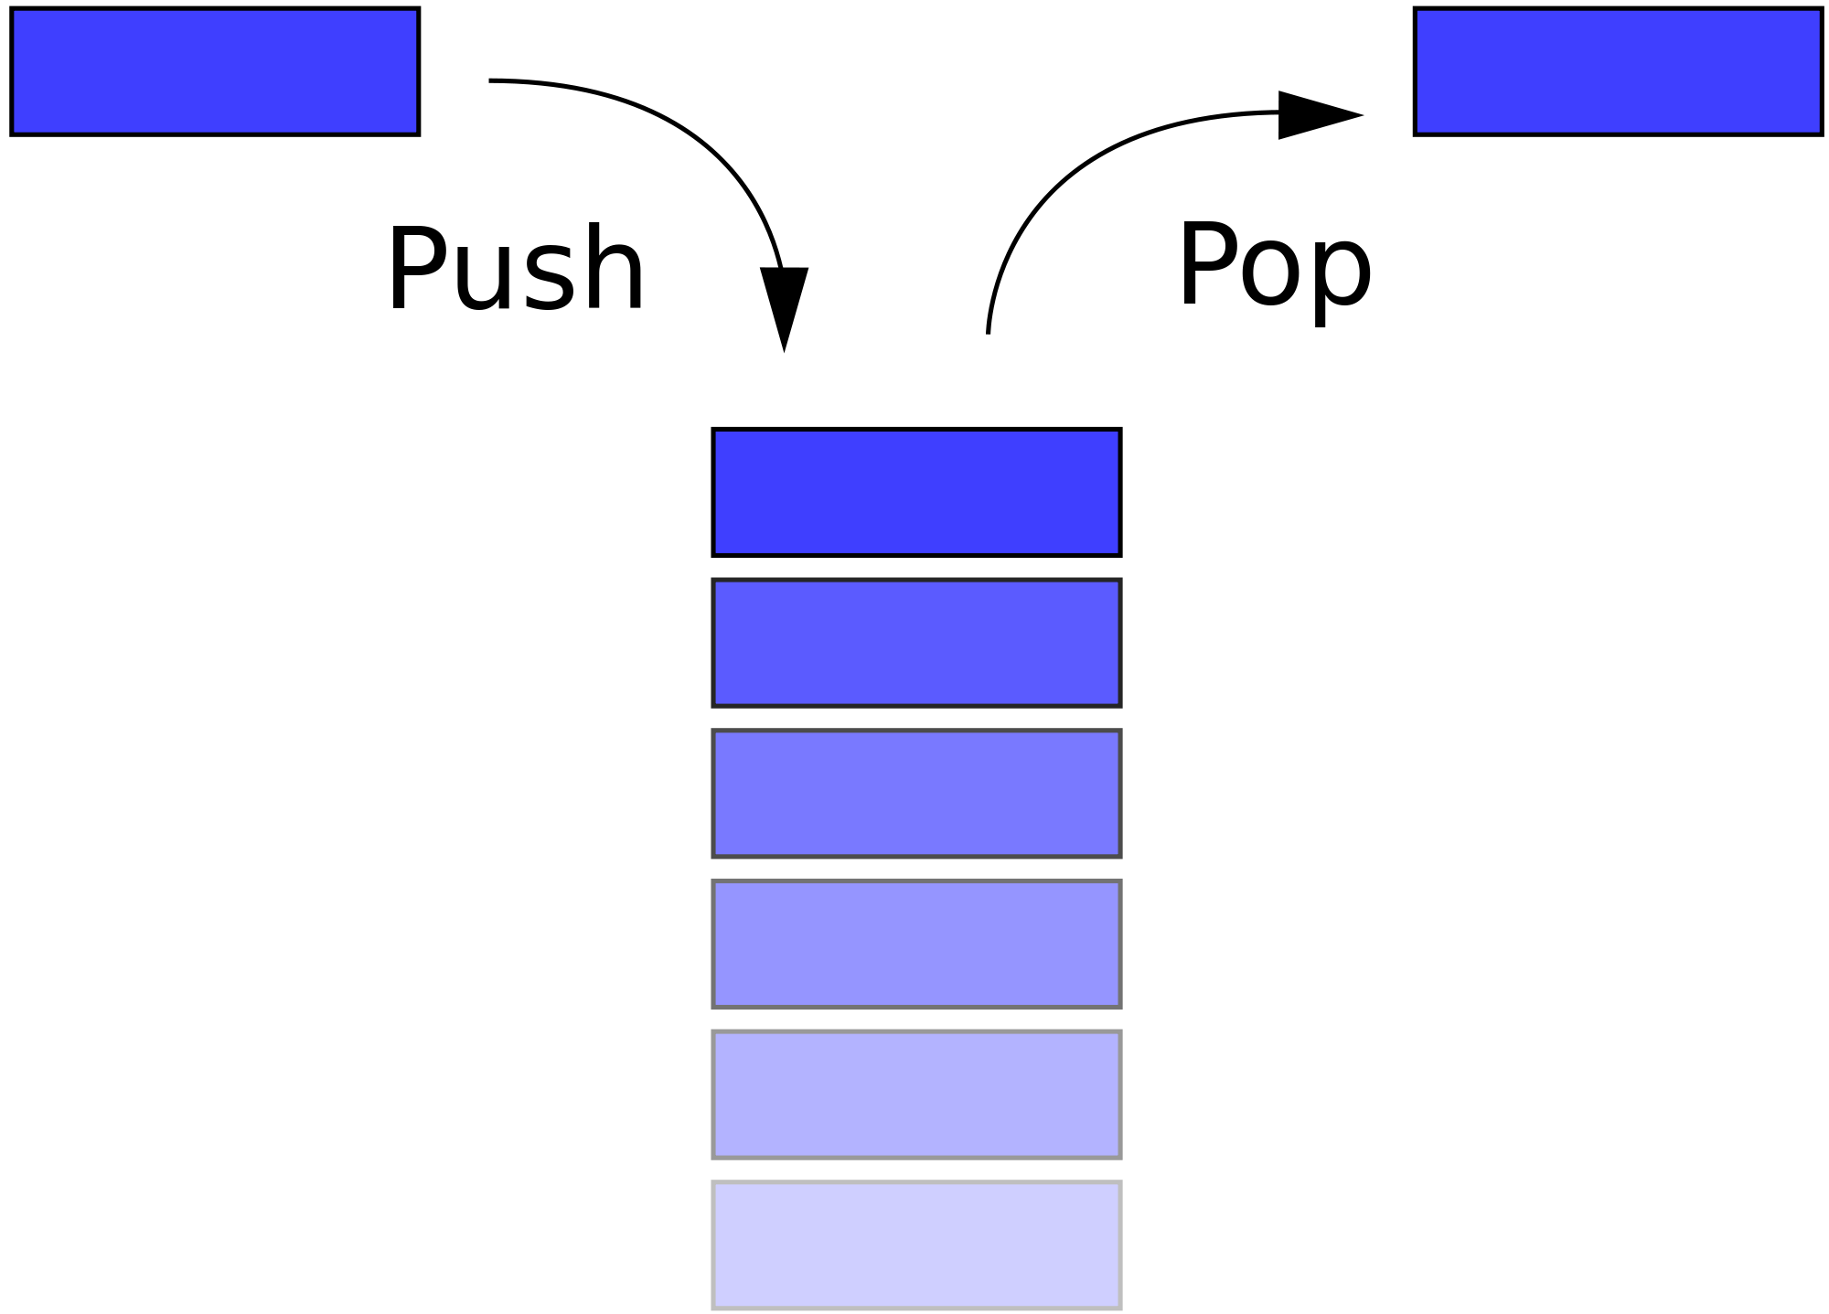

**STACK**

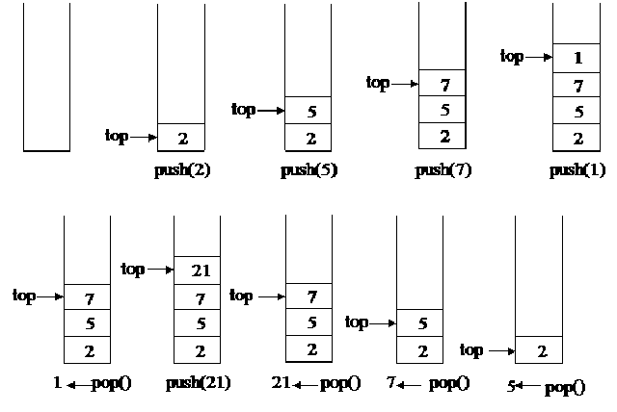

-------------------------------------------------------- END --------------------------------------------------------

Dear Students, if any mistakes found, Kindly inform to me.

A.Tandava Ramakrishna

Email: ramakrishna@vectorindia.org