MXEN2003 – Micro Controller Project
Laboratory Logbook
Lab 2
Aaron Fredrick (20932390)
3-14-2024

Contents
Task 1 1
Objective 1
Calculations 1
Equipment Used 1
Circuit Diagrams 2
Program Logic 3
Code Snippet 4
map function 4
main code 4
Procedure & Methodology 5
Appendix 6
Part 1: Image of physical circuit of Task 1 6

Task 1

Objective
The objective is to create a circuit that reads the position of a joystick and the state of a push button, and then uses this input to control the illumination of a series of eight LEDs. The circuit will be wired to accurately detect the position of the joystick along different axes and interpret the push button press to determine which channel of the joystick is being read.

Calculations
With reference to the provided data sheet, the maximum current through a (red) LED is 20mA and the voltage output from a digital pin is 5V.
$$R=\frac{V}{I}$$
$$R=\frac{5}{0.02A}=250Ω$$

Equipment Used
- Arduino Mega 2560 Board
- Bread Board
- 1 x Joystick
- 8 x LEDs
- Jumper Wires

Circuit Diagrams
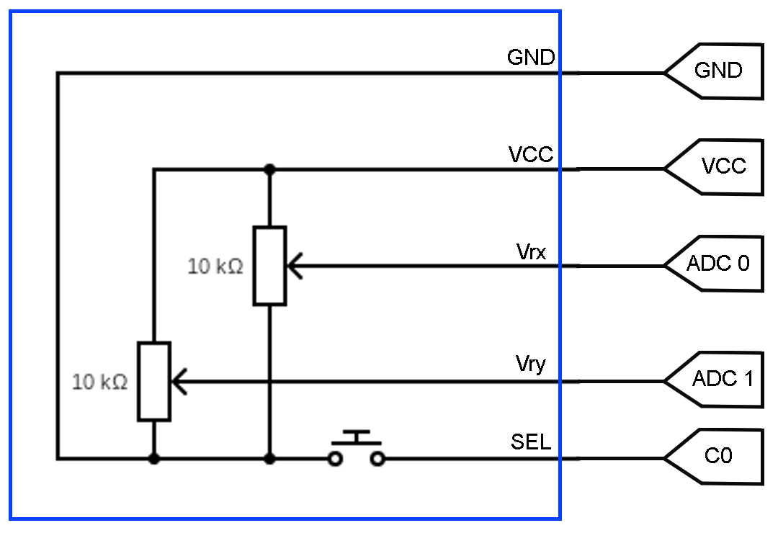
Figure 1- Lab1 task 1 internal joystick circuit diagram
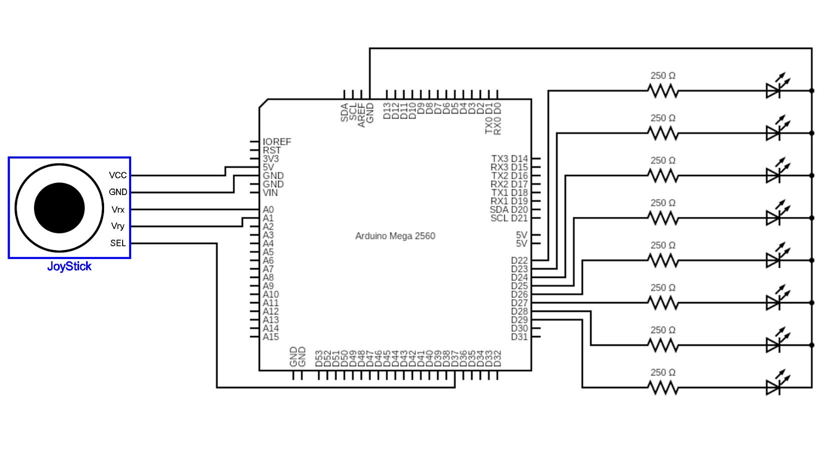
Figure 2- Lab1 task 1 circuit diagram

Program Logic
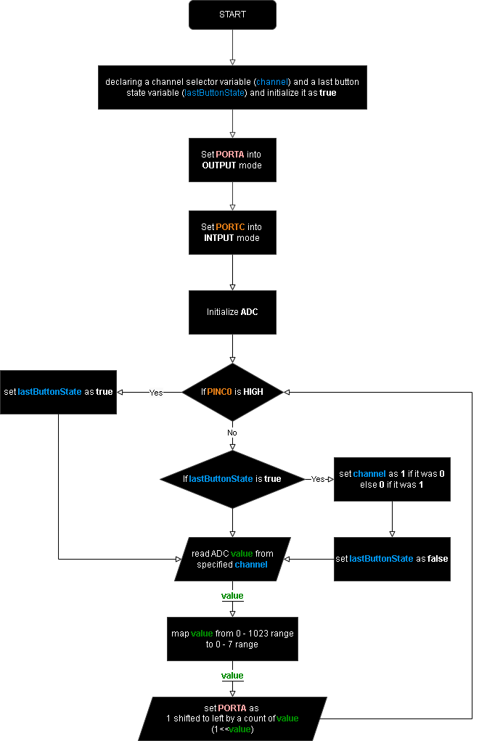
Figure 3- Lab1 Task 1 flow chart

Code Snippet

map function

main code

Procedure & Methodology
- Initially we connect the 8 LEDs to resistor each individually in series.
- Then the LED circuit is completed by connecting the cathode of the bulbs to ground and the anode sides(resistors) to pin 22 to 29.
- Following this we setup the joystick
  - We connected the GND pin to common ground.
  - The VCC (+5V) pin is connected to a 5V VCC output pin of the Arduino.
  - Vrx and Vry pins are connected to adc pins 0 and 1 respectively.
  - The SEL pin is connected to 0th pin of PORTC (C0, digital pin 37).
- Finally. We program the Arduino to function in order to get the final outcome as required in the task objective.
  - Initially we import all the header files which contains the required libraries, data types and methods we require in our main code.
  - Then we also code a mapping function to map a value from a set range to another range and include the function through an appropriate header file.
  - Then, we initialize two variables where one is to track the channel which we read the ADC value from and the other to track the previous push button state with respect to each iteration in the main loop.
  - Next, we set PORTA into OUTPUT mode and the first pin of PORTC into INPUT mode while leaving the rest as OUTPUT.
  - Following DDR configurations, we set first pin of PORTC as high to enable the internal pull-up resistor for first pin of PORTC (C0).
  - Then, we initialize the ADC configurations.
  - Finally, we code the main loop of the program.
    - Initially at each iteration we check if pin C0 is high and if so, we set the last button state as true or else if last button state is true, we alternate between the channel selection such that if current channel selection is 1 it will switch to 0 and vice versa, and then set the last button state as false.
    - Finally at each iteration we set the PORTA’s value as 1 with bits shifted to left for a count such that it’s the relative mapping value in range 0 to 7 from a range 0 to 1023 of the ADC value read from the specified channel.

Task 2

Objective
The objective is to create a circuit that reads the position of a potentiometer, and then uses this input to control the illumination of a series of eight LEDs.

Calculations
With reference to the provided data sheet, the maximum current through a (red) LED is 20mA and the voltage output from a digital pin is 5V.
$$R=\frac{V}{I}$$
$$R=\frac{5}{0.02A}=250Ω$$

Equipment Used
- Arduino Mega 2560 Board
- Bread Board
- 1 x Potentiometer
- 8 x LEDs
- Jumper Wires

Circuit Diagrams
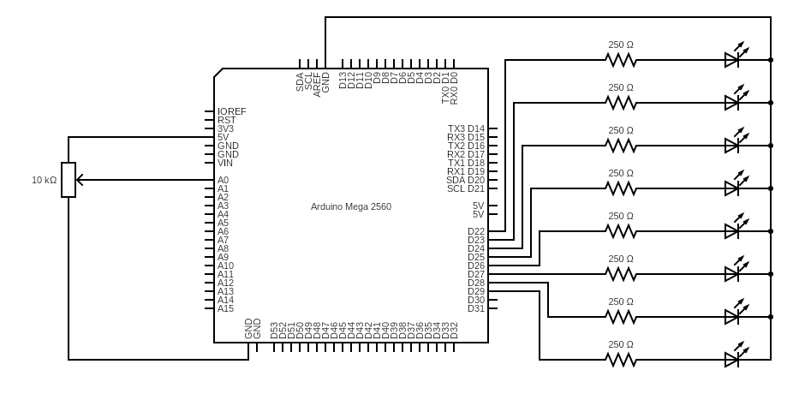
Figure 4- Lab1 task 2 circuit diagram

Program Logic
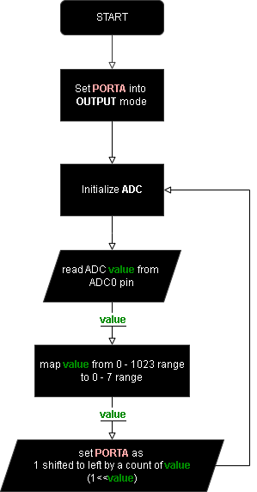
Figure 5- Lab1 Task 2 flow chart

Appendix

Part 1: Image of physical circuit of Task 1

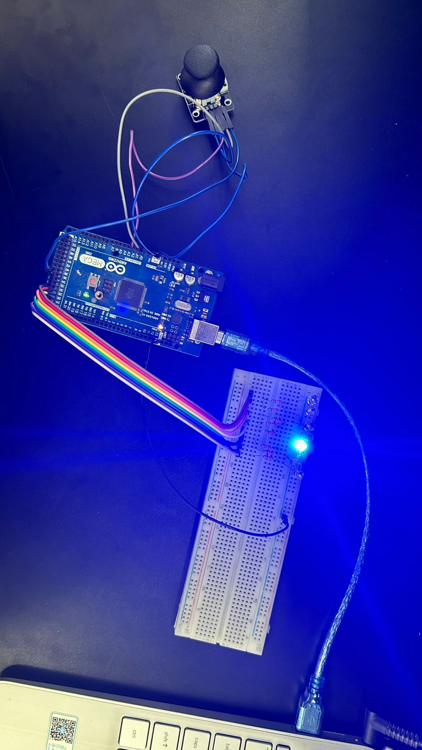

Part 2: Image of physical circuit of Task 2

