1. A 2

2. Booleans 5

3. Comprehensions 6

4. Debugger 7

5. Decimal 8

6. Dictionaries 9

7. Error-Handling 12

8. File Handling 14

9. Formatting, Printing 16

10. Functions 17

10.1. General 17

10.2. Function executor 18

10.3. Scopes 19

10.4. Recursion 20

11. Imports 21

12. Lists 22

13. Matrix 23

14. OOP 25

14.1. First-Steps-in-OOP 25

14.2. Classes-and-Objects 25

14.3. Inheritance 26

14.4. Encapsulation 27

14.5. Static-and-Class-Methods 30

14.6. Polymorphism and Abstraction 30

14.7. SOLID 30

14.8. Iterators-and-Generators 30

14.9. Decorators 30

14.10. Testing 31

14.11. Design-Patterns 31

15. PyCharm 32

15.1. Shortcuts 32

15.2. Settings 36

16. Referenced 37

17. Regex 39

18. Sets - кортежи(tuple) и множества(set) 42

19. Shortcuts 44

20. Slicing 45

21. Symbol names 46

22. Text 47

23. Time 50

24. Tuples - кортежи(tuple) и множества(set) 51

25. Queues and Stacks 52

26. ZZZ Other 53

26.1. If… Else … replacement 53

# A

Гордият човек е като локва - хвърли в нея камък и ще опръска всичко наоколо с мръсотия. А смиреният е като море - ще погълне безследно всеки камък и даже кръгове по водата няма да се образуват.

Дядо Добри

self.is_on = not self.is_on

# change “on” to “off” or vice versa

elif idx == int(len(word) // 2) # int can be omitted, because len(word) is integer // 2 will return the type of len(word)

Referenced list, ????

biggest_sum = -float("inf")

Dunder – double underscore ???

**round_half_correctly.py**

a = 7.55  
b = 240 - 232.45  
print(b) # 7.550000000000011  
print(f"{a:.1f}") # 7.5  
print(f"{b:.1f}") # 7.6  
print(f"{240 - 232.45:.1f}") # 7.6

snake**_**case

**P**ascal**C**ase

camel**C**ase

Mangling

**or** has a lower priority than **and**

**and** has a lower priority than **not**

Parameters

Arguments

Attributes

print(f"Milk: {', '.join(str(x) for x in cups) or 'empty'}")

@staticmethod  
def find_object(collection: list, attribute: str, value: str):  
 for obj in collection:  
 if str(getattr(obj, attribute)) == value:  
 return obj

print(isinstance('a', int)) # False  
print(isinstance(5, int)) # True

from functools import reduce

map_functions = {

'*': lambda x: reduce(lambda a, b: a * b, x),

'/': lambda x: reduce(lambda a, b: a / b, x),

# '/': lambda x: reduce(lambda a, b: a + b if a == 0 or b == 0 else a / b, x),

'+': lambda x: reduce(lambda a, b: a + b, x),

'-': lambda x: reduce(lambda a, b: a - b, x),

} 02_expression_evaluator_a.py in 03_Stacks_Queues_Tuples_and_Sets_Exercise

summation_pairs.py

W:\1_Python\1-Training\1_Projects\1st_Project\03_Advanced

\02_Tuples_and_Sets\Lab\6_summation_pairs.py

command = "Replace-{file_name}-{old_string}-{new_string}"  
action, *info, last = command.split('-')

a, b, c = 2, '*', 3  
print(eval(f"{a}{b}{c}")) # 6

eval is slow and info inside eval could be stolen from hacker

if ("Doll" and "Wooden") in crafted:# Wrong!!!

if "Doll" in crafted and "Wooden" in crafted**:** # Correct!!!

for i in range(0, 2, **0.5**):  
 print(i)

**TypeError: 'float' object cannot be interpreted as an integer**

for i in range(0, 5, **int**(0.5)):  
 print(i, end=' ')

**ValueError: range() arg 3** (int(0.5)) **must not be zero**

Python is a **dynamic** language

Variables are **not** directly associated with

any particular value type

Any variable can be **assigned** (and **re-assigned**)

values of all types

x = 2.45 # float   
y = 5 # int  
w = x // 2 # float - take the class of x  
print(type(w)) # class 'float'

w = y // 2 # int - changing to the class of y  
print(type(w)) # class 'int'

Python **integers** are **immutable**

Python **floats** are **immutable**

Python **strings** are **immutable**

This means that once a string is created,

it is **not** possible to **modify** it

name = 'George'  
name[0] = 'P' # Error не може да променим G

print(name) # George

name = 'Ime' # заделя друго място в паметта

различно от мястото за George  
print(name) # Ime  
name = 4 # заделя трето място в паметта  
print(name) # 4

string **interpolation** are string **literals**(буквален)

that allow **embedded**(вградени) expressions

result = first_number **//** second_number # **integer division**  
result = first_number **%** second_number # **modular division**

result = first_number **/** second_number # result is **always float**

“Prime number” Просто число

“Complex number”

# *TODO: Add logic here*# *TODO: Check the other cases…*

# Booleans

self.is_on = not self.is_on

# change “on” to “off” or vice versa

print(bool(0)) # False  
print(bool(-0)) # False  
print(bool("")) # False  
print(bool(" ")) # True  
print(bool(False)) # False  
print(bool(None)) # False  
print(bool(True)) # True  
print(bool(1)) # True  
print(bool("a")) # True

# Comprehensions

action, *info, last = command.split('-')

action, way, *info = [int(x) if x.isdigit() else x for x in input().split()]

return {r1, c1}.issubset(range(rows)) and {r2, c2}.issubset(range(cols))

03_Advanced\04_Multidimensional_Lists\Recapitulate\Exercises_2\03_knight_game.py

knight_attacks=len({(i+di,j+dj)for di,dj in positions if (i+di,j+dj) in knights})  
knight_attacks=len({(i+di,j+dj)for di,dj in positions}.intersection(knights))

# row using intersection isfaster than row with if

set1 = {input() for _ in range(n)}

data1, data2 = [list(map(int, el.split(','))) for el in input().split('-')]

materials.reverse() <=> materials[:: -1]

[print(f"{toy}: {crafted.count(toy)}") for toy in sorted(set(crafted))]

matrix = [[int(x) for x in input().split(", ")] for _ in range(int(input().split(", ")[0]))]

email = "avs@gmail.com" # correct  
email = "avs@gmail.come" # wrong  
if **any**(email.**endswith(x)** for x in (".com", ".bg", ".net", ".org")):  
 print("correct")  
else:  
 print("wrong")

# Debugger

<https://softuni.bg/trainings/resources/video/86023/video-28-june-2023-ines-kenova-python-oop-june-2023/4108> - 11 minute

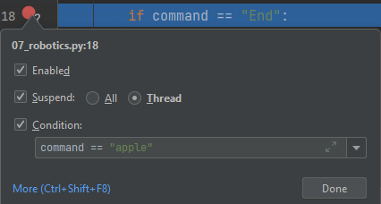 right click over the existing break point (brake) stops if command = = “apple” - this is new statement different from the one in file

# Decimal

from decimal import localcontext, Decimal, ROUND_HALF_UP, ROUND_HALF_DOWN

**round_half_correctly.py**

import **decimal** - in **decimal.py**

**ERROR скапах всичко**

a = Decimal('0.1')  
b = Decimal('0.1')  
c = Decimal("0.1")

result = a + b + c # 0.3

a = 0.1  
b = 0.1  
c = 0.1

result = a + b + c # 0.30000000000000004

a = Decimal(0.1) # without apostrophe  
b = Decimal(0.1) # without apostrophe  
c = Decimal(0.1) # without apostrophe  
result = a + b + c # 0.3000000000000000166533453694  
price = Decimal("3 * 1.2") Error

price = Decimal("3 + 1.2") Error

no operations allowed, just one number

# Dictionaries

symbols[ch] = symbols.get(ch, 0) + 1

resources = {}

if key not in resources:  
 resources[key] = 0

dict_test = {3: 4, 4: 5, 5: 5, 7: 2, 11: 2}  
print(len(dict_test))

sorted_dict = dict(sorted(dict_test.items(), key=lambda x: (-x[1], -x[0]))) # -x[0] error if x[0] is str!!!  
print(sorted_dict) # {5: 5, 4: 5, 3: 4, 11: 2, 7: 2}  
sorted_dict = dict(sorted(dict_test.items(), key=lambda x: (-x[1], x[0]))) # -x[0] error if x[0] is str!!!  
print(sorted_dict) # {4: 5, 5: 5, 3: 4, 7: 2, 11: 2}

# dict_test1 = {"k3": 4, "k4": 5, "k5": 5, "k7": 2}  
# sorted_dict = dict(sorted(dict_test1.items(), key=lambda x: (x[1], x[0]))) # -x[0] error if x[0] is str!!!  
# print(sorted_dict)

# race_info = sorted(race_info, key=lambda x: -race_info[x]) # returns list with keys sorted by values  
  
# sorted(symbols.items()) # returns list of tuples  
# dict_test = dict(sorted(symbols.items()))  
# for ch, count in dict_test.items():  
# print(f"{ch}: {count} time/s")  
# for ch, count in sorted(dict_test.items()):  
# print(f"{ch}: {count} time/s")

from collections import defaultdict  
# from collections import OrderedDict  
  
# student_info = defaultdict(list)  
# # student_info = defaultdict(lambda: [0.0])  
# for _ in range(int(input())):  
# name, grade = input().split()  
# # if name not in student_info: this check can be omitted with defaultdict  
# # student_info[name] = []  
# student_info[name].append(float(grade))  
  
# x = ('key1', 'key2', 'key3')  
# y = 0, 1, 2  
# this_dict = dict.fromkeys(x)  
# # this_dict = dict.fromkeys(x, y)  
# print(this_dict)  
# this_dict = dict(zip(x, y))  
# print(this_dict)  
#  
# txt = "Hello, welcome to my world."  
# print(txt.find("q")) # -1 or index if q in txt  
# print(txt.index("q")) # Error or index if q in txt  
#  
car = {  
 "brand": "Ford",  
 "model": "Mustang",  
 "year": 1964  
}  
# x = car.items()  
# print(car)  
# print(type(car))  
# print(x)  
# print(type(x))  
# for key, value in car.items():  
# print(key, value)  
  
# x = car.setdefault("model", "Bronco") # return Mustang if key exists  
# print(x)  
# print(car)  
# y = car.setdefault("mod", "Bronco") # add it and return Bronco if key does not exist  
# print(y)  
# print(car)  
#  
# car.update({"model": "laguna"}) # change value if key exists  
# print(car)  
# car.update({"test": "New_mod"}) # add key, value if key does not exist  
# print(car)  
# car["li"] = 5 # act as update  
# print(car)  
# car["model"] = "lag" # act as update  
# print(car)  
  
# bus = {  
# "br": "Fo",  
# "model": "Mus",  
# "ye": 19  
# }  
# # car.setdefault(bus) # Error - requires (key, value)  
# # car.update("model", "Bronco") # Error - requires dict  
# car.update(bus) # requires dict {key, value}  
# print(car)  
  
  
# x = car.get("br", ) # None  
# print(x)  
# x = car.get("br", 47) # 47  
# print(x)  
# y = car["br"] # Error  
# print(y)  
  
# x = car.keys() # Returns a list containing the dictionary's keys  
# x = car.values() # Returns a list of all the values in the dictionary  
  
# for el in car.items(): # !!!! tuple is the answer  
# print(el)  
  
# car.popitem() # Removes the last inserted key-value pair  
# car.pop("br") # Removes key-value pair or Error  
# car.pop("br", defaultvalue) returns defaultvalue and no Error  
  
#  
# a = ("a", "b", "c", "d")  
# a = ("a", "b")  
# b = ("1", "2", "3")  
# x = zip(a, b)  
# # print(tuple(x))  
# print(x)  
# print(dict(x))  
  
  
# print({ch: ord(ch) for ch in input().split(',')})  
  
# data = [("Peter", 22), ("Amy", 18), ("George", 35)]  
# dict_data = {key: value for (key, value) in data}  
# print(dict_data)  
# print(f"{key}: {value} for (key, value) in data}") # do not work  
  
# x = "012"  
# y = "01234567"  
# for i in range(len(y)):  
# j = i % len(x)  
# print(i, j, sep='->')  
  
# print(list(car.items()))  
# print(car['model'])

# Error-Handling

methods are faster than try except!!!

Syntax errors(parsing errors) and Exceptions

times = "asd"  
print(7 / times) # TypeError: unsupported operand type(s) for /: 'int' and 'str'  
print("7" / times) # TypeError: unsupported operand type(s) for /: 'str' and 'str'  
print(7 / int(times)) # ValueError: invalid literal for int() with base 10: 'asd'  
print(int("asd")) # ValueError: invalid literal for int() with base 10: 'asd'  
print(int([11])) # TypeError: int() argument must be a string, a bytes-like object or a real number, not 'list'

try:  
 times = int(input())  
 # times = float(input())  
except ValueError as ex:  
 print(f"ValueError: {ex}")

print("blabla")  
except KeyError:  
 print()  
except (NameError, TypeError, IndexError) as ex:  
 print(ex)

# custom exceptions  
class SmallValueException(Exception):  
 pass  
  
  
class HighValueException(Exception):  
 pass  
  
  
amount = float(input()) # you cannot transfer negative money  
  
if amount < 1:  
 raise SmallValueException("Amount can not be less than 1lv.")  
elif amount > 1000:  
 raise HighValueException("Transaction limit max 1000")  
# custom exceptions

try:  
 print("try")  
 a = 7  
 b = int(input()) # if b = 0 print("End") would not be executed, but print("finally")  
 c = a / b  
except ValueError as text:  
 print("ValueError") # ValueError  
 print(text) # invalid literal for int() with base 10: 'dhhfd'  
else:  
 print("from else") # Not very useful. will be executed if successful try.  
finally:  
 print("finally") # will always be executed  
  
print("End") # if b = 0, code could not reach that line, because of error. if b = 'str' will print End.  
# if b = 0 -> ZeroDivisionError. if b = 'str' ValueError.

# File Handling

**io** (in / out) module is the default module for accessing files - Built-in

file = open('W:/1_Python/1-Training/1_Projects/1st_Project/text.py') correct  
file = open('W:\1_Python\1-Training\1_Projects\1st_Project\text.py') **wrong**

We should always make sure that an open file is properly **closed**

To avoid **unwanted** **behaviour** **always** **close** the files

Files opened with “**with”** statement will be **closed** **automatically** once it leaves the **with** block

with open("file.txt", "w") as f:  
 f.write("Hello World!!!")

print(f.read()) # Error: io.UnsupportedOperation:

f is not readable if the file is open for writing, adding …

modes 'w', 'a' ….etc

* + **w** - open for writing, truncating the file first. Truncating(съкращавам) - If the file exists, its **overwritten**
  + **x** - create a new file and open it for writing
  + **r** – open in reading mode. ‘r’ is by default. No diff, If ‘r’ or mode is empty.
  + **a** - open for writing, appending to the end of the file. Or create a file, if it doesn’t exists.
  + **t** - text mode (default)
  + **b** - binary mode
  + **+** - open a disk file for updating (reading and writing)
* try:  
   file = open('zzz_text.py', 'r')  
   print(file.read())  
  except FileNotFoundError:  
   print("File not found or path is incorrect")  
  finally:  
   print("exit")

file = open('text.txt') # => open('python.txt', 'r')  
print(file.read())  
print(file.read(7)) # will print nothing if file has been read already  
print(file.readline())  
print(file.readline(7))  
for line in file: # line is str + \n  
 # print(line) # adds additional empty line after printing each line of file  
 print(line, end="") # will print nothing if file has been read already  
 print(line.split())  
print(file.read()) # will print nothing if file has been read in

"for line in file" already  
file.close()

Delete File  
import os  
  
file_path = "text.txt"  
if os.path.exists(file_path):  
 os.remove(file_path)  
  
try:  
 os.remove('text.txt')  
except FileNotFoundError:  
 print('File already deleted!')

# region Directory manipulation  
import os

os.path.isfile(path) # method that returns True if the path is a file or a symlink(symbolic link) to a file.  
os.path.exists(path) # method that returns True if the path is a file, directory, or a symlink(symbolic link) to a file.

# print(os.mkdir('W:/1_Python/1-Training/1_Projects/1st_Project/Lessons_Notes/File_Handling_Notes/Test_Folder'))  
print(os.getcwd()) # Return a string representing the current working directory.  
# os.mkdir('Test')  
# os.rmdir('W:/1_Python/1-Training/1_Projects/1st_Project/Lessons_Notes/File_Handling_Notes/Test_Folder')  
# os.chdir('Test_Folder')  
print(os.listdir('W:/1_Python/1-Training/1_Projects/1st_Project'))  
  
# endregion

# Formatting, Printing

int(5 / 2) ⬄ 5 // 2

orders = list("abcdef")

print("Orders left: ", end='')  
print(*orders, sep=', ') # * splat operator

print("Orders left:", *orders, "text", '.')

print(int(1.5)) # 1

print(f"{minutes}:{seconds:02d}") # 5:07

print(f"{num:.1f}") # 1 -> 1.0 ; 1.333 -> 1.3

print(round(**4.5**)) #-> **4** round to nearest even number  
print(round(**5.5**)) #-> **6** banker's number

x = 4.5  
print(f'{x:.0f}') #-> **4** round to nearest even number  
x = 5.5  
print(f'{x:.0f}') #-> **6** banker's number

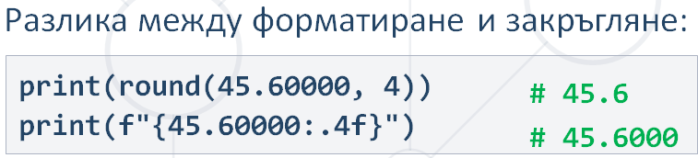

# Functions

## General

def sum_nums(a, c=5, *args):

def even_odd(*args): is OK

def even_odd(*args, action): not OK

print(even_odd(1, 2, 3, 4, 5, 6, "even"))

*args (packing)-> tuple with 0 or more ele-> a: 3 c: 7 args: (12, 19)

**kwargs -> dict with 0 or more ele-> a: 3 kwargs: {'b': 7, 'c': 12}

def add_number_12(num_seq):  
 num_seq.append(12)  
# no return, but list nums is modified

nums = [1, 2, 3]  
print(nums) # [1, 2, 3]  
add_number_12(nums) # no return, but list nums is modified, because lists are referenced. num_seq and nums are pointing to one and the same place in memory  
print(nums) # [1, 2, 3, 12]

print(**{"name": "George", "town": "Sofia", "age": 20}) # error  
print(*[1, 2, 3]) # OK

def get_info(name, age, town):  
 return f"This is {name} from {town} and he is {age} years old"  
print(get_info(**{"name": "George", "town": "Sofia", "age": 20})) # **(unpacking) transforms dict to next row  
print(get_info(name="George", town="Sofia", age=20)) # kwargs can read this tipe of info  
print(get_info("George", "Sofia", 20)) # for correct result needs correct sequence

## Function executor

03_Advanced\05_Functions_Advanced\Recapitulate\Exercises\06_function_executor.py

def func_executor(*args):  
 return "\n".join(f"{el[0].__**name**__} - {el[0](*el[1])}" for el in args)

**Test One !!!**def sum_numbers(num1, num2):  
 return num1 + num2  
  
  
def multiply_numbers(num1, num2):  
 return num1 * num2  
  
  
print(func_executor(  
 (sum_numbers, (1, 2)),  
 (multiply_numbers, (2, 4))  
))

**Test 2 !!!**  
def make_upper(*strings):  
 result = tuple(s.upper() for s in strings)  
 return result

def make_lower(*strings):  
 result = tuple(s.lower() for s in strings)  
 return result  
  
print(func_executor(  
 (make_upper, ("Python", "softUni")),  
 (make_lower, ("PyThOn",)),  
))

## Scopes

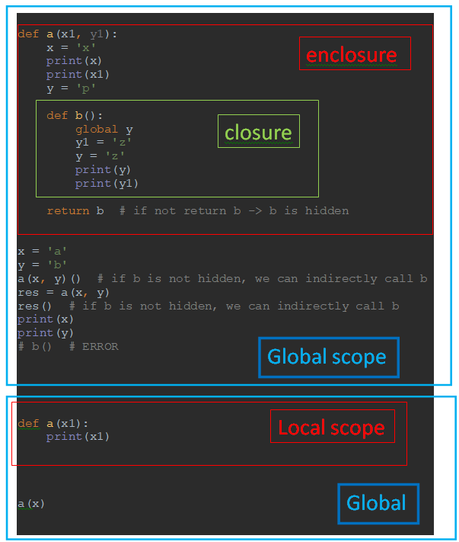

def a(x1, y1): # no task in judge for global and non local - don’t use them  
 x = 'xa' # not changed on global scope  
 print(x) # xa => changed on local scope  
 print(x1) # x => not changed on global scope  
  
 def b():  
 global y # y => changed on global scope  
 nonlocal y1  
 y1 = 'y1b'  
 y = 'yb'  
 print(y) # yb => changed on global scope  
 print(y1) # y1b => changed on local scope  
  
 return b # if not return b -> b is hidden  
x = 'x'  
y = 'y'  
a(x, y)() # if b is not hidden, we can indirectly call b  
# res = a(x, y)  
# res() # if b is not hidden, we can indirectly call b  
print(x)  
print(y)  
# # b() # ERROR

## Recursion

The process in which a function calls itself is called **recursion**

A recursive function has the following structure:

base case and recursive case

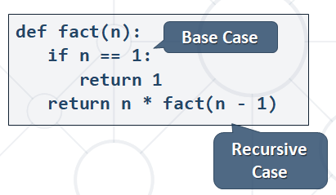

1-Training\1_Projects\1st_Project\Lessons_Notes\recursive_funcs.py

def not_recursion():  
 def not_recursion():  
 def not_recursion():  
 print(3)  
 print(2)  
 not_recursion()  
 print(1)  
 not_recursion()  
not_recursion()

def a(): # infinite recursion  
 a()  
  
a() # [Previous line repeated 996 more times]  
# RecursionError: maximum recursion depth exceeded

def recursive_power(num, power): # short but not good for debugging   
 if power == 0:  
 return 1  
 return num * recursive_power(num, power - 1)

def recursive_power(number, power): # longer but in debug you can see how recursion works  
 result = 1  
 if power == 0:  
 return result  
 result = number * recursive_power(number, power - 1)  
 return result  
 # return number ** power

print(recursive_power(2, 3))

# Imports

from string import punctuation # !"#$%&'()*+,-./:;<=>?@[\]^_`{|}~

import math  
x = 5.98  
print(math.floor(x)) -> not floor(x)  
print(int(x)) => floor(x)

from math import ceil, floor  
x = 5.98  
print(floor(x)) -> not math.floor(x)

import **decimal** - in **decimal.py**

**ERROR скапах всичко**

import random  
number = random.randint(1, 100)  
print(number)

from functools import reduce

map_functions = {

'*': lambda x: reduce(lambda a, b: a * b, x),

'/': lambda x: reduce(lambda a, b: a / b, x),

# '/': lambda x: reduce(lambda a, b: a + b if a == 0 or b == 0 else a / b, x),

'+': lambda x: reduce(lambda a, b: a + b, x),

'-': lambda x: reduce(lambda a, b: a - b, x),

} 02_expression_evaluator_a.py in 03_Stacks_Queues_Tuples_and_Sets_Exercise

from string import ascii_lowercase  
chars = list(ascii_lowercase)

py -m pip install PyQt5

py -m pip install pyfiglet or keep the cursor over the library and click install

py -m pip install opencv-python

# Lists

Be very careful with **remove** in **for** cycle!!!

nums = [1, 2, 3]  
nums2 = nums # referenced  
nums3 = nums.copy() ⬄ list(nums) # not referenced

bottles = list(map(int, input().split()))

my_list = list(range(5))) # [0, 1, 2, 3, 4]

enumerate <class 'enumerate'>

print(list(enumerate(list("123")))) # [(0, '1'), (1, '2'), (2, '3')]

print(list(enumerate(list(range(3))))) # [(0, 0), (1, 1), (2, 2)]

indexes = [idx for idx, el in enumerate(test_tuple) if el == “asd”]

return list with idx for all el == “asd”

x = [[]] * 3 # [[], [], []]  
x[1].append(5) # [[5], [5], [5]] !!!  
a = [0] * 3 # [0, 0, 0]  
a[2] += 7  
print(a) # [0, 0, 7]

my_list = [1, 2, 3, 1, 2, 2, 2, 2, 4, 5, 'a']  
result = list(filter(lambda x: x == 2, my_list)) # [2, 2, 2, 2, 2]  
result1 = next(filter(lambda x: x == 2, my_list)) # 2  
result2 = next(filter(lambda x: x == 7, my_list), "Not in list") # Not in list  
# result3 = next(filter(lambda x: x == 7, my_list)) # StopIteration (error)

a = [1, 2, 3]  
b = ['w', 'f']  
d = [*a, *b]  
print(d) # [1, 2, 3 'w', 'f']  
print(*d) # 1 2 3 w f

a = "12345"  
b = list(a) # ['1', '2', '3', '4', '5']

# removing elements in the middle of the list

a_nums = a_nums[:left_idx] + a_nums[right_idx + 1:]  
print(a_nums)  
# =>  
for i in range(idx + value, idx - value - 1, -1):  
 b_nums.pop(i)  
print(b_nums)  
# =>  
del c_nums[left_idx:right_idx + 1]  
print(c_nums)

# Matrix

matrix = [[0 for j in range(2)] for i in range(3)] # [[0, 0], [0, 0], [0, 0]]  
matrix = [[0 for _ in range(2)] for _ in range(3)] # [[0, 0], [0, 0], [0, 0]]

matrix = [[int(j) for j in input().split(", ") if int(x) % 2 == 0] for i in range(int(input()))]

matrix = [[int(x) for x in input().split(", ") if int(x) % 2 == 0] for _ in range(int(input()))]

# flattening matrix 2d

matrix = [[int(j) for j in input().split(", ")] for i in range(int(input()))]  
flatten_matrix = [el for list_i in matrix for el in list_i]

# flattening matrix 3d  
m3d = [[[k for k in range(3)] for j in range(3)] for i in range(3)]  
print(m3d) # [[[0, 1, 2], [0, 1, 2], [0, 1, 2]], [[0, 1, 2], [0, 1, 2], [0, 1, 2]], [[0, 1, 2], [0, 1, 2], [0, 1, 2]]]  
flatten_m3d = [k for m2d in m3d for list_i in m2d for k in list_i]  
print(flatten_m3d) # [0, 1, 2, 0, 1, 2, 0, 1, 2, 0, 1, 2, 0, 1, 2, 0, 1, 2, 0, 1, 2, 0, 1, 2, 0, 1, 2]

# sum of primary or secondary diagonal  
n = int(input())  
matrix = [[int(x) for x in input().split()] for _ in range(n)]  
primary_diagonal = sum([matrix[i][i] for i in range(n)])  
secondary_diagonal = sum([matrix[i][n - i - 1] for i in range(n)])  
print(primary_diagonal)  
print(secondary_diagonal)  
  
# faster solution  
primary_diagonal_sum = 0  
secondary_diagonal_sum = 0  
for i in range(n):  
 row = [int(x) for x in input().split()]  
 primary_diagonal_sum += row[i]  
 secondary_diagonal_sum += row[n - i - 1]  
print(primary_diagonal_sum)  
print(secondary_diagonal_sum)

03_Advanced\04_Multidimensional_Lists\Recapitulate\Exercises_2\03_knight_game.py

possible_moves = {(i + di, j + dj)  
 for v, h in [[1, 2], [2, 1]]  
 for di, dj in [[v, h], [v, -h], [-v, h], [-v, -h]]  
 if i + di in range(n) and j + dj in range(n)}

03_Advanced\04_Multidimensional_Lists\Exercises_2\04_easter_bunny.py

directions = {  
 "up": (-1, 0),  
 "down": (1, 0),  
 "left": (0, -1),  
 "right": (0, 1)  
}

# OOP

from sys import path  
print(*path, sep="\n") # prints Source Root Directories

from typing import List, Dict …..

Mangling

class is a blueprint that defines the nature of a future object

## First-Steps-in-OOP

Object is a data abstraction that captures an internal representation and an interface

The interface defines behaviors but hides implementation

state attribute

behavior attributes – methods are like functions,

that work only within a class

## Classes-and-Objects

def __init__(self, mileage, **max_speed: int = 150**)

def __init__(self, mileage, **max_speed=150**)

Example.text # attribute reference – state(data attribute)

Example.print_text # attribute reference – behavior(method)

x = Example() # instantiation - uses **function notations**

There are two kinds of attribute references: Data and Methods

Data attributes - Instance variables and Class variables

Instance variables - unique to each instance

It is not a good practice to declare or remove data attributes outside the class

Class variables - shared by all instances of the class

Built-in methods "magic" or “dunder”

Surrounded by double underscores __dict__

Dunder – double underscore ???

__str__() - returns a printable string representation

__repr__() - returns a machine-readable representation

__doc__() - Provides a documentation of the object as a string

class MyClass:

"""This is MyClass."""

def example(self):

"""This is the example module of MyClass."""

print(MyClass.__doc__) # This is MyClass.

print(MyClass.example.__doc__) # This is the example module of MyClass.

__dict__() is a dictionary containing a **module's symbol table**

class Dog:

def __init__(self, name):

self.name = name

x = Dog("Max")

print(x.__dict__) #{"name": "Max"}

## Inheritance

\s\addaa

Fsgsfgs

## Encapsulation

prop + Tab @property (getter)

props + Tab @property and @???.setter (getter + setter)

Encapsulation is Packing of data and methods into a single component

Encapsulation put restrictions and can preventtheaccidental modification of data

To do that, an object’s variable can only be changed by an object’s method

Everything written within the Python class (methods and variables) are public by default

Python implements weak encapsulation. This means it is performed by convention rather than being enforced by the language

It is a matter of convention to differentiate them into three terms – public, protected and private

Using a single leading underscore is just a convention

naming an attribute with two leading underscores invokes name

mangling is used for attributes that one class does not want subclasses to use, but it is still possible to **access** or **modify** a variable that is considered "private" **from outside** the class

def get_id(self, pin) -> (str, int):  
 if pin == self.__pin:  
 return self.__id

def change_pin(self, old_pin, new_pin) -> str:  
 if old_pin == self.__pin:  
 self.__pin = new_pin

class Person:  
 def __init__(self, name: str, age: int):  
 self.__name = name  
 self.__age = age  
 def get_name(self): # or @property def name(self): return self.__name  
 return self.__name  
 def get_age(self):  
 return self.__age  
person = Person("George", 32)  
print(person.get_name())  
print(person.get_age()) # 32  
person.age = 37 # person.age is variable type(int) in that case  
print(person.get_age()) # 32  
print(person.age) # <class 'int'>  
print(type(person.age)) # 37 - person.age is variable in that case  
print(person.age()) # TypeError: 'int' object is not callable

__get_fuel_and_speed(self) - "private" class methodthat should only be called from inside the class where it is defined

class Car:  
 def __init__(self, fuel: int):  
 self.fuel = fuel  
 self.__max_speed = 200  
 def drive(self):  
 print('driving max speed ' + str(self.__max_speed))  
 @property  
 def fuel(self):  
 return self.__fuel  
 @fuel.setter  
 def fuel(self, value):  
 if value < 100:  
 self.__fuel = value

def __get_fuel_and_speed(self): # "private" class method  
 return f"{self.fuel} - {self.__max_speed}"  
 def get_info(self):  
 return self.__get_fuel_and_speed()

red_car = Car(47)  
# print(red_car.__max_speed) # AttributeError: 'Car' object has no attribute '__max_speed'  
print(red_car._Car__max_speed) # 200  
red_car.drive() # driving max speed 200  
red_car.__max_speed = 10 # won't change because it is name mangled  
red_car.drive() # driving max speed 200  
print(red_car.fuel) # 47  
red_car.fuel = 120 # 47 because 120 > 100 - AttributeError if no @fuel.setter  
red_car.fuel = 83 # 83 - AttributeError if no @fuel.setter

print(red_car.__get_fuel_and_speed()) # AttributeError: 'Car' object has no attribute '__get_fuel_and_speed'  
print(red_car.get_info()) # 83 - 200

hasattr()

method takes two parameters - **Object and Name**

class Person:

def __init__(self, name):

self.name = name

person = Person('Peter')

print(hasattr(person, 'name')) # True

print(hasattr(person, 'age')) # False

getattr()

class Person:

def __init__(self, name):

self.name = name

person = Person('Peter')

print(getattr(person, 'name')) # True

print(getattr(person, 'age')) # AttributeError

print(getattr(person, 'age', 'None')) # None

__getattr__()

class Phone:

def __getattr__(self, attr):

return None

phone = Phone()

print(phone.color) # None

print(getattr(phone, 'size')) # None

setattr()

method takes three parameters – **Object, Name and Value**

class Person:

def __init__(self, name):

self.name = name

person = Person('Peter')

print(setattr(person, 'name', 'George')) # None – returns None

print(person.name) # George

print(setattr(person, 'age', 21)) # None – returns None

print(person.age) # 21

__setattr__()

method takes 2 parameters –**Name and Value**

class Phone:

def __setattr__(self, attr, value):

self.__dict__[attr] = value.upper()

phone = Phone()

phone.color = 'black'

print(phone.color) # BLACK

class Person:  
 def __init__(self, name: str, age: int):  
 self.__name = name  
 self.__age = age # _Person__age  
p = Person("Tom", 23)  
print(p.__age) # AttributeError: 'Person' object has no attribute '__age'  
print(p._Person__age) # 23

delattr()

method takes two parameters - **Object and Name**

class Person:

def __init__(self, name):

self.name = name

person = Person('Peter')

print(person.name) # Peter

print(delattr(person, 'name')) # None

print(person.name) # AttributeError

__delattr__()

method takes 1 parameter – **Name**

class Phone:

def __delattr__(self, attr):

del self.__dict__[attr]

print(f"'{str(attr)}' was deleted")

phone = Phone()

phone.color = 'black'

del phone.color # 'color' was deleted

## Static-and-Class-Methods

Agag

## Polymorphism and Abstraction

Gadgadg

## SOLID

Adadgad

## Iterators-and-Generators

dfgdgsdga

## Decorators

dffa

## Testing

dFFSDFASF

## Design-Patterns

gfsfshshg

# PyCharm

## Shortcuts

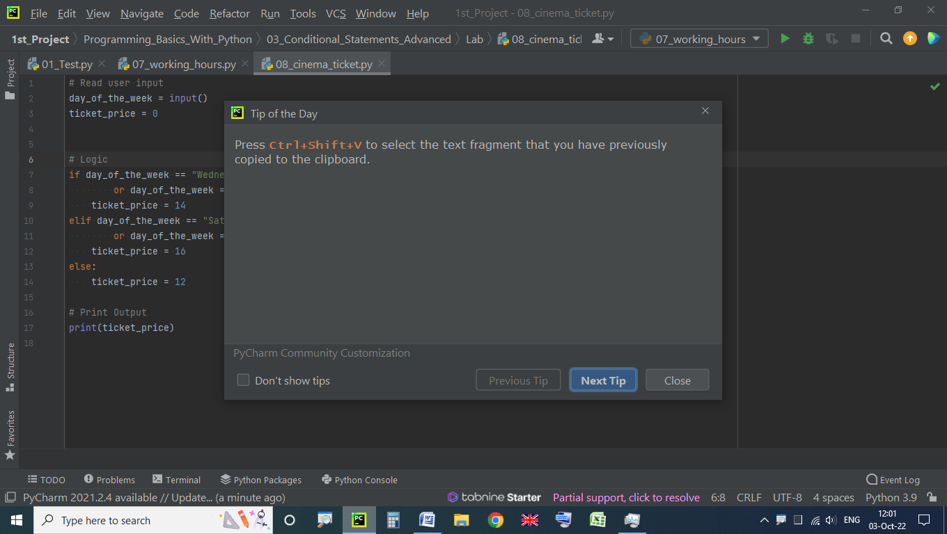

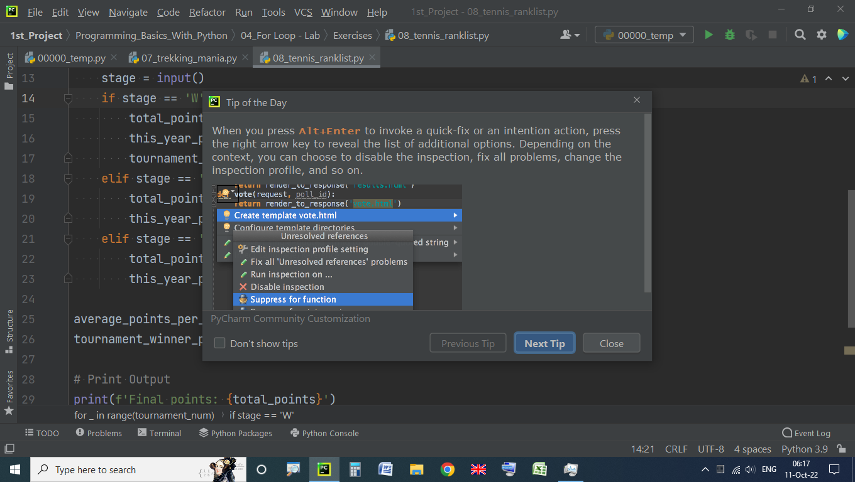

Successively press Alt+J to find and select the next occurrence of case-sensitively matching word or text range. To remove selection from the last selected occurrence, press Alt+Shift+J

After the second or any consecutive selection was added with Alt+J, you can skip it and select the next occurrence with F3. To return the selection to the lastly skipped occurrence, press Shift+F3

Press Ctrl+Alt+Shift+J to select all case-sensitively matching words or text ranges in the document.

To redo Ctrl + Shift + Z

Ctrl+Alt+T - To surround with (if or try or ….)

To select multiple fragments (create multiple cursors) in the press and hold **Ctrl+Alt+Shift** and drag the mouse (Windows and Linux):

Press   Alt   F7   to quickly locate all occurrences of code referencing the symbol at the caret, no matter if the symbol is a part of a class, method, field, parameter, or another statement.

To toggle between the upper and lower case for the selected code fragment, press Ctrl+Shift+U

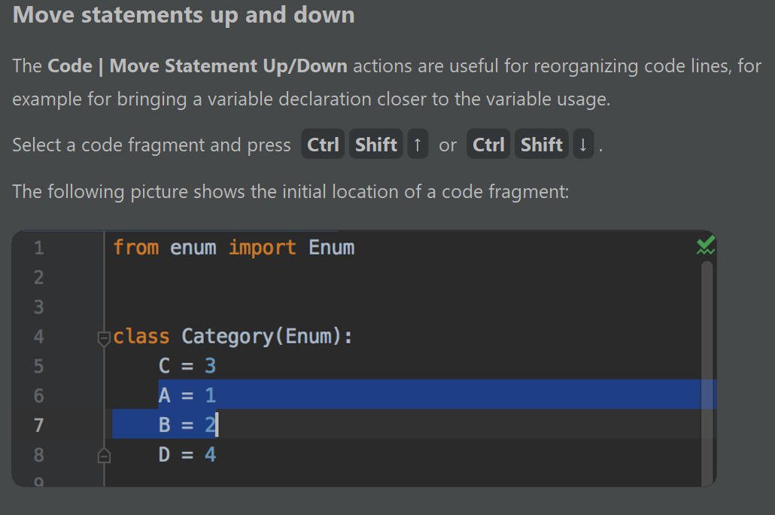

**Ctrl + Enter** new raw while caret stays

Complete statement **Shift + Enter** (Ctrl + Shift + Enter)

Start new line with - **Ctrl + Shift + Enter** (Shift + Enter)

**Ctrl + Alt + L** **or Ctrl+ ** automatically format code with spaces and lines

Move Caret To Code Block End with - **Ctrl + right bracket ]**

[Extend selection](https://www.jetbrains.com/help/pycharm/working-with-source-code.html) - **Ctrl+W**

Decrease selection - **Ctrl+Shift+W or Ctrl+** 

Select Several Rows To Be Simultaneously Edited - **Mouse Middle Click**

Duplicate current line or selection - **Ctrl + D**

Comment with line comment - **Ctrl + /**

New Python File - **Shift + Right Mouse Click**





To scroll a file horizontally, **turn the** **mouse wheel** while keeping **shift** pressed

Press **Ctrl + Shift + V** to select the text fragment that you have previously copied to the clipboard

Press **Ctrl + Shift + mouse**  to select the text word by word fragm

Press **Ctrl + `** - **zoomit** command

Mouse Middle Click or **Alt + shift + left mouse click** - select several rows to be simultaneously edited

Move Caret To Code Block End - **Ctrl +]**

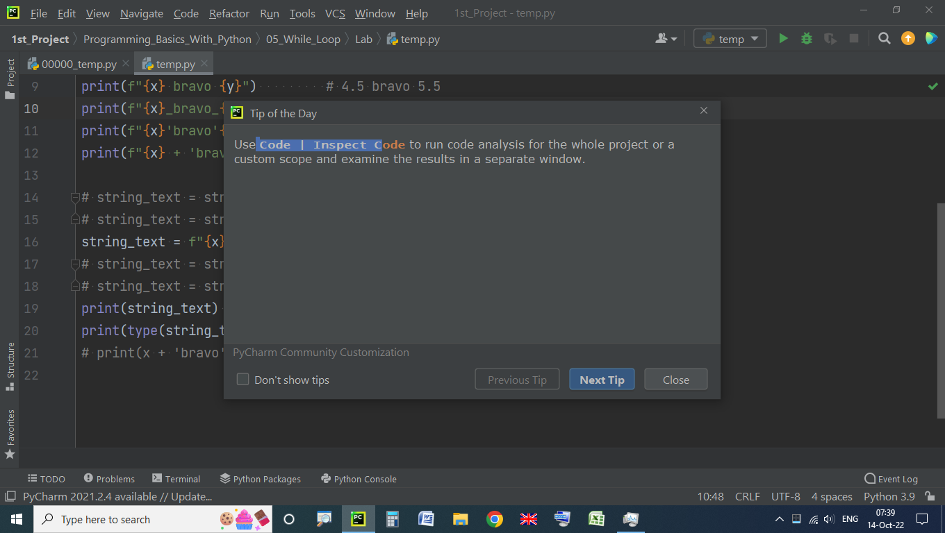

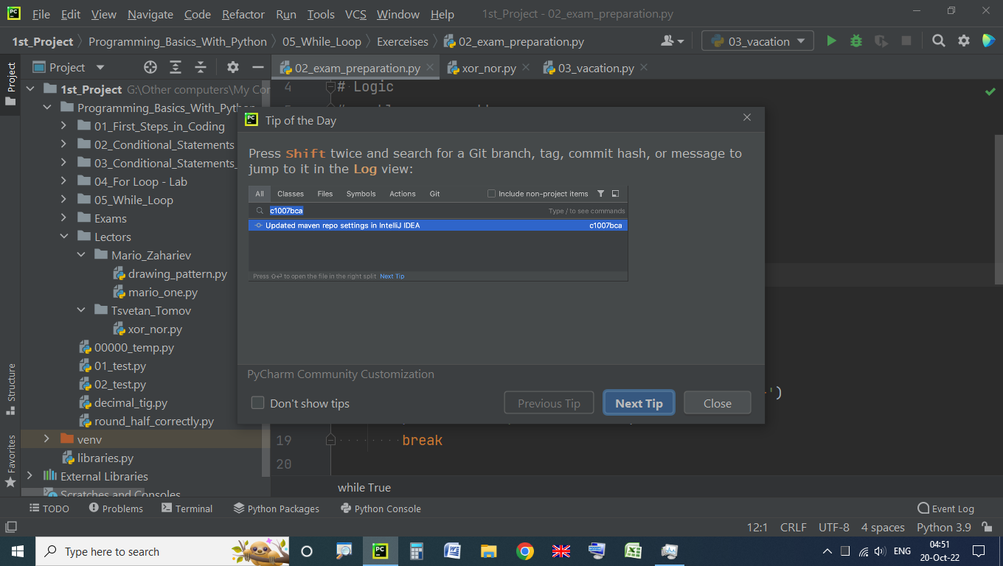

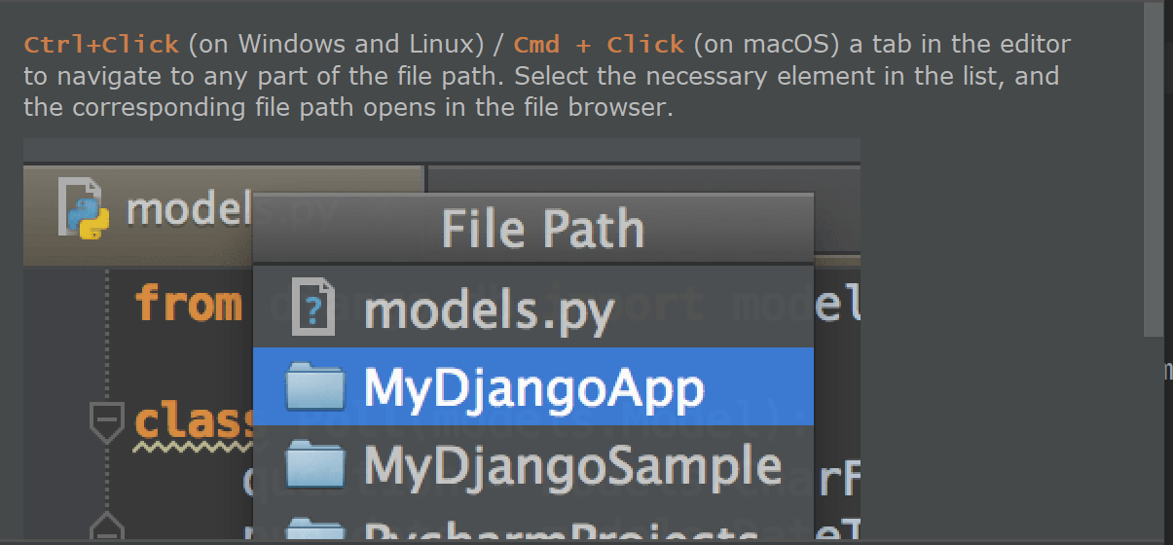

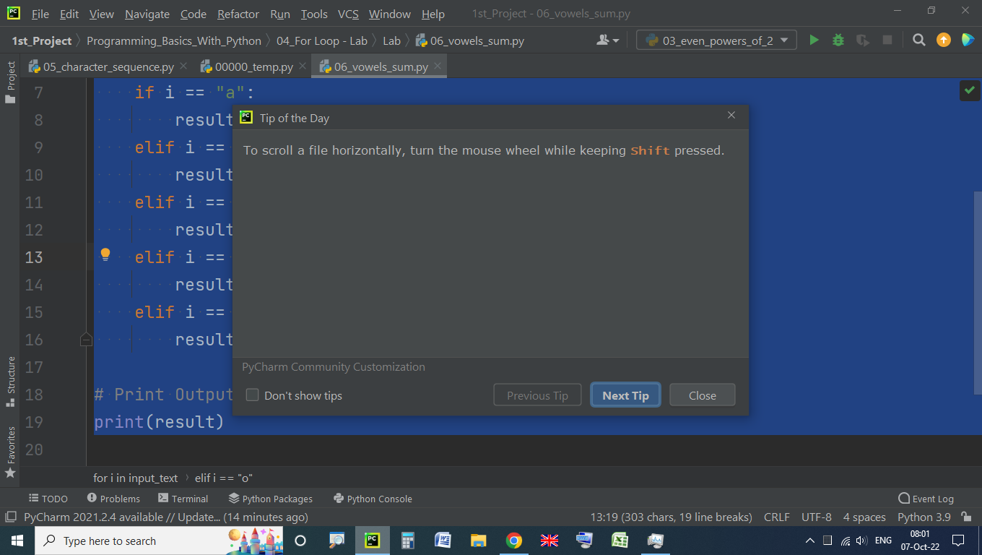

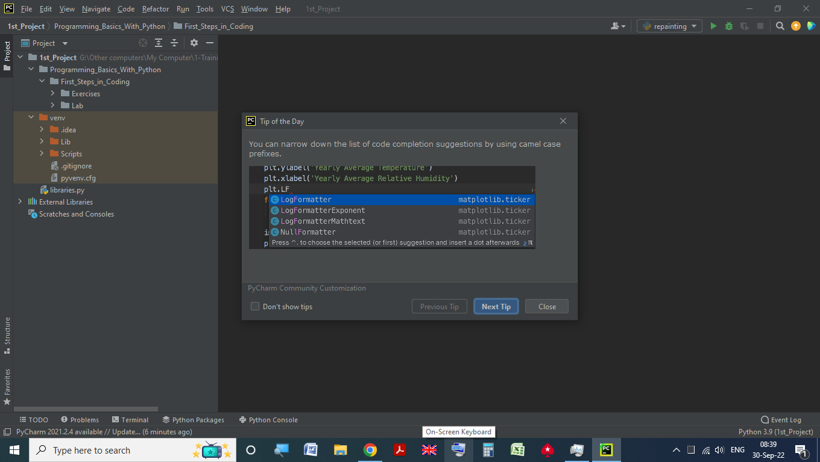

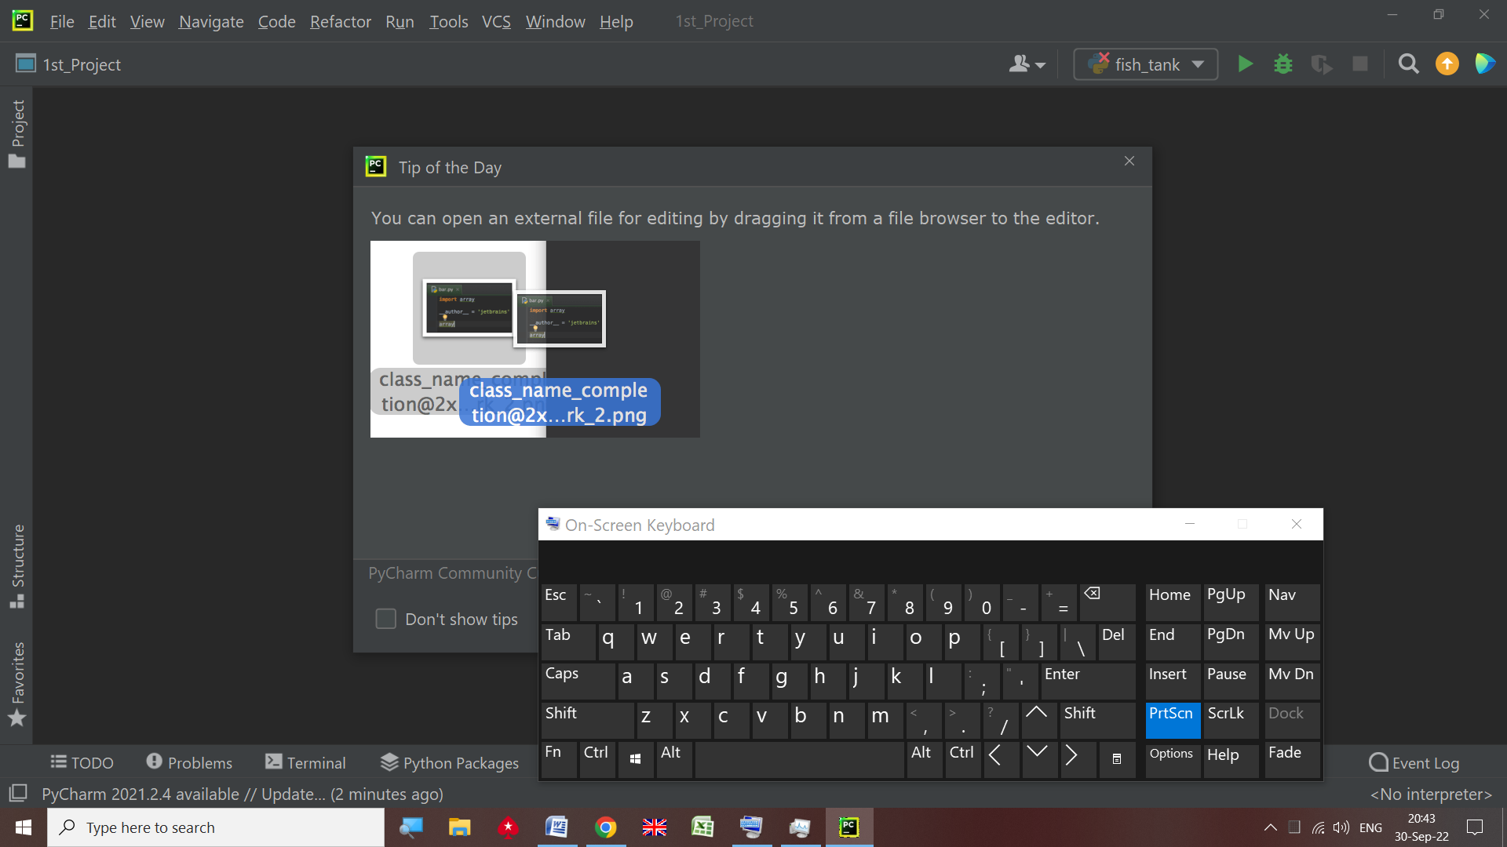

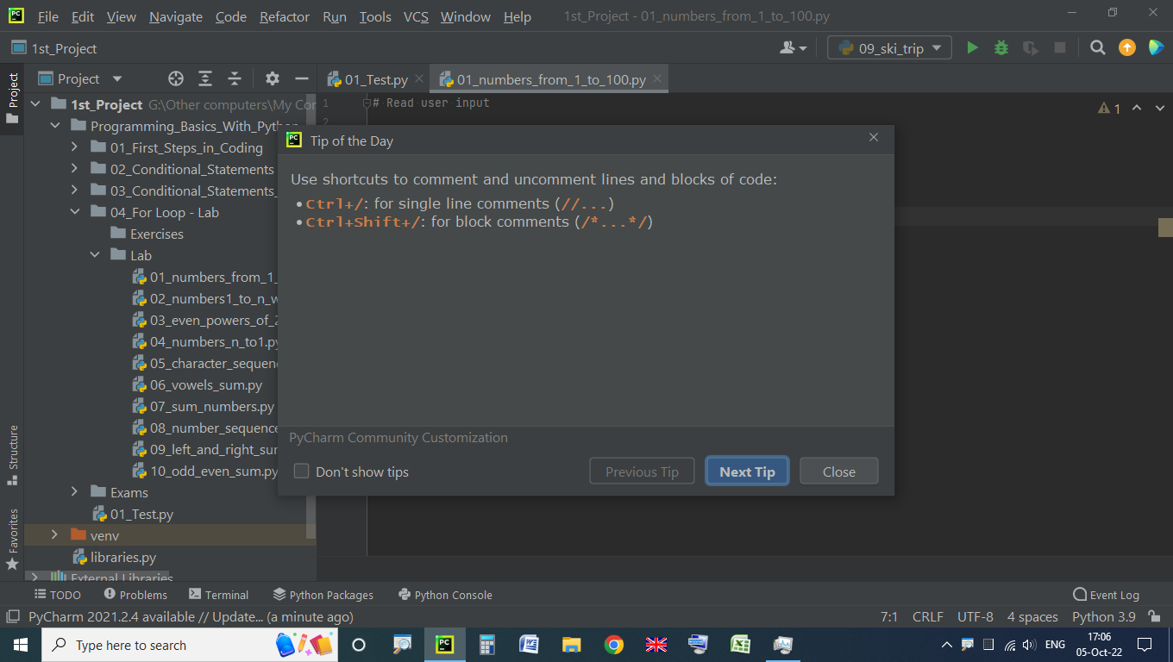

## Settings

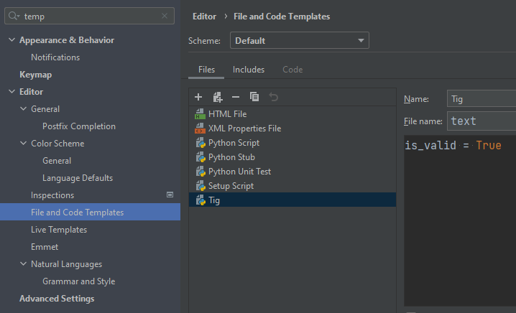

# Referenced

**List, Set, Dictionary – mutable – referenced** – it’s pointing to place in memory, even if you change it. But if you reassigned it would point to a different place in memory.

**Int, str, float, tuple, frozenset – immutable – not referenced.**

If you change it, it’ll point different place in memory

# All values in Python are references. What you need to worry about is if a type is mutable. The basic numeric and string types, as well as tuple and frozenset are immutable; names that are bound to an object of one of those types can only be rebound, not mutated.

a = 10  
b = a   
a = 30 # now a = 30 but b remains 10

list1 = [10,20,30,40]  
list2 = list1 #[10,20,30,40] list1 and list2 are one and the same object  
list1 = [3,4] # this list1 is different from the list1 up, because it’s reassigned ( it’s different object, written on a different place in memory and it’s not possible to invoke list1 anymore)  
# list1 ==> [3,4]  
# list2 ==> [10,20,30,40]

-------------------------------------------------------------------------------------

list1 = [10,20,30,40]  
list2 = list1 #[10,20,30,40] - one and the same object  
# change value of list 1 at a certain index say index 0  
list1[0] = 500 # now list1 is the same object as list1 with changed attribute value – mutated value  
# If you check again the values of list1 and list2 you will be surprised.  
#list1 ==> [500,20,30,40]  
#list2 ==> [500,20,30,40]

--------------------------------------------------------------------------------------

Set

a = {"a", "b", "c"}  
b = a  
a.add("d")  
print(a) # {'d', 'a', 'c', 'b'}  
print(b) # {'d', 'a', 'c', 'b'} set b is also changed

--------------------------------------------------------------------------------------

Dictionary

a = {"a": 1, "b": 2, "c": 3}  
b = a  
a["a"] = 7  
print(a) # {'a': 7, 'b': 2, 'c': 3}  
print(b) # {'a': 7, 'b': 2, 'c': 3} dictionary b is also changed

------------------------------------------------------------

def add_number_12(num_seq):  
 num_seq.append(12)  
# no return, but list nums is modified

nums = [1, 2, 3]  
print(nums) # [1, 2, 3]  
add_number_12(nums) # no return, but list nums is modified, because lists are referenced. num_seq and nums are pointing to one and the same place in memory  
print(nums) # [1, 2, 3, 12]

-------------------------------------------------------------

def update_set(num_seq):  
 num_seq.update("a", "s")  
# no return, but set nums is modified  
nums = {1, 2, 3}  
print(nums) # {1, 2, 3}  
update_set(nums) # no return, but set nums is modified, because sets are referenced. num_seq and nums are pointing to one and the same place in memory  
print(nums) # {1, 2, 3, 's', 'a'}

-----------------------------------------------------------

def update_dictionary(num_seq):  
 num_seq.update({7: "s"})  
# no return, but dictionary nums is modified  
nums = {1: "z", 2: "x", 3: "e"}  
print(nums) # {1: 'z', 2: 'x', 3: 'e'}  
update_dictionary(nums) # no return, but dictionaries nums is modified, because dictionaries are referenced. num_seq and nums are pointing to one and the same place in memory  
print(nums) # {1: 'z', 2: 'x', 3: 'e', 7: 's'}

# Regex

import re  
  
([0]|[1-9][0-9]*) -> matches 0 but not 00 or 01  
(?: ) - does not capture/assign a group ID.  
( ) - group with ID. \+359([\s-])\d\1 -> \1 recall group with ID=1 ([\s-])  
(?P<name> ) - group with name. \+359(?P<sep>[\s-])\d(?P=sep) -> (?P=sep) recall group (?P<sep>[\s-])  
\b - only letters, nums and _, but not +-@....  
([0]|[1-9]\d*)(\.\d+)? vs ([0]|[1-9]\d*\.?\d+)  
\w [a-zA-Z0-9_] be careful for _ !!!!!!  
(^|(?<=\s)) new line or space  
(^|\s) new line or space, but add the space to the result  
  
word = input()  
pattern = rf'\b{word}\b' # rf''

re.compile

email = input()

VALID_DOMAINS = (".com", ".bg", ".net", ".org")  
regex_domain = re.compile(r'\.[a-z]+')

if regex_domain.findall(email)[-1] not in VALID_DOMAINS:  
 print("Domain must be one of the following: .com, .bg, .org, .net")

word = input().casefold()  
pattern = rf'\b{word}\b' # -> how?  
# matches = re.findall(rf'(^|(?<=\s)){word}($|(?=\s))', text) # will not much HOW+?  
matches = re.findall(rf'\b{word}\b', text)  
print(len(matches))  
  
if there is more than 1 group, do not use re.findall(), but re.finditer or (?:...)  
(?:...) means do not create a group ID, but act as a group  
  
result = re.findall() # finds all, returns list  
result = re.search() # finds first, not iterable, returns match type or None  
re.match is anchored at the start  
re.fullmatch is anchored at the start and end of the pattern  
re.search is not anchored  
result = re.match() # finds first, if it's at the beginning only, but  
if re.search(pattern, names):  
 print("yes")  
else:  
 print("no")  
  
  
# pattern = r"\b(?P<Day>\d{2})([./-])(?P<Month>[A-Z][a-z][a-z])\2(?P<Year>\d{4})\b"  
pattern = r"\b(?P<Day>\d{2})(?P<sep>[\./-])(?P<Month>[A-Z][a-z][a-z])(?P=sep)(?P<Year>\d{4})\b"  
text1 = "13/Jul/1928, 10-Nov-1934, , 01/Jan-1951,f 25.Dec.1937 23/09/1973, 1/Feb/2016"  
dates = re.finditer(pattern, text1)  
# print(dates)  
for date in dates:  
 print(date)  
 num_dict = date.groupdict() # Match into dict  
# print(f"Day: {num_dict['Day']}, " # calling value of key=Day from num_dict  
# f"Month: {num_dict['Month']}, "  
# f"Year: {num_dict['Year']}")  
# print(f"Day: {num[1]}, " # group(1) returns the group(1) Match  
# f"Month: {num[3]}, " # group(3) returns the group(3) Match  
# # f"Month: {num['Month']}" <=> f"Month: {num[3]}" -> both can be used  
# f"Year: {num['Year']}") # group(Year)(4) returns the group(Year)(4) Match  
# # f"Year: {num['Year']}" <=> f"Year: {num[4]}"  
# # -> both num['Year'] and num[4] can be used, because group4 is named Year  
 print(f"Day: {num_dict['Day']}, Month: {num_dict['Month']}, Year: {num_dict['Year']}")  
 print(f"Day: {date['Day']}, Month: {date['Month']}, Year: {date['Year']}")  
 print(f"Day: {date[1]}, Month: {date.group(3)}, Year: {date[4]}")  
 # !!! use date.group(1) or date.group('Day'), but not date[1] or date['Day'],  
 # because it could NOT be available in next release!!!  
 print(date.group()) # group(0) returns the whole Match  
 print(date.group(1)) # group(1) returns Day  
 print(date.group('Month')) # group(2) returns 'Month'  
 print(date.groups()) # all groups as tuple ('13', '/', 'Jul', '1928')  
# dates1 = re.findall(pattern, text1)  
# print(dates1)  
# for date in dates1:  
# print(f"Day: {date[0]}, Month: {date[2]}, Year: {date[3]}")  
dates = re.match(pattern, text1) # MATCH IS NOT ITERABLE, searches at the BEGINNING ONLY  
print(dates) # match & search are same type, but the scope  
print(type(dates))  
print(dates.groupdict())  
dates = re.search(pattern, text1) # returns the same as match, BUT in ALL ROWS  
print(dates) # match & search are same type, but the scope  
print(type(dates))  
print(dates.groupdict())  
  
txt = "The rain in Spain"  
x = re.sub(r"\s", "9", txt, 2) # substitute(replace)  
print(x)  
  
txt = "The rain in Spain"  
x = re.split(r"\s", txt)  
print(x)  
  
text1 = input()  
text2 = input()  
text3 = input()  
pattern = r"\+359 2 \d{3} \d{4}\b|\+359-2-\d{3}-\d{4}\b"  
num1 = re.findall(pattern, text1) # more time  
num2 = re.findall(pattern, text2) # more time  
num3 = re.findall(pattern, text2) # more time  
regex_pattern = re.compile(pattern)  
num11 = regex_pattern.findall(text1) # faster  
num12 = regex_pattern.findall(text2) # faster  
num13 = regex_pattern.findall(text3) # faster  
  
print(*res_list, sep=', ')  
print(str_res[:-2])

# Sets - кортежи(tuple) и множества(set)

Unique unordered collection

Sets can be used to perform mathematical set operations (union, intersection, symmetric difference, etc.)

usernames = set()

knight_attacks = len({(i + di, j + dj) for di, dj in positions if (i + di, j + dj) in knights})  
knight_attacks = len({(i + di, j + dj) for di, dj in positions}.intersection(knights))  
faster than the upper row due to intersection.  
intersection is faster than if !!!

sorted(set(crafted))] => return list

[print(f"{toy}: {crafted.count(toy)}") for toy in sorted(set(crafted))]

1st_Project\03_Advanced\03_Stacks_Queues_Tuples_and_Sets_Exercise\Exercises\05_santas_present_factory_a.py

A set is a collection which is unordered and unindexed.

No repeated symbols.

Sets are written with braces curly brackets

text = "Hhello"   
set_text = set(text)   
print(text) # Hhello  
print(set_text) # {'H', 'o', 'e', 'l', 'h'}

a = set([1, 2, 3, 4])  
b = set([3, 4, 5, 6])  
print(a | b) # Union -> {1, 2, 3, 4, 5, 6}  
print(a & b) # Intersection -> {3, 4}  
print(a < b) # Subset -> False  
print(a > b) # Superset -> False  
print(a - b) # Difference -> {1, 2}  
print(a ^ b) # Symmetric Difference -> {1, 2, 5, 6}  
  
a.union(b) # Equivalent to a | b  
print(a.union(b)) # {1, 2, 3, 4, 5, 6}  
print(a) # {1, 2, 3, 4}  
a.intersection(b) # Equivalent to a & b  
a.issubset(b) # Equivalent to a <= b  
a.issuperset(b) # Equivalent to a >= b  
a.difference(b) # Equivalent to a - b  
a.symmetric_difference(b) # Equivalent to a ^ b

a.update() updates the current set, by adding items from another set

def isdisjoint(self, *args, **kwargs):   
 *""" Return True if two sets have a null intersection. """*

The discard() method removes the specified item from the set. This method is different from the remove() method, because the remove() method will raise an error if the specified item does not exist, and the discard() method will not.

# Shortcuts

See PyCharm chapter

**Word:**

Ctrl + F6 – switch between open Word docs

Alt+ F7 - starts spell check in MS Word

# Slicing

[::] no beginning and end  
a = "2371"  
x = a[::-1] # 1732

x = a[:-1] # 1  
y = a[::-2] # 13  
z = a[::2] # 27

z = a[:2] # 23  
b = list(a) # ['2', '3', '7', '1']  
a = "0123456789"  
x1 = a[1::2] # 13579  
x2 = a[::2] # 02468  
x3 = a[::3] # 0369  
c = list(a)  
c.extend(b)  
d = a[1:7]  
a = [1, 2, 3, 4, 5, 6, 7]  
b = a[-5:-2] # new not referent  
b = a[-3:-6:-2] # [5, 3]  
b = a[:] # new not referent  
b = a[::] # new not referent  
txt = "Welcome To My World"  
x = txt[-5::] # World

x = txt[-5:] # World  
x = txt[14:] # World  
x = txt[slice(-5, len(txt), 1)] # World  
x = txt[slice(-5, 19, 1)] # World  
x = txt[-5::2] # Wrd  
x = txt[-5:2] # empty because 2 = -17  
x = txt[-17:9] # lcome T  
x = txt  
print(x)

# removing elements in the middle of the list

a_nums = a_nums[:left_idx] + a_nums[right_idx + 1:]  
print(a_nums)  
# =>  
for i in range(idx + value, idx - value - 1, -1):  
 b_nums.pop(i)  
print(b_nums)  
# =>  
del c_nums[left_idx:right_idx + 1]  
print(c_nums)

# Symbol names

= equal

{ open brace

( ) parenthesis

[ open bracket

% percent

? Question Mark

| pipe or bar

! "bang", "exclamation point"

@ "at", and rarely, "strudel"

# "crunch", "hash", "pound", and rarely, "octothorpe"

^ "circumflex", "hat", "chapeau"

& "ampersand", "and"

* "splat", "star", "asterisk", "times" (as in multiplication)

_ "underscore"

- "hyphen", "dash", "minus sign"

. "dot", "period"

, "comma"

: "colon"

; "semi-colon"

/ "slash"

\ "backslash"

~ "twiddle", also "squiggle", or more correctly, "tilde"

' "tick", "quote", "apostrophe"

" " double-quote"

` "backtick", "backquote"

< "less-than", "left angle bracket"

> "greater-than", "right angle bracket"

# Text

if email.index("@") < 5:

print(chr(87)) # W  
print(ord('a')) # 97

name = 'Test'  
print('name is: {}'.format(name)) # name is: Test  
print(f'name is: {name}') # name is: Test  
# print() is function  
# .format(name) is method

Python **integers** are **immutable**

Python **floats** are **immutable**

Python **strings** are **immutable**

This means that once a string is created,

it is **not** possible to **modify** it

name = 'George'  
name[0] = 'P' # Error не може да променим G

print(name) # George

name = 'Ime' # заделя друго място в паметта

различно от мястото за George  
print(name) # Ime  
name = 4 # заделя трето място в паметта  
print(name) # 4

string **interpolation** are string **literals**(буквален)

that allow **embedded**(вградени) expressions

name = 'Test New'  
print(name[:2]) # Te  
print(name[:3]) # Tes  
print(name[ ]) # Error   
print(name[3:]) # t New

print(name[2:6]) # st N

# creating new text with removed chars in the middle of the list

a_nums = a_nums[:left_idx] + a_nums[right_idx + 1:]  
print(a_nums)

txt = "Welcome To My World"

# x = txt.casefold() # stronger than lower()  
# x = txt.lower()  
# x = txt.count('l', 3, 19) # string.count(value, start, end)

"welcome".find("com") # 3 string.find(value, start, end)

x = "bob".center(10, '@') # @@@bob@@@@  
x = txt.encode() # string.encode(encoding=encoding, errors=errors)  
x = txt.endswith("my world.", 5, 11) # True or False  
print("H\te\tl\tl\to".expandtabs(3)) # H e l l o  
print("H\te\tl\tl\to".expandtabs(5)) # H e l l o

x = "welcome".isascii() # True  
x = "wow_83".isidentifier() # True  
x = "lo!\nAre".isprintable() # False

print(isinstance(11, float)) # False  
print(isinstance(11.0, int)) # False  
print(isinstance(11, float) or isinstance(11, int)) # True  
print(isinstance(11.0, float) or isinstance(11.0, int)) # True

str_1 = "teststring12"  
x = str_1.isalnum() # True - "alnum" - alpha numeric  
y = str_1.isalpha() # False  
z = str_1.isdigit() # False Exponents, like ², are also considered to be a digit  
a = '-1'.isdecimal() # False 0-9  
b = '3/4'.isnumeric() # False  
c = '¾'.isnumeric() # True 0-9 like ² and ¾  
d = "0.7"  
print('0.7'.isnumeric()) # False  
print("0.7".isdigit()) # False  
print(isinstance("0.7", float)) # False  
print(isinstance(0.7, float)) # True  
print(d.isnumeric()) # False – AttributeError if d=0.7 instead “0.7”  
print(d.isdigit()) # False – AttributeError if d=0.7 instead “0.7”  
print(isinstance(d, float)) # False

# Time

03_Advanced\04_Multidimensional_Lists\Recapitulate\Exercises_2\03_knight_game.py

knight_attacks=len({(i+di,j+dj)for di,dj in positions if (i+di,j+dj) in knights})  
knight_attacks=len({(i+di,j+dj)for di,dj in positions}.intersection(knights))

# row using intersection isfaster than row with if

time.sleep(2) #-> wait for 2 seconds (secs)

# region datetime timedelta, strptime, strftime

from datetime import datetime, timedelta

# input_time = "8:00:00"  
input_time = "2023:8:00:00:17" # Month is omitted   
current_time = datetime.strptime(input_time, "%Y:%H:%M:%S:%d")  
current_time += timedelta(seconds=7)  
# class datetime.timedelta(days=0, seconds=0, microseconds=0, milliseconds=0, minutes=0, hours=0, weeks=0)  
print(current_time.strftime("p[%H:%M:%S{q")) # p[08:00:07{q  
print(current_time.strftime("%H:%M:%S-(%d/%Y)")) # 08:00:07-(17/2023) - Month is omitted

# endregion

# region Diff = End_time - Start_time

import time

start_time = time.time()  
test_list = [x for x in range(100000)]  
while test_list:  
 test_list.pop()  
diff = time.time() - start_time  
print(diff)  
start_time = time.time()  
test_list = [x for x in range(100000)]  
while test_list:  
 test_list.pop(0)  
diff = time.time() - start_time  
print(diff)

# endregion

# Tuples - кортежи(tuple) и множества(set)

t = (1, )   
t = (1, 2, 3)  
t = 1, 2, 3

nums = tuple(int(x) for x in input().split())

**two** available tuple methods

**count and index**

Tuples are **immutable objects,** but the **objects**, inside the tuples, **are mutable**

nums = [1, 2]  
my_tuple = (nums, 7, 9) # tuple are immutable but variables are mutable  
print(my_tuple) # ([1, 2], 7, 9)  
nums.append(3) # change NUMS in tuple!!! It will not work after redefining it in the next row  
nums = [1, 2, 29] # does not change NUMS in tuple!!! create new NUMS different from NUMS in tuple

print(my_tuple) # ([1, 2, 3], 7, 9) -> variables inside the tuple are mutable  
my_tuple[0][2] = 12 # if we want to access NUMS in tuple again  
my_tuple[0].append(43) # if we want to access NUMS in tuple again  
print(my_tuple) # ([1, 2, 12, 43], 7, 9) -> variables inside the tuple are mutable  
nums.append(23) # [1, 2, 29, 23]  
print(nums) # [1, 2, 29, 23]  
print(my_tuple) # ([1, 2, 12, 43], 7, 9) -> variables inside the tuple are mutable

# Queues and Stacks

nums = deque([0, 1, 2, 3]) # deque([0, 1, 2, 3])  
print(nums) # deque([0, 1, 2, 3])  
nums1 = deque()  
for i in range(5):  
 nums1.appendleft(i)  
print(nums1) # deque([4, 3, 2, 1, 0])

# ZZZ Other

## If… Else … replacement

even_set.add(num) if num % 2 == 0 else odd_set.add(num)

map_function = {  
 1: lambda x: numbers.append(x[1]),  
 2: lambda x: numbers.pop() if numbers else None,  
 3: lambda x: print(max(numbers)) if numbers else None,  
 4: lambda x: print(min(numbers)) if numbers else None,  
} # There must be lambda x: on each Key: Value !!!  
for _ in range(int(input())):  
 command = [int(x) for x in input().split()]  
 # map_function[command[0]](command)  
 if map_function.get(command[0]):  
 map_function[command[0]](command)  
 else:  
 print("anything")  
 # try:  
 # map_function[command[0]](command)  
 # except KeyError:  
 # print("anything")  
----------------------------------------------------------------------

from functools import reduce

map_function = {  
 '+': lambda x: reduce(lambda a, b: a + b, x),  
 '-': lambda x: reduce(lambda a, b: a - b, x),  
 '/': lambda x: int(reduce(lambda a, b: a / b, x)),  
 # '/': lambda x: reduce(lambda a, b: a + b if a == 0 or b == 0 else a / b, x),  
 '*': lambda x: reduce(lambda a, b: a * b, x),  
}  
for el in data:  
 if el in map_function:  
 res = map_function[el](temp_list)  
 else:  
 temp_list.append(int(el))

---------------------------------------------------------------

map_func = {  
 "Add First": lambda x: set1.update(x),  
 "Add Second": lambda x: set2.update(x),  
 "Remove First": lambda x: set1.difference_update(x),  
 "Remove Second": lambda x: set2.difference_update(x),  
 # "Check Subset": lambda x: print(set1.issubset(set2) or set2.issubset(set1))  
 **"Check Subset": lambda x: print("True") if set1.issubset(set2) or set2.issubset(set1) else print("False")**  
}  
for _ in range(int(input())):  
 action1, action2, *info = input().split()  
  
 map_func[action1 + ' ' + action2](map(int, info))