BdKCSE'2018 International Conference on
21-22 November 2018, Sofia, Bulgaria Big Data, Knowledge and Control Systems Engineering

Activation Function Permutation for

Multilayer Perceptron Training

Todor Balabanov, Tatiana Atanasova, Ivan Blagoev
Institute of Information and Communication Technologies
Bulgarian Academy of Sciences
acad. Georgi Bonchev Str., block 2, office 514
1113 Sofia, Bulgaria
todorb@iinf.bas.bg

Abstract: Artificial neural networks are very popular tool in the field of machine learning. Their common usage is in the fields of classification and forecasting. Artificial neural networks were developed as mathematical explanation of the natural neural networks, but their application is still far away from the live organisms. Artificial neural networks have two common woking phases. They are first trained and after that used for calculations. Once trained artificial neural networks are very efficient. Training is a key stone, because it is time consuming even on very powerful computers. This research proposes permutation of the neurons activation function in order convergence speed-up to be achieved.
Keywords: artificial neural networks, back propagation, machine learning.

Introduction
Artificial neural networks are heavily used in different scientific and daily life fields. As data handling tool they are very well known from decades [1,2]. In the common case artificial neural networks are weighted directed graph and there are many different configurations of this idea. In the simplest case it is a multilayer perceptron, but there are much more exotic configurations as generalized nets [3], for example.
In the literature many different training algorithms are presented, but back-propagation training of multilayer perceptron is the most popular one [4]. Because the back-propagation is gradient based exact numerical method it has a disadvantage of trapping in local optimums [5]. By using stochastic or hybrid training algorithms there are many options to fix a such disadvantage [6,7].
This research proposes activation function permutation as modification of back-propagation training algorithm, used for multilayer perceptron. By the proposed modification training speed-up is achieved. The paper is organized as follows: Section 1 is brief introduction of the problem; Section 2 explains the proposed modification; Section 3 presents some experiments and results and Section 4 concludes achieved results and proposes some further researches.

Neurons Activation Function Permutation
Permutation of the neurons in the hidden layer of а multilayer perceptron was proposed by Zankinski [8]. The efficiency of such neurons permutation is arguable, but it is perfect creativity direction for proposal of other permutation based ideas.
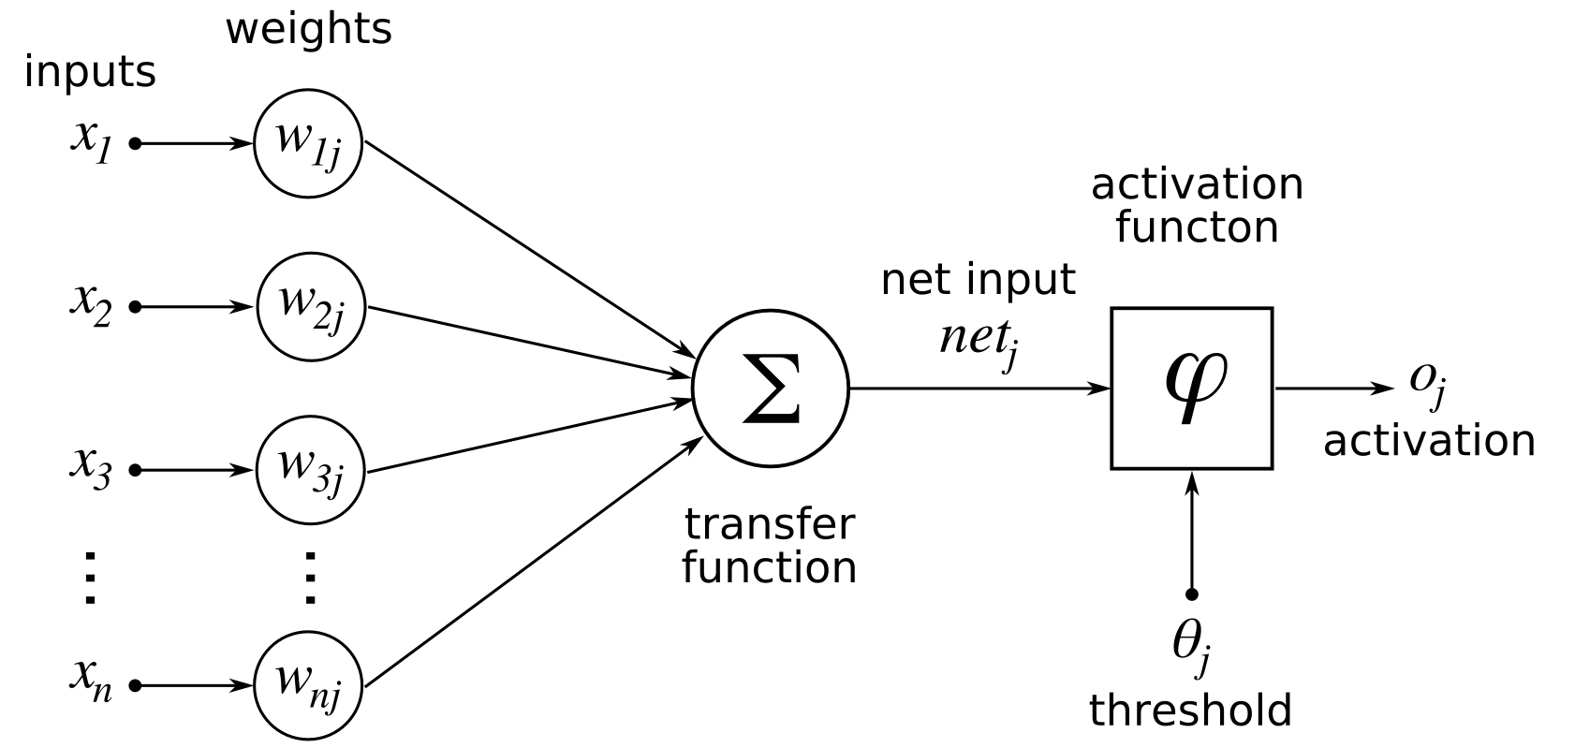
Figure 1. Artificial Neuron Components
Each neuron in an artificial neural network has weights attached to it, transfer function (in most cases sum of the weighted input signals) and activation function (Fig. 1).
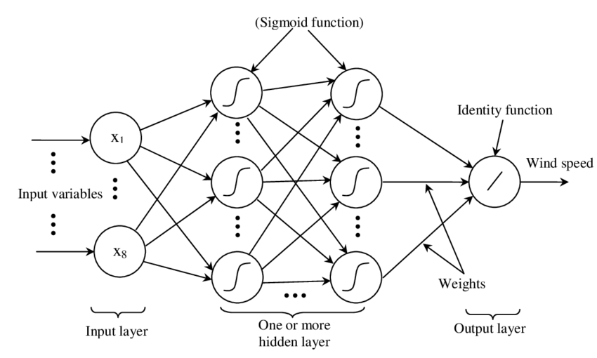
Figure 2. Multilayer Perceptron
When the topology of the network is multilayer perceptron neurons are organized in layers (Fig. 2). The input layer has only feeding duties, but neurons in the hidden layer have to transform the signals inside the network. Transfer function collects input signals with particular weighting multiplication. Sum is the most used transfer function. When signals are collected normalization should be applied in order single signal to be emitted by the neuron. For this normalization activation function is used. Many mathematical functions are proper for the activation [4], but the most used are hyperbolic tangent and sigmoid. Activation function is very important, because the amount of input links to a single neuron can vary from few to hundreds.
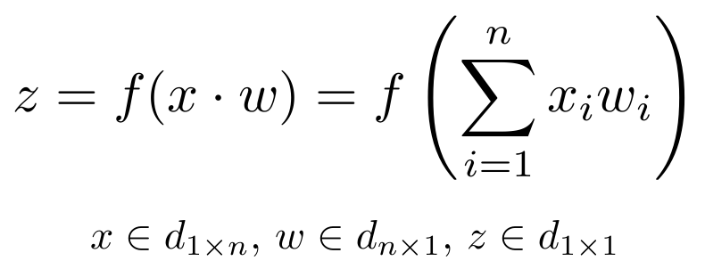
Figure 3. Artificial Neuron Transfer Function
The second factor are the weights it selves. In classical multilayer perceptron weights are unconstrained real numbers. It means that big negative and positive numbers can be involved in the regular artificial neural network working mode (Fig. 3). Sum of big number multiplications between input signals and weights is problematic, because different neurons will not participate in the network on an equal basis. All these problems are solved by normalization with proper activation function.
Encog programming library allows change of the activation function during training phase of artificial neural network operation [9]. In this research on a random basis neurons are selected and their activation function is changed to sigmoid function for a single cycle of training. Initial network topology has three layers and hyperbolic tangent is used for each neuron. By changing of the activation function permutation of the activation functions is achieved.

Experiments & Results
Experiments are done with custom made software solution, based on Encog programming library. The source code is under open source software license and it can be found at [9]. Digits charters recognition was selected as benchmark dataset. Model of 256-266-10 multilayer perceptron was programmed in Java. Hidden layer was selected to be bigger in order better differentiation to be achieved. Dataset of ten digits is presented as CSV file.
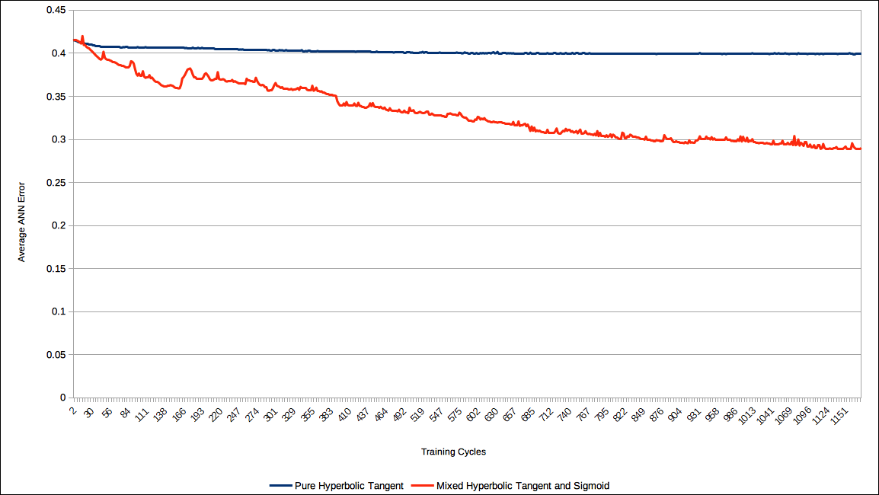
Figure 4. Training Convergence Comparison
Two separate artificial neural networks are tested – pure hyperbolic tangent and mixed (hyperbolic tangent and sigmoid). Experiments are done 30 times and the average results are presented in Fig. 4 (artificial neural network average total error according training cycles). Results shows that mixed activation function gives better convergence results. Swaps of the activation function give stairs like shape of the convergence curve.

Conclusions
The paper proposes neurons activation function permutation as modification of the back-propagation training algorithm. It is clearly shown by the presented results that the proposal is efficient enough in artificial neural network training speed-up.
As further work it would be interesting the proposed modification to be extended with many other neurons activation functions [4]. Training of artificial neural networks in distributed environment [6,7] would be also interesting if it is combined with the proposed modification.

Acknowledgements
This work was supported by private funding of Velbazhd Software LLC.

References
- Atanasova, T., Barova, M., Balabanov, T.: Use of neural patterns to analyze time lines in large amounts of data. Publishing complex Vasil Levski, 193--198, ISSN:1314-1937, (2016)
- Tomov, P., Monov, V., Artificial Neural Networks and Differential Evolution Used for Time Series Forecasting in Distributed Environment, Proceedings of International conference Automatics and Informatics, ISSN 1313-1850, 129--132, Sofia, Bulgaria, (2016)
- Tashev, T., Hristov, H., Modeling of synthesis of information processes with generalized nets. In: Drinov, M. (ed.) Cybernetics and Information Technologies, vol. 2, Academic Publishing House, Sofia, 92–104, (2003)
- Zankinski, I., Tomov, P., Balabanov, T., Alternative Activation Function Derivative in Artificial Neural Networks, Proceedings of XXV International Symposium Management of Energy, Industrial and Environmental Systems, ISSN 1313-2237, Bankya, Bulgaria, 79--81, (2017)
- Balabanov, T., Avoiding Local Optimums in Distributed Population based Heuristic Algorithms (in Bulgarian), Proceedings of XXIII International Symposium Management of energy, industrial and environmental systems, John Atanasoff Union of Automation and Informatics, Sofia, Bulgaria, 83–86, (2015)
- Balabanov, T., Zankinski, I., Dobrinkova, D., Time Series Prediction by Artificial Neural Networks and Differential Evolution in Distributed Environment, International Conference on Large-Scale Scientific Computing, Sozopol, Bulgaria, Lecture Notes in Computer Science, vol. 7116, no. 1, 198–205, (2011)
- Balabanov, T., Zankinski, I., Barova, M., Strategy for Individuals Distribution by Incident Nodes Participation in Star Topology of Distributed Evolutionary Algorithms, Cybernetics and Information Technologies, Sofia, Bulgaria, vol. 16, no. 1, 80–88, (2016)
- Zankinski, I., Stoilov, T., Effect of the Neuron Permutation Problem on Training Artificial Neural Networks with Genetic Algorithms in Distributed Computing, Proceedings of XXIV International Symposium Management of Energy, Industrial and Environmental Systems, ISSN 1313-2237, Bankya, Bulgaria, 53--55, (2016)
- Balabanov, T., Encog digits classification resilient training example with regulated sin as activation functions, https://github.com/TodorBalabanov/EncogDigitsResilient , (2018)

