BdKCSE'2018 International Conference on
21-22 November 2018, Sofia, Bulgaria Big Data, Knowledge and Control Systems Engineering

Activation Function Permutation for Multilayer Perceptron Training

Todor Balabanov, Tatiana Atanasova, Ivan Blagoev
Institute of Information and Communication Technologies - Bulgarian Academy of Sciences
Acad. Georgi Bonchev Str., block 2, office 514
1113 Sofia, Bulgaria
todorb@iinf.bas.bg, atanasova@iit.bas.bg, i.blagoev@iit.bas.bg

Abstract: Artificial neural networks are very popular tool in the field of machine learning. Their common usage is in the fields of classification and forecasting. Artificial neural networks were developed as mathematical explanation of the biological neural networks, but their application is still far away from the live organisms. Artificial neural networks have two common working phases. They are first trained and after that used for solving of the specific task. Numerous studies have shown that a well-trained network can solve their tasks very efficiently. Training is a key stone, because it is time consuming even on very powerful computers. This research proposes permutation of the neurons activation function in order the convergence speed-up to be achieved.
Keywords: artificial neural networks, back propagation, machine learning.

Introduction
Artificial neural networks (ANN) are profoundly used in different scientific and daily life tasks. As a data handling tool they are very well known from decades [1, 2]. Generally artificial neural networks are weighted directed graph and there are many different configurations of this scheme. In the simplest case it is a multilayer perceptron, but there are much more exotic architectures as generalized nets [3], for example.
In the literature many different training algorithms are presented, but the back-propagation of errors to calculate a gradient that is needed to define weights in multilayer perceptron is the most popular one [4]. The back-propagation is an exact numerical method that is why it has a disadvantage of trapping in local optimums [5]. By using stochastic or hybrid training algorithms there are many attempts to fix this disadvantage [6, 7].
This research proposes activation function permutation as modification of back-propagation training algorithm, used for multilayer perceptron. By the proposed modification the training speed-up is achieved. The paper is organized as follows: Section 1 gives a brief introduction of the problem. Section 2 explains the proposed modification; Section 3 presents some experiments and results. Section 4 discusses the achieved results and proposes directions for some further investigations.

Neurons Activation Function Permutation
Permutation of the neurons in the hidden layer of а multilayer perceptron was proposed by Zankinski [8]. The efficiency of such neurons permutation is arguable, but it is perfect creativity direction for proposal of other permutation based ideas.
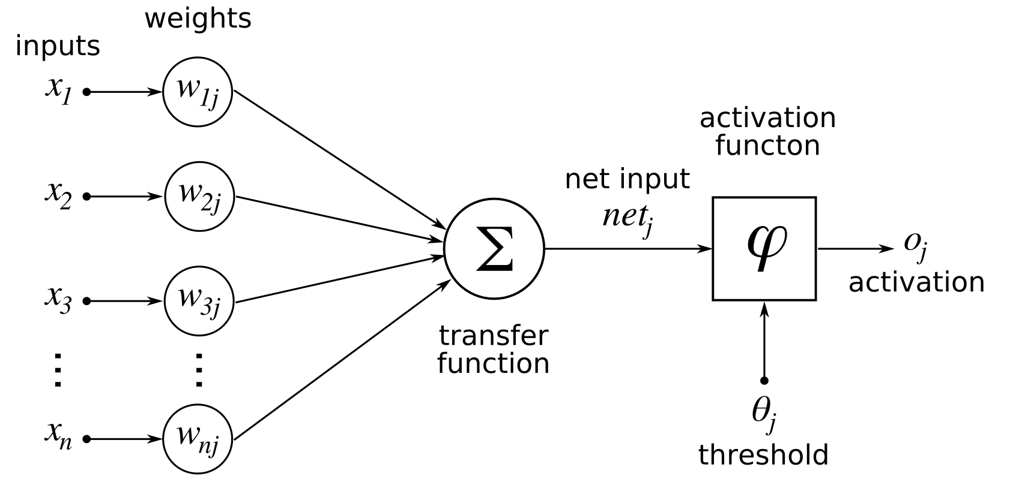
Figure 1. Artificial Neuron Components

Each neuron in an artificial neural network has weights attached to it, transfer function (in most cases a sum of the weighted input signals) and activation function (Fig. 1).
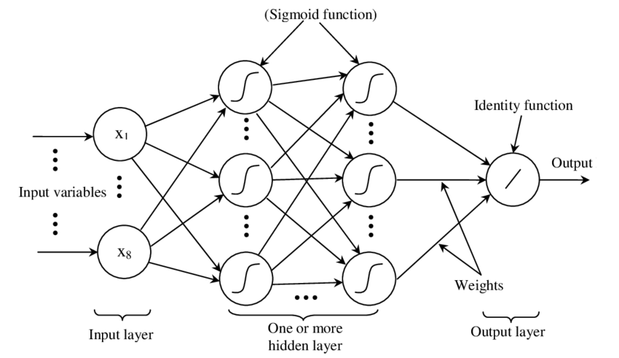
Figure 2. Multilayer Perceptron

The neurons within the topology of multilayer perceptron network are organized in layers (Fig. 2). The input layer has only feeding duties, but neurons in the hidden layer have to transform the signals inside the network. The transfer function collects input signals with particular weighting multiplication. Summation is the most used transfer function. When signals are collected then normalization should be applied in order a single signal to be emitted by the neuron. For this normalization an activation function is used. Different mathematical functions can be used for the activation [4], but the most widespread are hyperbolic tangent and sigmoid. The role of activation function is very important, because the amount of input links to a single neuron can vary from few to hundreds.
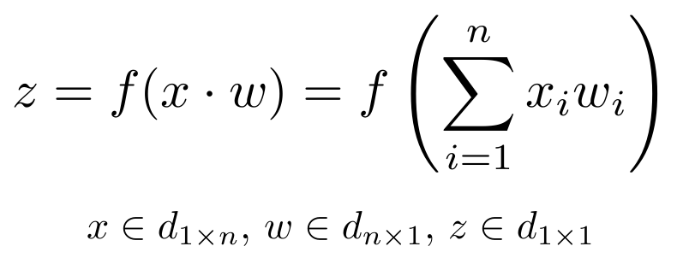
Figure 3. Artificial Neuron Transfer Function
The weights themselves are among another important factor for neural network training. In classical multilayer perceptron weights are unconstrained real numbers. It means that big negative and positive values can be involved in the regular artificial neural network working mode (Fig. 3). Summation of multiplications between input signals and weights in large range is problematic, because different neurons will not participate in the network on an equal basis. All these problems are solved by normalization with proper activation function.
In this research a network with initial topology of three layers and hyperbolic tangent as activation function for each neuron is used. Several neurons are selected on a random basis and their activation functions are changed from hyperbolic tangent to sigmoid function for a single cycle of training. Thus permutation of the activation functions is achieved.
Encog Machine Learning Framework [https://www.heatonresearch.com/encog/] is used for experimenting and changing of the activation function during training phase of artificial neural network operation.

Experiments & Results
Experiments are done with custom made software solution, based on Encog programming library. The source code is under open source software license and it can be found at [9]. Digits charters recognition was selected as benchmark dataset. Model of multilayer perceptron with 256-266-10 neurons on input-hidden-output layers was programmed in Java. Hidden layer was selected to be bigger in order better differentiation to be achieved. Dataset of ten digits is presented as CSV file.
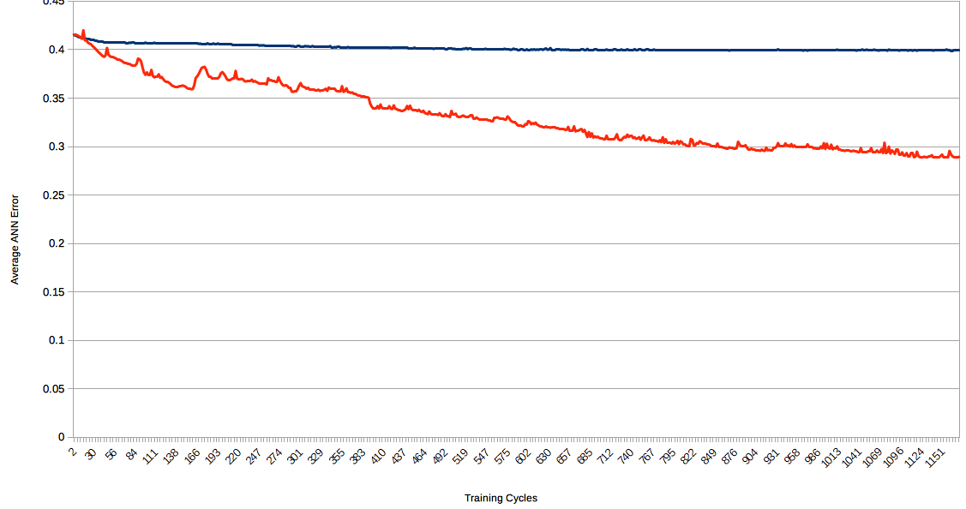
Figure 4. Training Convergence Comparison
Two artificial neural networks are tested for comparision. One network has only pure hyperbolic tangent activation functions and other network has mix of both two kinds (hyperbolic tangent and sigmoid). Experiments are conducted 30 times and their average results are presented in Fig. 4, where an ANN average total error is shown during training cycles. According the received results the mix of activation functions gives better convergence results. Swaps of the activation function give stairs like shape of the convergence curve.

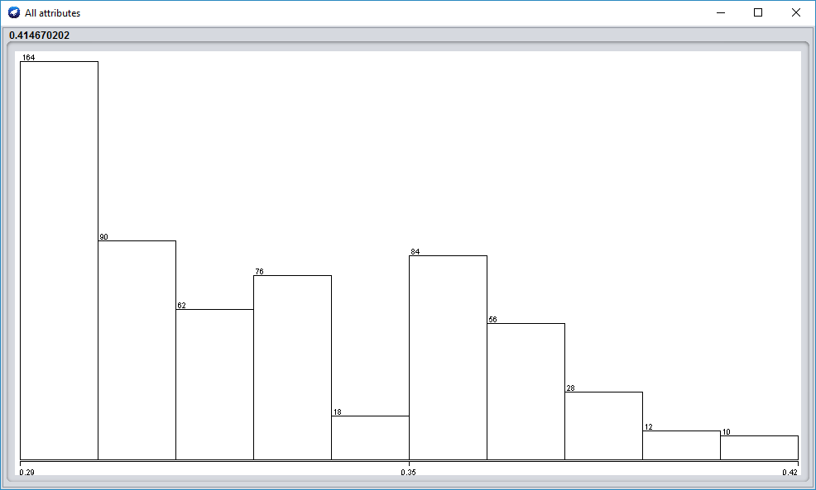
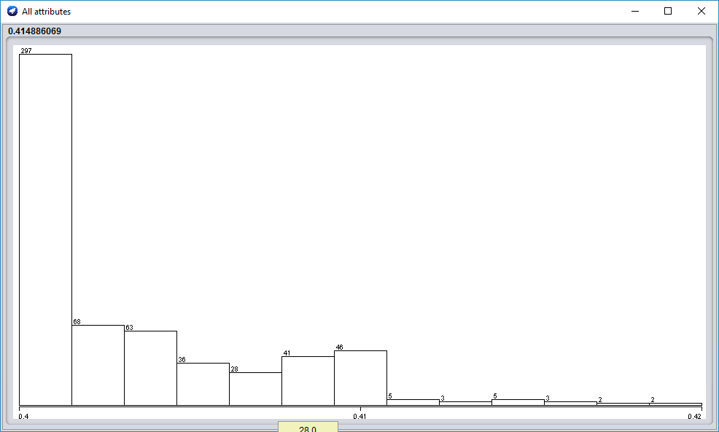

Figure 5. The error distribution for two kinds of ANN: left – mixed activation functions; right - pure hyperbolic tangent

Conclusions
The paper proposes permutation of ANN activation functions as modification of the back-propagation training algorithm. It is clearly shown by the presented results that the proposal is efficient enough in artificial neural network training speed-up.
As further work it would be interesting to extend the proposed modification in the direction of investigation of other neurons activation functions [4]. Training of artificial neural networks in distributed environment [6, 7, 8] would be also interesting if it is combined with the proposed modification.

Acknowledgements
This work was supported by private funding of Velbazhd Software LLC.
References
- Atanasova, T., Barova, M., Balabanov, T., Using neural models to analyze time series in large volumes of data, Int. Conf. NVU “Vasil Levski”, 193--198, ISSN:1314-1937, (2016)
- Tomov, P., Monov, V., Artificial Neural Networks and Differential Evolution Used for Time Series Forecasting in Distributed Environment, Proceedings of International conference Automatics and Informatics, ISSN 1313-1850, 129--132, Sofia, Bulgaria, (2016)
- Tashev, T., Hristov, H., Modeling of synthesis of information processes with generalized nets. In: Drinov, M. (ed.) Cybernetics and Information Technologies, vol. 2, Academic Publishing House, Sofia, 92–104, (2003)
- Zankinski, I., Tomov, P., Balabanov, T., Alternative Activation Function Derivative in Artificial Neural Networks, Proceedings of XXV International Symposium Management of Energy, Industrial and Environmental Systems, ISSN 1313-2237, Bankya, Bulgaria, 79--81, (2017)
- Balabanov, T., Avoiding Local Optimums in Distributed Population based Heuristic Algorithms (in Bulgarian), Proceedings of XXIII International Symposium Management of energy, industrial and environmental systems, John Atanasoff Union of Automation and Informatics, Sofia, Bulgaria, 83–86, (2015)
- Balabanov, T., Zankinski, I., Dobrinkova, D., Time Series Prediction by Artificial Neural Networks and Differential Evolution in Distributed Environment, International Conference on Large-Scale Scientific Computing, Sozopol, Bulgaria, Lecture Notes in Computer Science, vol. 7116, no. 1, 198–205, (2011)
- Balabanov, T., Zankinski, I., Barova, M., Strategy for Individuals Distribution by Incident Nodes Participation in Star Topology of Distributed Evolutionary Algorithms, Cybernetics and Information Technologies, Sofia, Bulgaria, vol. 16, no. 1, 80–88, (2016)
- Zankinski, I., Stoilov, T., Effect of the Neuron Permutation Problem on Training Artificial Neural Networks with Genetic Algorithms in Distributed Computing, Proceedings of XXIV International Symposium Management of Energy, Industrial and Environmental Systems, ISSN 1313-2237, Bankya, Bulgaria, 53--55, (2016)
- Balabanov, T., Encog digits classification resilient training example with regulated sin as activation functions, https://github.com/TodorBalabanov/EncogDigitsResilient, (2018)

