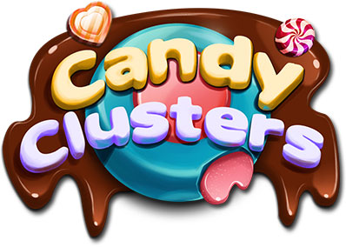
Game Document

Game Profile
Game Name | Candy clusters
Game Theme | Candy
Number of Lines | No lines
Game Type | 5 x 6 reels slot
Pay Direction | Clusters
Special Symbols | Wild, Free spins
Free Spins | Yes
Feature(s) | Yes
Jackpot | NA

Base game description

Main screen
It is a non-standard 5x6 reel slot game with cluster pay feature, collapsing reels and wild.

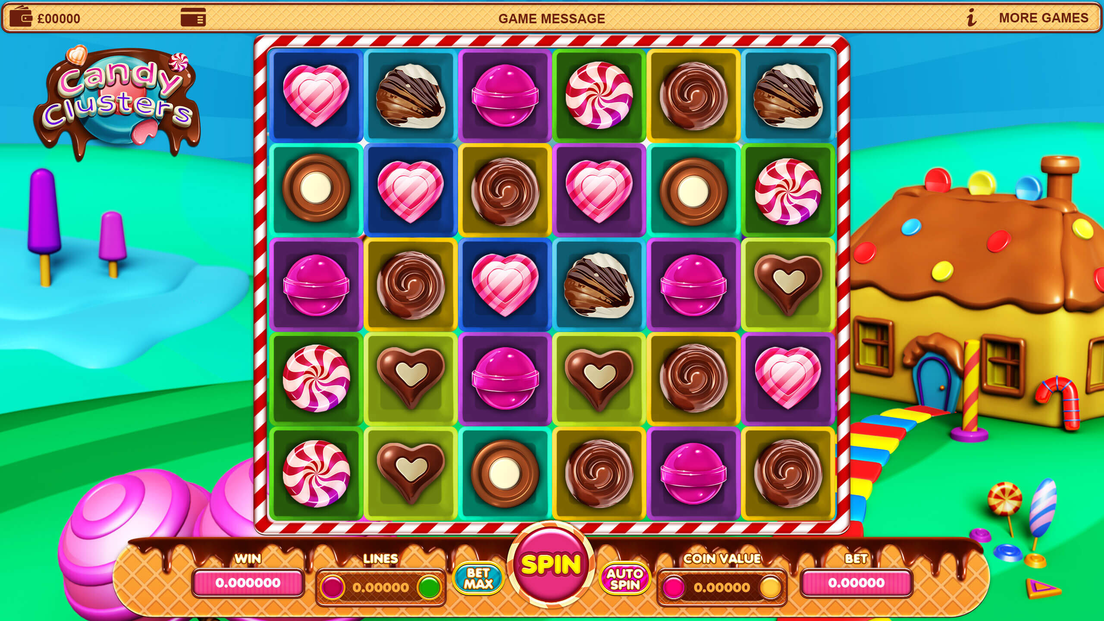

Theme:
The theme of the game is of sweets and candy.

Features
Cluster wins- Clusters of 8(subject to math) or more symbols award wins. Winning clusters collapse to offer a re-spin.

Free spins- Free spin symbol appearing on the reel in 5 or more places gives free spins according to the number of appearances.

Symbols
Symbol Name |  | Symbol Name
Milk single | 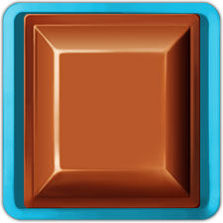 | White single | 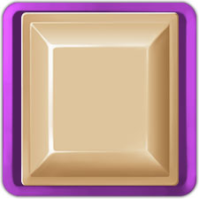
Choco spiral |  | Lollipop | 
Heart stripe |  | Choco heart | 
Choco round | 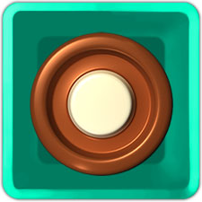 | Choco shell | 
Spiral stripe | 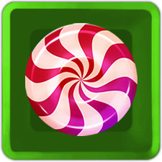 | Free spins double | 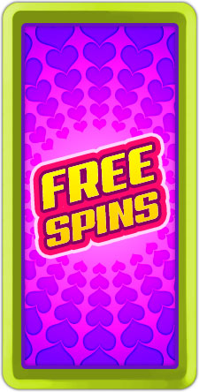
Milk choco double | 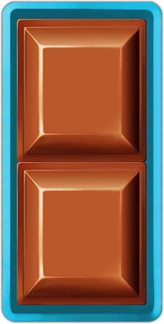 | White choco double | 