Trivia URS

Group 4

Todor Tsekov, Zirui Feng, George Vasileiadis

Contents

Requirements 3

Usecase diagram 4

Use cases 4

Start game 4

Win/Lose/Draw 5

Restart game 5

Give up game 5

Answer question 6

Send Chat Message 6

GUI 6

Non-functional requirements 8

Game description

Game consists of 5 rounds where both players will be asked one question each round (The same question).

The questions will have 3 possible answers. The player will get one point for each correct answer.

To prevent locking up the game there will be a time limit for answering each question.

After the 5 rounds the player with the highest score wins the game.

Draws are possible (Maybe implementing follow up questions till one player wins).

# Requirements

|  |  |  |
| --- | --- | --- |
| Nr. | Description | MOSCOW |
| 1 | A 10 second timer per question so the game does not lock up | M |
| 2 | 5 Questions with 3 possible answers per game | M |
| 3 | Score counter to keep score | M |
| 4 | Win/Lose/Draw dialog | M |
| 5 | After each question info about who was (not) correct answer will be shown | M |
| 6 | Give up game | S |
| 7 | Check if both players are ready | S |
| 8 | Restart game option | S |
| 9 | Leave game option | S |
| 10 | Pause game option(in between questions) | C |
| 11 | The system will show when a player leaves the game. | S |
| 12 | In game chat | C |
| 13 | Notification in case a player disconnects | S |
| 14 | Sound effects(win/lose; (in)correct answer) | C |
| 15 | User portal | W |
| 16 | Database | W |

# Usecase diagram

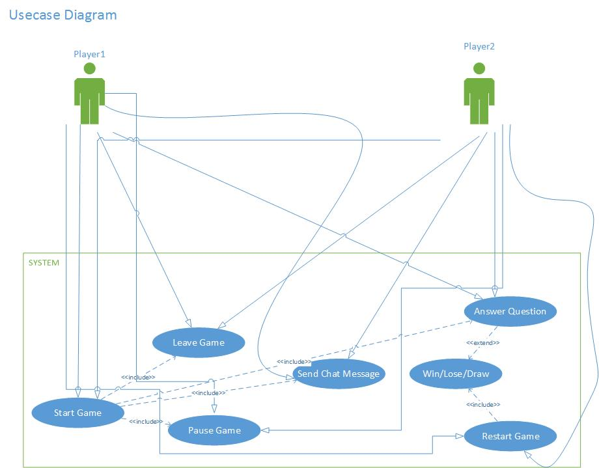

# Use cases

## Start game

|  |  |
| --- | --- |
| Goal | Players starts a new game |
| Actor | Actor1 Actor2 |
| Pre-condition | The actor opened the program and sees the Start game interface |
| MSS | 1. Actor1 clicks on start game 2. The game registers that one actor wants to start and waits for another actor to click start game 3. Actor2 accepts the game 4. The system starts the game together with Actor2 |
| Extension | 3A. Actor2 declines the game |
| Post-condition | The game begins. |

## Answer question

|  |  |
| --- | --- |
| Goal | Both Players answer the question and another question appears |
| Actor | Actor1 Actor2 |
| Pre-condition | There are two actors in a game and the system generates a question |
| MSS | 1. The system starts a 10 second timer  2. One actor answers a question  3. The other actor answers the question  4. The system continues the game |
| Extension | 2/3A. If an actor doesn’t answer a question in time it is automatically registered wrong. |
| Post-condition | Question is answered and points are awarded where necessary |

## Send Chat Message

|  |  |
| --- | --- |
| Goal- level | To chat with opponent during the game |
| Pre – condition | The game has already started |
| Actor | Actor1 Actor2 |
| MSS | 1.The Actor1 types a message in the chat box  2.The system sends the message in the User2 chat box  The Actor2 receives a message in the chat box(example) |
| Extension | 2.1 The message of Actor1 can be seen from all players/users in the game  All of this can be repeated with Actor2 sending a message and User1 receiving it. |
| Post Condition | Message sent. |

## Win/Lose/Draw

|  |  |
| --- | --- |
| Goal | User get result of the game |
| Actor | Actor1 Actor2 |
| Pre-condition | The game is running and two actors is playing. |
| MSS | 1. Actor1 and Actor2 finish all questions provide by system.  2. System check result of the two actors.  3. System compares the result of Actor1 and Actor2.  4. System shows the result to all actors whether win, lose or draw. |
| Extension | 1A.One of the actor leave the game directly before the game finish.  2B. Systems directly shows win message to the other actor. |
| Post-condition | Go to the EndGame page of the game |

## Restart game

|  |  |
| --- | --- |
| Goal | Game to back to start page |
| Actor | Actor1 Actor2 |
| Pre-condition | The game is finish and the end page is showed to actor |
| MSS | 1. One actor click on Restart Game button.  2. System shows a dialog window to the other actor whether he want to have a new game or not.  3. The second actor give chooses option Yes agreeing with the restart game.  4. System create a new game for actors. |
| Extension | 3A.The second actor decide don’t want to restart the game.  2B. System keep both side windows in EndGame page. |
| Post-condition | A new game is start |

## Give up game

|  |  |
| --- | --- |
| Goal | User give up the current game |
| Actor | Actor1 Actor2 |
| Pre-condition | The game is running and two actors are playing. |
| MSS | 1. One actor click on Give Up button  2. System shows a dialog window to the actor whether he want to give up the current game or not.  3. The actor chooses the option Yes.  4. System shows the message “Because your opponent give up the game so you win the game” and a win result to the other actor.  5. System shows the EndGame page to two actors. |
| Extension | 3A.The actor choose No option.  2B. The game is going on. |
| Post-condition | The game is stay in the EndGame page. |

# GUI

When a Player starts the game, this will be the form that he/she can see.

We simplified it as much as possible to avoid any distractions.

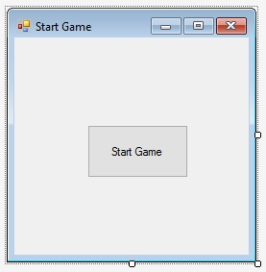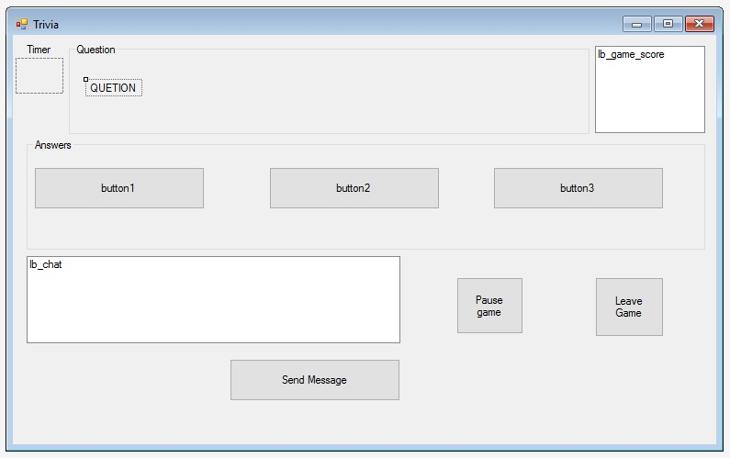

This form Trivia represents the game itself. In the top of the screen you can see Timer (Shows you how many seconds do you have left to answer a question.), Question (Shows you the current question that you need to answer) and Game Score (Shows the score of Player1 and Player2.) sections. If we go top to bottom the next section you can see is the Answer (You have 3 buttons for the 3 possible answers of the questions) section. In the bottom of the form you can see the Chat (You have a pretty straight forward chat box and message send button.) section and the two extra options Pause and Leave Game.

This form End Game appears when the game has ended.

In the picture box you will see if you win, lose or you finished as draw.

In the bottom of the form you have two options: Restart game (Players start a new game, the score from the last game is not saved) and Leave game.

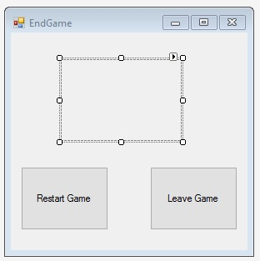

# Non-functional requirements

|  |  |
| --- | --- |
| Nr | Description |
| 1 | GUI should be easy to use |
| 2 | System should display outputs from one user to the others users within the same session |
| 3 | System should respond fast to user inputs |
| 4 | System should have stable connectivity in order to provide stable user interaction |
| 5 | System should relay information from one user to the other |
| 6 | System should display the output of the session to all current users within the session before ending the session |
| 7 | The application will be programmed in C#, which means Windows operation system version windows 7 or windows 8 are the required environments for it. |
| 8 | The application will be of type WCF. |
| 9 | The application can run on a basic computer. |